Step 1: Open <https://console.cloud.google.com/>

Step 2: Select New Project -> Create new project

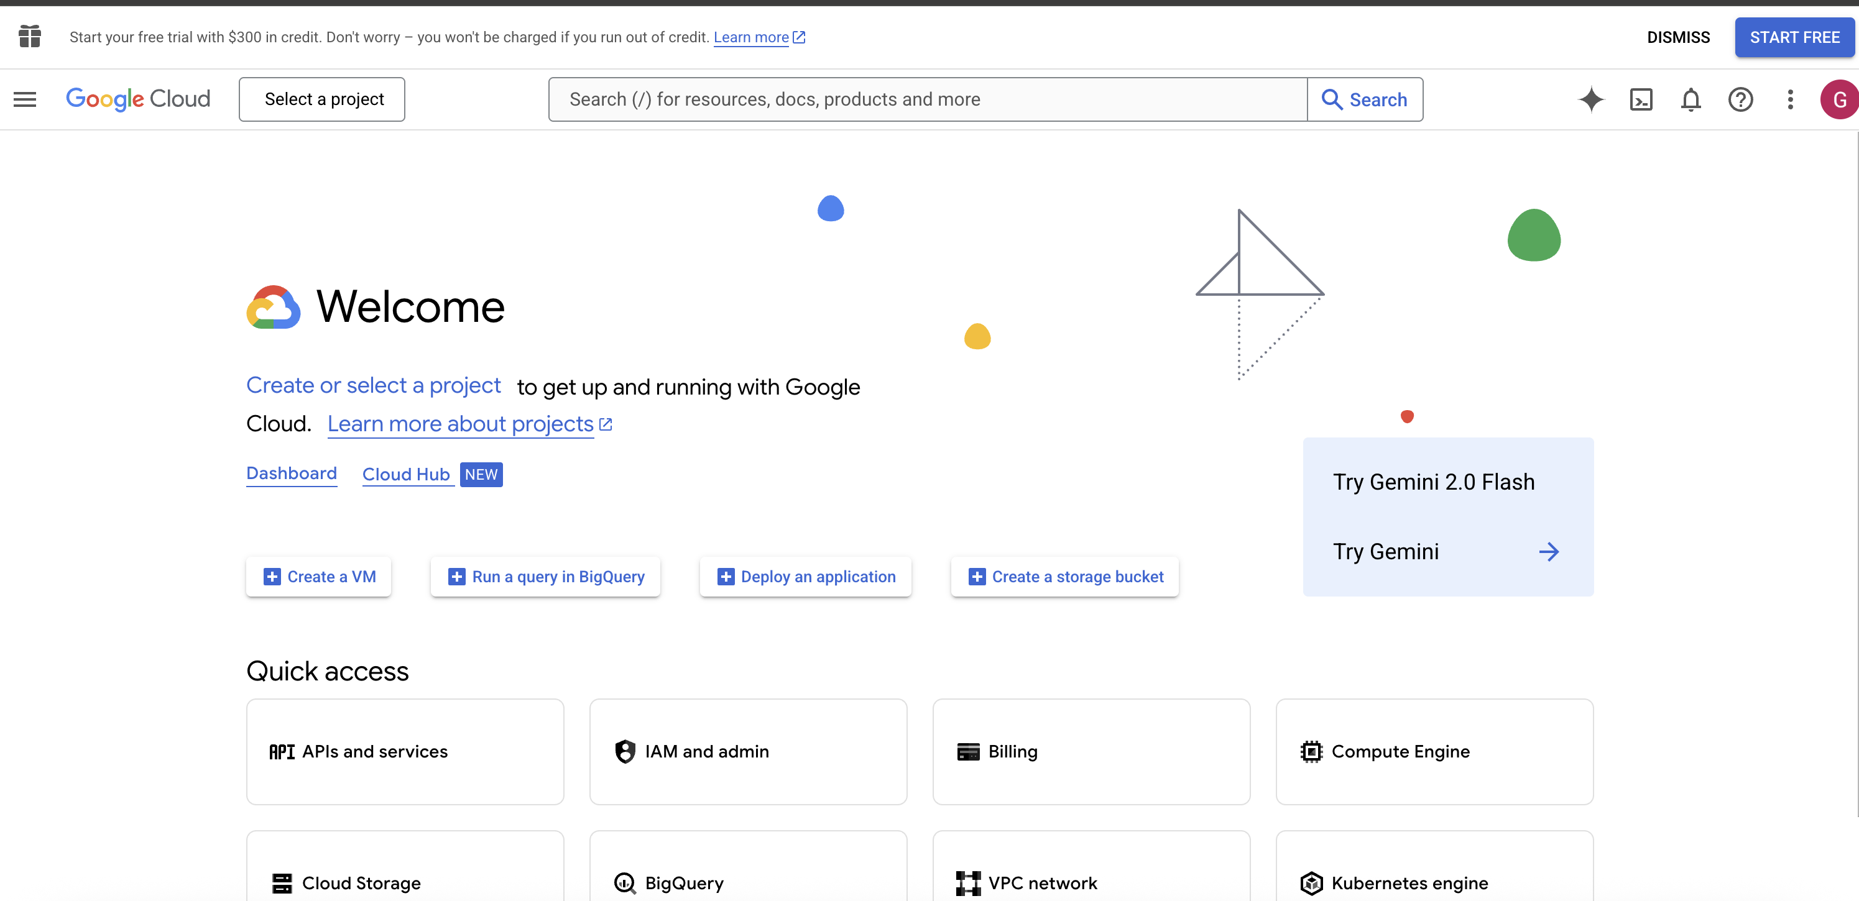



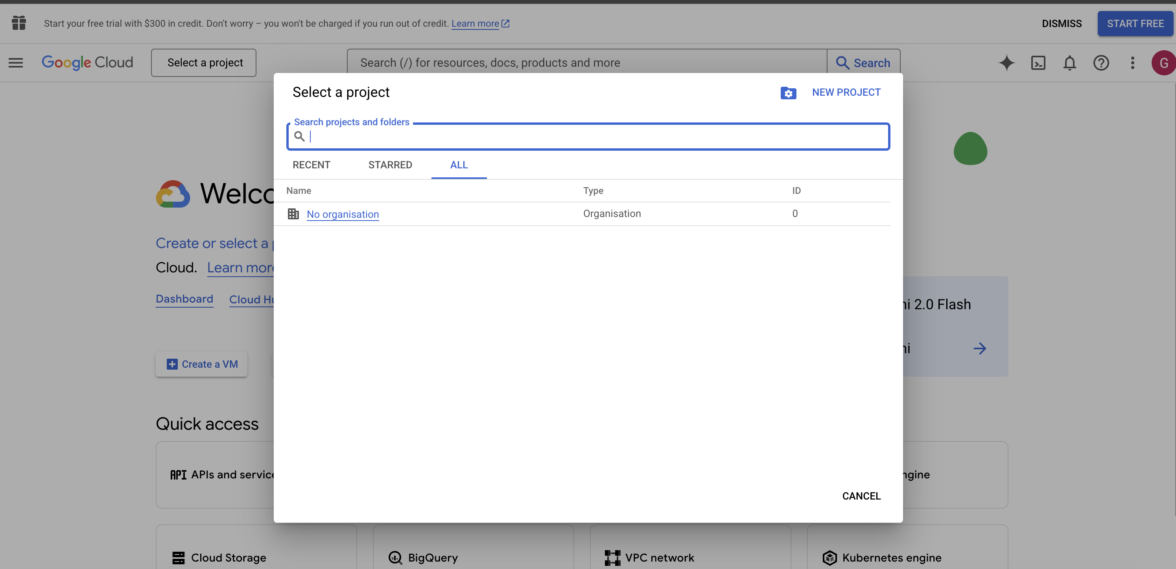



Step 3 – Fill Details

Project Name: Anything useful which you can remember

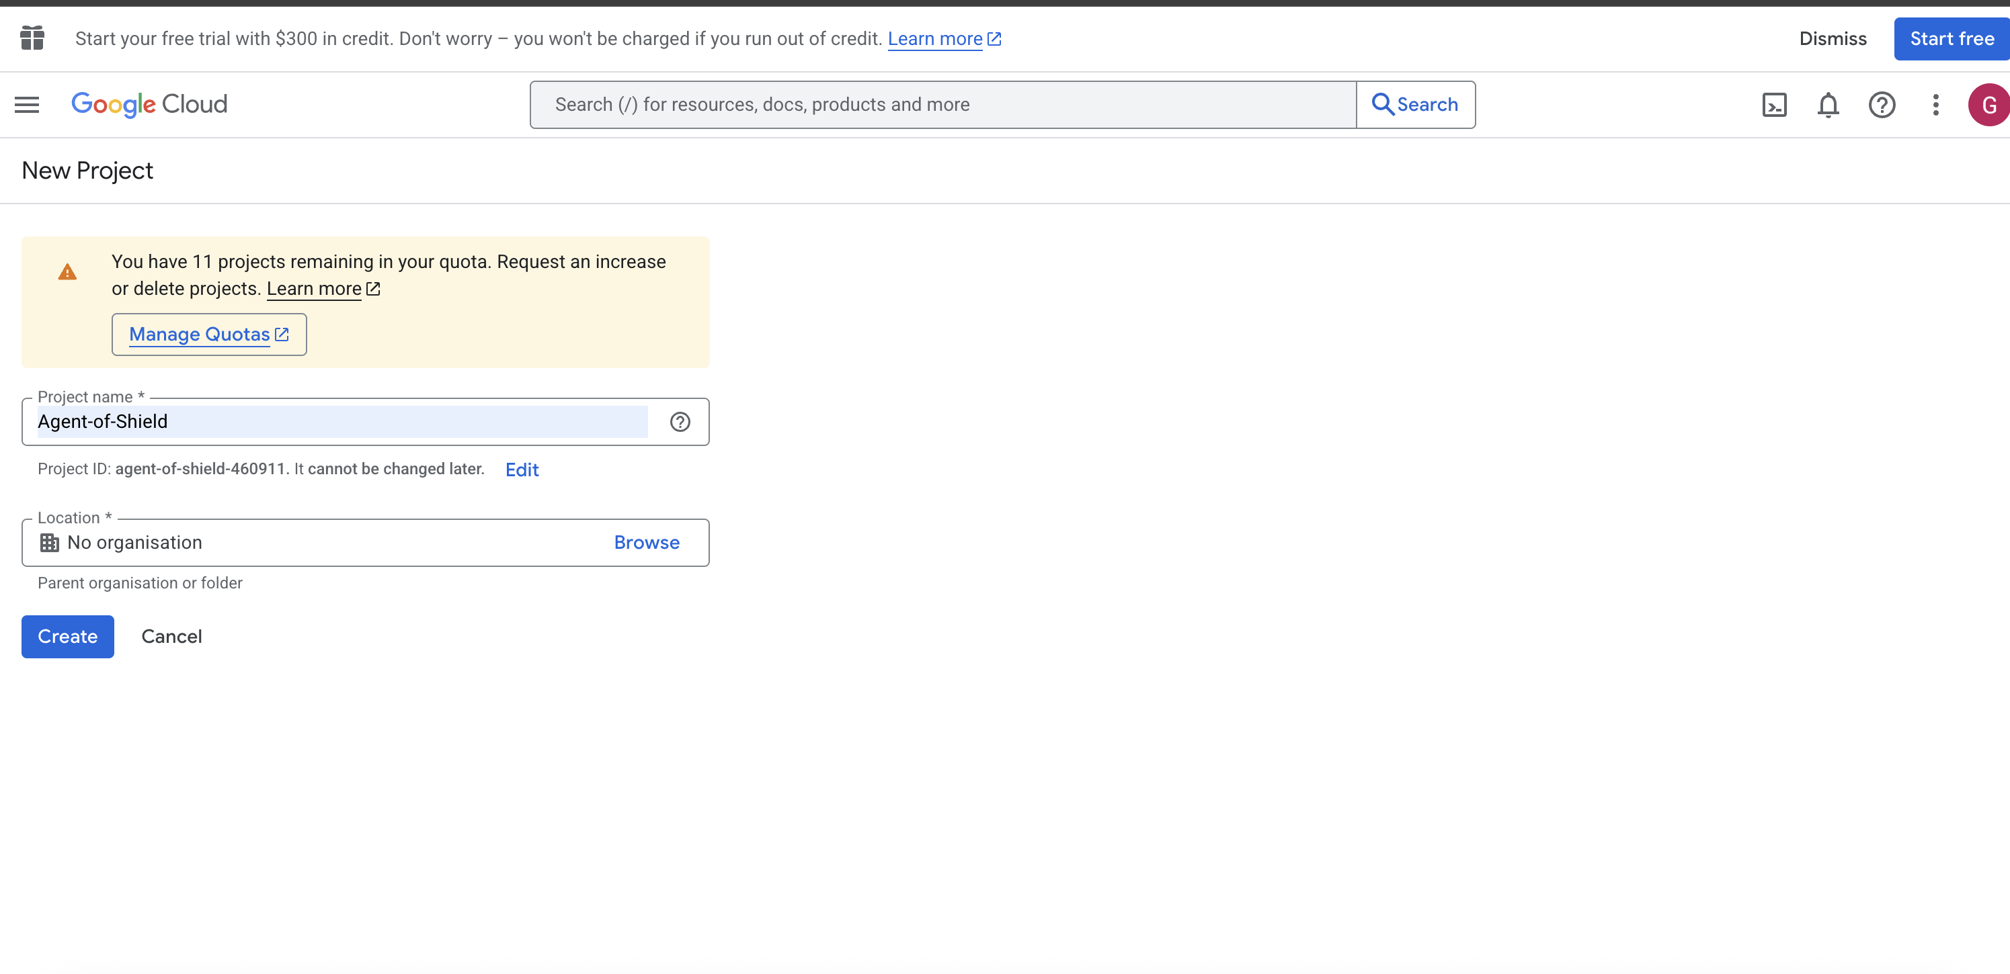

Step 4: Once project is created, you will be redirected back to home page, select this project then from top menu

Step 5: Left side menu, go to enable API and services

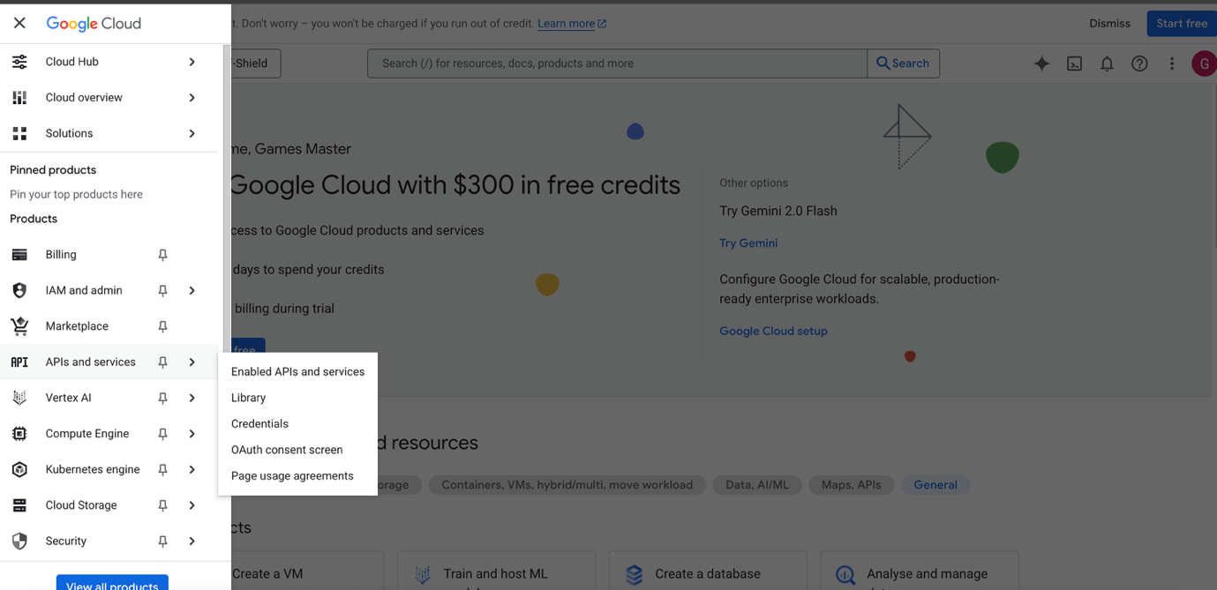

Step 6: Click Enable API and services

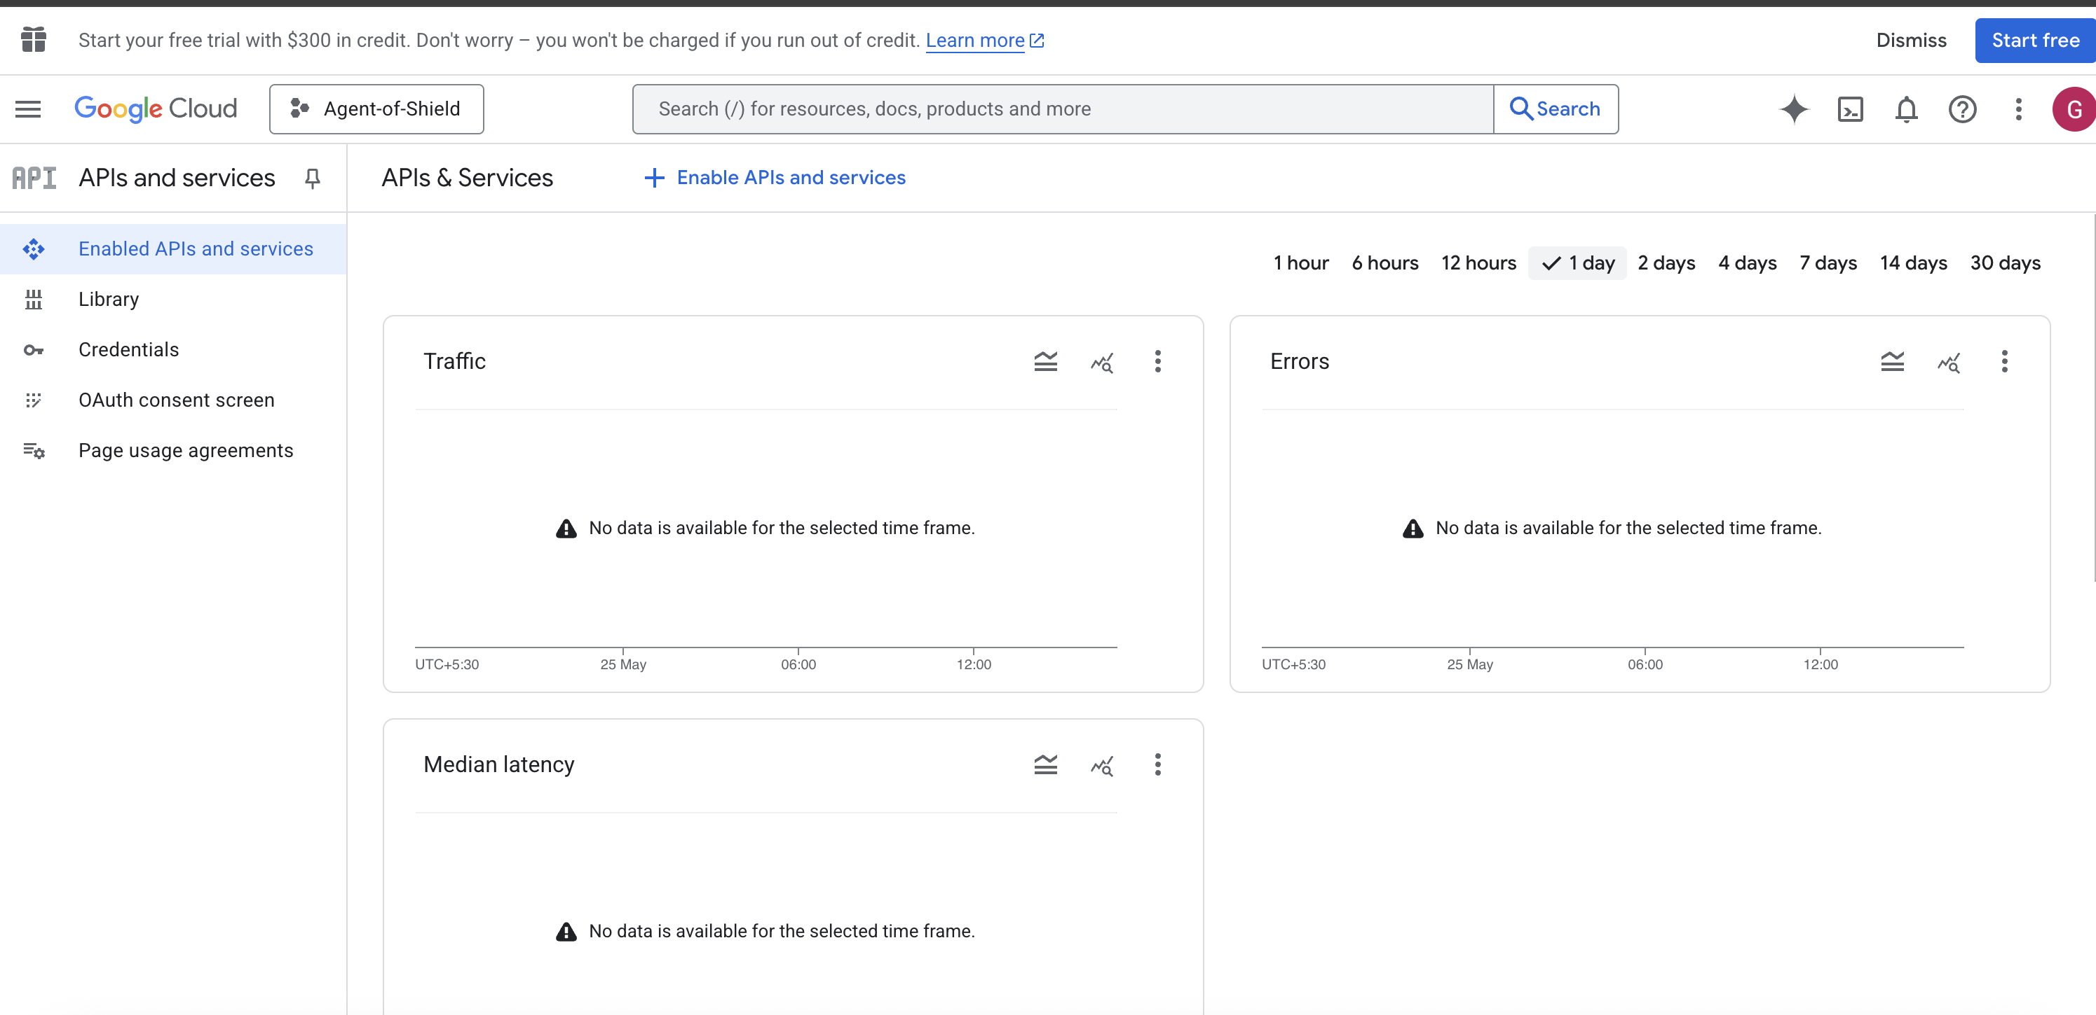



Step 7: Select Google API

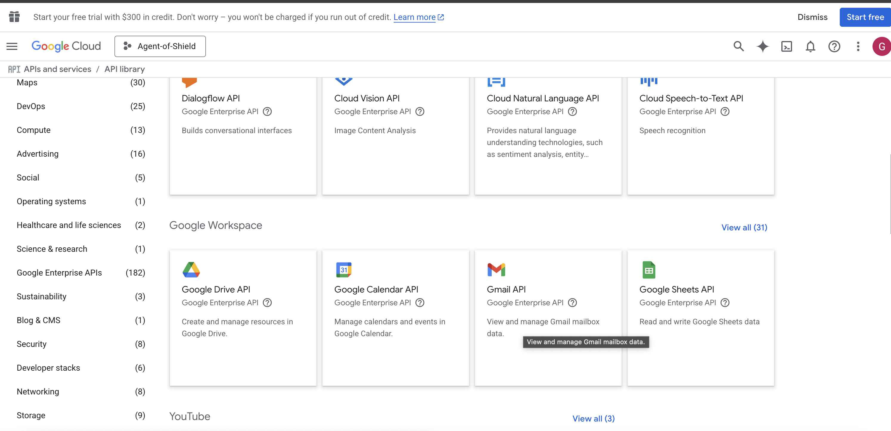



**Step 8**: Once enabled, go to credentials link from left and create new credentials

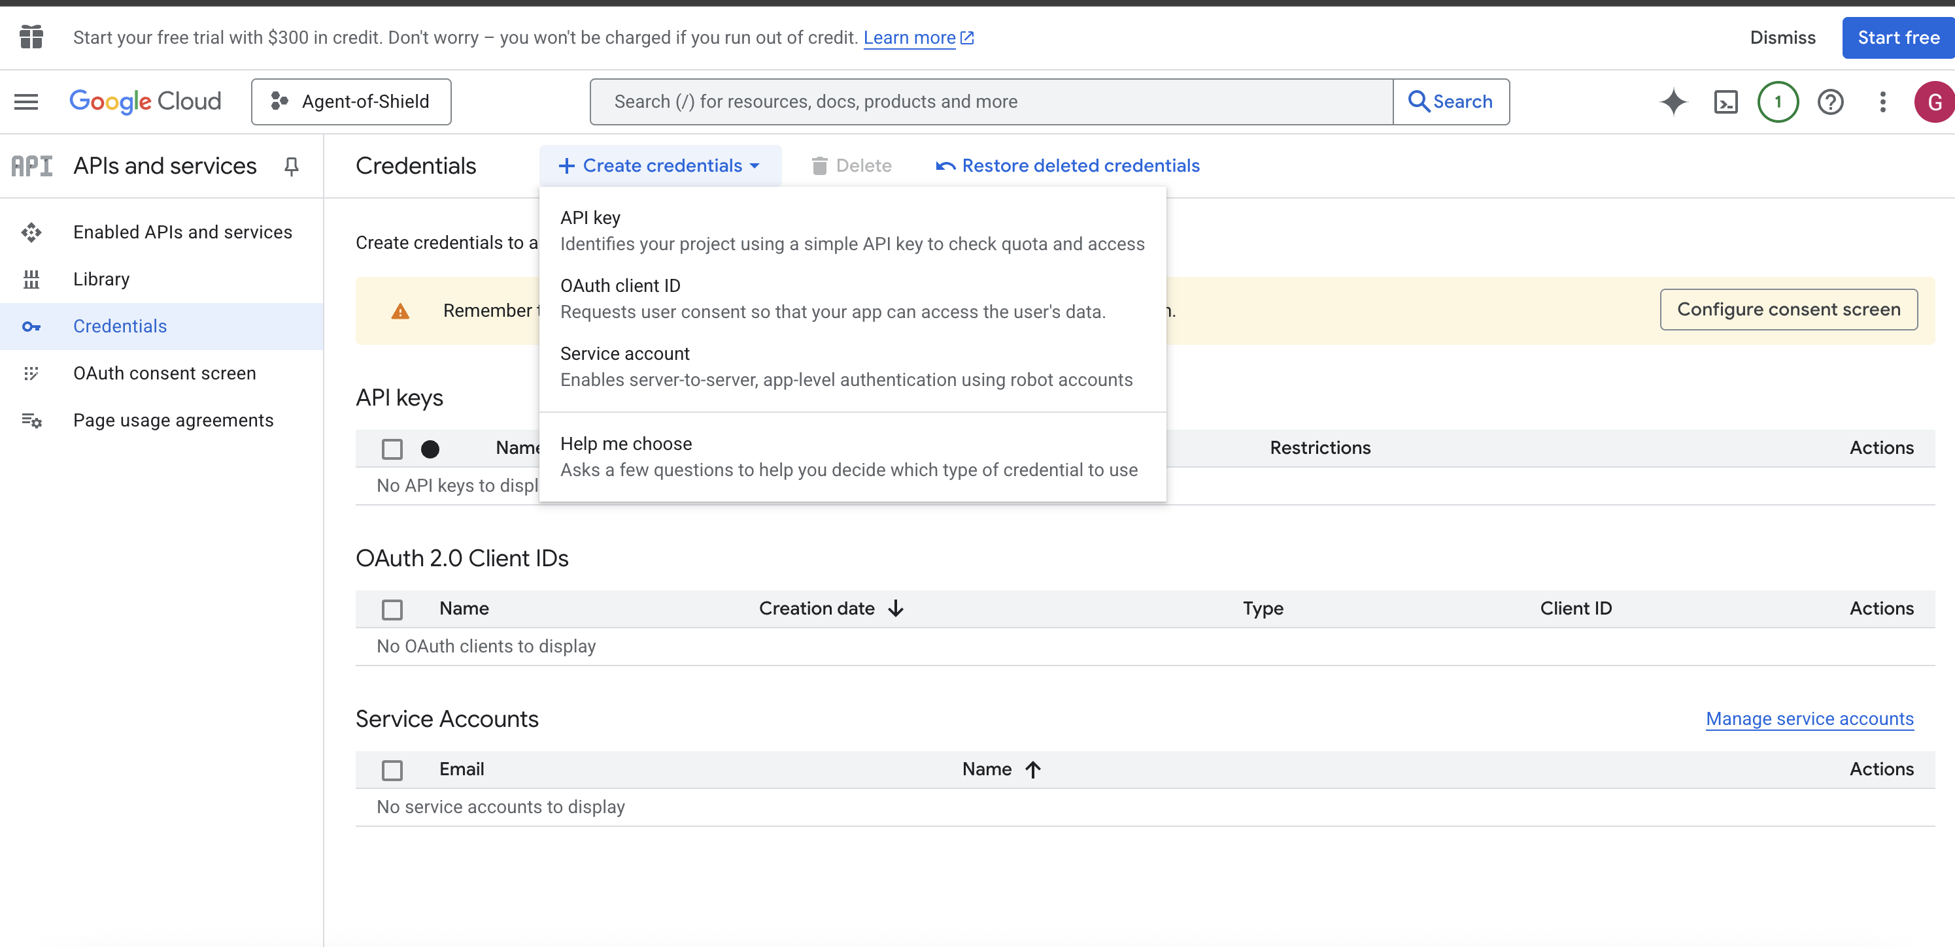



Step 9: Configure consent screen

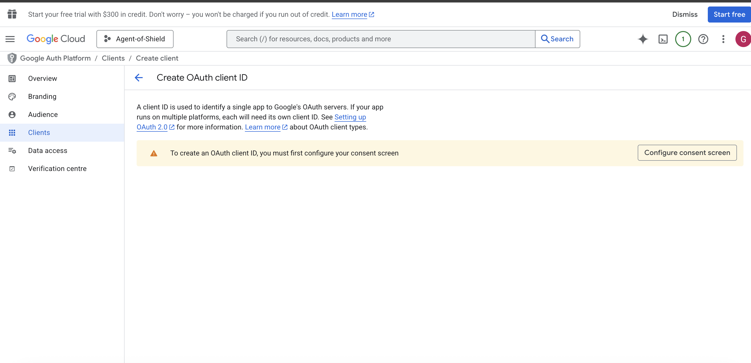

**Step 10**: Fill the details

App Info

Name – Anything worth remembering

User email – select your email from dropdown

Audience: Only External is available for personal accounts

Contact Info – Type your own email ID

Agree T&C

Create… [Imp Next step]

Step 11: Now create client for this

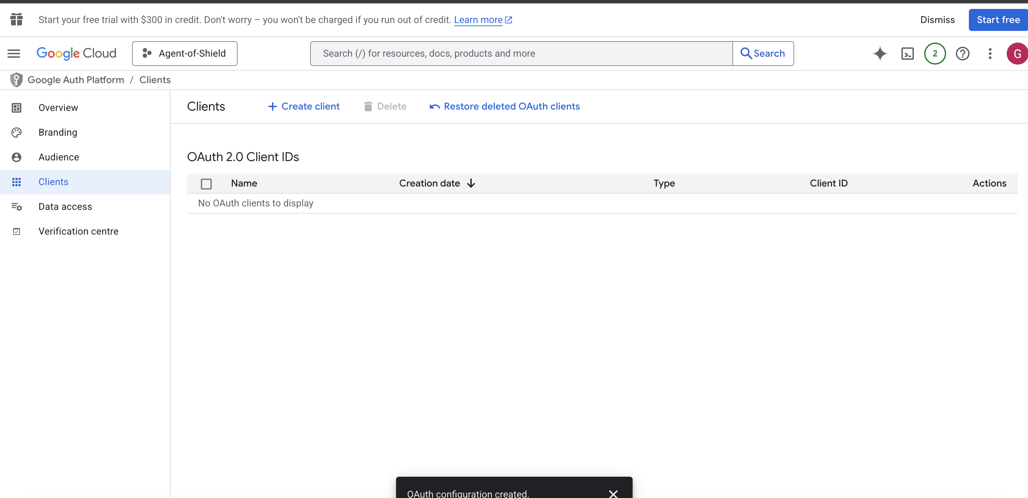

Step 12: Select application type as Desktop Application, Name can be anything

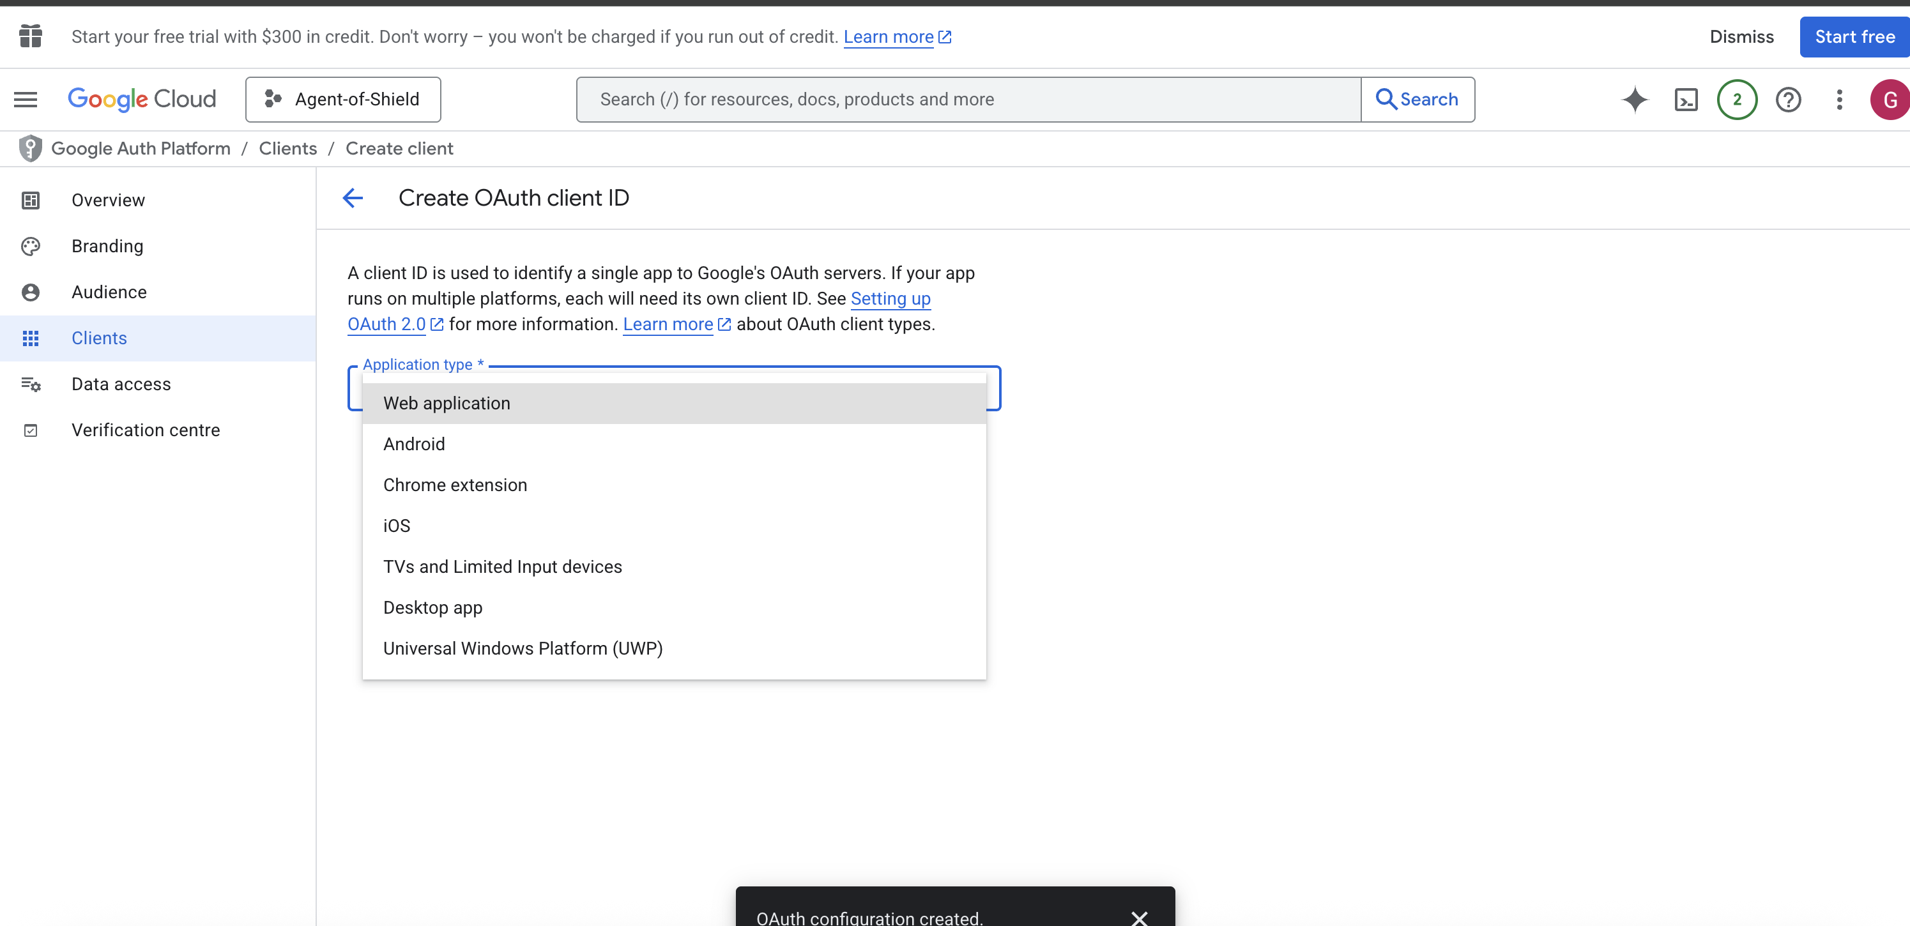

Step 13: Once its created, you get the popup, you should download the JSON from here (Important). If you missed it here, you need to download this from its home page.

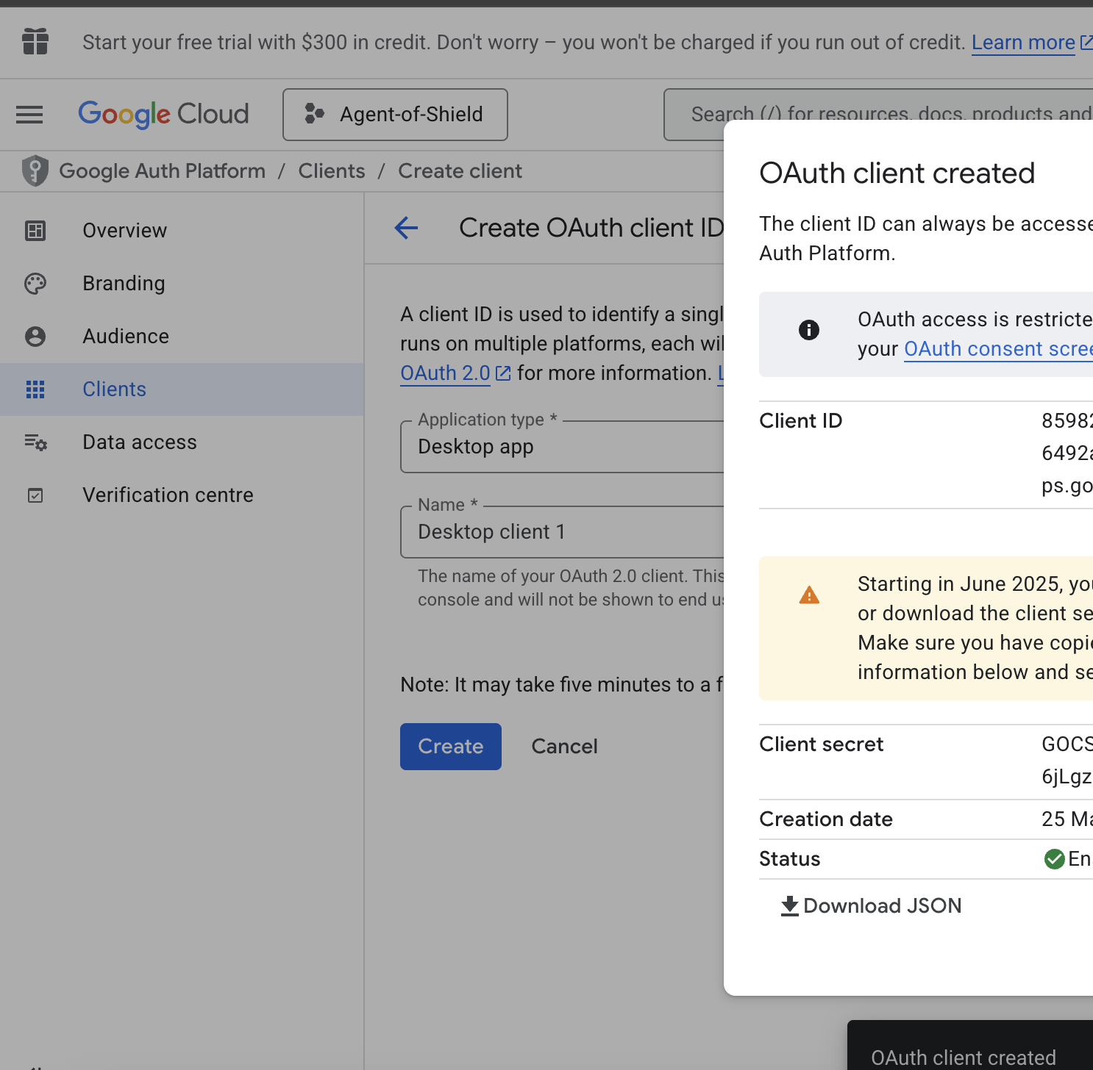

Step 14: Rename this downloaded file as **gmail_credentials.json** and copy this in your project root which you have just cloned from Github.

Step 15: Enjoy…