Step 1: Open <https://entra.microsoft.com/> and login with your account

Step 2: Go to app registration on left menu

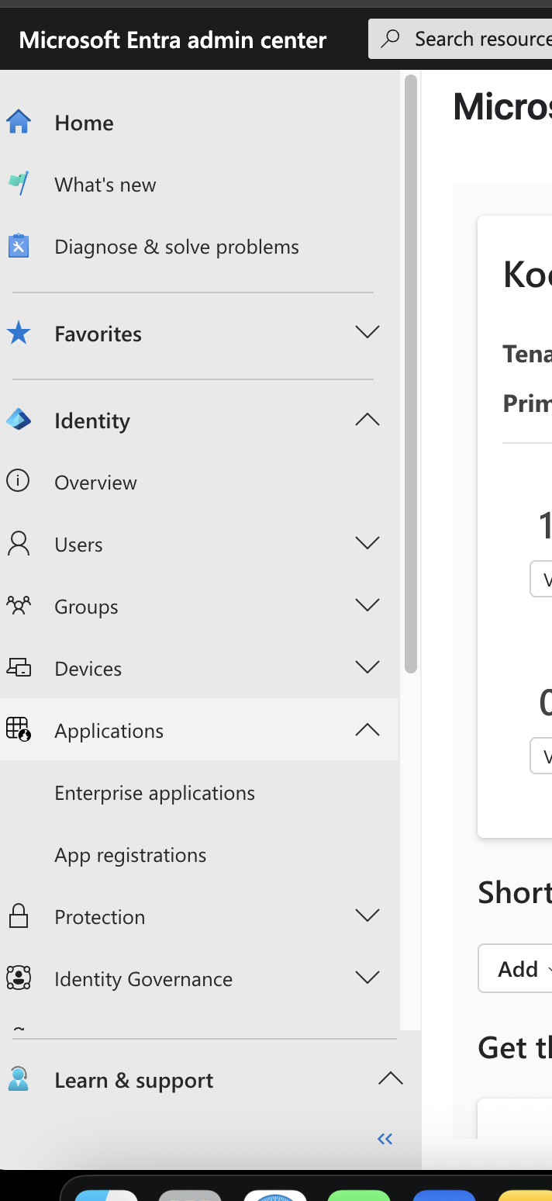



Step 3: New registration

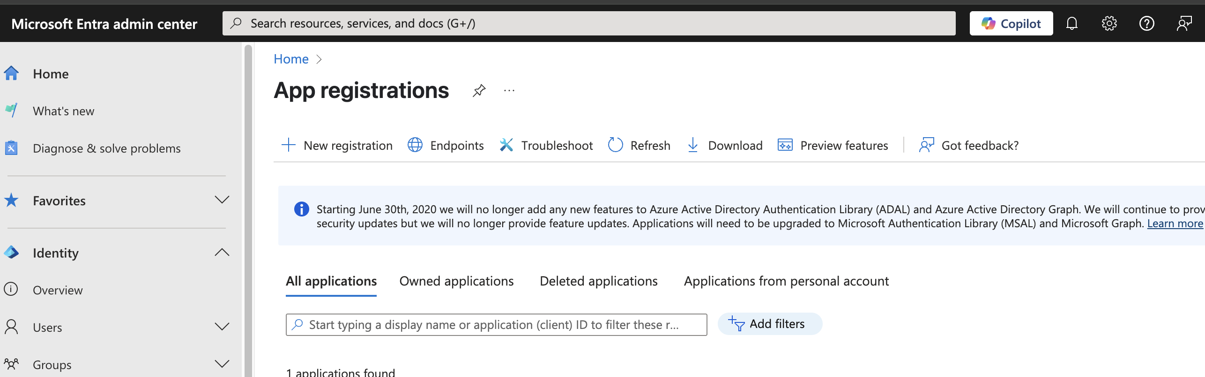



Step 4: Fill the details – similar to this

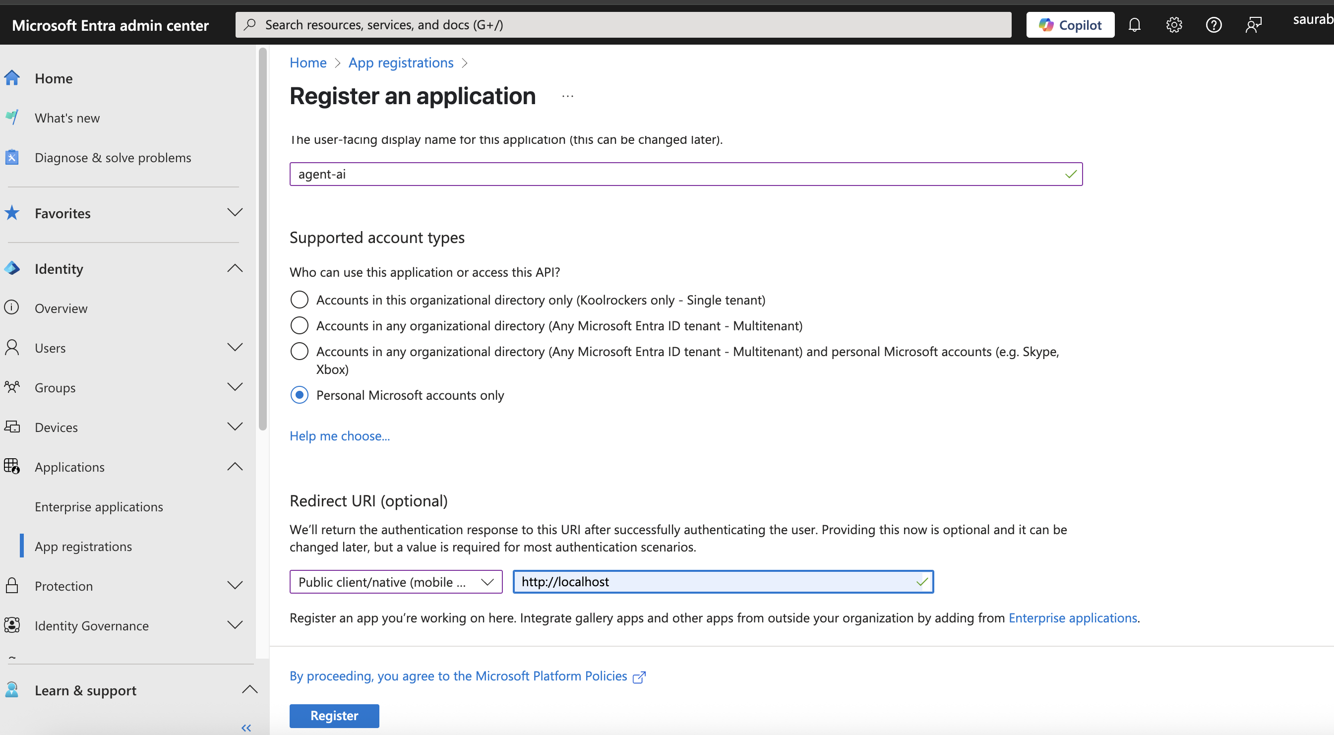

Step 5: On home of this app, select redirect URLs

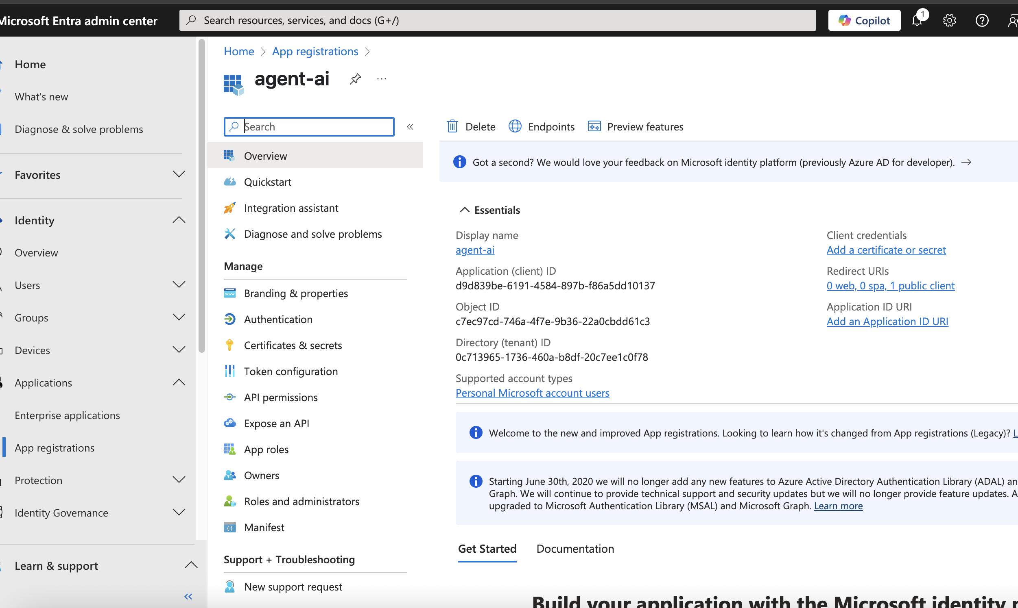



Step 6: Scroll Down and enable Allow public client flows

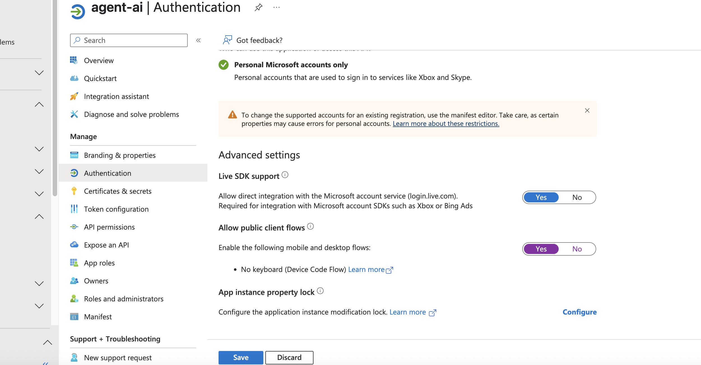



Step 7: Go to Token configuration then select ID and enable Graph API access for optional claim

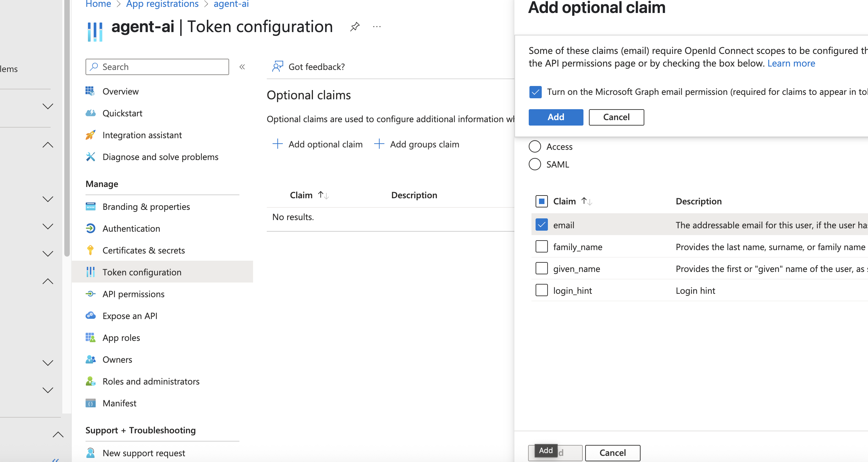

Step 8: Select API permissions now and select Add permissions

Select Microsoft Graph API

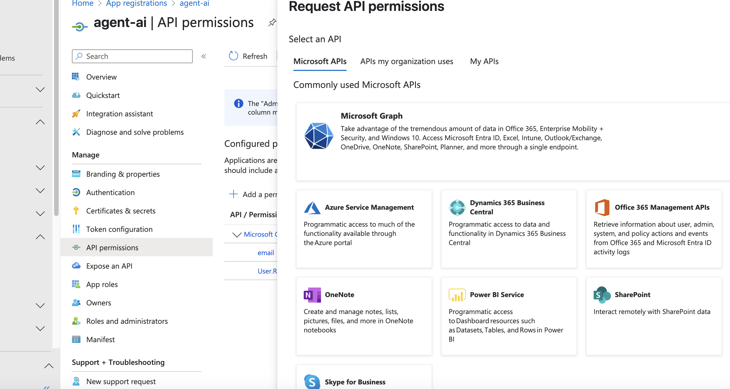



Step 9: Select / Type Mail and search box and select at-least following

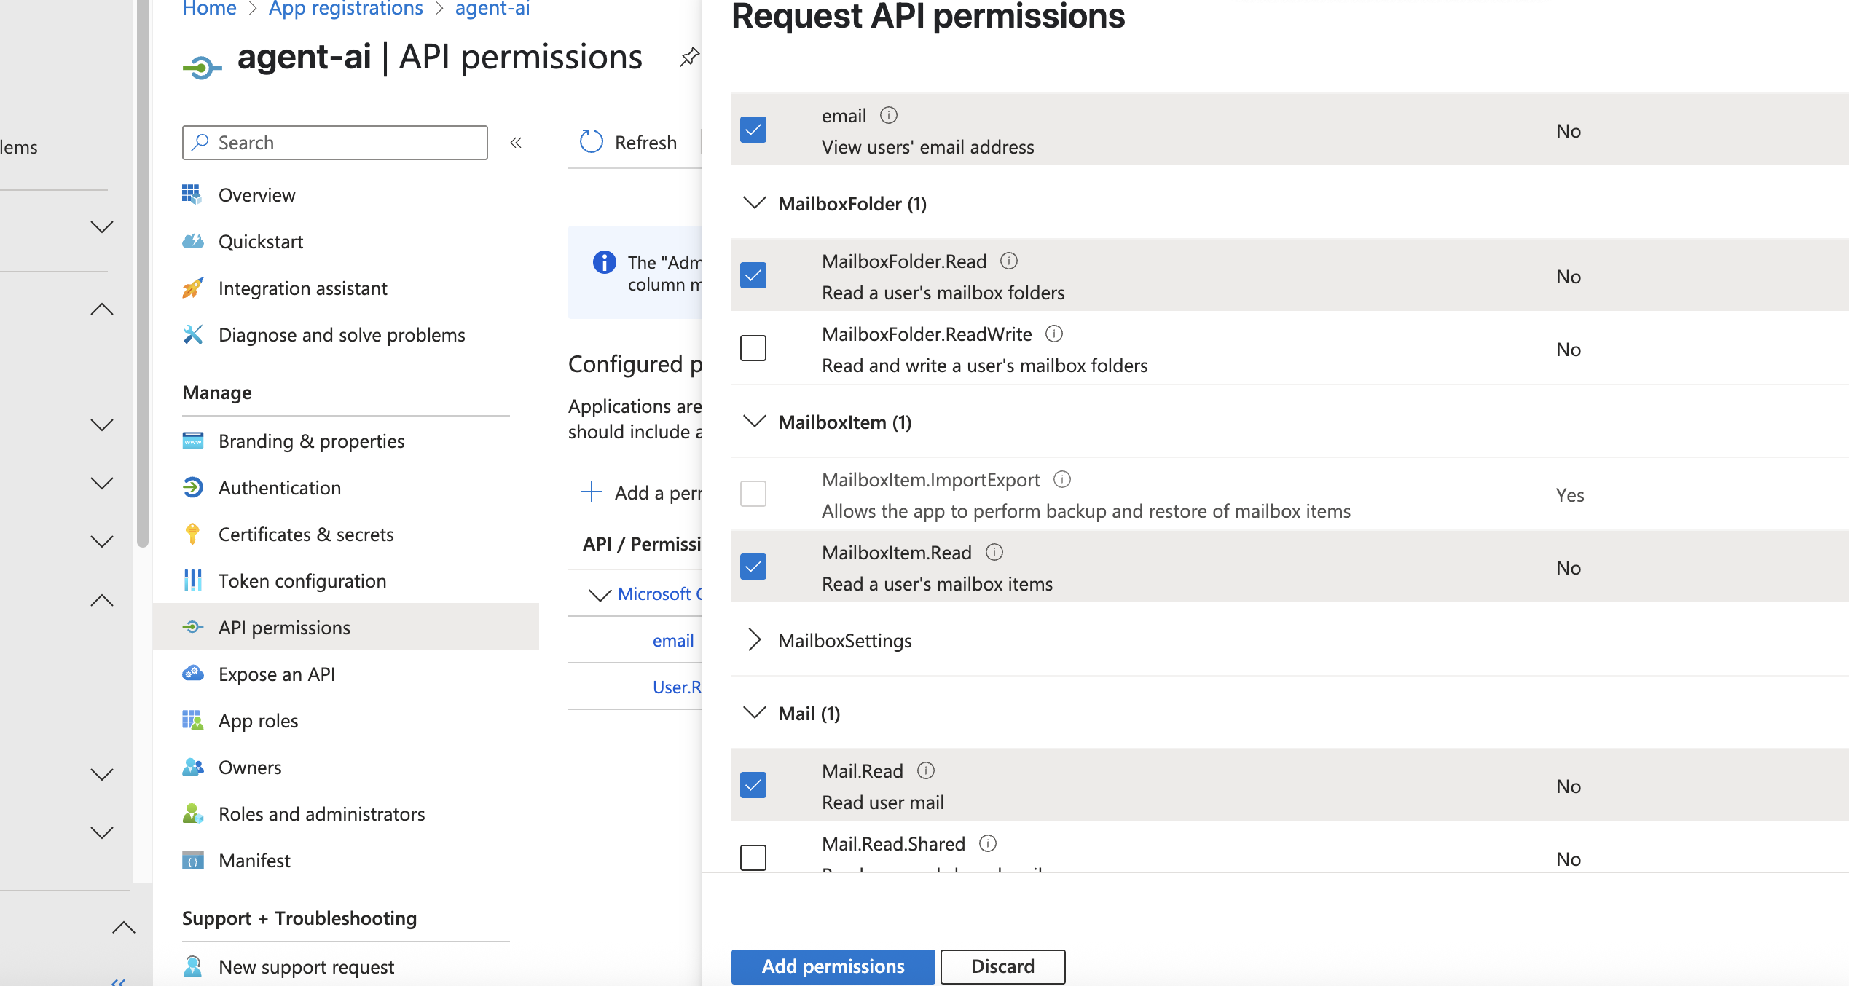

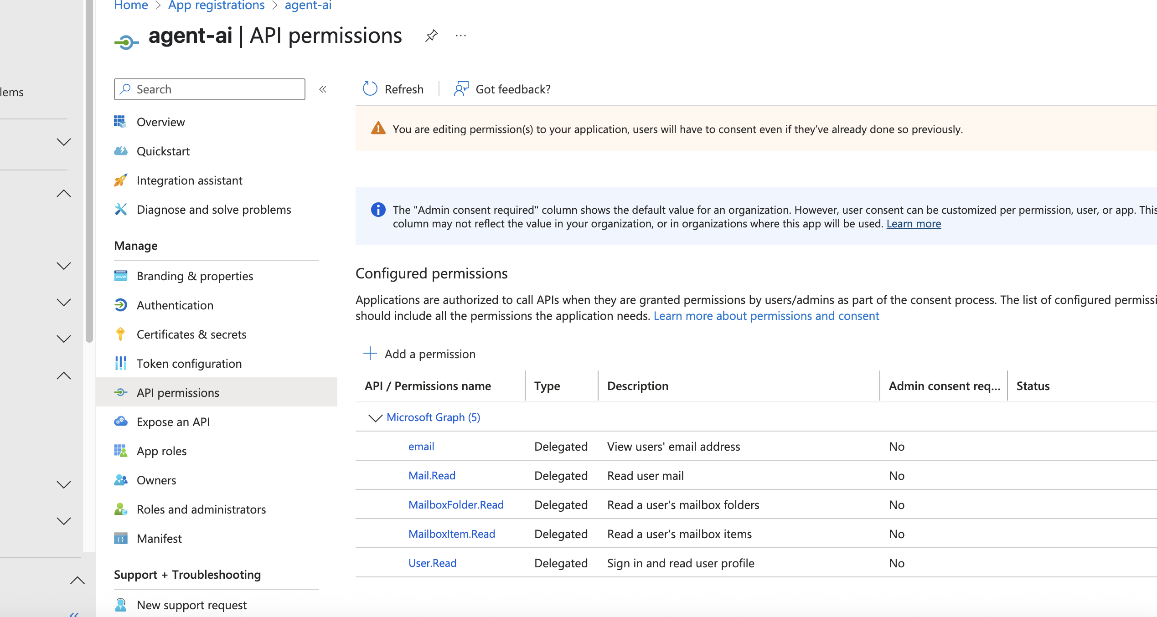

Step 10: Go back to overview page and note down the Application (client) ID. You need to provide this info in .env file under your project root file. It will be hidden as started with . so you need to unhide it first

Step 11: Enjoy