**The Tour Guide**

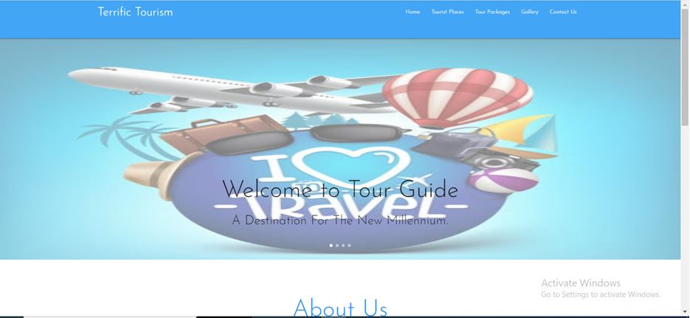

Main Page of Website

**Overview :**

My goal in this project is to focus on tourist places through design of this tour guide website. On this website, I include tourist places and all about to know the tourist locations. In addition website offers interface to get register with us to know our best tour packages. This web application is an online service for touring Incredible India.

Objective :

1. To let user knows everything about the tourist places.
2. To let us know the users about the region and to help them to interpret the sights that they are visiting.

System Users :

1. Home Page
2. Destinations
3. Virtual Trip
4. Plan My Trip
5. Tour Packages
6. Home Page

This feature has a role of main page of the website. This consists of a project heading, aboutus, services we provide for the user. About us feature tells about in brief of our project heading. Services feature provides the services we provide for the user.

1. Destinations

This feature has a role of suggesting bestest location for a user to let user lookup on the places they want to visit.From this feature user can view the the types of tourist places like Historical, Monuments etc. . A user can further explore any of these places in next feature which shows complete information of the places.

1. Virtual Trip

This feature provides the opportunity to the user to explore his trip on his computer. User can view the complete description of the places he wants to visit.

1. Plan my trip

This feature offers user a trip on the basis of his travelling needs like his favourite destination, interests and the number of days he wants to travel. To plan a trip user have to get registered with us.

1. Tour Packages

This feature offers some Standard Tour packages for the user which is comfortable & suitable for them to travel. User can see the packages, just click on the package & plan their trip.

1. Forum (contact us)

Forums form an important part of the travel facilitation service as they allow

users to interact with each other. It facilitates users to post any query, share their experiences like these.

**Software Requirements :**

1. IDE/Text Editor :

* Visual Studio Code

1. Front End:

* HTML5
* CSS3
* BootStrap
* JS

1. Browser:

* Google Chrome

**Case Diagram :**

|  |
| --- |
| Register  (For new User) |
| Login  (User) |
| Tourist Places |
| Tour Packages |

Plan a Trip

User