Practical NO. 6
Aim: Write a program to solve an optimization problem using the Hill Climbing
algorithm.
Code:
def objective_function(x):
return -(x - 3) ** 2 + 9
# Hill Climbing Function
def hill_climbing(start, step_size, max_iterations):
# Initial position
current = start
current_value = objective_function(current)
print("Initial Position =", current)
print("Initial Value =", current_value)
print("-" * 40)
for i in range(max_iterations):
left = current - step_size
right = current + step_size
left_value = objective_function(left)
right_value = objective_function(right)
print(f"Iteration {i+1}")
print(f"Current Position = {current}, Value = {current_value}")
print(f"Left Neighbor = {left}, Value = {left_value}")
print(f"Right Neighbor = {right}, Value = {right_value}")
if left_value > current_value:
current, current_value = left, left_value
print("Move Left")
elif right_value > current_value:
current, current_value = right, right_value
print("Move Right")
else:
print("No Better Neighbor Found")
print("Stopping Search...")
break
print("-" * 40)
return current, current_value
best_position, best_value = hill_climbing(
start=0,
step_size=1,
max_iterations=20
)
print("\nBest Position =", best_position)
print("Maximum Value =", best_value)

OUTPUT:
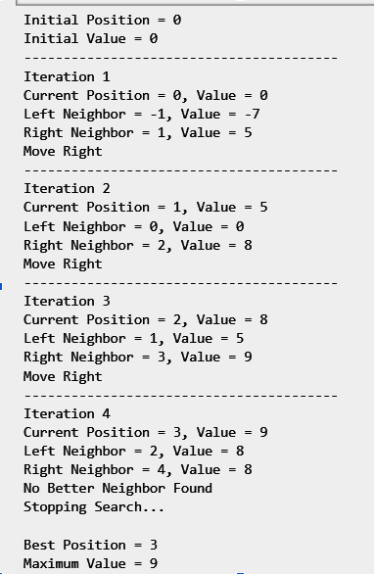

Practical No. 7
Aim: Implement the Minimax algorithm for a two-player game (e.g., Tic-Tac-Toe) and demonstrate how optimal decisions are made.
Code:
import math
def win(b):
w = [
(0,1,2), (3,4,5), (6,7,8),
(0,3,6), (1,4,7), (2,5,8),
(0,4,8), (2,4,6)
]
for a, c, d in w:
if b[a] == b[c] == b[d] and b[a] != " ":
return b[a]
return None
def minimax(b, max_player):
result = win(b)
if result == "O":
return 1
if result == "X":
return -1
if " " not in b:
return 0
if max_player:
best = -math.inf
for i in range(9):
if b[i] == " ":
b[i] = "O"
score = minimax(b, False)
b[i] = " "
best = max(best, score)
return best
else:
best = math.inf
for i in range(9):
if b[i] == " ":
b[i] = "X"
score = minimax(b, True)
b[i] = " "
best = min(best, score)
return best
def best_move(b):
best = -math.inf
move = 0
for i in range(9):
if b[i] == " ":
b[i] = "O"
score = minimax(b, False)
b[i] = " "
if score > best:
best = score
move = i
return move
def show(b):
print(b[0], "|", b[1], "|", b[2])
print("--+---+--")
print(b[3], "|", b[4], "|", b[5])
print("--+---+--")
print(b[6], "|", b[7], "|", b[8])
b = [" "] * 9
while True:
show(b)
p = int(input("Enter position (0-8): "))
if b[p] != " ":
print("Position already occupied!")
continue
b[p] = "X"
if win(b) == "X":
show(b)
print("You Win!")
break
if " " not in b:
show(b)
print("Draw!")
break

m = best_move(b)
b[m] = "O"
print("AI chooses:", m)
if win(b) == "O":
show(b)
print("AI Wins!")
break
OUTPUT:
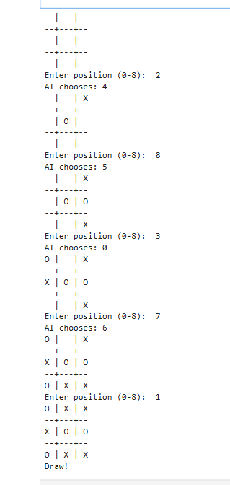

Practical No.8
Aim: Aim: Implement a simple Hidden Markov Model (HMM) and demonstrate sequence prediction or state estimation.
Code:
import math

states = ["Studying", "Playing"]

initial = {"Studying": 0.6, "Playing": 0.4}

trans = {
"Studying": {"Studying": 0.8, "Playing": 0.2},
"Playing": {"Studying": 0.3, "Playing": 0.7}
}

emit = {
"Studying": {"Low": 0.9, "High": 0.1},
"Playing": {"Low": 0.2, "High": 0.8}
}

obs = ["Low", "High", "High"]

def viterbi(obs):
prob = [{}]
path = {}

for s in states:
prob[0][s] = initial[s] * emit[s][obs[0]]
path[s] = [s]

for t in range(1, len(obs)):
prob.append({})
new_path = {}

for s in states:
p, prev = max(
(prob[t-1][p] * trans[p][s], p)
for p in states
)
prob[t][s] = p * emit[s][obs[t]]
new_path[s] = path[prev] + [s]

path = new_path

final = max(states, key=lambda s: prob[-1][s])
return path[final], prob[-1][final]

result, probability = viterbi(obs)

print("Observations:", obs)
print("Predicted states:", result)
print("Probability:", probability)

for i in range(len(obs)):
print("Day", i+1, ":", obs[i], "===", result[i])

import matplotlib.pyplot as plt

plt.plot([1, 2, 3], result, marker='o')
plt.title("HMM State Estimation")
plt.xlabel("Day")
plt.ylabel("Hidden State")
plt.grid()
plt.show()

OUTPUT:
import math

states = ["Studying", "Playing"]

initial = {"Studying": 0.6, "Playing": 0.4}

trans = {
"Studying": {"Studying": 0.8, "Playing": 0.2},
"Playing": {"Studying": 0.3, "Playing": 0.7}
}

emit = {
"Studying": {"Low": 0.9, "High": 0.1},
"Playing": {"Low": 0.2, "High": 0.8}
}

obs = ["Low", "High", "High"]

def viterbi(obs):
prob = [{}]
path = {}

for s in states:
prob[0][s] = initial[s] * emit[s][obs[0]]
path[s] = [s]

for t in range(1, len(obs)):
prob.append({})
new_path = {}

for s in states:
p, prev = max(
(prob[t-1][p] * trans[p][s], p)
for p in states
)
prob[t][s] = p * emit[s][obs[t]]
new_path[s] = path[prev] + [s]

path = new_path

final = max(states, key=lambda s: prob[-1][s])
return path[final], prob[-1][final]

result, probability = viterbi(obs)

print("Observations:", obs)
print("Predicted states:", result)
print("Probability:", probability)

for i in range(len(obs)):
print("Day", i+1, ":", obs[i], "===", result[i])

import matplotlib.pyplot as plt

plt.plot([1, 2, 3], result, marker='o')
plt.title("HMM State Estimation")
plt.xlabel("Day")
plt.ylabel("Hidden State")
plt.grid()
plt.show()

OUTPUT:
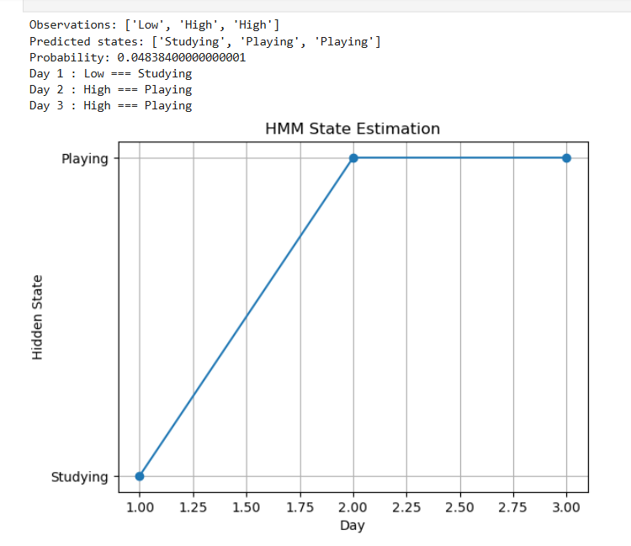

Practical NO.9
Aim: Aim: Write a program to implement the Expectation-Maximization (EM) algorithm for learning with hidden variables.
Code:
import numpy as np

X = np.array([10, 11, 12, 20, 21, 22], dtype=float)
k = 2

means = np.array([11.0, 21.0])
variances = np.array([1.0, 1.0])
weights = np.array([0.5, 0.5])

def gaussian(x, mean, variance):
return (1 / np.sqrt(2 * np.pi * variance)) * np.exp(-((x - mean) ** 2) / (2 * variance))

for iteration in range(10):
responsibilities = np.zeros((len(X), k))

for i in range(len(X)):
for j in range(k):
responsibilities[i, j] = weights[j] * gaussian(X[i], means[j], variances[j])
responsibilities[i] /= np.sum(responsibilities[i])

Nk = np.sum(responsibilities, axis=0)
means = np.sum(responsibilities * X[:, np.newaxis], axis=0) / Nk
variances = np.sum(responsibilities * (X[:, np.newaxis] - means) ** 2, axis=0) / Nk
weights = Nk / len(X)

print("\nIteration:", iteration + 1)
print("Means:", means)
print("Variances:", variances)
print("Weights:", weights)

print("\nFinal Responsibilities:")
print(responsibilities)

print("\nFinal Means:")
print(means)

print("\nFinal Variances:")
print(variances)

print("\nFinal Weights:")
print(weights)

OUTPUT:
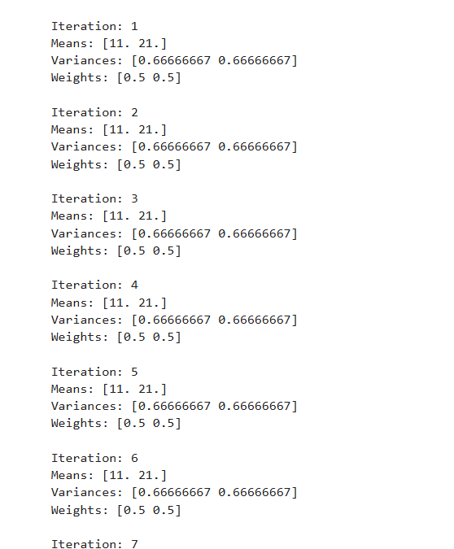
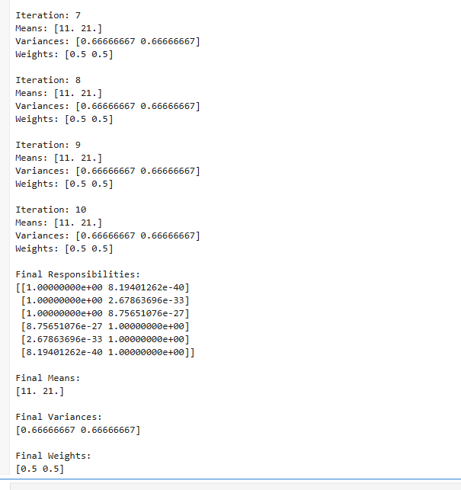

Practical No. 10
Aim: Write a program to implement forward chaining and backward chaining
in a rule based system.
Code:
facts = {"bird"}

rules = [
({"bird"}, "animal"),
({"animal"}, "living_thing"),
({"living_thing"}, "needs_food")
]

def forward_chaining(facts, rules, goal):
facts = set(facts)
print("\n--- Forward Chaining ---")
print("Initial Facts:", facts)

while True:
new_fact = False
for conditions, conclusion in rules:
if conditions.issubset(facts):
if conclusion not in facts:
facts.add(conclusion)
print("Derived:", conclusion)
new_fact = True
if conclusion == goal:
print("Goal reached:", goal)
return True
if not new_fact:
break

print("Goal cannot be reached.")
return False

def backward_chaining(goal, facts, rules):
print("\nTrying to prove:", goal)
if goal in facts:
print("Fact found:", goal)
return True
for conditions, conclusion in rules:
if conclusion == goal:
for condition in conditions:
if not backward_chaining(condition, facts, rules):
return False
print("Proved:", goal)
return True
return False

goal = "needs_food"

forward_chaining(facts, rules, goal)

print("\n--- Backward Chaining ---")
if backward_chaining(goal, facts, rules):
print("Goal reached:", goal)
else:
print("Goal cannot be proved.")

OUTPUT:
