Practical No 2
Aim:Write a Dart program demonstrating variables and functions.

Code:
int addNumbers(int a,int b){ return a+b;
}
void displayStudent(String name, int age){ print("Student name: $name"); print("Age: $age");
}
void main() {
String StudentName = "Aayush mule"; int StudentAge = 19;
double marks = 110; bool isPassed = true;
List<String> subjects = ["Flutter", "DNS", "IKS"]; Map<String, String> student = {
"Name": "Aayush mule", "City": "Panvel"
};
Runes Diamond = Runes('\u2666'); print("Name: $StudentName"); print("Age: $StudentAge"); print("Marks: $marks"); print("Passed: $isPassed"); print("\nSubjects: $subjects"); print("Student Map: $student");
print("Rune Symbol: ${String.fromCharCodes(Diamond)}"); displayStudent(StudentName, StudentAge);
int result = addNumbers(10, 20); print("Sum of Numbers: $result");
}

OUTPUT:
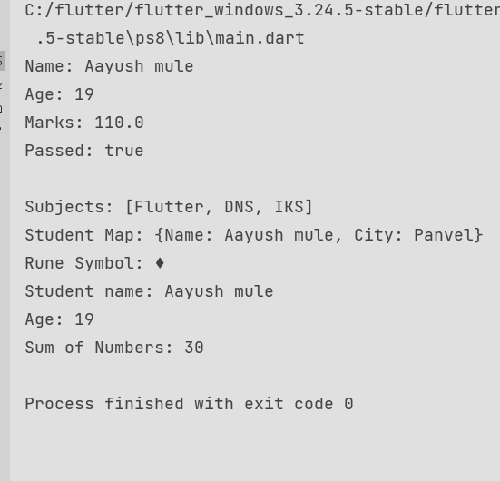

Practical No: 03

Aim: Design a simple UI using Text, Image, and Icon widgets.
A. Create layout using Row and Column. import 'package:flutter/material.dart'; void main() {
runApp(const MyApp());
}
class MyApp extends StatelessWidget { const MyApp({super.key});
// This widget is the root of your application. @override
Widget build(BuildContext context) { return MaterialApp(
debugShowCheckedModeBanner: false, home: const HomeScreen(),
);
}
}
class HomeScreen extends StatelessWidget { const HomeScreen({super.key});
@override
Widget build(BuildContext context){ return Scaffold(appBar: AppBar(
title: const Text("Simple UI"), centerTitle: true,
),
body: Center(
child: Padding(
padding: const EdgeInsetsGeometry.all(20), child: Column(
mainAxisAlignment: MainAxisAlignment.center, children: [
Image.asset(
"Images/spider.png", height: 350,
width: 350,
fit: BoxFit.cover,),

const SizedBox(height: 20), const Text(
'Welcome to Flutter', style: TextStyle(
fontSize: 34,
fontWeight: FontWeight.bold,
),
),
const SizedBox(height: 10),

const Text(
'Spidey is live',
textAlign: TextAlign.center, style: TextStyle(
fontSize: 26,
)
),
const SizedBox(height: 20), const Row(
mainAxisAlignment: MainAxisAlignment.center, children: [Icon(Icons.favorite,
color: Colors.red, size: 35,
),
SizedBox(width: 20), Icon(
Icons.star,
color: Colors.blue, size: 35,
),
SizedBox(width:20), Icon(
Icons.share,
color: Colors.blue, size: 35,
),
],
),

const Text(
'Spidey is live',
textAlign: TextAlign.center, style: TextStyle(
fontSize: 24,
fontWeight: FontWeight.bold,
),)
]
),),
),);
}}

OUTPUT:
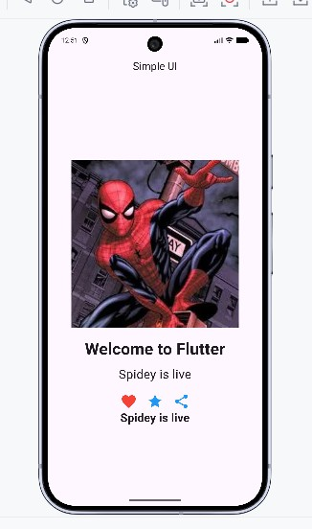

Practical No 4
Aim: A. To create a layout using Row and Column.
Code
import 'package:flutter/material.dart';

void main() { runApp(const MyApp());
}

class MyApp extends StatelessWidget { const MyApp({super.key});

@override
Widget build(BuildContext context) { return MaterialApp(
debugShowCheckedModeBanner: false, title: 'Row and Column Example',
home: Scaffold( appBar: AppBar(
title: const Text('Row & Column Layout'), backgroundColor: Colors.blue,
),
body: Center( child: Column(
mainAxisAlignment: MainAxisAlignment.center, children: [
const Text(
'Flutter Layout Example', style: TextStyle( fontSize: 24,
fontWeight: FontWeight.bold,
),
),
const SizedBox(height: 20),

// Row Widget Row(
mainAxisAlignment: MainAxisAlignment.spaceEvenly,

children: [ Container( width: 80,
height: 80,
color: Colors.red, child: const Center( child: Text(
'A',
style: TextStyle( color: Colors.white, fontSize: 24,
),
),
),
),
Container( width: 80,
height: 80,
color: Colors.green, child: const Center( child: Text(
'B',
style: TextStyle( color: Colors.white, fontSize: 24,
),
),
),
),
Container( width: 80,
height: 80,
color: Colors.orange, child: const Center( child: Text(
'C',
style: TextStyle( color: Colors.white, fontSize: 24,

),
),
),
),
],
),

const SizedBox(height: 30),

// Column inside Container Container(
padding: const EdgeInsets.all(10), color: Colors.grey.shade300, child: const Column(
children: [ Text(
'Column Item 1',
style: TextStyle(fontSize: 18),
),
SizedBox(height: 10), Text(
'Column Item 2',
style: TextStyle(fontSize: 18),
),
SizedBox(height: 10), Text(
'Column Item 3',
style: TextStyle(fontSize: 18),
),
],
),
),
],
),
),
),
);
}
}

OUTPUT:
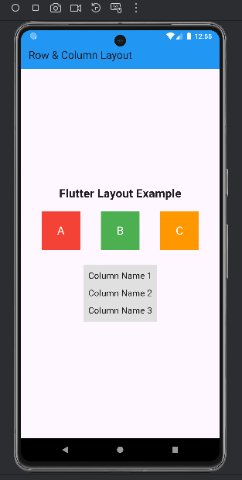

Practical No 5 Aim:To design a login form with validation. Code:
import 'package:flutter/material.dart';

void main() { runApp(const MyApp());
}

class MyApp extends StatelessWidget { const MyApp({super.key});

@override
Widget build(BuildContext context) { return MaterialApp(
debugShowCheckedModeBanner: false, title: 'Login Form',
theme: ThemeData( primarySwatch: Colors.blue,
),
home: const LoginPage(),
);
}
}

class LoginPage extends StatefulWidget { const LoginPage({super.key});

@override
State<LoginPage> createState() => _LoginPageState();
}

class _LoginPageState extends State<LoginPage> { final _formKey = GlobalKey<FormState>();

final TextEditingController emailController = TextEditingController(); final TextEditingController passwordController = TextEditingController();

@override
Widget build(BuildContext context) { return Scaffold(
appBar: AppBar(
title: const Text("Login Form"),
),
body: Padding(
padding: const EdgeInsets.all(20.0), child: Form(
key: _formKey, child: Column(
mainAxisAlignment: MainAxisAlignment.center, children: [
const Icon( Icons.lock, size: 80,
color: Colors.blue,
),
const SizedBox(height: 20), TextFormField(
controller: emailController, decoration: const InputDecoration( labelText: "Email",
border: OutlineInputBorder(), prefixIcon: Icon(Icons.email),
),
validator: (value) {
if (value == null || value.isEmpty) { return "Please enter email";
}
if (!RegExp(
r'^[\w-\.]+@([\w-]+\.)+[\w-]{2,4}$',
).hasMatch(value)) {
return "Enter a valid email";
}
return null;
},
),

const SizedBox(height: 20), TextFormField(
controller: passwordController, obscureText: true,
decoration: const InputDecoration( labelText: "Password",
border: OutlineInputBorder(), prefixIcon: Icon(Icons.lock),
),
validator: (value) {
if (value == null || value.isEmpty) { return "Please enter password";
}
if (value.length < 6) {
return "Password must be at least 6 characters";
}
return null;
},
),
const SizedBox(height: 25), ElevatedButton( onPressed: () {
if (_formKey.currentState!.validate()) { ScaffoldMessenger.of(context).showSnackBar( const SnackBar(
content: Text("Login Successful"),
),
);
}
},
style: ElevatedButton.styleFrom( minimumSize: const Size(double.infinity, 50),
),
child: const Text( "Login",
style: TextStyle(fontSize: 18),
),
),
],

),
),
),
);
}
}

OUTPUT:

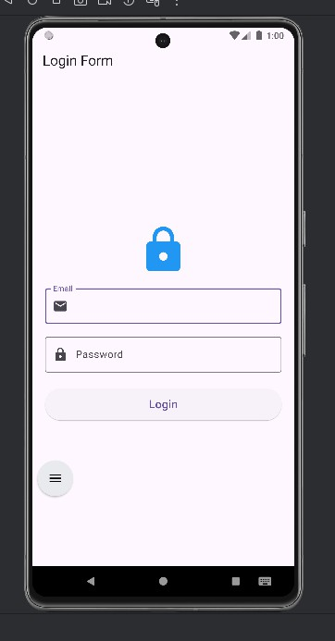
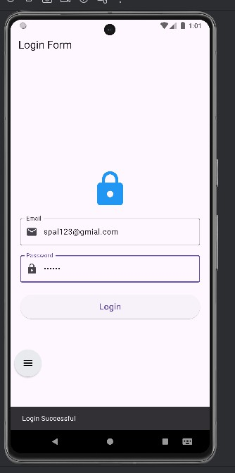

Practical No 6
Aim: To implement navigation between two screens.
import 'package:flutter/material.dart'; void main() {
runApp(const MyApp());

}

class MyApp extends StatelessWidget{ const MyApp({super.key});

@override
Widget build(BuildContext context){ return MaterialApp(
debugShowCheckedModeBanner: false, title: "Navigation demo",
home: const FS(),
);
}
}

class FS extends StatelessWidget{ const FS({super.key});

@override
Widget build(BuildContext context){ return Scaffold(
appBar: AppBar(
title: const Text("First Screen"), backgroundColor: Colors.blue,
),
body: Center(
child: ElevatedButton(
child: const Text("Go to sencond Screen"), onPressed: (){

Navigator.push( context, MaterialPageRoute(
builder: (context) => const SecondScreen(),
),
);
},
),
),
);
}
}

class SecondScreen extends StatelessWidget{ const SecondScreen({super.key});

@override
Widget build(BuildContext context){ return Scaffold(
appBar: AppBar(
title: const Text("Second Screen"), backgroundColor: Colors.green,
),
body: Center(
child: ElevatedButton(
child: const Text("Go back to First Screen"), onPressed: (){
Navigator.pop(context);

},
),
),
);
}
}

Output:
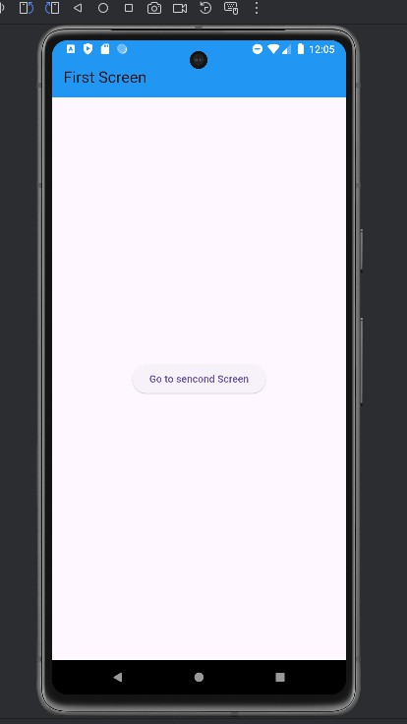
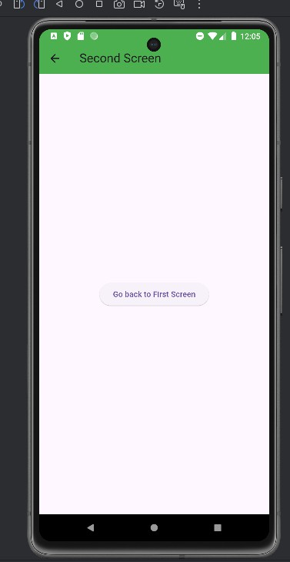

Practical NO 7 (A) Aim: Create a list View display dynamic Data
Code:
import 'package:flutter/material.dart';

void main() { runApp(const MyApp());
}

class MyApp extends StatelessWidget { const MyApp({super.key});

// This widget is the root of your application. @override
Widget build(BuildContext context) { return MaterialApp(
debugShowCheckedModeBanner: false, title: "Image Gallery",
theme: ThemeData( primarySwatch: Colors.blue,
),
home: const ImageGallery(),
);
}
}

class ImageGallery extends StatelessWidget{ const ImageGallery({super.key});
final List<String> imageUrls = const[

"https://static.wikia.nocookie.net/spiderman-films/images/b/be/Tom_Holland_Spidey_ Suit.webp/revision/latest/scale-to-width-down/1200?cb=20230914135801",

"https://encrypted-tbn0.gstatic.com/images?q=tbn:ANd9GcSGg4jFC9au4R-mckz3i7 8z0DTS0uukkmdvNh78Aq-GWA&s=10",

"https://encrypted-tbn0.gstatic.com/images?q=tbn:ANd9GcSTfCnpTx84kPBerrKctOB V19Rj4GbcFTBZif8gJ8Cy1g&s=10",

"https://encrypted-tbn0.gstatic.com/images?q=tbn:ANd9GcR5jhqj2jMavvqpRU-uToEt ycBVTMtlX6ohsxhqEZ36_g&s=10",

"https://encrypted-tbn0.gstatic.com/images?q=tbn:ANd9GcQDr98Hj9KUbL-lHBElbZ YKv5Irx359lQAJ5tKHlxE3gg&s=10",

"https://encrypted-tbn0.gstatic.com/images?q=tbn:ANd9GcQhkT-0ehsLQ0_9z9-RUJ wfxoCLGaSDoooKp2oQ1ihk8g&s=10",

"https://encrypted-tbn0.gstatic.com/images?q=tbn:ANd9GcQ556sHsTU8D_2XdJDLP 3yOswPm0hz6j9wQ4Cm4L-JPnA&s=10",

"https://encrypted-tbn0.gstatic.com/images?q=tbn:ANd9GcS_EFHvFzN5TbUNghJL4 1fvEpSgjA09RnPnke7vPYg2zg&s=10",

"https://encrypted-tbn0.gstatic.com/images?q=tbn:ANd9GcTeeKUT9Znatrc4gEMHKe
-wKgq6pGIE8JOlRR9xTgaimA&s=10",

"https://encrypted-tbn0.gstatic.com/images?q=tbn:ANd9GcT4VhgQDLwTj5WXB8ea 40qVj4V3IxkMQfg8vDUuYCS-2w&s=10"
];
@override
Widget build(BuildContext context){ return Scaffold(
appBar: AppBar(
title: const Text("Gallery"), centerTitle: true,),
body: Padding(padding: const EdgeInsets.all(25.0), child: GridView.builder(
itemCount: imageUrls.length, gridDelegate: const
SliverGridDelegateWithFixedCrossAxisCount(crossAxisCount: 2,crossAxisSpacing: 20,mainAxisSpacing: 20),
itemBuilder: (context, index){

return Container(decoration: BoxDecoration(borderRadius: BorderRadius.circular(25),
image: DecorationImage(image: NetworkImage(imageUrls[index]), fit: BoxFit.cover,
)
),
);
},
),
),
);
}
}

OUTPUT:
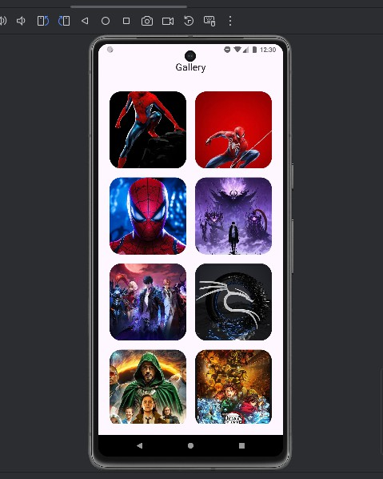

Practical No 11
Aim:To design a Flutter application that stores and retrieves user data locally using SharedPreferences.
Code:
import 'package:flutter/material.dart';
import 'package:shared_preferences/shared_preferences.dart';

void main() { runApp(const MyApp());
}

class MyApp extends StatelessWidget { const MyApp({super.key});

@override
Widget build(BuildContext context) { return MaterialApp(
debugShowCheckedModeBanner: false, title: "Shared Preferences Demo", theme: ThemeData(
primarySwatch: Colors.blue,
),
home: const HomePage(),
);
}
}

class HomePage extends StatefulWidget { const HomePage({super.key});

@override
State<HomePage> createState() => _HomePageState();
}

class _HomePageState extends State<HomePage> {
final TextEditingController nameController = TextEditingController(); final TextEditingController emailController = TextEditingController();

String savedName = ""; String savedEmail = "";

@override
void initState() { super.initState(); loadData();
}

Future<void> saveData() async {
SharedPreferences prefs = await SharedPreferences.getInstance();

await prefs.setString('name', nameController.text); await prefs.setString('email', emailController.text);

await loadData();

if (!mounted) return;

ScaffoldMessenger.of(context).showSnackBar( const SnackBar(
content: Text("Data Saved Successfully"),
),
);
}

Future<void> loadData() async {
SharedPreferences prefs = await SharedPreferences.getInstance();

setState(() {
savedName = prefs.getString('name') ?? "No Name Saved"; savedEmail = prefs.getString('email') ?? "No Email Saved";
});
}

Future<void> clearData() async {
SharedPreferences prefs = await SharedPreferences.getInstance();

await prefs.remove('name'); await prefs.remove('email');

nameController.clear(); emailController.clear();

await loadData();

if (!mounted) return;

ScaffoldMessenger.of(context).showSnackBar( const SnackBar(
content: Text("Data Cleared"),
),
);
}

@override
Widget build(BuildContext context) { return Scaffold(
appBar: AppBar(
title: const Text("Shared Preferences"),
),
body: Padding(
padding: const EdgeInsets.all(16.0), child: Column(
children: [ TextField(
controller: nameController, decoration: const InputDecoration( labelText: "Enter Name",
border: OutlineInputBorder(),
),
),

const SizedBox(height: 15),

TextField(
controller: emailController, decoration: const InputDecoration( labelText: "Enter Email",
border: OutlineInputBorder(),
),
),

const SizedBox(height: 20),

ElevatedButton( onPressed: saveData,
child: const Text("Save Data"),
),

const SizedBox(height: 10),

ElevatedButton( onPressed: loadData,
child: const Text("Retrieve Data"),
),

const SizedBox(height: 10),

ElevatedButton( onPressed: clearData,
child: const Text("Clear Data"),
),

const SizedBox(height: 30), const Divider(),
Text(
"Saved Name: $savedName", style: const TextStyle( fontSize: 18,
fontWeight: FontWeight.bold,

),
),

const SizedBox(height: 10),

Text(
"Saved Email: $savedEmail", style: const TextStyle( fontSize: 18,
fontWeight: FontWeight.bold,
),
),
],
),
),
);
}
@override
void dispose() { nameController.dispose(); emailController.dispose(); super.dispose();
}
}

OUTPUT:
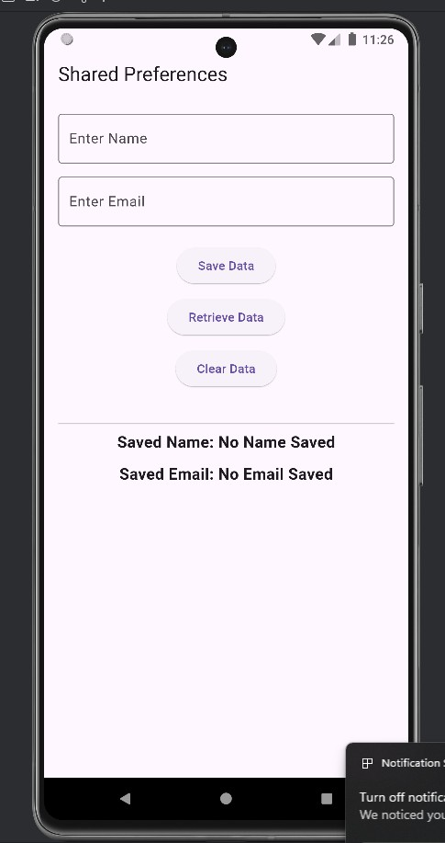
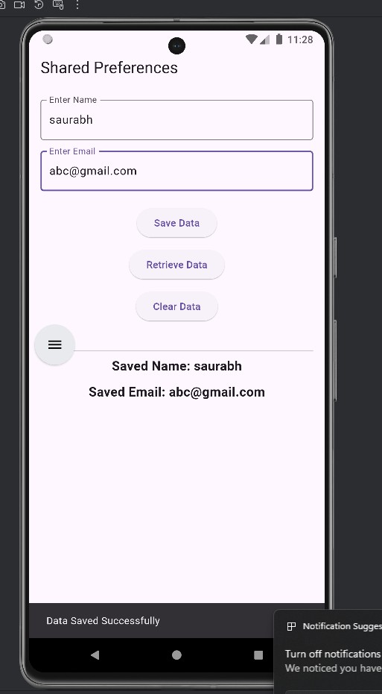

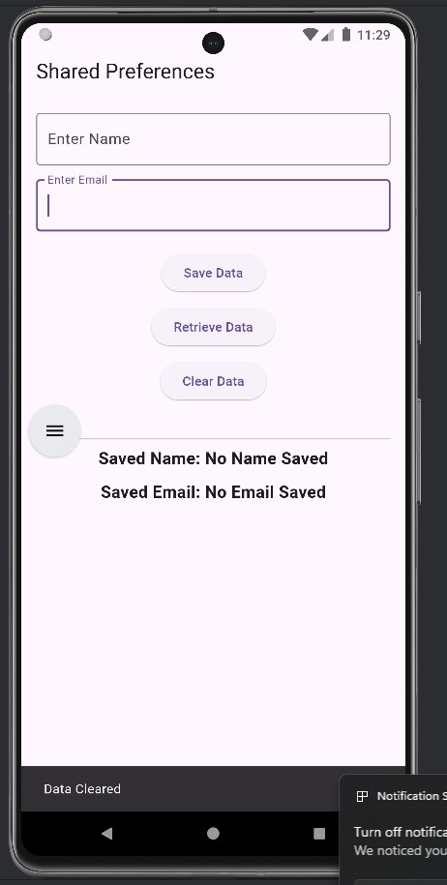

Practical No 12
Aim:To develop a Flutter application that performs basic Create, Read, Update, and Delete (CRUD) operations on data.
import 'package:flutter/material.dart'; import 'package:path/path.dart' as path; import 'package:sqflite/sqflite.dart';

void main() { runApp(const MyApp());
}

class MyApp extends StatelessWidget { const MyApp({super.key});

@override
Widget build(BuildContext context) { return MaterialApp(
debugShowCheckedModeBanner: false, title: 'Student CRUD',
theme: ThemeData(
colorScheme: ColorScheme.fromSeed( seedColor: Colors.blue,
),
useMaterial3: true,
),
home: const StudentScreen(),
);
}
}

class StudentScreen extends StatefulWidget { const StudentScreen({super.key});

@override
State<StudentScreen> createState() => _StudentScreenState();
}

class _StudentScreenState extends State<StudentScreen> { Database? database;

List<Map<String, dynamic>> students = [];

final TextEditingController nameController = TextEditingController();

final TextEditingController ageController = TextEditingController();
bool isLoading = true; int? editingStudentId; @override
void initState() {
super.initState(); initDatabase();
}

Future<void> initDatabase() async { try {
final String databasePath = await getDatabasesPath();

database = await openDatabase( path.join(databasePath, 'student.db'), version: 1,
onCreate: (Database db, int version) async { await db.execute('''
CREATE TABLE students(
id INTEGER PRIMARY KEY AUTOINCREMENT, name TEXT NOT NULL,
age INTEGER NOT NULL
) ''');
},
);

await fetchStudents();
} catch (e) {
if (!mounted) return;

showMessage('Database error: $e');
}

if (!mounted) return;

setState(() { isLoading = false;
});
}

Future<void> fetchStudents() async { if (database == null) return;

try {
final List<Map<String, dynamic>> data = await database!.query(
'students',
orderBy: 'id DESC',
);

if (!mounted) return;

setState(() { students = data;
});
} catch (e) {
if (!mounted) return;

showMessage('Error loading students: $e');
}
}

Future<void> addStudent() async { final String name =

nameController.text.trim();

final String ageText = ageController.text.trim();

if (name.isEmpty) {
showMessage('Please enter student name'); return;
}

if (ageText.isEmpty) { showMessage('Please enter student age'); return;
}
final int? age = int.tryParse(ageText); if (age == null || age <= 0) {
showMessage('Please enter a valid age'); return;
}

if (database == null) { showMessage('Database is not ready'); return;
}

try {
await database!.insert( 'students',
{
'name': name,
'age': age,
},
);

clearFields();

await fetchStudents();

showMessage('Student added successfully');
} catch (e) {
showMessage('Error adding student: $e');
}
}

void startEditStudent( Map<String, dynamic> student,
) {
setState(() { editingStudentId = student['id'] as int;

nameController.text = student['name'].toString();

ageController.text = student['age'].toString();
});
}

Future<void> updateStudent() async { if (editingStudentId == null) {
return;
}

final String name = nameController.text.trim();

final String ageText = ageController.text.trim();

if (name.isEmpty) {
showMessage('Please enter student name'); return;
}

final int? age =

int.tryParse(ageText);

if (age == null || age <= 0) { showMessage('Please enter a valid age'); return;
}

if (database == null) { showMessage('Database is not ready'); return;
}

try {
await database!.update( 'students',
{
'name': name,
'age': age,
},
where: 'id = ?',
whereArgs: [editingStudentId],
);

clearFields();
await fetchStudents(); showMessage(
'Student updated successfully',
);
} catch (e) { showMessage(
'Error updating student: $e',
);
}
}

Future<void> deleteStudent(int id) async { if (database == null) {

showMessage('Database is not ready'); return;
}

try {
await database!.delete( 'students',
where: 'id = ?', whereArgs: [id],
);

if (editingStudentId == id) { clearFields();
}
await fetchStudents(); showMessage(
'Student deleted successfully',
);
} catch (e) { showMessage(
'Error deleting student: $e',
);
}
}

void clearFields() { nameController.clear(); ageController.clear();

if (!mounted) return;

setState(() { editingStudentId = null;
});
}

void showMessage(String message) {

if (!mounted) return; ScaffoldMessenger.of(context).hideCurrentSnackBar();
ScaffoldMessenger.of(context).showSnackBar( SnackBar(
content: Text(message),
duration: const Duration(seconds: 2),
),
);
}

@override
void dispose() { nameController.dispose(); ageController.dispose();

database?.close();

super.dispose();
}

@override
Widget build(BuildContext context) { final bool isEditing =
editingStudentId != null;

return Scaffold( appBar: AppBar( title: Text(
isEditing
? 'Edit Student'
: 'Student CRUD',
),
centerTitle: true,
),
body: SafeArea( child: Padding(
padding: const EdgeInsets.all(16),

child: Column( children: [ TextField(
controller: nameController, textCapitalization: TextCapitalization.words, decoration: const InputDecoration( labelText: 'Student Name', hintText:
'Enter student name', prefixIcon: Icon(Icons.person), border: OutlineInputBorder(),
),
),
const SizedBox(height: 12), TextField(
controller: ageController, keyboardType: TextInputType.number, decoration: const InputDecoration( labelText: 'Student Age',
hintText:
'Enter student age', prefixIcon: Icon(Icons.cake), border: OutlineInputBorder(),
),
),
const SizedBox(height: 12), Row(
children: [ Expanded(
child: ElevatedButton.icon( onPressed: isLoading
? null
: isEditing

? updateStudent
: addStudent, icon: Icon( isEditing
? Icons.save
: Icons.add,
),
label: Text( isEditing
? 'Update Student'
: 'Add Student',
),
),
),
if (isEditing) ...[
const SizedBox(width: 8), IconButton(
tooltip: 'Cancel Edit',
style: IconButton.styleFrom( backgroundColor: Colors.grey.shade200,
),
onPressed: clearFields, icon: const Icon( Icons.close,
),
),
],
],
),
const SizedBox(height: 20), const Divider(),
const SizedBox(height: 10), Expanded(
child: isLoading
? const Center( child:
CircularProgressIndicator(),
)

: students.isEmpty
? const Center( child: Column( mainAxisAlignment:
MainAxisAlignment.center, children: [
Icon( Icons
.people_outline, size: 70,
color:
Colors.grey,
),
SizedBox( height: 10,
),
Text(
'No students found', style: TextStyle( fontSize: 18,
color:
Colors.grey,
),
),
],
),
)
: ListView.builder( itemCount: students.length, itemBuilder:
(
BuildContext context, int index,
) {
final Map<String, dynamic>
student = students[index];

final int id = student['id'] as int;

final String name = student['name']
.toString();

final int age = student['age'] as int;

final bool currentlyEditing =
editingStudentId == id;

return Card( margin:
const EdgeInsets
.only( bottom: 10,
),
color: currentlyEditing
? Colors.blue
.withOpacity( 0.1,
)
: null,
child: ListTile( leading: CircleAvatar( child: Text(
'${index + 1}',
),
),
title: Text(

name, style:
const TextStyle( fontWeight: FontWeight
.bold, fontSize: 17,
),
),
subtitle:
Text(
'Age: $age',
),
trailing:
Row( mainAxisSize: MainAxisSize
.min, children: [ IconButton(
onPressed: () {
startEditStudent( student,
);
},
icon:
const Icon( Icons.edit, color: Colors
.blue,
),
),
IconButton( onPressed:
() {
deleteStudent( id,

);
},
icon:
const Icon( Icons
.delete, color: Colors
.red,
),
),
],
),
),
);
},
),
),
],
),
),
),
);
}
}

OUTPUT:
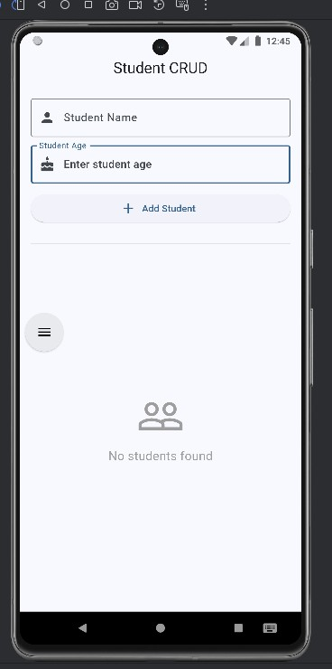
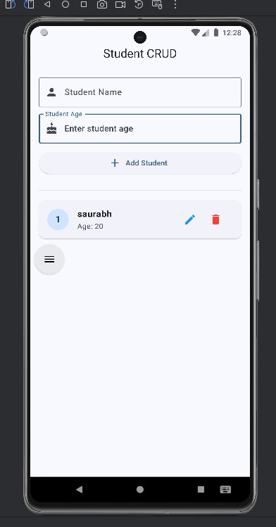

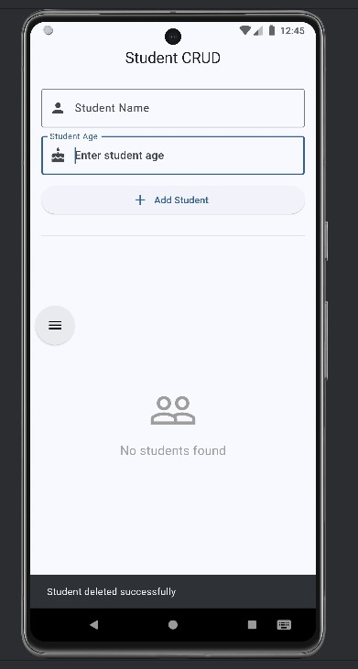

Practical No 4
Aim: A. To create a layout using Row and Column.
Code
import 'package:flutter/material.dart';

void main() { runApp(const MyApp());
}

class MyApp extends StatelessWidget { const MyApp({super.key});

@override
Widget build(BuildContext context) { return MaterialApp(
debugShowCheckedModeBanner: false, title: 'Row and Column Example',
home: Scaffold( appBar: AppBar(
title: const Text('Row & Column Layout'), backgroundColor: Colors.blue,
),
body: Center( child: Column(
mainAxisAlignment: MainAxisAlignment.center, children: [
const Text(
'Flutter Layout Example', style: TextStyle( fontSize: 24,
fontWeight: FontWeight.bold,
),
),
const SizedBox(height: 20),

// Row Widget Row(
mainAxisAlignment: MainAxisAlignment.spaceEvenly,

children: [ Container( width: 80,
height: 80,
color: Colors.red, child: const Center( child: Text(
'A',
style: TextStyle( color: Colors.white, fontSize: 24,
),
),
),
),
Container( width: 80,
height: 80,
color: Colors.green, child: const Center( child: Text(
'B',
style: TextStyle( color: Colors.white, fontSize: 24,
),
),
),
),
Container( width: 80,
height: 80,
color: Colors.orange, child: const Center( child: Text(
'C',
style: TextStyle( color: Colors.white, fontSize: 24,

),
),
),
),
],
),

const SizedBox(height: 30),

// Column inside Container Container(
padding: const EdgeInsets.all(10), color: Colors.grey.shade300, child: const Column(
children: [ Text(
'Column Item 1',
style: TextStyle(fontSize: 18),
),
SizedBox(height: 10), Text(
'Column Item 2',
style: TextStyle(fontSize: 18),
),
SizedBox(height: 10), Text(
'Column Item 3',
style: TextStyle(fontSize: 18),
),
],
),
),
],
),
),
),
);
}
}

OUTPUT:

