Git Assignment: Employee Management Project
Objective
Perform the following Git operations:
- Create Repository
- Create Branches
- Add & Commit Files
- Push Code
- Create Merge Conflict
- Resolve Merge Conflict
- Create Pull Request
- Use Restore Commands

Step 1: Create Local Repository
Create a folder:
mkdir EmployeeManagement
cd EmployeeManagement
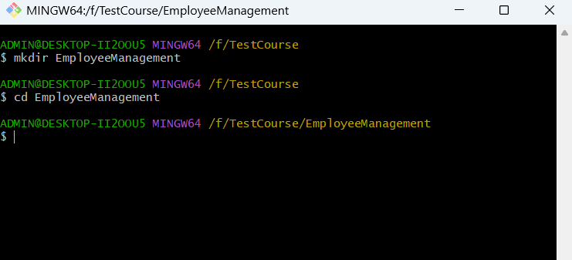

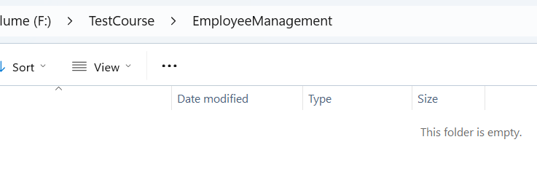
Initialize Git:
git init
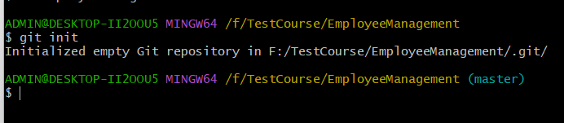

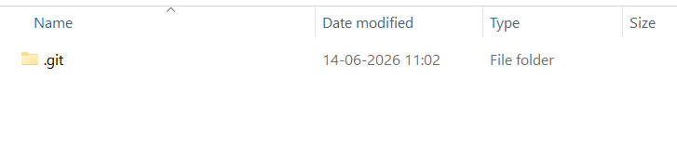

Step 2: Create First File
Create:
employee.txt
Content:
Employee Management System
Employee ID: 101
Employee Name: John
Department: QA
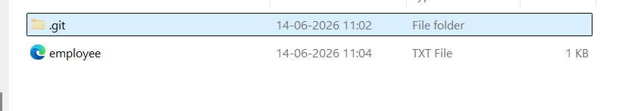
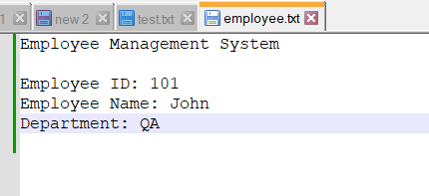

Check status:
git status
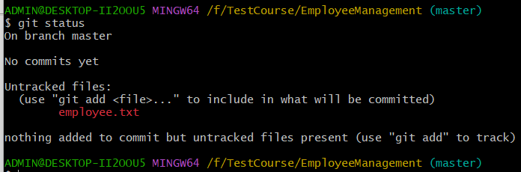
Add and commit:
git add .
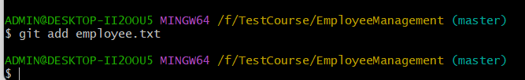
git commit -m "Initial employee file added"
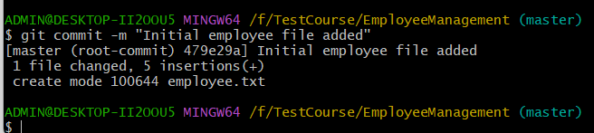

Step 3: Create GitHub Repository
Create repository on GitHub:
employee-management
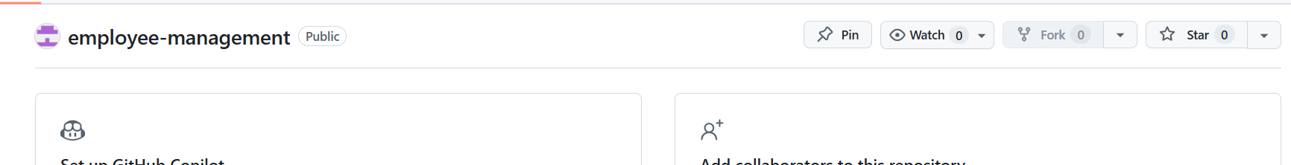
Add remote:
git remote add origin <repo-url>
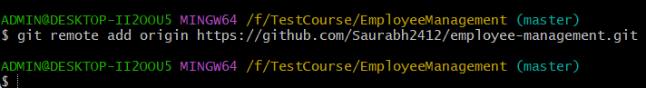
Verify:
git remote -v
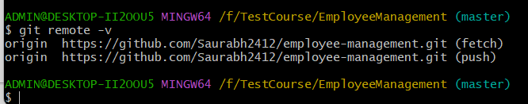
Push:
git push -u origin master
(or main)
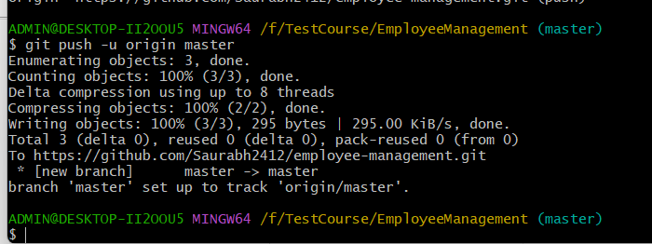
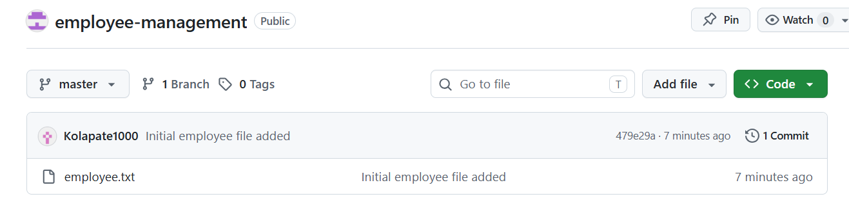

Step 4: Create Branch
Create branch:
git checkout -b feature-salary
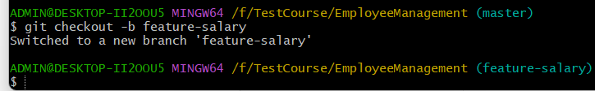
Modify employee.txt
Employee Management System
Employee ID: 101
Employee Name: John
Department: QA
Salary: 50000
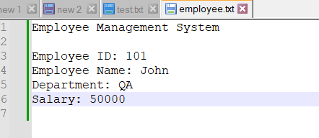
Commit:
git add .
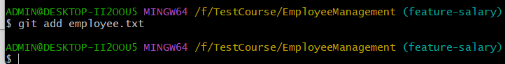
git commit -m "Added salary information"
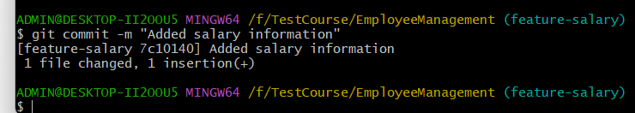
Push:
git push -u origin feature-salary
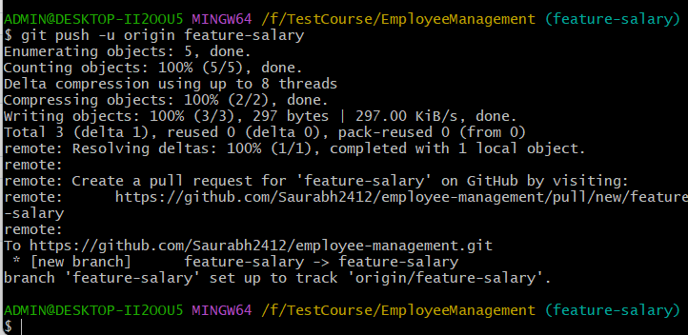
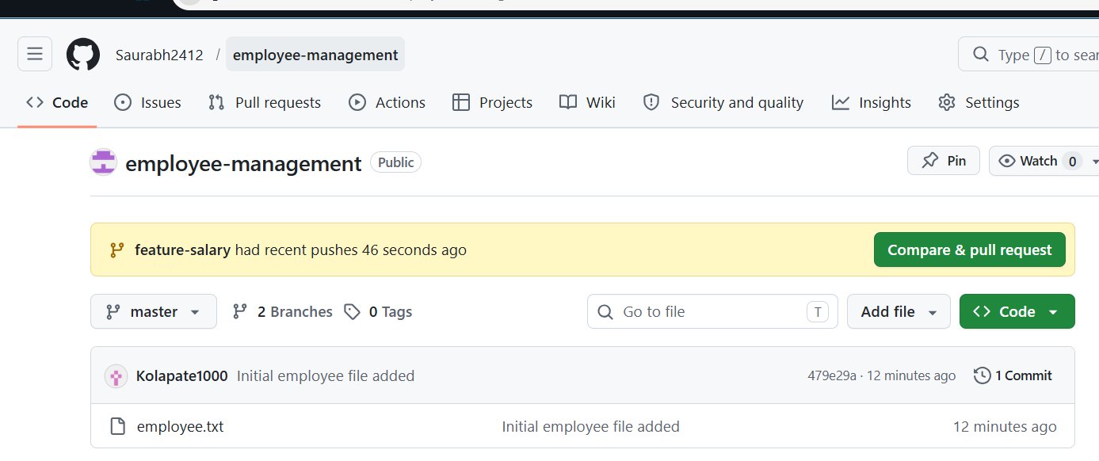

Step 5: Create Another Branch
Move to master:
git checkout master
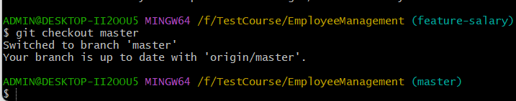
Create branch:
git checkout -b feature-address
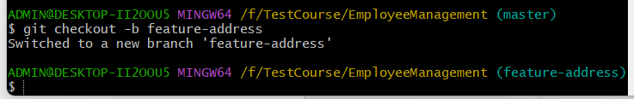
Modify same file:
Employee Management System
Employee ID: 101
Employee Name: John
Department: QA
Address: Delhi
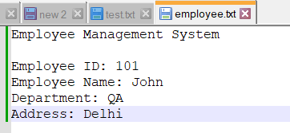
Commit:
git add .
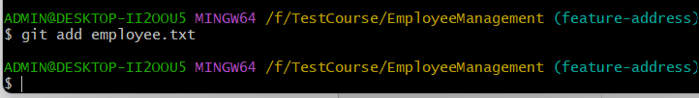
git commit -m "Added address information"
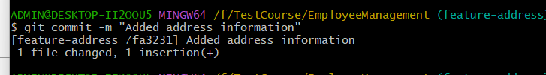
Push:
git push -u origin feature-address
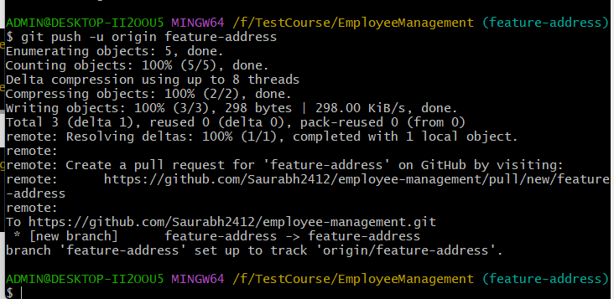

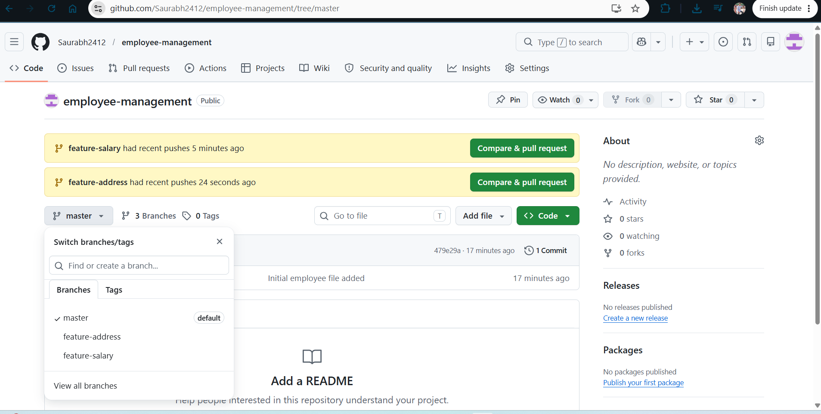

Step 6: Create Merge Conflict
Go to master:
git checkout master
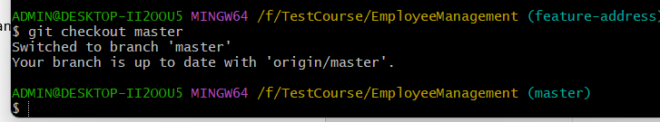

Merge first branch:
git merge feature-salary
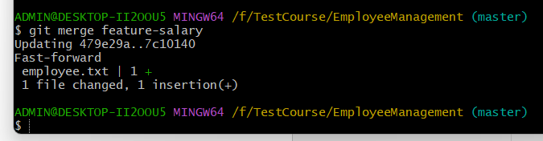

Now merge second branch:
git merge feature-address
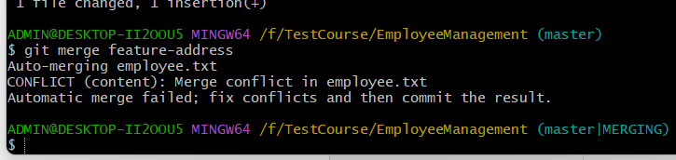
A merge conflict should occur because both branches modified the same location.

Step 7: Resolve Merge Conflict
Open employee.txt
Conflict may look like:
<<<<<<< HEAD
Salary: 50000
=======
Address: Delhi
>>>>>>> feature-address
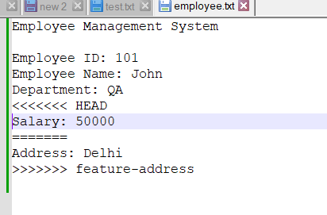
Resolve to:
Employee Management System
Employee ID: 101
Employee Name: John
Department: QA
Salary: 50000
Address: Delhi
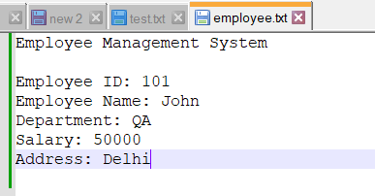
Commit:
git add .
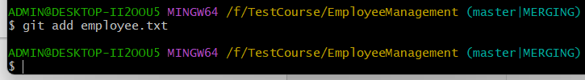
git commit -m "Resolved merge conflict"
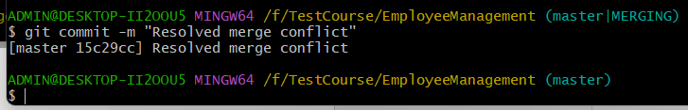
Push:
git push
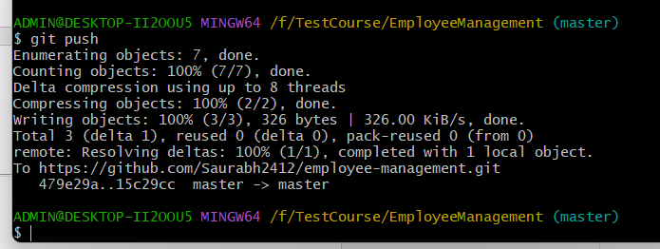

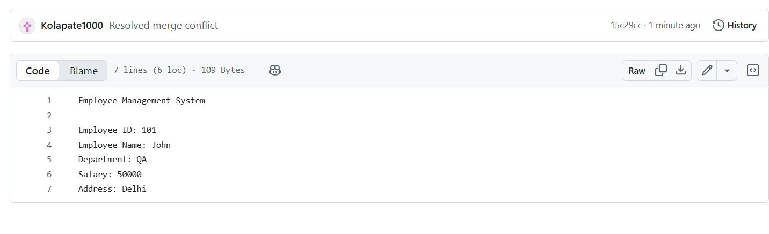

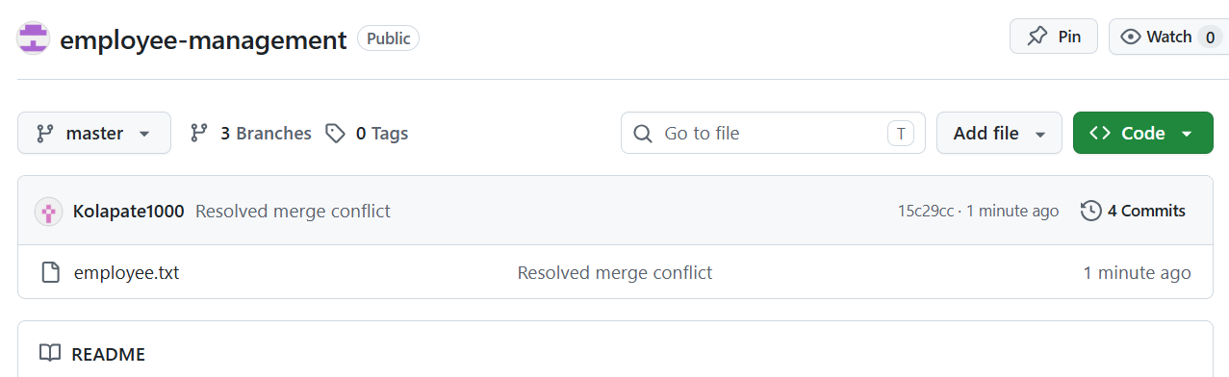

Step 8: Create Pull Request
Create another branch:
git checkout -b feature-email
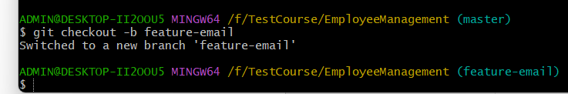
Update file:
Employee Management System
Employee ID: 101
Employee Name: John
Department: QA
Salary: 50000
Address: Delhi
Email: john@test.com
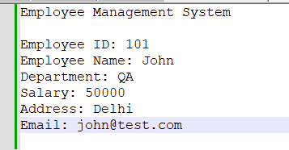
Commit:
git add .
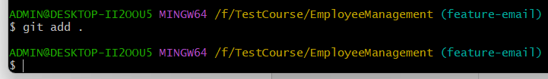
git commit -m "Added employee email"
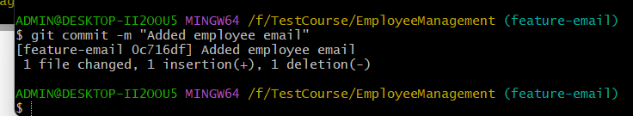
Push:
git push -u origin feature-email
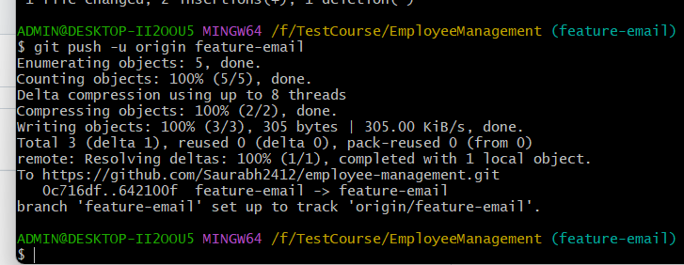
Go to GitHub and create a Pull Request:
feature-email → master
Merge the PR.
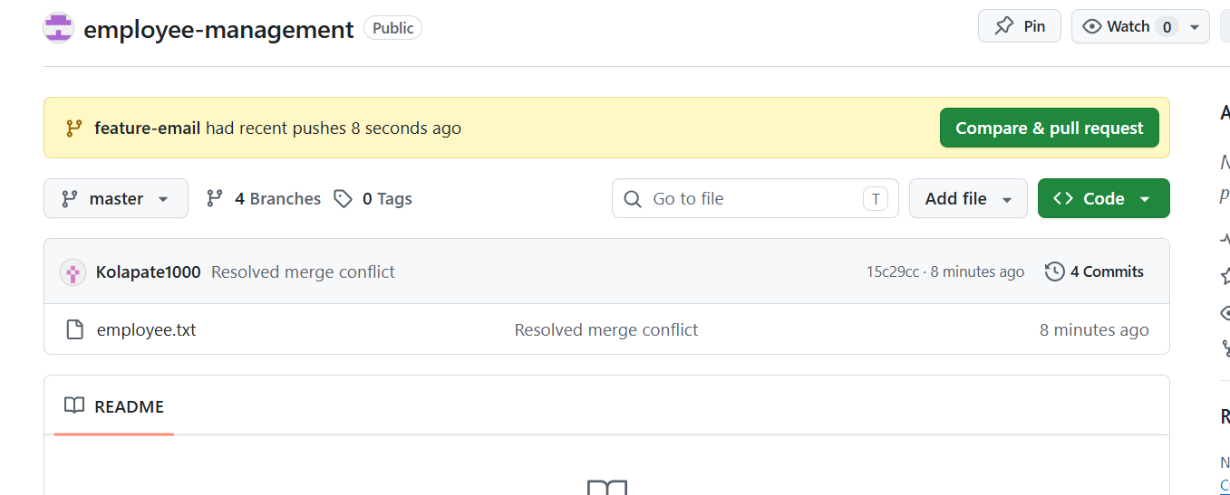

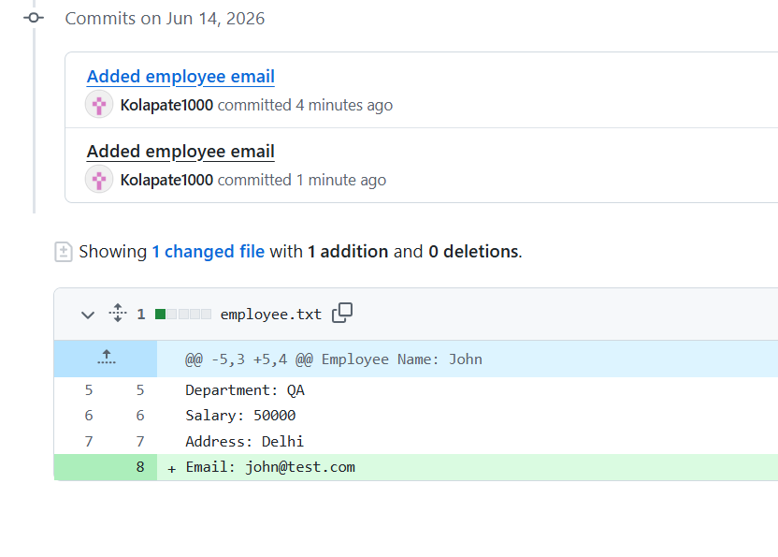

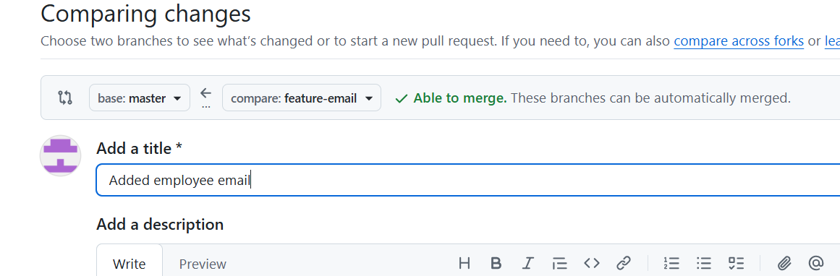

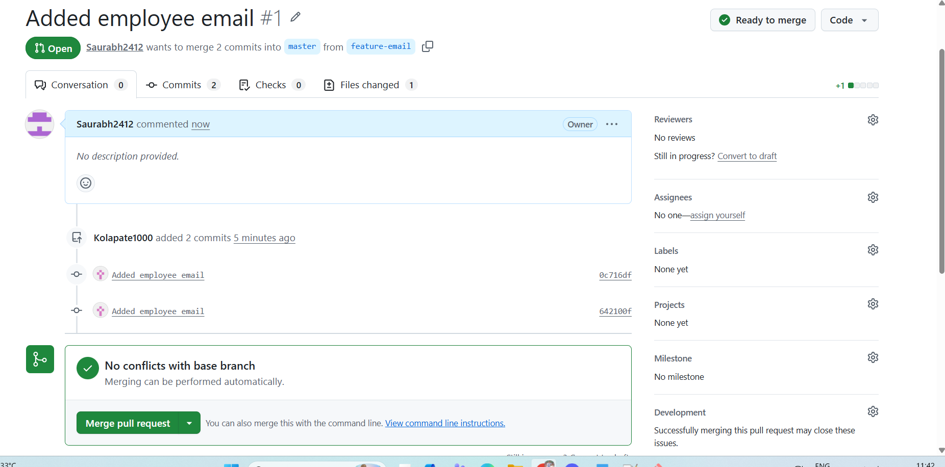

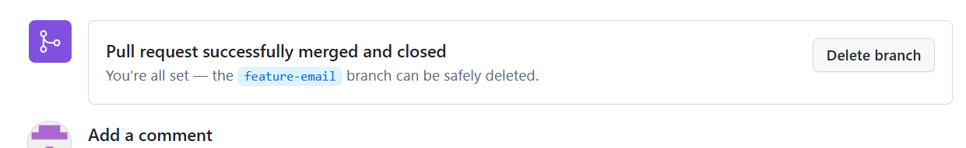

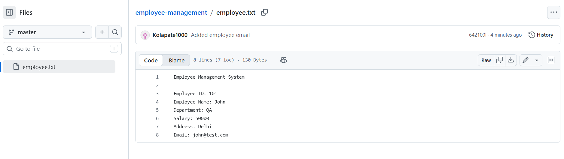

Step 9: Practice Restore Command
Modify employee.txt
Employee Management System
This line should be removed.
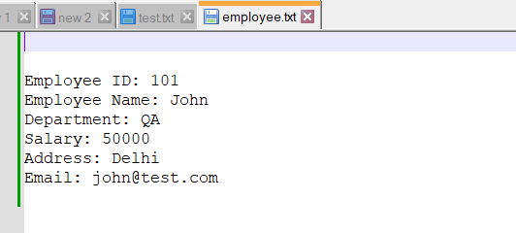
Check status:
git status
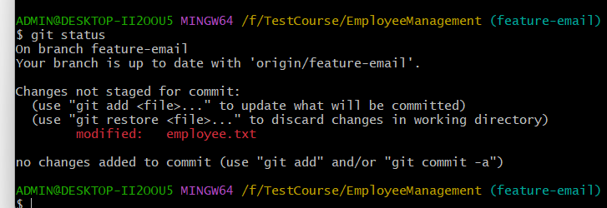
Restore:
git restore employee.txt
Verify file restored.
