***HUMAN_RESOURCE [SCHEMA]***

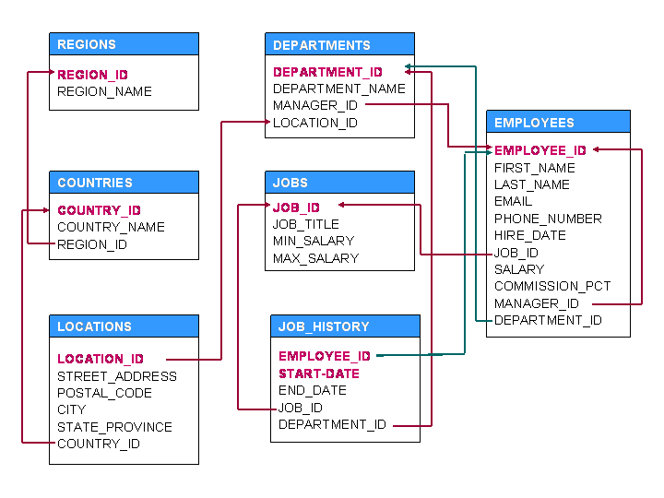

**HR Table Descriptions**

Table COUNTRIES

Name Null? Type

----------------------------------------- -------- ----------------------------

COUNTRY_ID NOT NULL CHAR(2)

COUNTRY_NAME VARCHAR2(40)

REGION_ID NUMBER

Table DEPARTMENTS

Name Null? Type

----------------------------------------- -------- ----------------------------

DEPARTMENT_ID NOT NULL NUMBER(4)

DEPARTMENT_NAME NOT NULL VARCHAR2(30)

MANAGER_ID NUMBER(6)

LOCATION_ID NUMBER(4)

Table EMPLOYEES

Name Null? Type

----------------------------------------- -------- ----------------------------

EMPLOYEE_ID NOT NULL NUMBER(6)

FIRST_NAME VARCHAR2(20)

LAST_NAME NOT NULL VARCHAR2(25)

EMAIL NOT NULL VARCHAR2(25)

PHONE_NUMBER VARCHAR2(20)

HIRE_DATE NOT NULL DATE

JOB_ID NOT NULL VARCHAR2(10)

SALARY NUMBER(8,2)

COMMISSION_PCT NUMBER(2,2)

MANAGER_ID NUMBER(6)

DEPARTMENT_ID NUMBER(4)

Table JOBS

Name Null? Type

----------------------------------------- -------- ----------------------------

JOB_ID NOT NULL VARCHAR2(10)

JOB_TITLE NOT NULL VARCHAR2(35)

MIN_SALARY NUMBER(6)

MAX_SALARY NUMBER(6)

Table JOB_HISTORY

Name Null? Type

----------------------------------------- -------- ----------------------------

EMPLOYEE_ID NOT NULL NUMBER(6)

START_DATE NOT NULL DATE

END_DATE NOT NULL DATE

JOB_ID NOT NULL VARCHAR2(10)

DEPARTMENT_ID NUMBER(4)

Table LOCATIONS

Name Null? Type

----------------------------------------- -------- ----------------------------

LOCATION_ID NOT NULL NUMBER(4)

STREET_ADDRESS VARCHAR2(40)

POSTAL_CODE VARCHAR2(12)

CITY NOT NULL VARCHAR2(30)

STATE_PROVINCE VARCHAR2(25)

COUNTRY_ID CHAR(2)

Table REGIONS

Name Null? Type

----------------------------------------- -------- ----------------------------

REGION_ID NOT NULL NUMBER

REGION_NAME VARCHAR2(25)