Faculty Course Allotment System

Software Requirements Specification

<Version 1>

<Date>

Saurabh Uttam

Sujay Kumar

Nilay Biswas

Tanmay Kacker

Sudhir Kumar Jaiswal

**Table of Contents**

**Document Approval ii**

**1. Introduction 1**

1.1 Purpose 1

1.2 Scope 1

1.3 References 1

1.5 Overview 1

**2. General Description 2**

2.1 Product Perspective 2

2.2 Product Functions 2

2.3 User Characteristics 2

2.4 General Constraints 2

2.5 Assumptions and Dependencies 2

**3. Specific Requirements 2**

3.1 External Interface Requirements 3

*3.1.1 User Interfaces 3*

*3.1.2 Hardware Interfaces 3*

*3.1.3 Software Interfaces 3*

*3.1.4 Communications Interfaces 3*

3.2 Functional Requirements 3

*3.2.1 System Input 3*

*3.2.2 Processing 3*

*3.2.3 System Output 3*

3.3 Use Cases 3

*3.3.1 Admin Use-case 3*

*3.3.2 User Use-case 3*

3.5 Non-Functional Requirements 4

*3.5.1 Performance 4*

*3.5.2 Reliability 4*

*3.5.3 Availability 4*

*3.5.4 Security 4*

*3.5.5 Maintainability 4*

*3.5.6 Portability 4*

3.6 Inverse Requirements 4

3.7 Design Constraints 4

3.8 Logical Database Requirements 4

3.9 Other Requirements 4

**4. Analysis Models 4**

4.1 Sequence Diagrams 5

4.3 Data Flow Diagrams (DFD) 5

4.2 State-Transition Diagrams (STD) 5

**5. Change Management Process**

1. **Introduction**

This document is meant to provide Software Requirement Specification of the system for “Faculty Course Allotment System”.

* 1. **Purpose**

The purpose of this SRS is to mention all the requirements and functionalities of the system to the allotment team and the development team.

* 1. **Scope**

This system is intended to provide all the facilities required in allocating courses to faculty members. This system can be used for any other allotment processes.

* 1. **References**

Introduction to Software Engineering - Rajib Mall

1. **General Description**
   1. **Product Perspective**

Website aim is to see that allotment of courses to faculty members should be done withoutarising any conflicts. Maintaining a teen friendly site is deemed of highest importance in order to hold student attention and guide the viewer to information that will lead to a decision to pursue courses of their interest.

* 1. **Product Functions**
* Manage all data.
* Different user accounts management.
* Sort faculty according to their seniority.
* Categorize courses into various broad categories.
* Course Allotment on the various basis (to be chosen)
* Seniority
* Preferences chosen
* Random
* Updation of data
  1. **User Characteristics**

**There are 2 types of users :**

1. **Admin : This type of user has administrative rights that includes approval of user registration, add or remove users, manage allotment process, generate and edit results.**
2. **User : This type of user is an eligible candidate for allotment who needs to register with the system, take part in allotment process by filling choices, and can view their allotted courses.**
3. **Specific Requirement**
   1. **External Interfaces Requirements**
      1. **User Interfaces**

An interactive system intended to be made workable on any web browsers like IE, Google Chrome, Firefox etc.

* + 1. **Hardware Interfaces**

There are no hardware interface requirements.

* + 1. **Software Interfaces**

Software interface requirements include the following:

Front end: HTML, CSS

Back end: JavaScript, PHP

Database: Mysql.

* + 1. **Communication Interfaces**

The communication requirement is workable internet connection.

* 1. **Functional Requirements**
     1. **System Input**
* List of all courses to be taught by department.
* List of all faculties of department.
* Following details of each faculty member –
* Designation – Professor, Associate Professor, Assistant Professor, Guest etc.
* Grade Pay
* Area of Interest
* Year of Joining
* Teaching hour weekly
* Previously Taught Courses
  + 1. **System Processing**
    2. **System Output**
* A well-organized efficient and reliable course-faculty allotment list according to provided specifications.
* List will be available to all faculty members mentioning courses allotted to them.
  1. **Use Case**

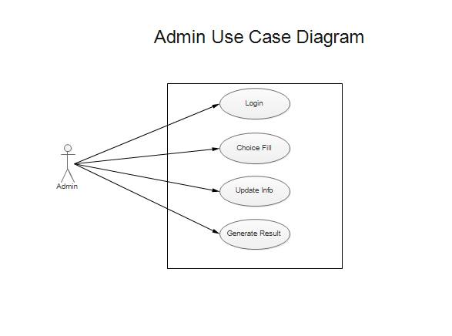

|  |  |
| --- | --- |
| **Name** | **Admin Use Case** |
| **Primary Actor** | **Admin** |
| **Stakeholders** | **User** |
| **Scope** | **Organisational** |
| **Pre-conditions** | 1. **Software should be in working condition** 2. **Admin must be an authorized personnel** |
| **Success Guarantee** | **1. User registration is approved.**  **2. Result is generated.**  **3. User information is updated.** |
| **Success Scenario** | **Scenario 1 :**  **After successful choice filling, result is generated.**  **Scenario 2:**  **After Scenario 1, if alteration is required, the alterations are done and then the final result is generated.** |

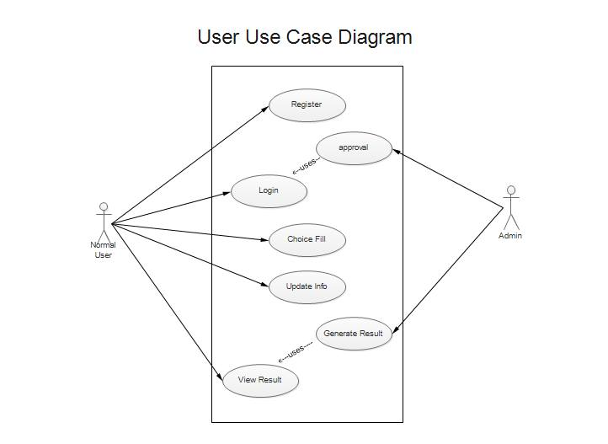

|  |  |
| --- | --- |
| **Name** | **User Use Case** |
| **Primary Actor** | **User** |
| **Stakeholders** | **User, Admin** |
| **Scope** | **System** |
| **Pre-conditions** | 1. **Software should be in working condition** 2. **User must be eligible for allotment process** |
| **Success Guarantee** | **Allotment is done fulfilling all specified constraints.** |
| **Success Scenario** | 1. **User Registration** 2. **User Login** 3. **Update Info** 4. **Fill Choices** 5. **Course Allotted** |

* 1. **Non-Functional Requirements**
     1. **Performance**

**System must be hosted on the server that can handle multiple requests simultaneously , provide adequate response time and support PHP 5.0 . System must meet following minimum requirements as well :**

* **32 bit-processor or above**
* **HDD 20 GB and above**
* **Pentium-III processor or above**
* **512 MB RAM or above**
* **Working Internet connection**
  + 1. **Reliability**
    2. **Availability**
* Network Connection to the server side and client side
* Working updated browser on client side
* Server must support for PHP 5.0
  + 1. **Security**
* **Encryption**
* **Proper account control**
* **SQL injection prevention**
* **User credentials encryption before storing into database**

* + 1. **Maintainability**

**System can be maintained by developers and should be notified of any bugs or hugs.**

* + 1. **Portability**

**System will be portable to any other devices meeting minimum requirements, that includes –**

**32 bit-processor or above**

**HDD 20 GB and above**

**Pentium-III processor or above**

**512 MB RAM or above**

**Working Internet connection**

* 1. **Inverse Requirements**
  2. **Design Constraints**
  3. **Logical Database Requirements**
  4. **Other Requirements**

1. **Analysis Models**
   1. **Activity Diagrams**

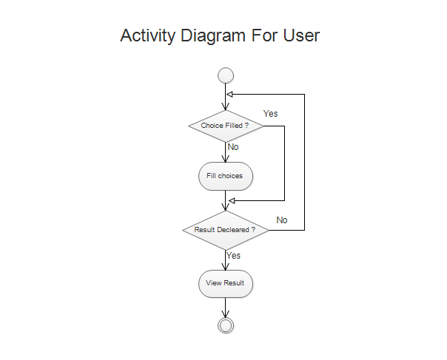

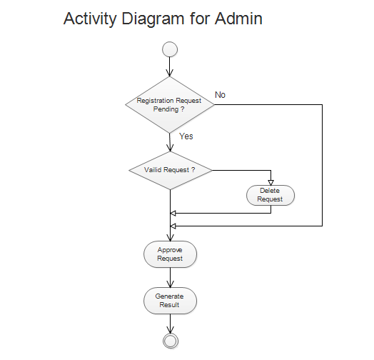

* 1. **Sequence Diagrams**

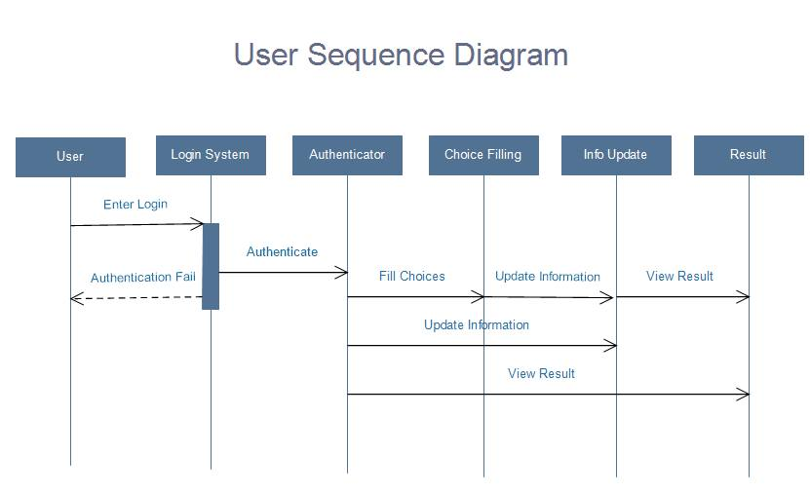

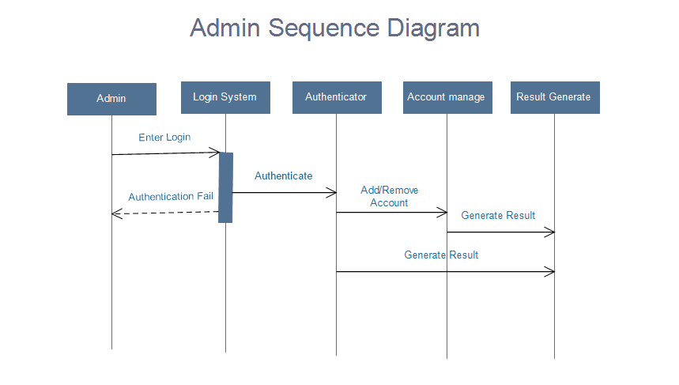

* 1. **State-Transition Diagrams**

1. **Change Management Process**