Assignment 1. Create a simple Webpage using basic HTML elements to understand the structure of an HTML document.
Code: -
<!DOCTYPE html>
<html lang="en">
<head>
<title>My First Webpage</title>
</head>
<body>
<h1>Welcome to My Webpage</h1>
<a href="https://www.anudip.org">Visit Anudip Page</a>
</body>
</html>
Output: -
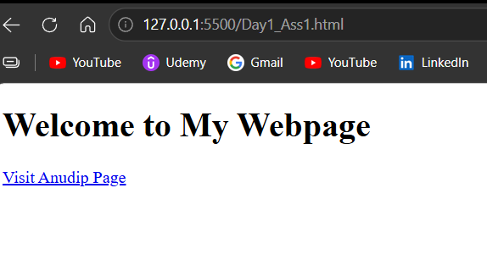

Assignment 2. Create a simple Webpage using an online HTML editor.
Code: -
<!DOCTYPE html>
<html lang="en">
<head>
<title>Welcome to my Web Page</title>
</head>
<body>
<h1>Saurabh Chavan</h1>
<p>
Hi, I am Saurabh Chavan. I have completed my Master of Computer Applications (MCA).
I have knowledge of Java, C, C++, Python, HTML, CSS, JavaScript, SQL and MySQL.
I am also learning Spring Boot and React.js. I am interested in software development
and enjoy solving real-world problems using programming.
</p>
</body>
</html>
Output: -
