Assignment 1. Create a simple webpage using HTML to create your resume. The page should use various text elements to show different types of formatted text. Also use unordered list to organize information within each section. Use
Code: -
<!DOCTYPE html>
<html lang="en">
<head>
<meta charset="UTF-8">
<title>My Resume</title>
<style>
body {
font-family: Arial, Helvetica, sans-serif;
background-color: #eef0f2;
margin: 0;
padding: 30px;
}
.resume-container {
background-color: #f0f0f0;
max-width: 700px;
margin: 0 auto;
padding: 30px 40px;
border-radius: 4px;
}
h1 {
text-align: center;
font-size: 32px;
margin-bottom: 5px;
}
.contact {
text-align: center;
margin-bottom: 25px;
}
.contact a {
color: #1a73e8;
text-decoration: none;
}
h2 {
color: #2255aa;
border-bottom: 2px solid #999;
padding-bottom: 5px;
margin-top: 30px;
margin-bottom: 10px;
}
ul {
margin: 0;
padding-left: 20px;
}
li {
margin-bottom: 6px;
}
.duration {
font-style: italic;
font-size: 14px;
color: #555;
}
.references p {
color: #555;
}
</style>
</head>
<body>

<div class="resume-container">
<h1>Saurabh Chavan</h1>
<p class="contact"><strong>Email:</strong> <a href="mailto:saurabh@example.com">saurabh@example.com</a></p>

<h2>Education</h2>
<ul>
<li><strong>University Name</strong> - Bachelor's Degree in Computer Science</li>
<li><strong>Graduation Date:</strong> May 2024</li>
</ul>

<h2>Work Experience</h2>
<ul>
<li><strong>Software Developer</strong> at IT Tech</li>
<li><strong>Duration:</strong> <span class="duration">June 2024 - Present</span></li>
</ul>

<h2>Skills</h2>
<ul>
<li><strong>Programming Languages:</strong> Java, JavaScript, Python</li>
<li><strong>Web Technologies:</strong> HTML, CSS, React</li>
</ul>

<h2>References</h2>
<div class="references">
<p>Contact available upon request.</p>
</div>
</div>

</body>
</html>

Output: -
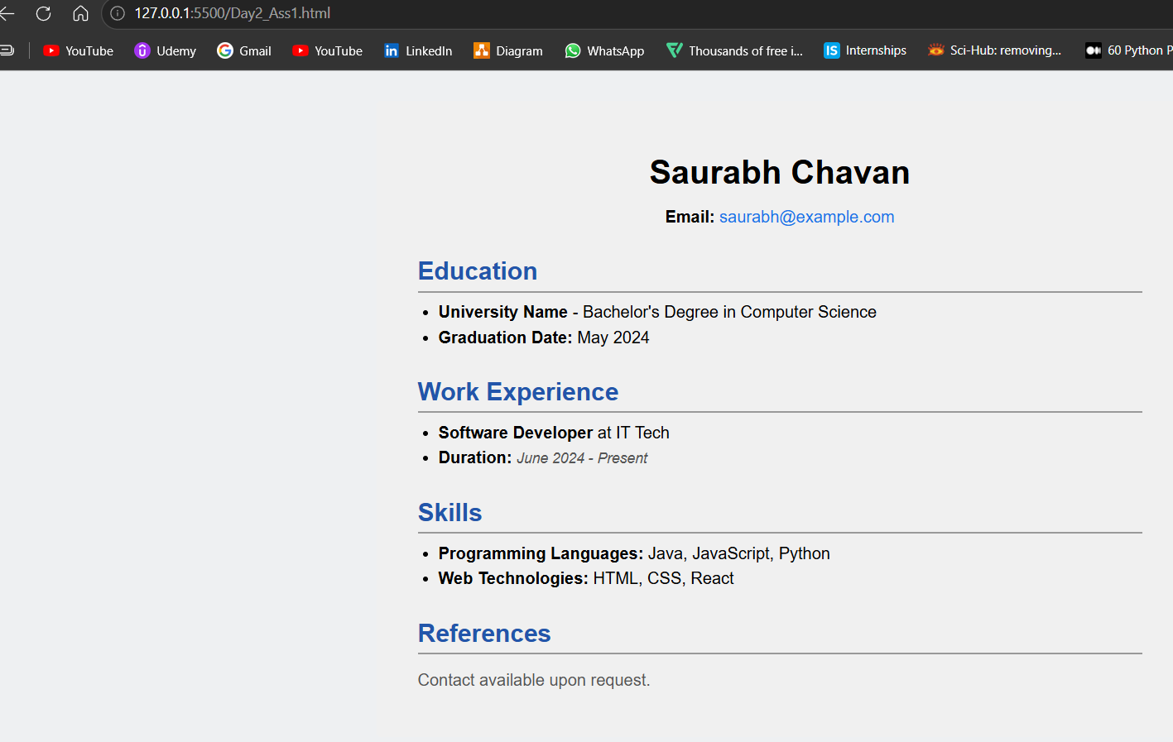

Assignment 2. Create an HTML page to list different types of motor vehicles available in the Indian market with a brief description for each of them. Use
Code: -

<!DOCTYPE html>
<html lang="en">
<head>
<meta charset="UTF-8">
<title>Motor Vehicles in the Indian Market</title>
<style>
body {
font-family: Arial, Helvetica, sans-serif;
background-color: #f5f5f5;
margin: 0;
padding: 0;
}
header {
background-color: #4acadb;
color: white;
text-align: center;
padding: 25px 10px;
}
header h1 {
margin: 0;
font-size: 28px;
}
.content {
max-width: 800px;
margin: 0 auto;
background-color: white;
padding: 30px 40px;
}
dt {
color: #150706;
font-weight: bold;
font-size: 18px;
margin-top: 20px;
}
dd {
margin: 5px 0 0 0;
color: #333;
line-height: 1.5;
}
</style>
</head>
<body>

<header>
<h1>Motor Vehicles in the Indian Market</h1>
</header>

<div class="content">

<dt>Scooter</dt>
<dd> It is known for its ease of use and fuel efficiency.</dd>
<p>Scooters are lightweight, two-wheeled vehicles with a step-through frame and a platform for the rider's feet. They are popular for short-distance commuting and urban transportation.</p>

<dt>Motorcycle</dt>
<p>Motorcycles are two-wheeled vehicles that are powered by an engine. They come in various styles, including sport bikes, cruisers, and touring bikes. Motorcycles are known for their speed, agility, and fuel efficiency.</p>

<dt>Electric Vehicle</dt>
<p>Electric vehicles (EVs) are powered by electric motors and use energy stored in rechargeable batteries. They produce zero emissions and are considered environmentally friendly. EVs are gaining popularity in India due to government incentives and increasing awareness of environmental issues.</p>
</div>

</body>
</html>
Output: -
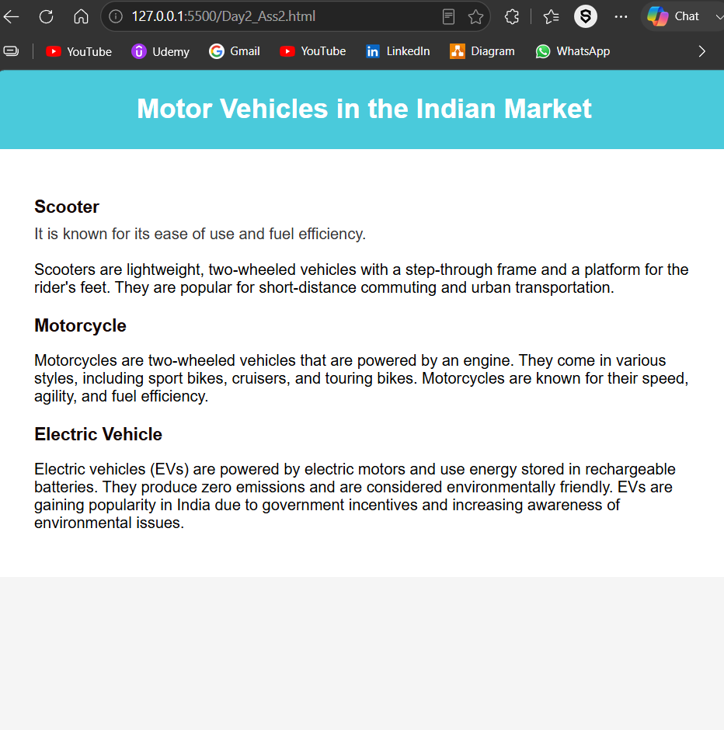
Assignment 3. You are developing a home page for an online music store. Create an HTML page that can be used as a starting page for the users. Use
Code: -
<!DOCTYPE html>
<html lang="en">
<head>
<meta charset="UTF-8">
<title>Your Music Company</title>
<style>
body {
font-family: Arial, Helvetica, sans-serif;
background-color: #7f6b80;
margin: 0;
padding: 0;
}
header {
background-color: #19f0d3;
color: white;
text-align: center;
padding: 25px 10px 20px;
}
header h1 {
margin: 0 0 5px 0;
font-size: 30px;
}
header p {
margin: 0;
font-size: 14px;
}
.container {
max-width: 800px;
margin: 0 auto;
}
section {
background-color: white;
margin: 15px 20px;
padding: 20px 25px;
border-radius: 3px;
}
section h2 {
margin-top: 0;
color: #222;
}
ul {
margin: 0;
padding-left: 20px;
}
li {
margin-bottom: 6px;
}
a {
color: #020c08;
text-decoration: underline;
}
footer {
background-color: #28bd7f;
color: white;
text-align: center;
padding: 12px;
font-size: 13px;
margin-top: 20px;
}
</style>
</head>
<body>

<header>
<h1>Ebix Music Company</h1>
<p>Connecting Cultures Through Music into the soul</p>
</header>

<div class="container">

<section>
<h2>Featured Indian Album: "Raga Reverie"</h2>
<p>Bestselling album featuring the mesmerizing sounds of traditional Indian classical music.</p>
</section>

<section>
<h2>Explore Genres</h2>
<ul>
<li><a href="#">Indian Classical</a></li>
<li><a href="#">Western Classical</a></li>
<li><a href="#">Bollywood</a></li>
<li><a href="#">Pop</a></li>
<li><a href="#">Jazz</a></li>
<li><a href="#">Rock</a></li>
</ul>
</section>

<section>
<h2>Featured Artists</h2>
<ul>
<li>Ravi Sitar Maestro</li>
<li>Emily Violin Virtuoso</li>
<li>Amit Bollywood Beats</li>
<li>Sophia Jazz Sensation</li>
</ul>
</section>

<section>
<h2>Contact Us</h2>
<p>Have questions or feedback? Reach out to us and we'll get back to you soon.</p>
</section>
</div>

<footer>
&copy; 2026 Ebix Music Company. All rights reserved.
</footer>

</body>
</html>
Output: -
