Customer Support Ticket Analysis
Ticket trends, resolution performance and customer satisfaction
Project report: Introduction to Data Analytics
Course: B.Tech - CSE
semester: III
Group ID : DA-25
Instructor: Arsh Singh
Date: October 30 , 2026
Tools: Python (pandas, NumPy, matplotlib, seaborn, SciPy) in Google Colab; HTML dashboard

1. Introduction
Customer support teams handle thousands of requests across several channels. Understanding what customers ask about, how quickly tickets move, and how satisfied customers are helps a team decide where to put its effort. This project analyses a customer support ticket dataset using the Python workflow in the Google Colab notebook customer_ticket_analysis.ipynb, and presents the results in this report and in an interactive HTML dashboard.

1.1 Objectives
- Load, inspect and clean the ticket dataset.
- Describe ticket patterns by type, priority, channel, product, subject, customer age and gender.
- Measure ticket status, resolution time and customer satisfaction.
- Test statistically whether ticket type, channel, priority, status and satisfaction are related.
- Summarise the findings, the data limitations and practical recommendations.

2. Dataset description
The dataset has 8,469 tickets and 17 columns, with no duplicate rows. Each row is one support ticket. Purchase dates run from January 2020 to December 2021, and the response and resolution timestamps fall within a window of about 27 hours around 1 June 2023.
Column | Meaning | Type
Ticket ID | Unique ticket number | Integer
Customer Name | Name of the customer | Text
Customer Email | Email of the customer | Text
Customer Age | Age in years (18 to 70) | Integer
Customer Gender | Male, Female or Other | Category
Product Purchased | Product the ticket is about (42 products) | Category
Date of Purchase | Date the product was bought | Date
Ticket Type | Refund, Technical, Cancellation, Product or Billing | Category
Ticket Subject | Specific subject (16 subjects) | Category
Ticket Description | Customer message | Text
Ticket Status | Open, Pending Customer Response or Closed | Category
Resolution | Text of the resolution | Text
Ticket Priority | Low, Medium, High or Critical | Category
Ticket Channel | Email, Phone, Chat or Social media | Category
First Response Time | Timestamp of the first response | Timestamp
Time to Resolution | Timestamp of the resolution | Timestamp
Customer Satisfaction Rating | Rating from 1 to 5 | Number
Table 1. Data dictionary of the 17 original columns.

3. Methodology
The analysis was done in a Google Colab notebook with Python. The workflow followed these stages:
- Import libraries and upload the CSV file.
- Inspect the structure with shape, info, describe, missing-value and duplicate checks.
- Clean the data and create new columns.
- Explore single variables (univariate analysis) with count plots, histograms and box plots.
- Compare variables (bivariate analysis) with cross-tabulations, heatmaps and grouped averages.
- Run statistical tests: chi-square tests, one-way ANOVA and a correlation matrix.
- Analyse the words used in ticket descriptions, and export a cleaned CSV.

4. Data cleaning and preparation

4.1 Inspection
The inspection found 5,700 missing values in Resolution, Time to Resolution and Customer Satisfaction Rating, and 2,819 in First Response Time. Grouping by ticket status showed that these gaps are not errors. Resolution, resolution time and rating exist only for the 2,769 Closed tickets, and the first response time is missing only for the 2,819 Open tickets. Because the missing values follow the ticket status by design, they were kept and not filled.
Column | Missing | Why
Resolution | 5,700 | Only closed tickets have a resolution
Time to Resolution | 5,700 | Only closed tickets have a resolution time
Customer Satisfaction Rating | 5,700 | Only closed tickets are rated
First Response Time | 2,819 | Open tickets have no first response yet
Table 2. Missing values and their cause.

4.2 Cleaning steps
- Dates. Date of Purchase, First Response Time and Time to Resolution were converted to datetime.
- Description placeholder. Every Ticket Description contained the raw text {product_purchased}. It was replaced with the actual product name from the Product Purchased column.
- Resolution time. Resolution Hours was calculated as Time to Resolution minus First Response Time, in hours. 1,365 of the 2,769 closed tickets have a negative value, which is impossible because a ticket cannot be resolved before the first response. These were flagged invalid and excluded from resolution-time results. Only 1,404 closed tickets have a valid resolution time.
- New columns. Age Group (18-25, 26-35, 36-45, 46-55, 56-70), Purchase Year, Response Hour, Has Rating, Valid Resolution Time, Resolution Hours Clean and Closed.
- Privacy. Customer Name and Customer Email were dropped because they are not needed for analysis. The result is the DataFrame df_clean with 8,469 rows and 23 columns, exported as cleaned_support_tickets.csv.

5. Exploratory analysis of single variables

5.1 Ticket type, status, priority, channel and gender
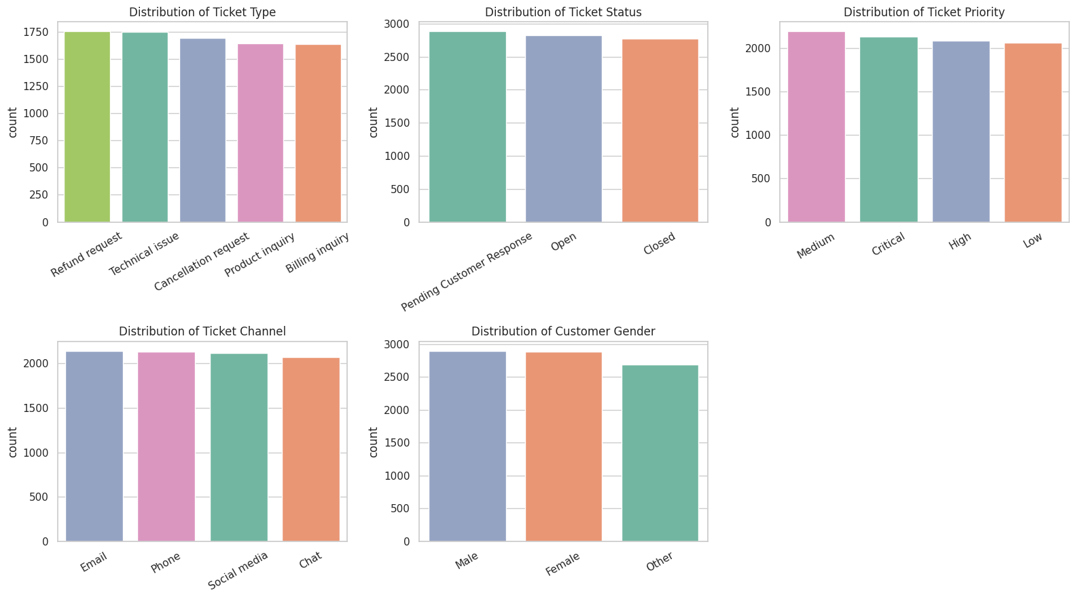
Figure 1. Distribution of ticket type, status, priority, channel and customer gender.
Variable | Categories and share of tickets
Ticket Type | Refund 20.7%, Technical 20.6%, Cancellation 20.0%, Product inquiry 19.4%, Billing 19.3%
Ticket Status | Pending Customer Response 34.0%, Open 33.3%, Closed 32.7%
Ticket Priority | Medium 25.9%, Critical 25.1%, High 24.6%, Low 24.4%
Ticket Channel | Email 25.3%, Phone 25.2%, Social media 25.0%, Chat 24.5%
Customer Gender | Male 34.2%, Female 34.1%, Other 31.7%

Each variable is spread almost evenly across its categories. The largest and smallest ticket types differ by only 1.4 percentage points. About two thirds of all tickets (67.3%) are not yet closed, which is a large backlog.

5.2 Customer age
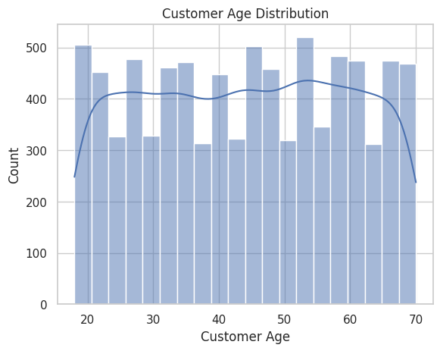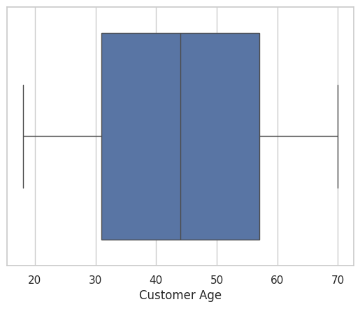
Figure 2. Customer age histogram (left) and box plot (right).
Customer age ranges from 18 to 70, with a mean and median of 44. The distribution is close to flat and the box plot shows no outliers. The 56-70 group has the most tickets (2,396), but this is partly because that bin spans 15 years while the other bins span 10 years.

5.3 Products and subjects
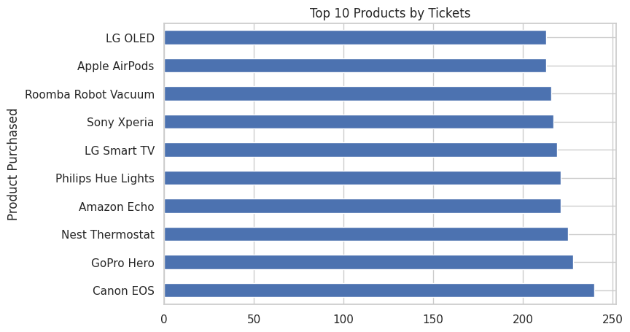
Figure 3. Top 10 products by number of tickets.
There are 42 products. Canon EOS has the most tickets (240), followed by GoPro Hero (228) and Nest Thermostat (225). The least frequent product, Nintendo Switch, still has 178 tickets, so no product stands out strongly.
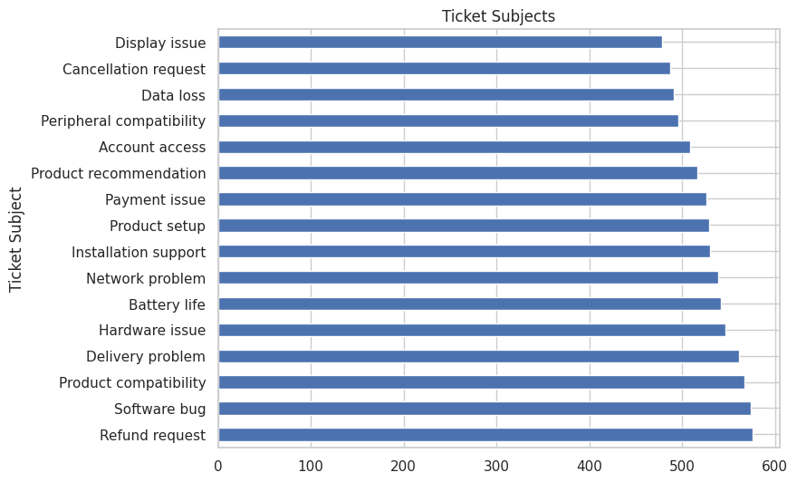
Figure 4. Number of tickets for each of the 16 ticket subjects.
The 16 subjects range from 478 tickets (Display issue) to 576 (Refund request). Software bug (574) and Product compatibility (567) are next.

5.4 Satisfaction rating
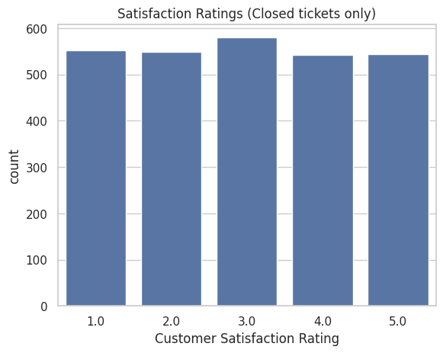
Figure 5. Satisfaction ratings of closed tickets.
Only the 2,769 closed tickets have a rating. The average is 2.99 out of 5 with a standard deviation of 1.41. Each rating from 1 to 5 was given by between 543 and 580 customers, so ratings are spread evenly and are not concentrated at either end.

6. Relationships between variables

6.1 Ticket type by priority and by channel
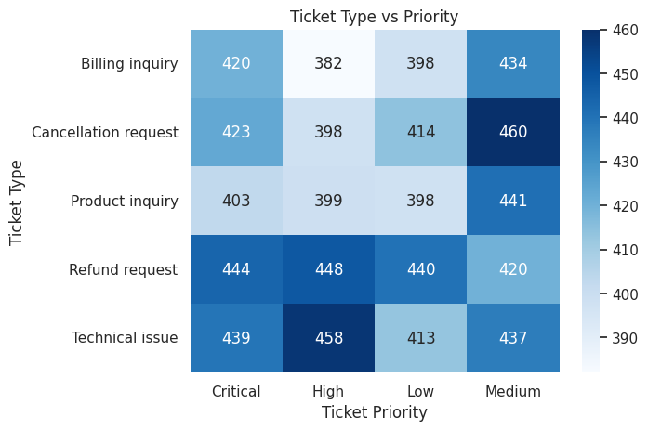
Figure 6. Ticket type compared with priority (counts).
Counts in the cells range from 382 to 460. Cancellation requests with Medium priority (460) and Technical issues with High priority (458) are the highest, and Billing inquiries with High priority (382) is the lowest. The differences are small, which the chi-square test in Section 7 confirms.
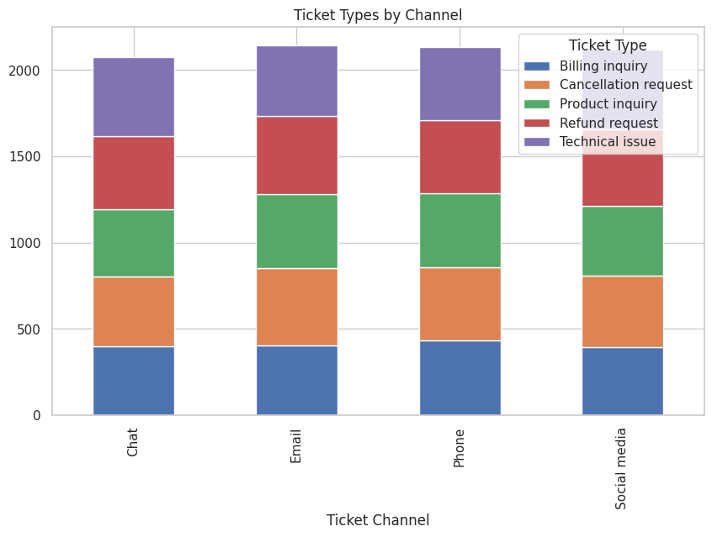
Figure 7. Ticket types by channel.
Every channel receives a similar mix of ticket types, with no channel dominated by one type.

6.2 Satisfaction by group
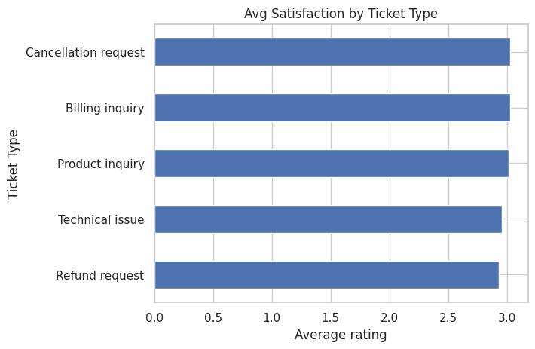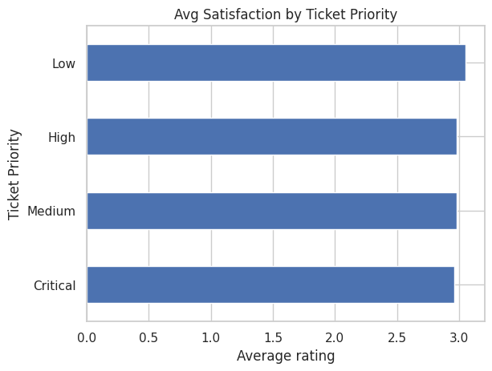
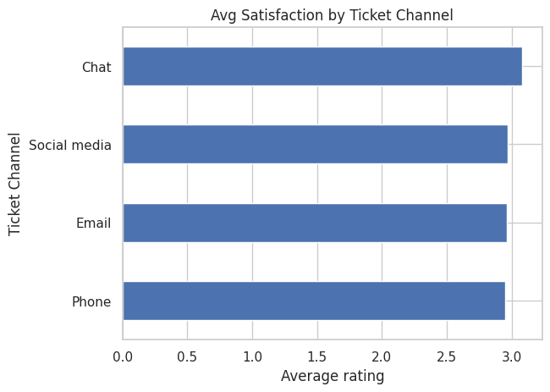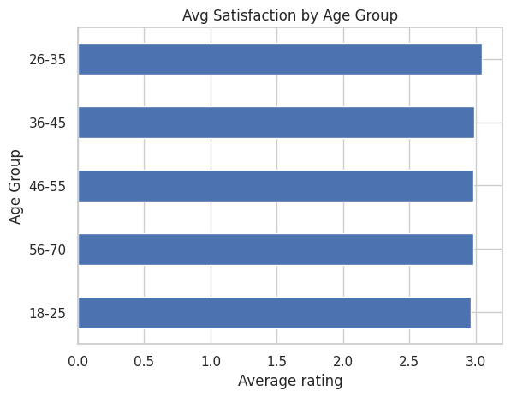
Figure 8. Average satisfaction by ticket type, priority, channel and age group (closed tickets).
Group | Average rating (out of 5)
Ticket type | Billing 3.03, Cancellation 3.03, Product inquiry 3.02, Technical 2.96, Refund 2.93
Priority | Low 3.05, High 2.98, Medium 2.98, Critical 2.96
Channel | Chat 3.08, Social media 2.97, Email 2.96, Phone 2.95
Age group | 26-35 3.05, 36-45 2.98, 46-55 2.98, 56-70 2.98, 18-25 2.96

Averages stay between 2.93 and 3.08 for every grouping, a range of 0.15 points on a 5-point scale. Refund requests have the lowest average and Chat has the highest, but the gaps are small.

6.3 Closure rate and resolution time
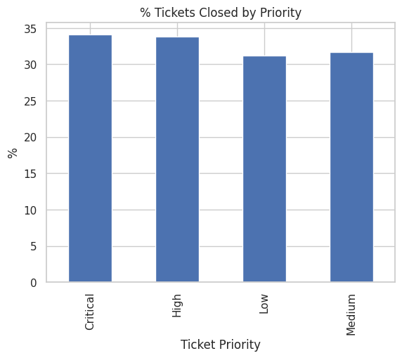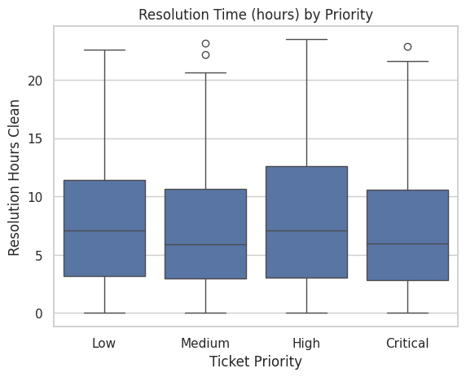
Figure 9. Percentage of tickets closed by priority (left) and valid resolution time by priority (right).
The closure rate is 34.1% for Critical, 33.8% for High, 31.7% for Medium and 31.2% for Low. Critical tickets are closed slightly more often, but the gap is small. Among the 1,404 tickets with a valid resolution time, the average is 7.58 hours, the median is 6.34 hours and the longest is 23.5 hours. By priority the average is 7.1 hours for Critical, 7.2 for Medium, 7.9 for Low and 8.1 for High. Critical tickets are not resolved noticeably faster than Low ones.

6.4 Products by ticket type and purchase year
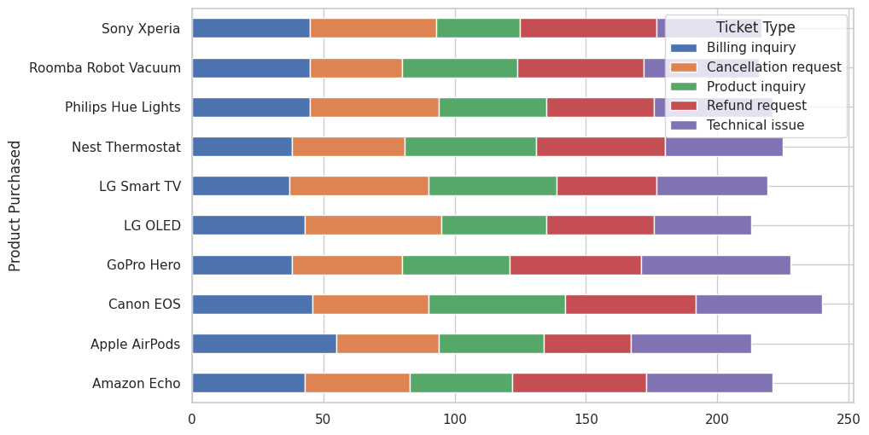
Figure 10. Ticket types for the ten products with the most tickets.
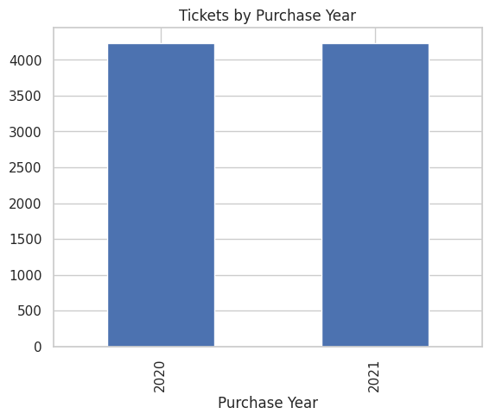
Figure 11. Tickets by year of purchase.
Tickets are split almost equally between products bought in 2020 (4,236) and 2021 (4,233).

7. Statistical analysis
Chi-square tests check whether two categorical variables are related. One-way ANOVA checks whether average satisfaction differs between ticket types. The significance level is 0.05. For each test the null hypothesis (H0) is that there is no relationship or difference, and the alternative (H1) is that there is one.
Test | Statistic | p-value | Result
Chi-square: Ticket Type vs Ticket Channel | chi2 = 11.85 | 0.4578 | Not significant
Chi-square: Ticket Type vs Ticket Priority | chi2 = 10.63 | 0.5613 | Not significant
Chi-square: Ticket Priority vs Ticket Status | chi2 = 8.15 | 0.2270 | Not significant
ANOVA: satisfaction across ticket types | F = 0.548 | 0.7008 | Not significant
Table 3. Results of the statistical tests.
All p-values are above 0.05, so H0 is not rejected in any test. There is no evidence that ticket type depends on channel or priority, that closure depends on priority, or that satisfaction differs by ticket type.
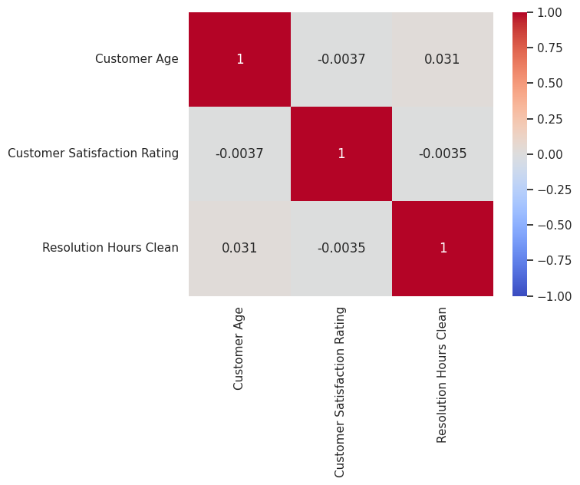
Figure 12. Correlation between customer age, satisfaction rating and valid resolution hours.
The correlations are age with rating -0.004, age with resolution hours 0.031, and rating with resolution hours -0.004. All are essentially zero, so there is no linear relationship among these three variables. In particular, longer resolution times are not linked to lower satisfaction in this data.

8. Ticket description text
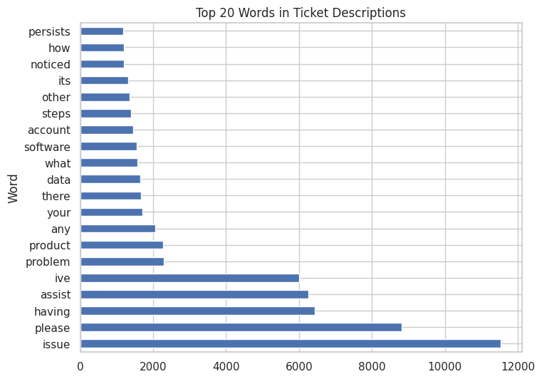
Figure 13. Twenty most common words in ticket descriptions.
After removing common stop words, the most frequent words are issue (11,530 times), please (8,808), having (6,430), assist (6,250) and problem (2,285). The wording is repetitive, which suggests the descriptions follow templates instead of free customer writing. A deeper text analysis would give little extra information.

9. Interactive dashboard
The results were also built into a single HTML file, customer_support_dashboard.html, which opens in any browser without installing anything. It has filters for ticket type, priority, channel, status, age group and gender. When a filter changes, the status bar, the four summary numbers (tickets shown, percentage closed, average satisfaction and average valid resolution time) and all charts update. The dashboard also covers every analysis in the notebook, including the statistical test results.
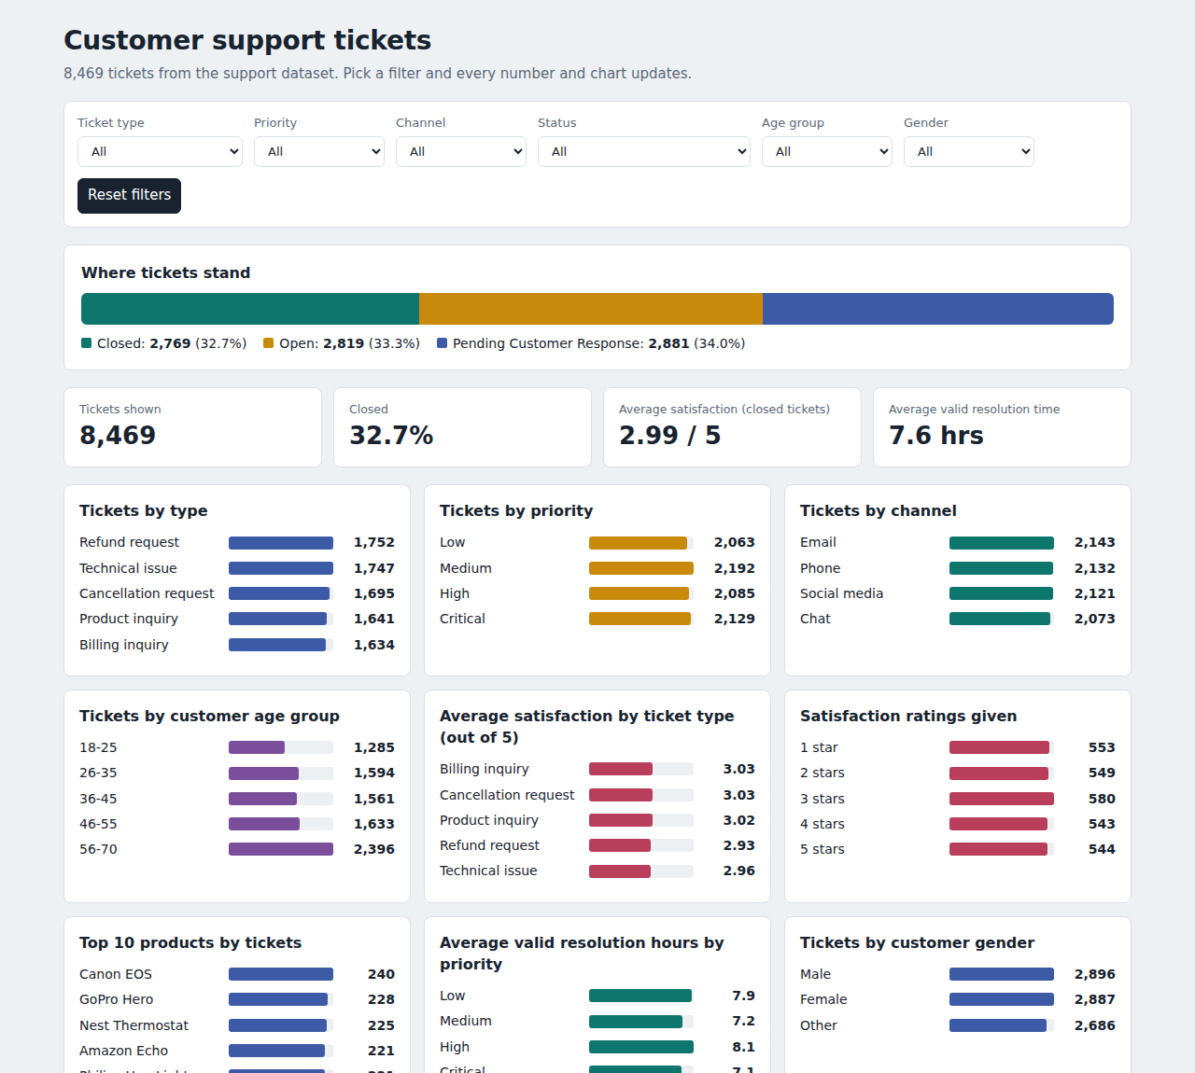
Figure 14. Top of the dashboard with no filters applied.
The dashboard values were checked against pandas results for the full dataset and for several filter combinations, and they matched exactly. With no filters it shows 8,469 tickets, 32.7% closed, an average satisfaction of 2.99 and an average valid resolution time of 7.6 hours.

10. Key findings
- Tickets are spread evenly across types, priorities, channels, products and subjects. No single category dominates.
- About two thirds of tickets (67.3%) are Open or Pending Customer Response, and only 32.7% are closed.
- The average satisfaction is 2.99 out of 5, which is neutral. Ratings are evenly spread from 1 to 5, and averages differ by at most 0.15 points between groups.
- Average valid resolution time is 7.58 hours (median 6.34). Critical tickets are not resolved faster than Low-priority ones.
- None of the chi-square tests or the ANOVA is significant, and all correlations are near zero.
- Data quality is a major issue: 1,365 of 2,769 closed tickets have a resolution before the first response.

11. Recommendations
- Fix timestamp logging so first response and resolution times are recorded correctly. Without this, response-time performance cannot be measured reliably.
- Reduce the backlog of Pending Customer Response tickets (34.0%) with automatic reminders and clear follow-up rules.
- Set and track separate response-time targets for Critical and High priority tickets, because they are currently resolved no faster than Low priority tickets.
- Collect a satisfaction rating for more tickets. Only 2,769 of 8,469 tickets (32.7%) have one, so the results describe closed tickets only.
- Review refund requests and technical issues, which have the lowest average satisfaction (2.93 and 2.96), although the difference from other types is small.
- Repeat the analysis on real, recent data, since the near-uniform patterns here suggest the dataset may be artificially generated.

12. Limitations
- The distributions are almost perfectly even and correlations are near zero, which is unusual for real support data. The dataset appears to be synthetic, so the findings should not be applied to a real business without checking.
- Resolution time is available for only 1,404 closed tickets because of invalid timestamps, so it may not represent all tickets.
- Satisfaction ratings exist only for closed tickets, which may bias the average.
- The data has no information on ticket cost, agent identity or customer history, so deeper causes cannot be examined.
- The Age Group bins have unequal widths (the last spans 15 years), which makes group counts not directly comparable.

13. Conclusion
The notebook cleaned and explored 8,469 support tickets, tested relationships with chi-square and ANOVA, and presented the results in an interactive dashboard. The analysis found a balanced mix of tickets, a neutral average satisfaction of 2.99, a large share of unresolved tickets, and no statistically significant relationships between the variables tested. The most useful practical outcome is the data-quality finding: resolution timestamps need to be fixed before response performance can be trusted. This project covers the core steps of a data analytics workflow: data loading, cleaning, exploration, statistical testing, visualisation and reporting.

Appendix: files produced
File | Content
customer_ticket_analysis.ipynb | Google Colab notebook with all code and outputs
cleaned_support_tickets.csv | Cleaned dataset (8,469 rows, 23 columns)
customer_support_dashboard.html | Interactive dashboard

