**Cucumber Automation Project:**

This project demonstrates automated testing using **Cucumber**, **WebdriverIO**, and **Allure Reporting**. The tests are written in Gherkin syntax and use the WebdriverIO framework to execute scenarios on mobile platforms.

## **Prerequisites**

1. **Node.js**: Ensure Node.js is installed on your system.
   * Download: [Node.js](https://nodejs.org/)
   * Verify installation:  
     node -v  
     npm -v

2. **Java Runtime Environment**: Required for Allure CLI.

* + Download: [Java](https://www.oracle.com/java/technologies/javase-downloads.html)

**Verify installation:**  
 java -version

3. **Install Allure Commandline**:  
 > Using NPM:  
 npm install -g allure-commandline --save-dev  
  
 > Verify installation:  
 allure --version

**Project Setup**

1. Clone the Repository:  
   git clone <repository_url>  
   cd <repository_folder>
2. **Install Dependencies**: Run the following command to install all required packages:  
   npm install
3. **Check WebdriverIO Configuration**: Ensure wdio.conf.js is correctly configured for your platform (e.g., web or mobile).

**Directory Structure  
  
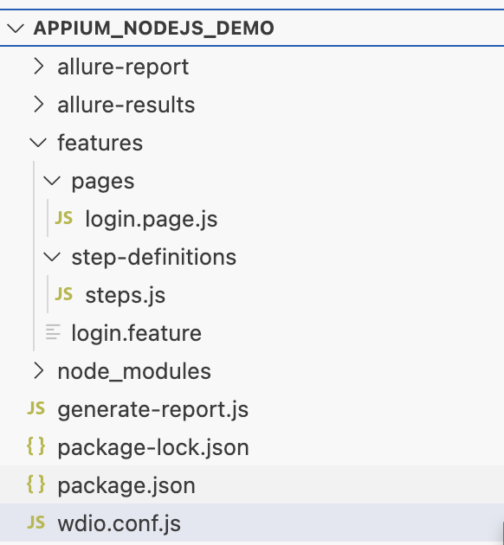**

**How to Execute Tests**Run All Tests

To execute all Cucumber tests:  
npx wdio wdio.conf.js

**Generating Allure Report**

1. **Run Tests to Generate Results**: Execute the tests to generate Allure results:  
   npx wdio wdio.conf.js  
   This creates the allure-results directory.
2. **Generate the Allure Report**: Use the Allure CLI to generate the report:  
   allure generate allure-results --clean -o allure-report
3. **View the Allure Report**: Open the generated report in a browser:  
   allure open allure-report