Subject: BUDT702

Project Group: 0503-02

Group Member:

1. Saurabh Ashok Shinde
2. Jaya Bhavgana Pabbisetty
3. Shruti Bishnoi

**PROJECT DESIGN**

**Brand Name:** SmithRanker

**Mission Statement:**

To develop a comprehensive database of Robert H. Smith School of Business rankings using credible sources in order to give our Management a fair and unbiased evaluation of the educational institution.

**Mission Objectives:**

1. To find which program ranked best in any year.
2. Find out improvement in ranking for Course from previous year.
3. To find the top three graduate programs at Smith School based on any Criteria and year.
4. To find the top three graduate programs at Smith School which have the highest International student count.
5. To find career outcomes of top programs at Smith School.

These goals will lead our efforts to build a rich and valuable database of Smith School program rankings, ultimately giving actionable insights to our Management.

**Business Terms, Facts, attributes and identifiers:**

**Business Terms**

* Program: Represents educational programs offered by the Smith School.
* Source: Represents the sources providing ranking information.
* Criteria: Represents the criteria used for ranking educational programs.
* Ranking: Stores ranking information associated with sources and criteria and program.
* Information: Contains detailed information about programs, enrollment, and other relevant data.
* Student: Contain information about students present in each program.
* Alumni: Contains information about alumni of Smith School and their current job roles.

**Facts:**

* Programs have unique identifiers (ProgramID) along with attributes like ProgramName, ProgramType, Duration, etc.
* Sources have unique identifiers (SourceID) along with attributes like SourceName, SourceType, SourceURL.
* Criteria have unique identifiers (CriteriaID) along with CriteriaName.
* Rankings have multiple identifiers (ProgramID,SourceID,CriteriaID )along with RankValue.
* Information captures data related to programs for specific years, including EnrollmentNumbers, Ratios, Percentages, AcceptanceRates and associated ProgramID ‘
* Student have unique identifiers (studentID) along with attribute like Name, Enrollment Year and Status.
* Alumni have unique identifiers (alumniID) along with attributes like Name, Year, Employer and job title.

**Attributes:**

* 1. Program :
* ProgramID (Primary Key): Unique identifier for each program.
* ProgramName: Name of the educational program offered by the institution.
* ProgramType: Type or category of the program (e.g., undergraduate, graduate, certification).
* Duration: Time span or length of the program.
  1. Source :
* SourceID (Primary Key): Unique identifier for each source providing ranking or assessment data.
* SourceName: Name of the source providing the rankings or assessment.
* SourceType: Type or category of the source (e.g., magazine, website, organization).
* SourceURL: URL or link to the source's website or location.
  1. Criteria :
* CriteriaID (Primary Key): Unique identifier for each criterion used in evaluating programs.
* CriteriaName: Name or description of the criterion used for evaluation.
  1. Ranking :
* RankValue: The numerical or ordered value assigned to the program based on the ranking.
* RankYear:Year of Ranking.
* SourceID (Foreign Key): Relates to the SourceID in the Source entity to identify the source of the ranking.
* CriteriaID (Foreign Key): Relates to the CriteriaID in the Criteria entity to specify the criteria used for the ranking.
* programID(Foreign Key): Relates to the programID in the Programentity to specify the program for which ranking is there.
  1. Information:
* InformationID (Primary Key): Unique identifier for each set of information related to a program and a specific ranking.
* Year: The year to which the information pertains.
* EnrollmentNumbers: Number of enrolled students in the program.
* StudentToStaffRatio: Ratio of students to staff members within the program.
* FemalePercentage: Percentage of female students in the program.
* InternationalPercentage: Percentage of international students in the program.
* AcceptanceRates: Rates indicating the percentage of applicants accepted into the program.
* ProgramID (Foreign Key): Relates to the ProgramID in the Program entity to associate information with a specific program.
  1. Student :
* StudentID (Primary Key): Unique identifier for each set of student information related to a program and a specific ranking.
* StudentName: Name of the student associated with the StudentID.
* StudentEnrollmentYear: The year to which the student's information pertains, indicating the enrollment year.
* StudentStatus: Status of the student within the program (e.g., International, In-State).
  1. Alumni:
* AlumniID (Primary Key): Unique identifier for each alumni record.
* AlumniName: Name of the alumni associated with the AlumniID.
* AlumniGraduationYear: The year in which the alumni graduated from the program.
* AlumniJobTitle: The job title or professional position held by the alumni after graduation.

These descriptions provide a comprehensive understanding of the business terms, facts, attributes, and identifiers associated with the given entities in the database

**Entities, Attributes and Primary Keys:**

Source(**sourceID**, sourceName, sourceType, sourceURL)

Criteria(**criteriaID**, criteriaName, *sourceID*)

Program(**programID**, programName, programType, programDuration)

Ranking(***sourceID*, *criteriaID, programID*,** rankValue*,* yearData)

Information(**infID*,*** *programID , rankID,* infYear, infEnrollmentNumbers, infStudentToStaffRatio, infFemalePercentage, infInternationalPercentage, infAcceptanceRates)

Alumni(**alumniID** , *programID,* alumniName, alumniGraduationYear, alumniEmployer, alumniJobTitle)

Student(**studentID**, *programID*, studentName,studentEnrollmentYear,studentStatus)

**Relationships, Attributes, Degrees, Participating Entities and Constraints:**

**Relationships:**

**Ranking() : Ternary relationship**

1 Source to 1 Criteria to 1 Program.

1 Source to many Criteria to 1 Program. Note: Inferred by best judgment.

Many sources and 1 criteria to 1 programs. Note: Inferred by best judgment.

Many Source and Many Criteria and Many Programs. Note: Inferred by best judgment.

**Describes(): Binary relationship**

1 or many information to 1 program

1 Program to 1 or many Information

**Graduated(): Binary relationship**

0 or many Alumn ito 1 Program

1 program to 1 Alumni.

**Enrolled(): Binary relationship**

0 or many Student to 1 Program

1 Program for 1 Student

**Degrees:**

* **Program**: Participates in one or more Information records.
* **Source**: Associated with one or more Rankings.
* **Criteria**: Associated with one or more Rankings.
* **Ranking**: Associated with one Source and one Criteria and on each program.
* **Information**: Tied to one Program.
* **Student**: Tied to one Program.
* **Alumni**: Tied to one Program.

**Participating Entities:**

1. **Program**
2. **Source**
3. **Criteria**
4. **Ranking**
5. **Information**
6. **Student**
7. **Alumni**

**Constraints:**

* **Primary Keys**:
  + programID in Program
  + sourceID in Source
  + criteriaID in Criteria
  + programID ,sourceID ,criteriaID acts as a cumulative key in Ranking.
  + informationID in Information
  + studentId in Student
  + alumniID in Alumni
* **Foreign Keys**:
  + programID in Information references ProgramID in Program
  + sourceID in Ranking references SourceID in Source
  + criteriaID in Ranking references CriteriaID in Criteria
  + (programID,sourceID,criteriaID ) acts as a cumulative foreign key.
  + programID in Program references programID in Student.
  + programID in Program references programID in Alumni.

**ER Diagram :**

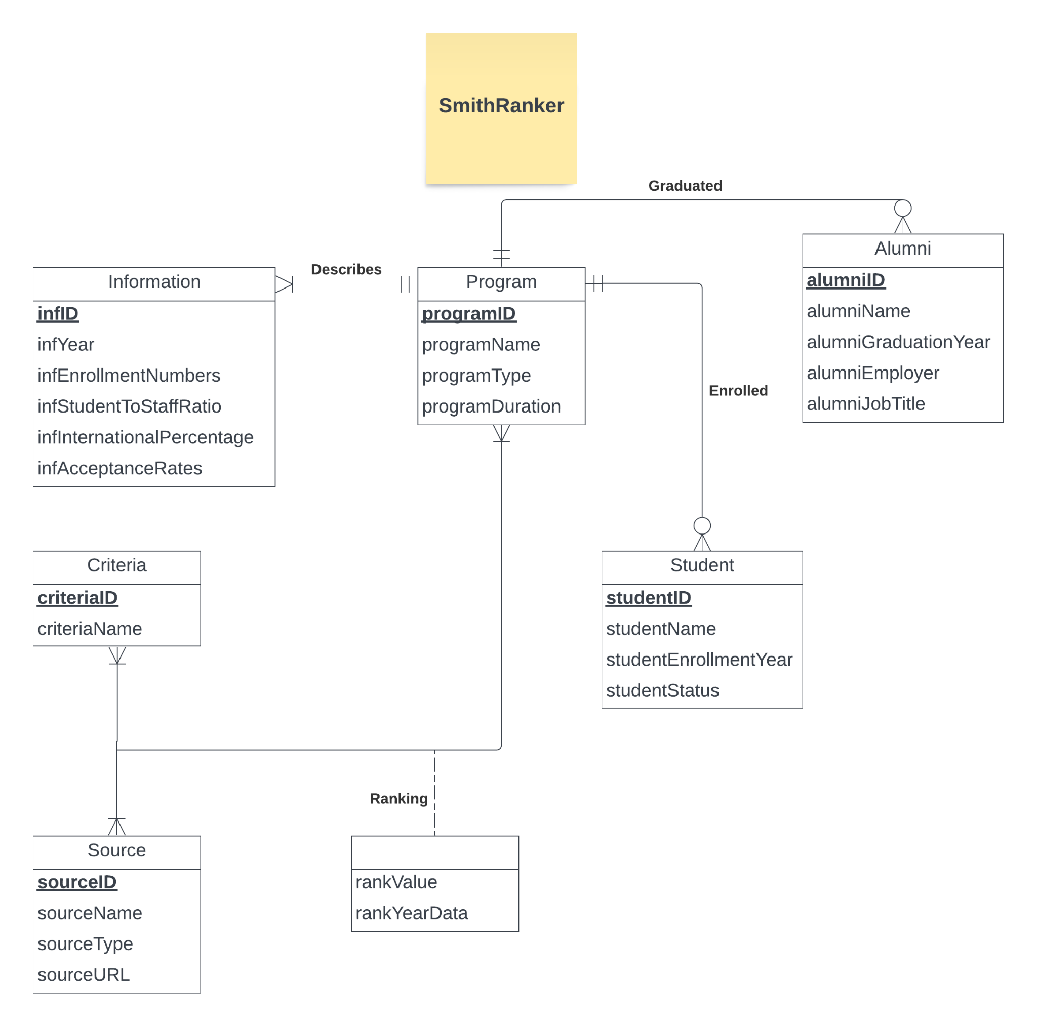

**Relational Schema:**

* Source(**sourceID**, sourceName, sourceType, sourceURL)
* Criteria(**criteriaID**, criteriaName, *sourceID*)
* Program(**programID**, programName, programType, programDuration)
* Ranking(***sourceID*, *criteriaID, programID*,** rankValue*,* rankYearData)
* Information(**infID*,*** *programID ,* infYear, infEnrollmentNumbers, infStudentToStaffRatio, infFemalePercentage, infInternationalPercentage, infAcceptanceRates)
* Alumni(**alumniID** , *programID,* alumniName, alumniGraduationYear, alumniEmployer, alumniJobTitle)
* Student(**studentID**, *programID*, studentName,studentEnrollmentYear,studentStatus)

**Functional Dependencies:**

ProgramID -> ProgramName, ProgramType, programDuration

SourceID -> SourceName, SourceType, SourceURL

CriteriaID -> CriteriaName

sourceID, criteriaID, programID-> rankValue*,* rankYearData

infID -> programID *,* infYear, infEnrollmentNumbers, infStudentToStaffRatio, infFemalePercentage, infInternationalPercentage, infAcceptanceRates

alumniID → programID, alumniName, alumniGraduationYear, alumniEmployer, alumniJobTitle

studentID → programID, studentName,studentEnrollmentYear,studentStatus

**Business Rules:**

R1:

If there is an attempt to **DELETE OR UPDATE** a record in the "Source" table that is being referenced by a record in the "Ranking" attribute, the deletion will not be allowed. This is to maintain referential integrity and prevent the deletion of a Source that has associated Ranking.

R2:

If there is an attempt to **DELETE OR UPDATE** a record in the "Criteria" table that is being referenced by a record in the " Ranking " attribute, the deletion will not be allowed. This is to maintain referential integrity and prevent the deletion of a Criteria that has associated Ranking.

R3:

If there is an attempt to **DELETE OR UPDATE** a record in the "Program" table that is being referenced by a record in the " Ranking " attribute, the deletion will not be allowed. This is to maintain referential integrity and prevent the deletion of a Program that has associated Ranking.

R4:

If there is an attempt to **DELETE OR UPDATE** a record in the "Program" table that is being referenced by a record in the " Information " table, the deletion will not be allowed. This is to maintain referential integrity and prevent the deletion of a Program that has associated Information.

R5:

If there is an attempt to **DELETE OR UPDATE** a record in the "Program" table that is being referenced by a record in the " Alumni " table, the deletion will not be allowed. This is to maintain referential integrity and prevent the deletion of a Program that has associated Alumni.

R6:

If there is an attempt to **DELETE OR UPDATE** a record in the "Program" table that is being referenced by a record in the " Student " table, the deletion will not be allowed. This is to maintain referential integrity and prevent the deletion of a Program that has associated Student.

**Referential Integrity Table :**

| **Relation** | **Foreign key** | **Base-Relation** | **Primary Key** | **Business Rule** | **Constraints: ON DELETE** | **Business Rule** | **Constraints: ON UPDATE** |
| --- | --- | --- | --- | --- | --- | --- | --- |
| **Ranking** | **sourceID** | **Source** | **sourceID** | **R1** | **NO ACTION** | **R1** | **NO ACTION** |
| **Ranking** | **criteriaID** | **Criteria** | **criteriaID** | **R2** | **NO ACTION** | **R2** | **NO ACTION** |
| **Ranking** | **programID** | **Program** | **programID** | **R3** | **NO ACTION** | **R3** | **NO ACTION** |
| **Describes** | **programID** | **Program** | **programID** | **R4** | **NO ACTION** | **R4** | **NO ACTION** |
| **Graduated** | **programID** | **Progranm** | **programID** | **R5** | **NO ACTION** | **R5** | **NO ACTION** |
| **Enrolled** | **programID** | **Program** | **programID** | **R6** | **NO ACTION** | **R6** | **NO ACTION** |