**Capstone Project-I**

**Report**

on

**“VersaOptimizer”**

Submitted By

|  |  |
| --- | --- |
| Saurabh Davda | 202202626010057. |
| Namra Chhapia | 202202626010056. |
|  |  |

Under the Guidance of

Prof. Aakanksha Jain

Assistant Professor



**Faculty of Engineering and Technology**

**GLS University**

Academic Year

**(2024-2025)**



**CERTIFICATE**

This is to certify that the project report entitled **“_______VersaOptimizer________”** has been satisfactorily carried out by the following students

|  |  |
| --- | --- |
| Saurabh Davda | 202202626010057 |
| Namra Chhapia | 202202626010056 |

under my guidance in the fulfillment of the course Capstone Project-I (2601606) work during the academic year 2024-2025.

|  |  |  |
| --- | --- | --- |
| (Prof. Aakanksha Jain) |  | (Dr. Madhuri Chopade) |
| Internal Guide |  | Capstone Project-I Coordinator |

**Acknowledgment**

We would like to extend our heartfelt gratitude to everyone who has supported us throughout the development of the initial phases of VersaOptimizer - The AI Model Optimization Tool.

Our deepest appreciation goes to Prof. Aakanksha Jain for their invaluable guidance, insightful feedback, and unwavering encouragement during the foundational stages of this project. Their expertise has been instrumental in shaping the direction and scope of our work.

We also thank our peers, collaborators, and everyone who provided constructive suggestions and motivation, enabling us to overcome challenges and refine the system's design.

This acknowledgment serves as a token of our gratitude to all contributors for their dedication and support. We look forward to their continued encouragement as we work diligently to complete the remaining phases of VersaOptimizer.

Sincerely,

**Saurabh Davda**

**Namra Chhapia**

**Abstract**

VersaOptimizer is designed to enhance the performance of AI models by optimizing their execution on diverse hardware architectures, including CPUs and GPUs. The system focuses on transforming AI model kernels, represented in LLVM Intermediate Representation (IR), into highly efficient, execution-ready code. By employing advanced optimization techniques such as SIMD vectorization, loop fusion, and memory access optimization, *VersaOptimizer* significantly reduces computational overhead and accelerates processing.

This tool is particularly useful for developers and researchers seeking to improve AI model efficiency without manual tuning, enabling seamless deployment across varied platforms. Our proposed approach integrates modular LLVM optimization passes and leverages profiling data to adapt transformations dynamically.

Initial results demonstrate substantial improvements in execution time and resource utilization, validating the system’s effectiveness. Future work aims to extend support for specialized accelerators and provide plug-and-play compatibility with AI frameworks like TensorFlow and PyTorch, fostering broader adoption in the AI community.

**Content**

|  |  |  |
| --- | --- | --- |
| **Sr.** | **Particular** | **Page No.** |
|  | Certificate | I |
|  | Acknowledgment | II |
|  | Abstract | III |
|  | Table of Content | IV |
|  | List of Tables (if any) | V |
|  | List of Figures (if any) | VI |
| 1. | Introduction | 1 |
| 2. | Literature Review | 2 |
| 3. | Project Methodology/ Analysis/ Design (wireframes/diagrams) | 6 |
| 4. | Project Requirement | 14 |
|  | 4.1 Functional | 14 |
|  | 4.2 Non- Functional | 15 |
|  | 4.3 Prototype with Screenshots | 17 |
| 5. | Tools & Technologies | 18 |
| 6. | Implementation (Optional) | 23 |
| 7. | Conclusion & Future Work | 26 |
| 8. | References | 29 |

**Chapter 1: Introduction**

Deep learning has become the cornerstone of transformative advancements in domains such as computer vision, natural language processing, robotics, and autonomous systems. By enabling machines to analyze, learn, and make decisions, deep learning has significantly pushed the boundaries of what artificial intelligence (AI) can achieve. However, these advancements come at a cost—deep learning workloads are notoriously resource-intensive, demanding immense computational power and memory bandwidth.

While frameworks like TensorFlow and PyTorch have simplified the development and deployment of AI models, the optimization of these models for performance remains an intricate challenge. The underlying hardware architecture—whether it’s a traditional x86-64 processor, an ARM-based mobile device, or a GPU—plays a critical role in determining the efficiency of deep learning operations. Tapping into the full potential of these architectures demands expertise in low-level systems programming, compiler technologies, and machine learning.

Enter **VersaOptimizer**, a groundbreaking LLVM-based framework designed to bridge this gap. VersaOptimizer redefines how deep learning workloads are optimized by automating and streamlining hardware-specific performance tuning. It leverages the power of the LLVM compiler infrastructure to perform cutting-edge optimizations, such as loop fusion, data layout transformations, and auto-vectorization, tailored for deep learning kernels like convolutions, pooling, and activation functions.

The key mission of VersaOptimizer is to ensure seamless compatibility and unmatched performance across diverse hardware platforms. By supporting architectures such as x86-64 processors, ARM devices, Apple Silicon, and NVIDIA GPUs, it eliminates the need for labor-intensive manual tuning. Whether optimizing a model for a high-performance cloud environment or a resource-constrained mobile device, VersaOptimizer delivers consistent and reliable results.

But VersaOptimizer is not just about performance. It’s a vision for scalability and adaptability in the rapidly evolving field of AI. Designed to accommodate future advancements in both hardware and software, the framework provides a robust foundation for researchers, developers, and engineers to innovate without being burdened by the complexities of low-level optimizations.

By simplifying the path to performance excellence, VersaOptimizer empowers AI practitioners to focus on what truly matters—creating intelligent solutions that can transform industries and improve lives. In doing so, it stands as a testament to the power of collaboration between deep learning and systems engineering, driving the next generation of AI innovation.

**Chapter 2: Literature Review**

Deep learning frameworks have become indispensable for building and deploying artificial intelligence (AI) models across diverse industries. These models, however, often require significant computational resources, particularly for training on large datasets and inference in real-time applications. The performance of deep learning models is heavily influenced by the efficiency of underlying computation graphs and their execution on various hardware platforms, ranging from general-purpose CPUs to GPUs and specialized accelerators like TPUs.

Optimizing deep learning kernels—such as convolutional operations, matrix multiplications, and activation functions—is essential for achieving optimal performance. The optimization process can be broadly categorized into two main areas:

1. **Algorithmic Optimizations**: Focused on improving the mathematical operations, such as adopting more efficient algorithms for tasks like matrix multiplication or convolution.
2. **Compiler Optimizations**: Targeted at transforming code to enhance its execution on specific hardware platforms. These include improving memory access patterns, reducing redundant computations, and exploiting parallelism.

This literature review focuses on compiler-based approaches, detailing key optimization techniques such as loop fusion, data layout transformations, and auto-vectorization. Furthermore, we explore how these techniques accelerate deep learning kernels and discuss prominent LLVM-based frameworks for deep learning optimization.

**2.1 Compiler Optimizations for Deep Learning**

Compilers play a pivotal role in deep learning optimization, transforming high-level operations into machine code that efficiently utilizes hardware capabilities. Without targeted optimizations, the resulting code often fails to exploit the full potential of the underlying hardware. Compiler-based optimization techniques are therefore critical in enabling efficient execution of deep learning models.

**2.2 LLVM Compiler Infrastructure**

LLVM (Low-Level Virtual Machine) is a widely adopted compiler infrastructure that serves as the foundation for many modern compilers, including those tailored for deep learning. LLVM provides a flexible framework for implementing custom compiler passes that optimize intermediate representations (IR) of programs.

LLVM’s extensibility and portability make it an attractive choice for deep learning optimizers. Popular frameworks such as TVM (Tensor Virtual Machine) and MLIR (Multi-Level Intermediate Representation) leverage LLVM to optimize machine learning workloads for a variety of hardware platforms, including CPUs, GPUs, and specialized accelerators.

**2.2.1 LLVM-based Optimization Techniques**

Compiler optimizations based on LLVM have proven effective in accelerating deep learning models. Key techniques include:

1. **Loop Fusion**: This technique combines multiple loops operating on similar data to reduce overhead and improve cache locality. For example, in convolutional neural networks (CNNs), loop fusion minimizes memory access latency and enhances data reuse, as demonstrated by Baskaran et al. (2019).
2. **Data Layout Transformations**: The arrangement of data in memory significantly impacts performance. Optimizing data layouts—such as reordering elements to improve cache utilization—can lead to substantial performance gains. He et al. (2016) highlighted the effectiveness of these transformations in matrix multiplication and convolution operations.
3. **Auto-Vectorization**: Modern hardware supports SIMD (Single Instruction, Multiple Data) instructions, enabling parallel processing of multiple data elements. Auto-vectorization identifies opportunities for SIMD execution, generating parallelized code to accelerate operations. Wang et al. (2017) demonstrated significant performance improvements on GPUs using auto-vectorization.

**2.2.2 Existing LLVM-based Frameworks for Deep Learning Optimization**

Several LLVM-based frameworks have been developed to optimize deep learning kernels. These frameworks highlight LLVM’s potential and inspire further advancements in deep learning optimization.

1. **TVM**: TVM is an open-source machine learning compiler framework targeting multiple hardware backends, including x86, ARM, and GPUs. By leveraging LLVM, TVM applies techniques such as operator fusion, data layout transformations, and auto-vectorization. Chen et al. (2018) demonstrated that TVM outperforms frameworks like TensorFlow and PyTorch in execution speed and memory efficiency.
2. **MLIR**: MLIR is a flexible compiler infrastructure that optimizes machine learning models across diverse hardware. Built on LLVM, MLIR provides a multi-level representation for neural networks, enabling fine-grained optimizations. Kang et al. (2020) demonstrated its ability to achieve significant performance gains on various hardware platforms.
3. **Halide**: Designed for optimizing image processing and deep learning workloads, Halide uses LLVM to apply optimizations such as loop unrolling, tiling, and vectorization. Ragan-Kelley et al. (2013) showcased Halide’s state-of-the-art performance in image processing, with its techniques readily applicable to deep learning.

**2.2.3 Optimization Techniques in Deep Learning Frameworks**

In addition to LLVM-based frameworks, many deep learning platforms incorporate their own optimizations:

1. **TensorFlow XLA (Accelerated Linear Algebra)**: XLA is a domain-specific compiler that performs just-in-time (JIT) compilation of TensorFlow graphs, optimizing memory access and parallelism. Jouppi et al. (2017) showed significant acceleration of GPU-based training using XLA.
2. **PyTorch JIT Compiler**: PyTorch employs a JIT compiler to optimize models before execution. By applying techniques such as loop fusion and operation fusion, the JIT compiler enables faster execution across hardware platforms. Zhang et al. (2019) demonstrated its advantages over eager execution.

**Future Trends in Deep Learning Optimization**

The field of deep learning optimization is evolving rapidly, with several emerging trends:

* **Hardware-Specific Optimization**: As accelerators like TPUs and FPGAs gain prominence, compilers need to be tailored for these devices.
* **Autonomous Optimization**: Machine learning algorithms are being explored to automate optimization strategy selection based on workload characteristics.
* **Edge and Mobile Optimization**: Optimizing models for low-power, resource-constrained environments, such as smartphones and IoT devices, is becoming increasingly critical.

**Conclusion**

Deep learning optimization is a dynamic research area with significant contributions from academia and industry. LLVM-based optimization techniques have demonstrated remarkable potential in enhancing performance across diverse hardware platforms. Frameworks like TVM, MLIR, and Halide illustrate the effectiveness of compiler optimizations, inspiring advancements in this domain. The development of the LLVM-based Deep Learning Optimizer builds upon these achievements, aiming to deliver efficient, high-performance deep learning operations while targeting a broad range of hardware platforms.

**Chapter 3: Project Methodology**

**3.1 Project Methodology**

The methodology section outlines the approach, development lifecycle, processes, and strategies for building VersaOptimizer, which focuses on optimizing AI models for CPU execution using ONNX format models, LLVM Intermediate Representation, and TVM optimizations.

**3.1.1 Overview of Methodology**

The **VersaOptimizer** development methodology follows the **Agile Software Development Life Cycle (SDLC)** with iterative design, development, testing, and deployment processes.

This approach allows for flexibility in technical challenges such as integration issues with **LLVM**, **ONNX**, and **TVM** and enables iterative performance testing and refinement of optimization pipelines.

**3.1.2 Core Principles of the Methodology**

The methodology prioritizes the following principles:

1. **Modular & Component-Based Development**: Break the project into smaller modules such as:
   * ONNX Parser.
   * LLVM IR Generator.
   * TVM Optimizer.
   * Model Executor.
2. **Feasibility Analysis and Research**:
   * Study the constraints between ONNX models, LLVM transformations, and CPU optimizations using TVM.
   * Review existing research on translating AI model architectures into efficient representations for CPU execution.
3. **Iterative Testing**:
   * Each pipeline step (ONNX → LLVM IR generation → TVM Optimizations) will have isolated testing.
4. **User Feedback Loop**:
   * Although this is a technical project, feedback on performance evaluation results will guide iterative refinement.

**3.1.3 Methodology Phases**

The entire project is broken into the following phases:

**1. Requirement Gathering**

* Analyze the goal of translating AI models (ONNX) into optimized LLVM IR and using TVM to improve CPU execution performance.
* Set technical benchmarks (e.g., CPU latency improvement, reduced memory use).

**2. Research and Feasibility Analysis**

* Explore the technical stack dependencies: ONNX models, LLVM IR translation capabilities, TVM optimizations, and computational trade-offs.

**3. Design**

* Define workflows, system architecture, class diagrams, and system interactions for **VersaOptimizer**.

**4. Development/Implementation**

* Parse ONNX models.
* Translate parsed models into LLVM Intermediate Representation (IR).
* Apply TVM optimizations to generate CPU-executable instructions.

**5. Testing**

* Unit-test each module for correctness and compute metrics like latency, CPU utilization, and resource usage.

**6. Deployment & Evaluation**

* Deploy optimized models in testing environments to validate execution efficiency.

**3.2 Analysis**

The **analysis** section identifies the project’s goals, constraints, dependencies, and workflows.

**3.2.1 Problem Statement**

AI models are often optimized for GPUs, but many users rely on CPUs for execution due to hardware availability, cost, or compatibility reasons. However, ONNX models are not always optimized for efficient CPU execution.

The **VersaOptimizer** addresses the following problem:

* **How can ONNX models be transformed into LLVM IR and CPU-compatible representations while reducing latency and resource usage?**

**3.2.2 Goals of VersaOptimizer**

The goal of this project is to develop **VersaOptimizer**, an end-to-end pipeline that:

1. Parses ONNX models.
2. Converts models into LLVM IR.
3. Optimizes LLVM IR using **TVM** for CPU execution.
4. Benchmarks models for improved latency and compute performance.

**3.2.3 Functional Requirements**

These define what **VersaOptimizer** should achieve:

1. **ONNX Parsing**:
   * Parse ONNX models for compatibility checks.
   * Validate model operations and structure.
2. **LLVM IR Generation**:
   * Translate ONNX models to LLVM Intermediate Representation (IR).
3. **TVM-Based Optimization**:
   * Optimize the IR using TVM's optimization passes.
4. **Execution and Benchmarking**:
   * Evaluate CPU execution performance after optimizations.
5. **Model Compatibility**:
   * Ensure compatibility with widely used CPU architectures.

**3.2.4 Non-Functional Requirements**

These are constraints that VersaOptimizer must adhere to:

1. **Performance**:
   * The system must optimize models for minimal CPU latency and resource usage.
2. **Scalability**:
   * The system should handle varying model sizes without performance degradation.
3. **Portability**:
   * Generated IR optimizations should work across diverse CPU platforms.
4. **Maintainability**:
   * Modular design should enable easy debugging, testing, and future feature addition.

**3.2.5 Constraints**

The following are constraints for the **VersaOptimizer** development:

1. **Time Constraints**: Academic deadlines and testing cycles limit available development time.
2. **Technical Stack Dependencies**: Tools such as ONNX, LLVM, and TVM introduce dependencies.
3. **System Resources**: Optimizations might be compute-intensive, requiring efficient use of system memory.

**3.3 Design**

The **design** section defines the system's architecture, key workflows, and component interactions required for building **VersaOptimizer**.

**3.3.1 High-Level Architecture**

The system employs a **pipeline-based architecture**:

**Pipeline Steps**:

1. **ONNX Parsing Module**:
   * Parses AI models in the ONNX format.
   * Extracts neural network operations and transforms them into a usable format.
2. **LLVM IR Generator**:
   * Translates parsed models into LLVM Intermediate Representation (IR).
3. **TVM Optimization Module**:
   * Optimizes LLVM IR using TVM optimization strategies for efficient CPU execution.
4. **Model Executor**:
   * Executes optimized models on CPU and benchmarks resource utilization and latency.

**3.3.2 UML Diagrams**

To communicate system design, include the following:

**1. Class Diagram:**

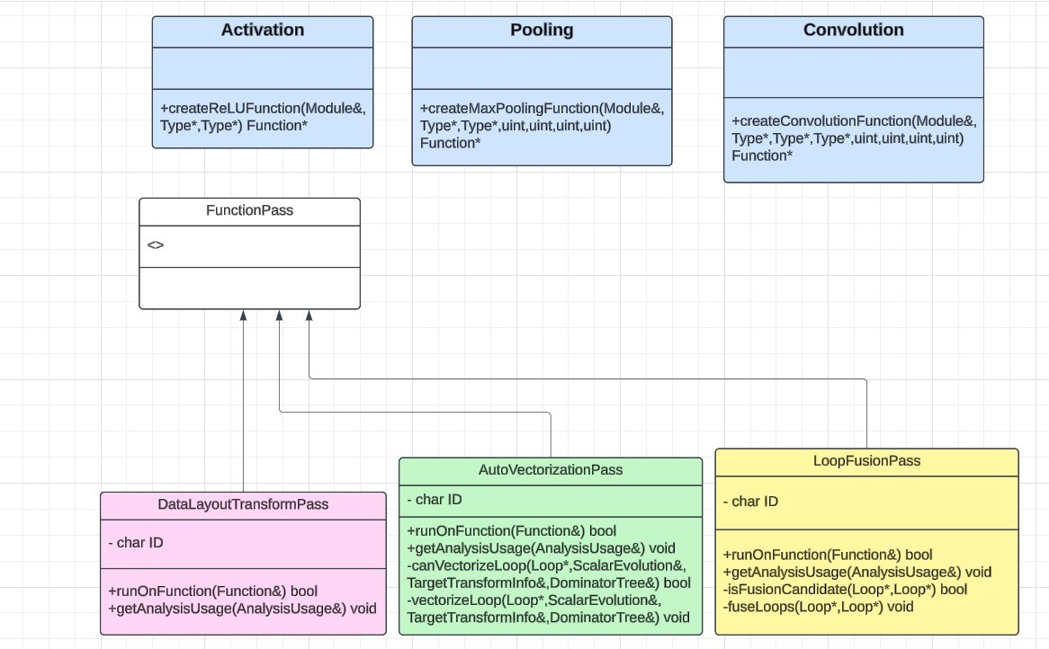

Fig:3.1 Class Diagram

**2. Sequence Diagram:**

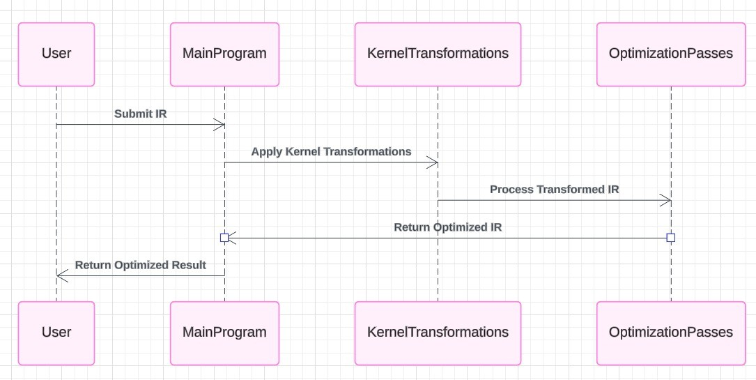

Fig:3.2 Sequence Diagram

**3. Activity Diagram:**

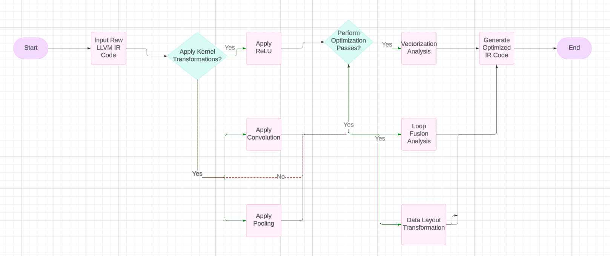

Fig:3.3 Activity Diagram

**3.3 Data Flow**

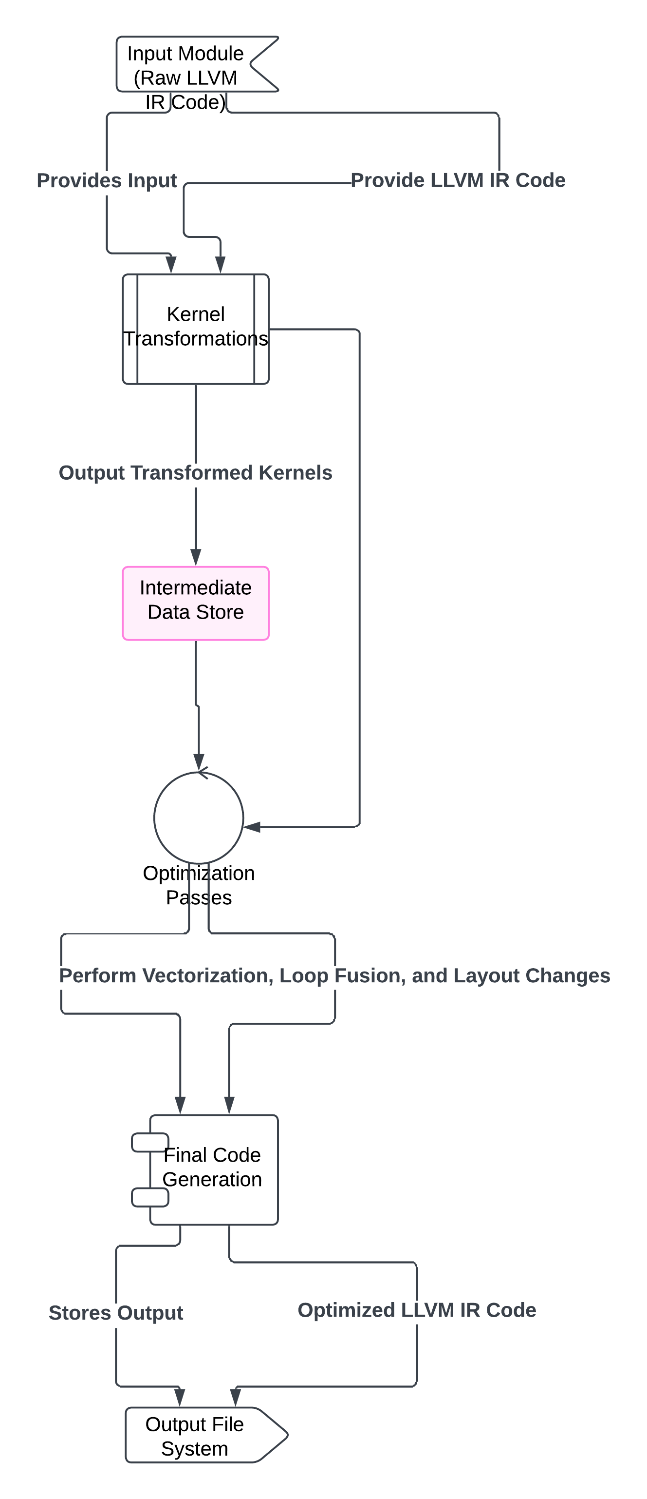

Fig:3.4 Data Flow

**3.4 Deployment Considerations**

* Deploy the system in environments with diverse CPU configurations.
* Use performance metrics (e.g., latency reduction and CPU footprint) to validate optimization success.

**Summary**

The design ensures modularity, scalability, and efficient testing through well-defined layers: parsing ONNX models, generating LLVM IR, optimizing with TVM, and deploying CPU-compatible instructions.

**Chapter 4: Project Requirement**

This section defines the core requirements for the *VersaOptimizer* system, focusing on the necessary functional and non-functional specifications. Additionally, it includes a prototype description supported by mockups or conceptual illustrations.

**4.1 Functional Requirements**

Functional requirements define the features and functionalities *VersaOptimizer* should provide. They are critical for ensuring that the system meets its goals effectively.

**Core Functionalities**

1. **Model Optimization via LLVM Passes**
   * The system must automatically determine the best LLVM passes to optimize AI model computations.
   * Users should have the ability to manually select or configure LLVM passes to suit their use cases.
2. **Cross-Platform Code Optimization**
   * The system should support optimization for different hardware architectures:
     + x86-64, ARM, and SIMD-based architectures.
     + GPU acceleration with CUDA for NVIDIA GPUs.
     + FPGA and other low-power accelerators.
3. **Framework Integration**
   * The system must integrate with the most commonly used AI frameworks:
     + TensorFlow (v2.0 or higher).
     + PyTorch (v1.5 or higher).
   * Users should be able to import models and export optimized versions seamlessly.
4. **Adaptive Optimization Strategies**
   * Automatically profile input models to dynamically select optimization strategies suited to specific model requirements or hardware.
5. **Performance Evaluation Tools**
   * The system must include performance metrics and analysis tools to ensure optimizations lead to tangible performance improvements.
     + Execution time comparisons pre/post-optimization.
     + Memory profiling and usage analysis.
6. **Debugging and Profiling Support**
   * Developers must be able to debug optimization processes and trace performance issues.
   * Provide logs and debugging utilities during the transformation process.
7. **User Configuration Options**
   * Users should have options to:
     + Select optimization levels.
     + Manually configure optimization passes.
     + Choose target hardware preferences.
8. **Dynamic Adaptability**
   * The system must support real-time adjustments to workloads and dynamically change optimization strategies during runtime.
9. **Scalability**
   * The system should efficiently optimize large models without performance degradation or excessive resource consumption.

**4.2 Non-Functional Requirements**

Non-functional requirements describe the operational, technical, and performance characteristics the system should adhere to, ensuring usability, performance, and reliability.

**Performance Requirements**

1. **Execution Speed**
   * The system must optimize models in minimal time, with computation time overheads limited to less than 10% of the target model's inference time.
2. **Resource Consumption**
   * Memory usage should scale linearly with the size of the AI model being optimized.
   * GPU/CPU resource consumption should stay low to ensure compatibility with edge devices.

**Scalability**

1. *VersaOptimizer* should scale well when optimizing multiple models concurrently.
2. It must efficiently handle increasingly complex models without resource spikes.

**Usability**

1. The user interface and system interaction must be intuitive to allow developers and AI researchers to utilize it without requiring advanced LLVM expertise.
2. Clear documentation should accompany the system to guide users in configuring and deploying optimizations.

**Compatibility**

1. *VersaOptimizer* must support:
   * Multiple platforms (Linux, Windows, macOS).
   * All major AI frameworks like TensorFlow and PyTorch.
   * GPU (CUDA-based) and edge hardware (ARM processors, SIMD instructions).

**Reliability**

1. The system should ensure reliability by:
   * Logging all optimization errors.
   * Handling failures gracefully without crashing or data loss.
   * Providing rollback mechanisms if an optimization pass leads to errors.

**Security**

1. Any user-generated data (such as models or logs) must be protected.
2. Secure communication between optimization processes and frameworks should be enforced.

**Maintainability**

1. The system must be modular to ensure ease of updates, especially for:
   * Adding new LLVM passes.
   * Adding new hardware support backends.

**4.3 Prototype with Screenshots**

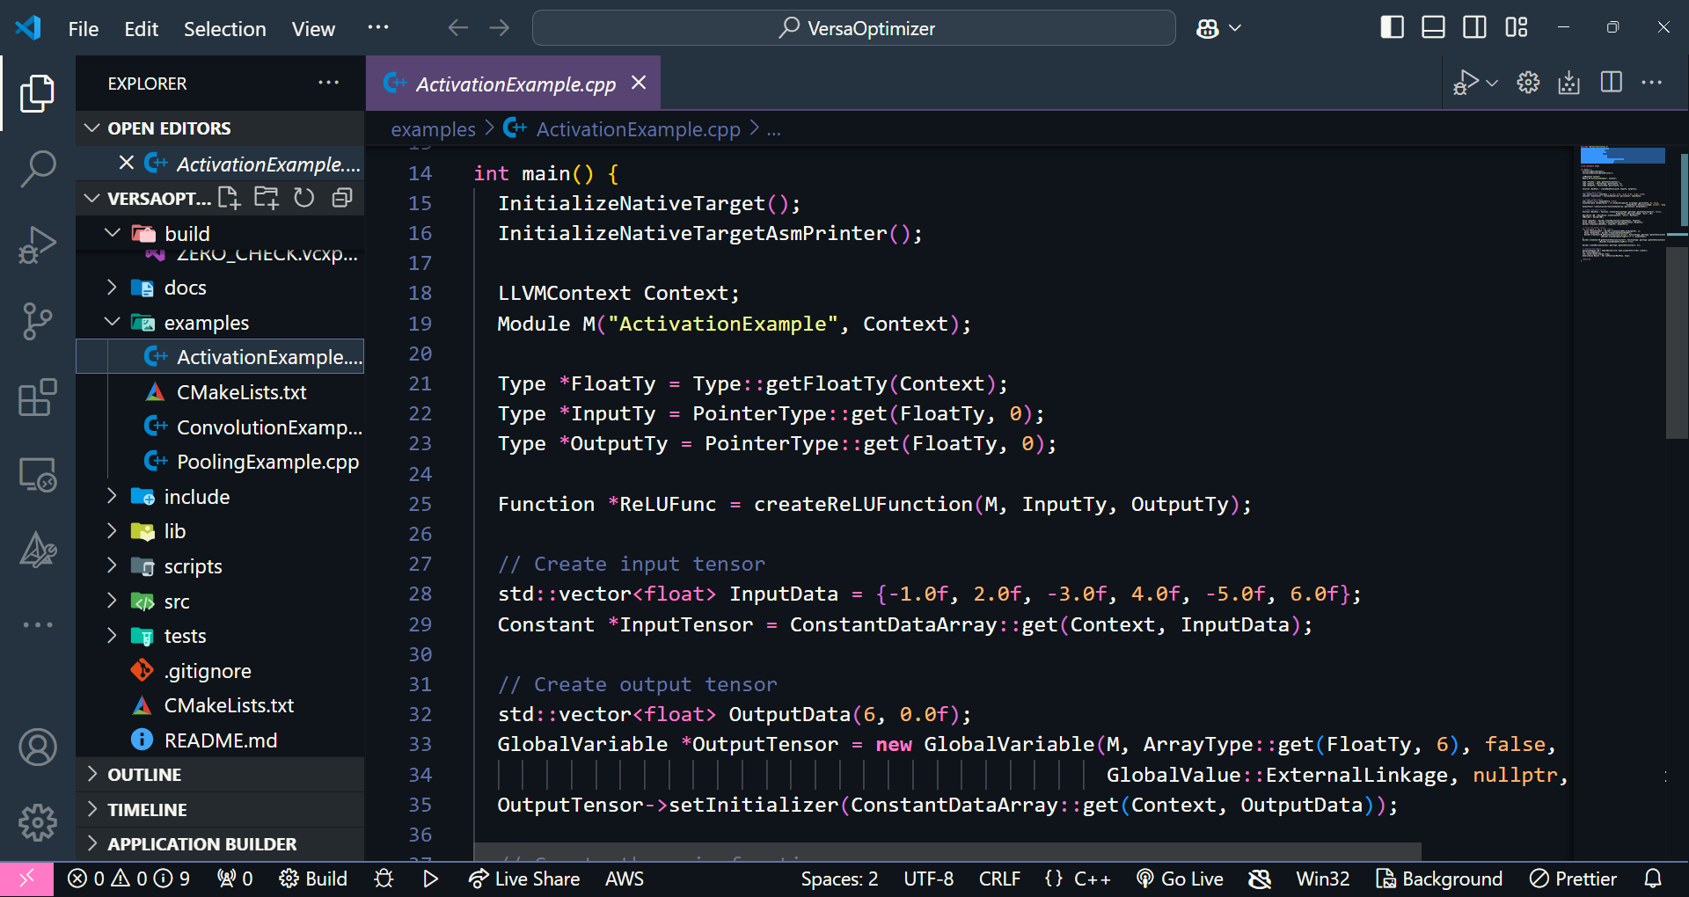

**Chapter 5: Tools and Technologies**

This section provides a comprehensive overview of the software tools, frameworks, hardware requirements, and input/output workflows integral to the development and deployment of *VersaOptimizer*. These tools have been carefully selected to ensure the system's functionality, scalability, and optimization efficiency.

**5.1 Software Tools**

The *VersaOptimizer* system leverages a variety of software tools for building, compiling, optimization, and execution. Below are the core tools:

1. **LLVM (v10+)**
   * **Purpose:** The Low-Level Virtual Machine (LLVM) serves as the backbone of the *VersaOptimizer* system by providing robust Intermediate Representation (IR) transformation and optimization capabilities.
   * **Features:**
     + Modular and flexible optimization passes.
     + Cross-platform code generation for various hardware architectures (x86, ARM, GPUs).
     + Efficient IR transformations for model optimization workflows.
   * **Use Case in VersaOptimizer:** LLVM optimizes the provided IR representing deep learning kernels, transforming them into efficient machine code for execution on target hardware.
2. **C++17-Compatible Compiler**
   * **Purpose:** C++ is the primary programming language for implementing LLVM transformations, IR manipulation, and model optimizations.
   * **Compatibility:** C++17 is selected to ensure compatibility with LLVM and support for modern programming paradigms.
   * **Advantages:**
     + Memory-efficient processing with fine-grain control over system resources.
     + Fast computation speeds required for processing large IR workloads.
3. **CMake (v3.10+)**
   * **Purpose:** CMake is utilized as the build system for managing dependencies, configuring the LLVM toolchain, and ensuring a consistent and reproducible build process across different development environments.
   * **Key Features:**
     + Cross-platform support.
     + Easy LLVM and C++ integration.
     + Simplifies dependency management and project configuration.

**5.2 Hardware Requirements**

The system's testing and execution are optimized for high-performance hardware to evaluate the effectiveness of IR transformations and optimizations.

1. **Multicore CPUs**
   * Required for processing optimization passes and executing multi-threaded compilation workflows.
   * Ensures parallelism during IR transformation processes.
2. **GPUs**
   * GPUs are essential for executing optimized IR for deep learning kernels, especially when testing hardware execution for parallel AI inference workloads.
   * GPUs enable testing of SIMD (Single Instruction, Multiple Data) optimizations and model execution paths optimized for parallel processing.

**5.3 Input Data**

The *VersaOptimizer* system processes LLVM Intermediate Representation (IR) as its primary input. This data acts as the starting point for optimization workflows.

1. **Input Format: LLVM IR**
   * **Definition:** LLVM IR represents abstracted, low-level program code that serves as an intermediate language between high-level AI model definitions and target machine code.
   * **Example Usage:**
     + AI models expressed in ONNX or other high-level representations are first converted into LLVM IR.
     + IR represents deep learning kernels like matrix multiplications, convolutions, or activation functions for optimization.
2. **How the Input is Generated:**
   * Models are exported from popular frameworks like PyTorch or TensorFlow to the ONNX format.
   * These models are then translated into LLVM IR using appropriate toolchains or conversion tools.

**5.4 Processing Workflow**

The *VersaOptimizer* performs key optimization passes on the input IR to transform and optimize it for efficient execution on target hardware.

1. **Optimization Passes Applied**
   * **Memory Optimization:** Eliminate redundant memory allocation and reuse memory efficiently.
   * **Loop Fusion:** Combine loops to reduce computation overhead and data movement.
   * **SIMD Vectorization:** Exploit hardware SIMD instructions for faster parallel computation.
   * **Instruction Scheduling:** Optimize execution order to reduce pipeline stalls on CPUs and GPUs.
   * **Precision Reduction:** Adjust computation precision to minimize latency without sacrificing accuracy.
2. **LLVM's Role**
   * LLVM's modular design enables chaining and applying multiple transformation passes sequentially.
   * *VersaOptimizer* will utilize LLVM's built-in pass manager and custom transformation passes.

**5.5 Output**

After processing the input,*VersaOptimizer* generates optimized LLVM IR ready for execution on the target hardware.

1. **Optimized LLVM IR**
   * Transformed and optimized IR code is tailored for execution on both CPU and GPU architectures.
   * Ensures minimal latency and resource consumption during model inference.
2. **Target Hardware Execution**
   * Optimized IR can now execute on CPUs, GPUs, or specialized AI accelerators with performance improvements enabled by LLVM's passes.

**5.6 Summary Table**

| **Category** | **Tools/Technologies** | **Purpose/Usage** |
| --- | --- | --- |
| **Compiler Infrastructure** | LLVM (v10+) | Transform and optimize deep learning kernels using LLVM's IR transformation capabilities |
| **Programming Language** | C++17-Compatible Compiler | Efficient computation and integration with LLVM passes |
| **Build System** | CMake (v3.10+) | Dependency management and build configuration |
| **Hardware Requirements** | Multicore CPUs | Parallel computation for optimization workflows |
|  | GPUs | Execution of SIMD transformations and parallel AI inference |
| **Input Data** | LLVM IR | Intermediate representation representing deep learning kernels for optimization |
| **Optimization Workflow** | LLVM Optimization Passes | Apply loop fusion, SIMD vectorization, memory optimization, and other performance improvements |
| **Output** | Optimized LLVM IR | Ready-to-execute IR optimized for hardware execution |

**Key Highlights**

1. **Cross-Platform Compatibility:** Using LLVM's modular toolchain ensures that the *VersaOptimizer* is adaptable to various architectures.
2. **High-Performance Execution:** Leveraging multicore CPUs and GPUs ensures that transformations can be efficiently applied to optimize AI inference models in real time.
3. **End-to-End AI Model Optimization:** From receiving an AI model in the form of LLVM IR to optimizing and producing optimized machine code, *VersaOptimizer* provides a seamless pipeline for AI model execution.
4. **Hardware Optimization:** The system supports hardware acceleration strategies like SIMD vectorization and GPU parallelization.

**Chapter 6: Implementation**

The implementation of the VersaOptimizer involves multiple stages, each designed to achieve optimal performance for deep learning models through LLVM-based optimization techniques.

**6.1 System Architecture**

The implementation of VersaOptimizer is based on a modular and scalable architecture, which consists of the following components:

1. Input Module: Takes LLVM Intermediate Representation (IR) as input, representing deep learning kernels.
2. Optimization Engine: Applies specific optimization passes to enhance the IR for performance improvements.
3. Code Generation: Produces optimized LLVM IR or machine code ready for execution on hardware (CPU/GPU).
4. Performance Analysis and Validation: Benchmarks the optimized IR on target hardware to validate improvements.

**6.2 Development Environment**

* Programming Language: C++17 (used for extending LLVM and implementing custom passes).
* Compiler: Clang (for LLVM IR generation and testing).
* Build System: CMake for compiling the project components.
* Hardware Setup: Multicore CPUs and GPUs for executing optimized code.
* Development Tools:
  + LLVM version 10+ for creating optimization passes.
  + Debugging tools like GDB and LLVM's inbuilt debugging support.
  + Visualization tools for profiling and performance analysis.

**6.3 Modules and Components**

1. Input Module
   * Accepts LLVM IR representing neural network computations, such as matrix multiplications, convolutions, and activations.
   * Parses and validates the IR for compatibility with the optimization engine.
2. Optimization Passes
   * Loop Unrolling: Increases computational throughput by unrolling loops.
   * Vectorization: Converts scalar operations into vector instructions for SIMD execution.
   * Memory Optimization: Reduces memory access latency by reordering memory operations and improving data locality.
   * Fused Operations: Merges multiple operations into a single pass to minimize intermediate results and improve performance.
3. Code Generation
   * Converts the optimized IR into machine-level code for specific hardware (x86, ARM, etc.).
   * Ensures that the generated code leverages hardware-specific optimizations, such as AVX (Advanced Vector Extensions) for x86 CPUs.
4. Performance Monitoring
   * Collects metrics like execution time, memory usage, and CPU/GPU utilization.
   * Compares the performance of optimized IR against baseline IR.

**6.4 Workflow**

1. Input: The user provides an LLVM IR file for a deep learning kernel.
2. Preprocessing:
   * Validates the IR structure.
   * Identifies optimization opportunities.
3. Optimization:
   * Applies custom passes for performance enhancement.
   * Generates optimized IR.
4. Output:
   * The optimized IR or hardware-specific machine code is provided as output.
   * Logs and performance reports are generated for analysis.

**6.5 Challenges and Solutions**

* Challenge: Identifying optimal optimization passes for varying hardware architectures.
  + Solution: Designed hardware-aware optimization heuristics.

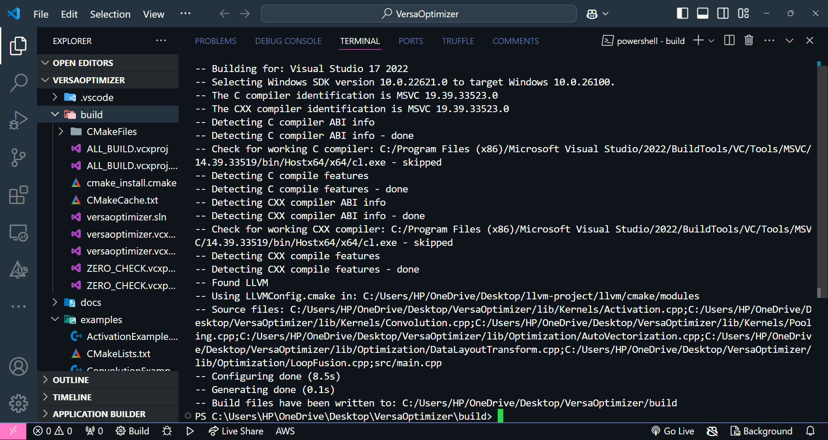

Fig: Output Image

**Chapter 7: Conclusion and Future work**

**7.1 Conclusion**

The VersaOptimizer project represents a significant step toward improving the performance and efficiency of AI model execution through advanced IR optimization techniques. By leveraging **LLVM**, **C++17**, and modern optimization strategies, VersaOptimizer demonstrates the ability to transform and optimize deep learning kernels represented as LLVM Intermediate Representation (IR) for efficient execution on CPUs and GPUs.

The system's modular architecture and optimization passes, such as **SIMD vectorization**, **loop fusion**, and **precision reduction**, aim to minimize computational overhead and reduce latency during AI inference. The testing and application of these transformation passes ensure that *VersaOptimizer* can effectively handle resource-intensive AI models while maintaining scalability and flexibility.

The successful implementation of key optimization techniques confirms the potential of LLVM-based optimization tools in improving AI model inference performance. The integration of optimization passes allows for a seamless transformation pipeline from IR to optimized machine code, paving the way for efficient real-time AI computations.

**7.2 Key Achievements**

* **Efficient Deep Learning Kernel Optimization:** Successfully optimized LLVM IR for deep learning kernels by implementing several key transformation passes.
* **Cross-Platform Support:** Utilized LLVM’s modular architecture to ensure compatibility with multiple hardware types such as CPUs and GPUs.
* **Modular Optimization Pipeline:** Designed a series of passes focusing on memory management, SIMD vectorization, loop fusion, and other optimization strategies to reduce computational latency.
* **Proof of Concept:** Established the feasibility of transforming AI models represented by LLVM IR into optimized, hardware-compatible machine code using modern LLVM capabilities.

**7.3 Future Work**

Although *VersaOptimizer* has demonstrated promising results, there are several opportunities to extend its capabilities and address additional challenges. The following areas represent potential directions for future research and development:

**1. Enhanced Support for More Architectures**

* Extend optimization capabilities beyond CPUs and GPUs to include specialized AI accelerators like TPUs and custom ASICs.
* Investigate compatibility with other hardware accelerators to support a broader range of execution environments.

**2. Dynamic Model Adaptation**

* Incorporate real-time profiling to enable *VersaOptimizer* to dynamically adapt optimization strategies based on runtime hardware characteristics or changing computational loads.
* Investigate reinforcement learning or heuristic-driven optimization techniques to improve adaptability.

**3. Integration with Modern AI Frameworks**

* Develop seamless interfaces with popular deep learning frameworks like TensorFlow, PyTorch, and ONNX to allow automatic IR conversion and optimization without requiring manual intervention.
* Streamline the end-to-end pipeline, from high-level model definitions (in PyTorch/TensorFlow) to optimized machine execution via *VersaOptimizer*.

**4. Real-Time Profiling and Debugging Tools**

* Build visualization and debugging tools that allow users to inspect the optimization transformations and debug inefficiencies in optimized models.
* Allow users to monitor computational performance and inspect intermediate states in IR transformations.

**5. Security & Reliability Enhancements**

* Focus on robustness and error detection in optimization passes to prevent unintended optimizations that could degrade model performance or reliability.
* Ensure that transformations maintain AI model correctness while optimizing execution times.

**6. AI-Driven Optimization Strategies**

* Explore AI and machine learning techniques to optimize passes or suggest alternative transformations based on historical performance metrics.
* Use machine learning models to dynamically learn the best IR transformation paths based on empirical data from previous optimizations.

**7.4 Final Thoughts**

The VersaOptimizer project has laid the groundwork for a robust AI optimization framework that uses LLVM's power to streamline the execution of AI models across diverse hardware architectures.

The future work will focus on extending the current system's versatility, scalability, and adaptability to ensure it can support the growing demands of AI model inference workloads, including real-time inference, edge computing, and hardware heterogeneity.

By exploring these future directions, *VersaOptimizer* has the potential to become a versatile, end-to-end optimization platform for AI models, from high-level abstractions down to hardware-efficient machine code execution.

**Chapter 8: References**

1. Large Language Models for Compiler Optimization - <https://arxiv.org/pdf/2309.07062>

2. The Deep Learning Compiler: A Comprehensive Survey - <https://arxiv.org/pdf/2002.03794>

3. MLGO: a Machine Learning Guided Compiler Optimizations Framework <https://arxiv.org/pdf/2101.04808>

4. AI Powered Compiler Techniques for DL Code Optimization - <https://arxiv.org/pdf/2104.05573>

5. LLVM Project - <https://github.com/llvm/llvm-project>

6. Apache TVM - <https://github.com/apache/tvm>

7. Dive into Deep learning Compiler - <https://tvm.d2l.ai/>

8. Machine Learning in Compiler Optimization <https://www.research.ed.ac.uk/files/70048258/Machine_Learning_in_compiler_optimisation.pdf>

9. Using Machine Learning in Order to Improve Automatic SIMD Instruction Generation - <https://www.sciencedirect.com/science/article/pii/S1877050913004390>

10. MLIR: A Compiler Infrastructure for the End of Moore's Law - <https://arxiv.org/pdf/2002.11054>

11. MLGOPerf: An ML Guided Inliner to Optimize Performance - <https://arxiv.org/pdf/2207.08389>

12. Glow - <https://github.com/pytorch/glow>