Steps to run api;

---------------------------------------------------  
1. First step the project in your local

2. Run **php artisan migrate**

3. Run **php artisan db:seed**

**First API to get all available window slots for select event and date**

Method: **GET**

Api: **schedulabl/events/{event_id}/slots.json**

Param: **date**

Sample request => **schedulabl/events/1/slots.json?date=2021-05-22**

**API Success Response:**

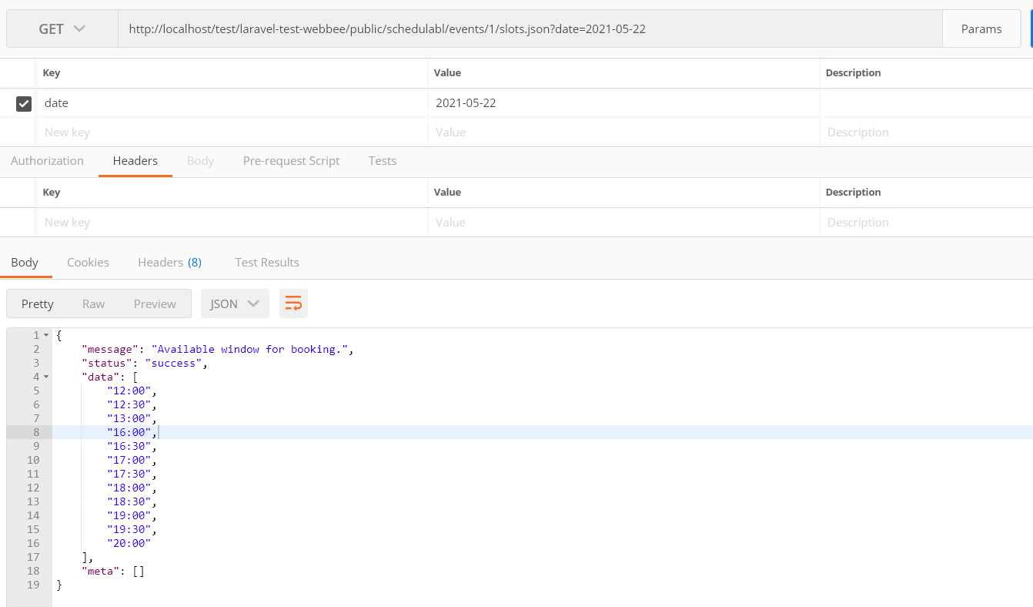

Second API to book available window for user.

Method: **POST**

Api: **book/schedule/event**

Param: **slot,date,email,last_name,first_name**

Sample request => **book/events/{eventId}/slot**

**{"slot":"15:19","date":"2021-05-22","email":" Saurabh@ Dwivedi.com","last_name":"Dwivedi","first_name":"Saurabh"}**

**API Success Response:**

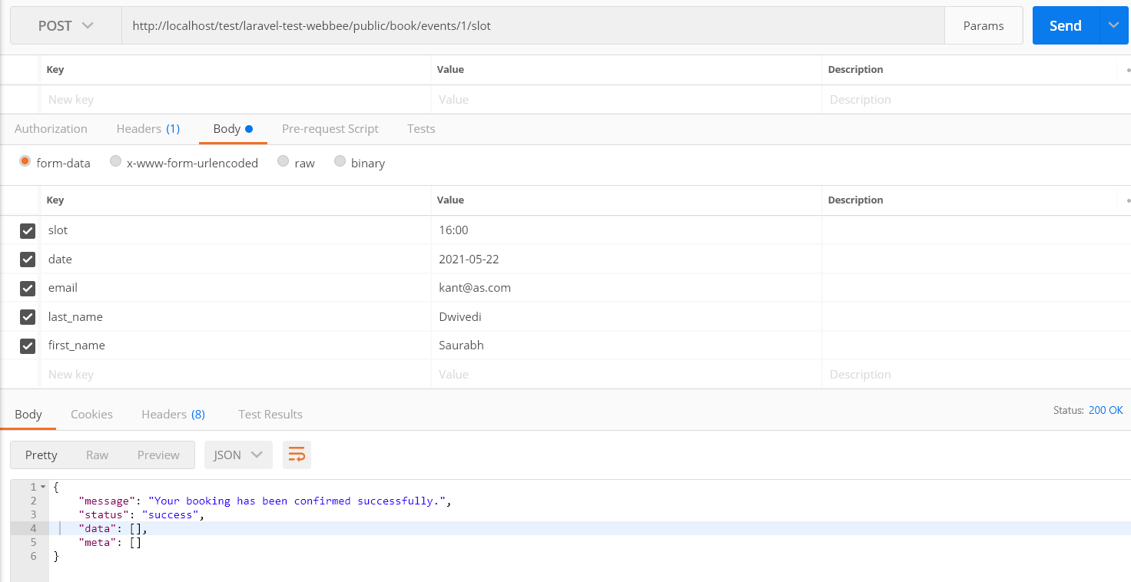

Api Request error:

