Question1:

Step1:Lounching

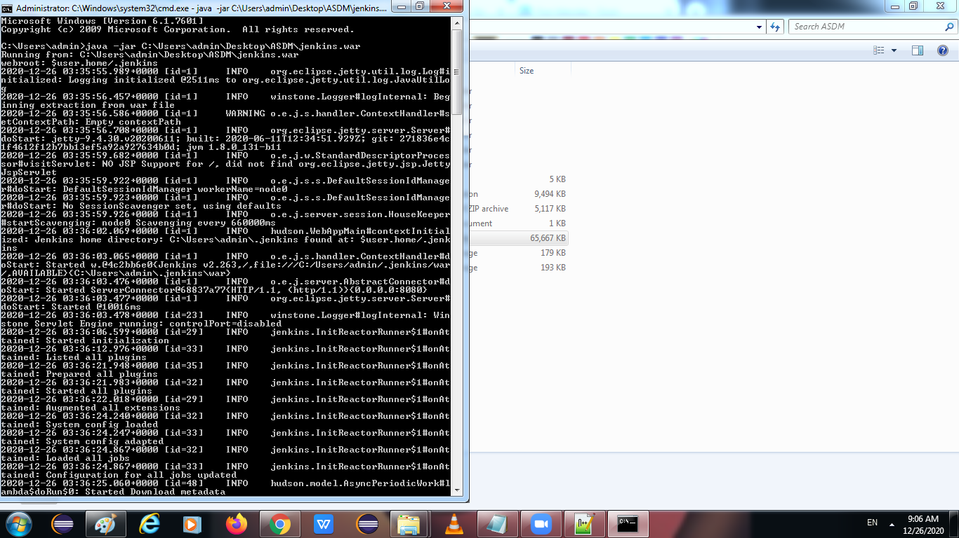

Step2:

Freestyle Project

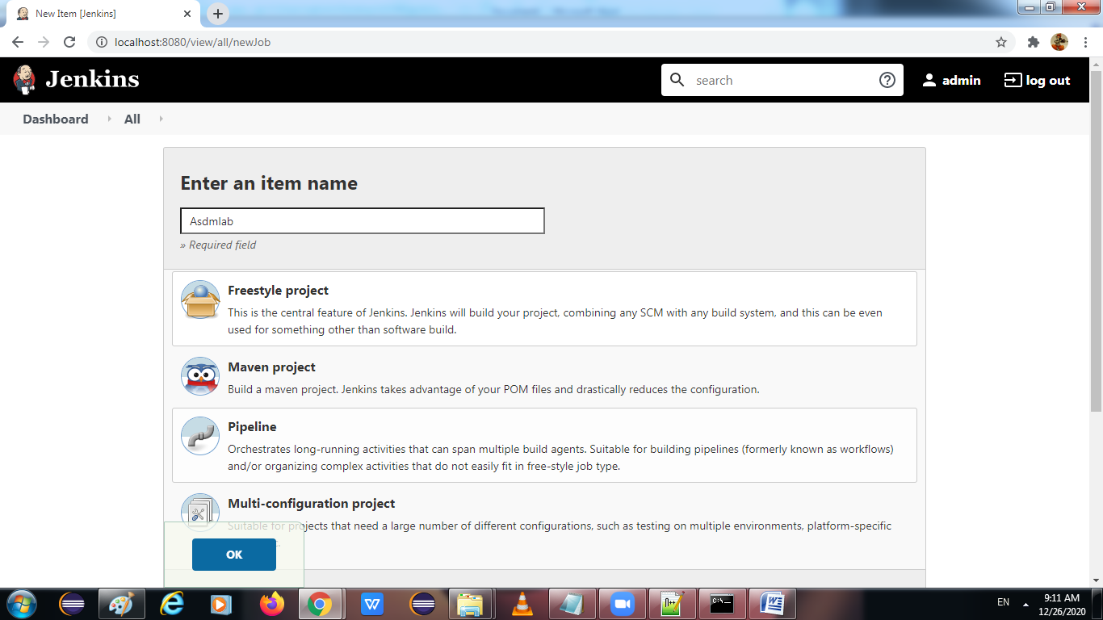

Step 3:

New item->Crete a maven project->ok

Give pom.xml file location in build

In manage maven->

Give jdk and maven version

Apply

Build the project

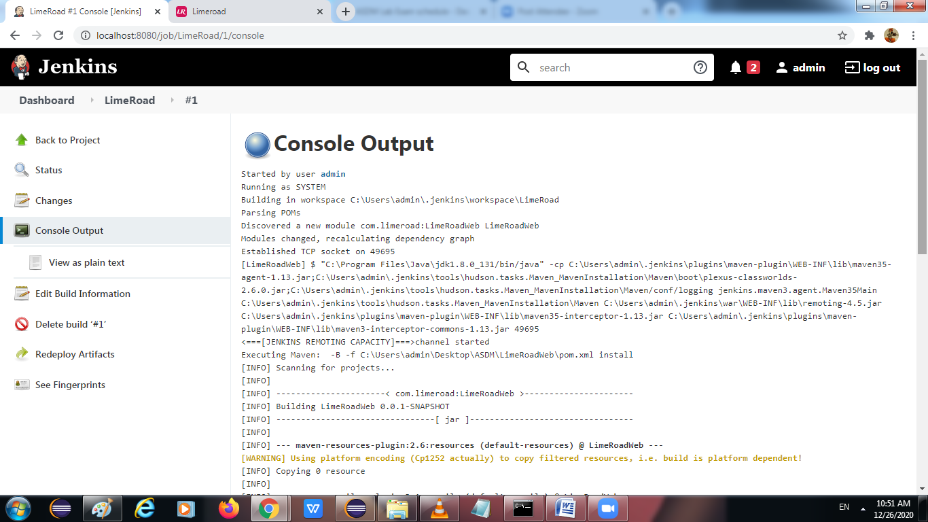

**********************************Question2******************************************

**import** org.openqa.selenium.By;

**import** org.openqa.selenium.WebDriver;

**import** org.openqa.selenium.chrome.ChromeDriver;

**public** **class** LimeRoad {

**public** **static** **void** main(String[] args) **throws** InterruptedException {

System.*setProperty*("webdriver.chrome.driver","C:\\Users\\admin\\Desktop\\ASDM\\chromedriver.exe");

WebDriver driver=**new** ChromeDriver();

driver.get("https://www.limeroad.com/");

driver.manage().window().maximize();

driver.findElement(By.*xpath*("//*[@id=\"shopMen\"]/span")).click();

driver.findElement(By.*xpath*("//*[@id=\"srcInpu\"]"));

//driver.findElement(By.name("search")).click();

Thread.*sleep*(2000);

//driver.close();

}

}

Step1:

Open the Limeroad website

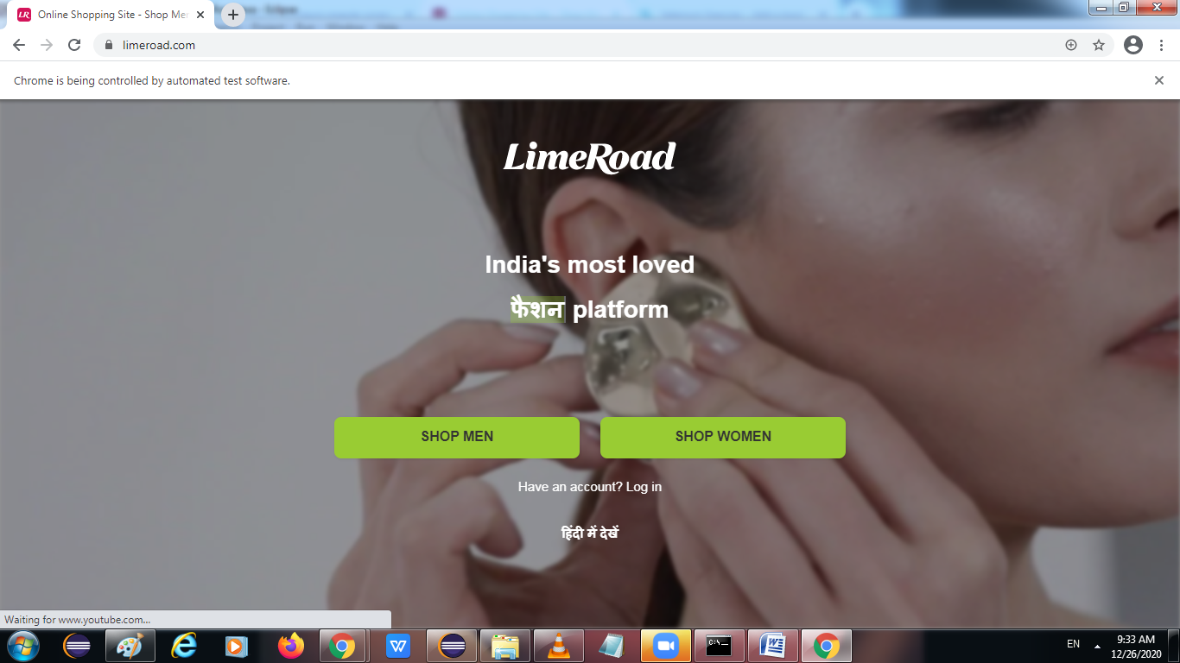

Step2:

After selecting men

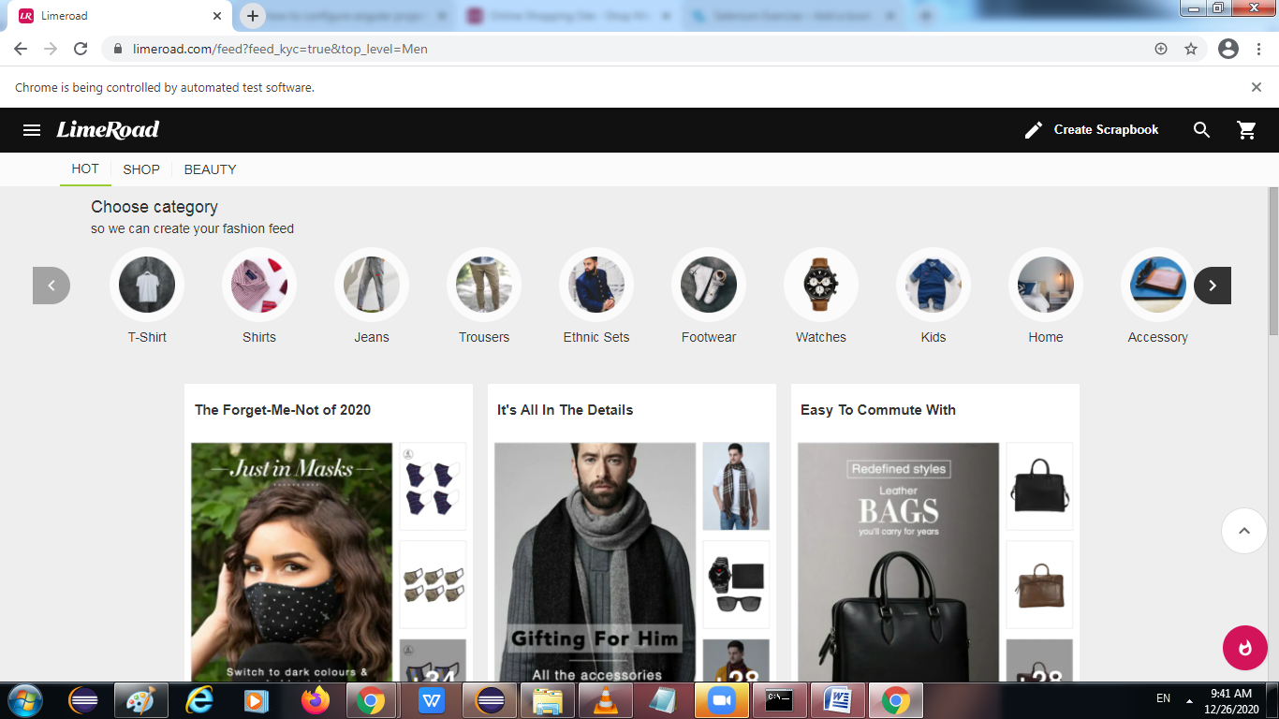

Step3: