Header > navBar = logo, search bar(center), Home, recipes, fav li, dark mode

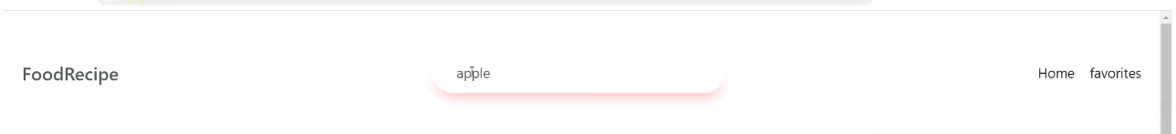

just below nav various categories

<main>
home page from angle brace
various random food items
api – geekProbin
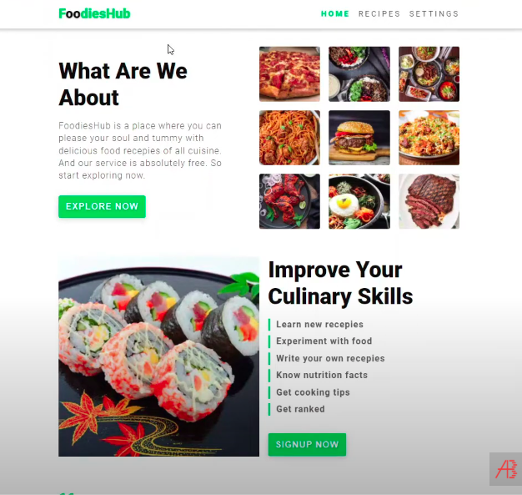

</main>

<footer />

