|  |  |
| --- | --- |
| Student Name | Saurabh Khodke |
| SRN No | 202200497 |
| Roll No | 33 |
| Program | Computer Engg |
| Year | Third Year |
| Division | B |
| Subject | Computer Network Laboratory (BTECCE22506) |
| Assignment No | Eight |

Assignment Number - 08

**Title :** Installation and configuration of DHCP server for Linux/Windows.

**Problem Statement :** Configure a server with Dynamic Host Configuration Protocol (DHCP). Connect different nodes with DHCP server and show that all nodes autoconfigure with DHCP.

**Theory :**

DHCP stands for Dynamic Host Configuration Protocol. It is the critical feature on which the users of an enterprise network communicate. DHCP helps enterprises to smoothly manage the allocation of IP addresses to the end-user clients’ devices such as desktops, laptops, cellphones, etc. is an application layer protocol.

DHCP helps in managing the entire process automatically and centrally. DHCP helps in maintaining a unique IP Address for a host using the server. DHCP servers maintain information on TCP/IP configuration and provide configuration of address to DHCP-enabled clients in the form of a lease.

**How DHCP works**

DHCP runs at the application layer of the TCP/IP stack. It dynamically assigns IP addresses to DHCP clients and allocates TCP/IP configuration information to DHCP clients. This information includes subnet mask information, default gateway IP addresses and domain name system (DNS) addresses.

DHCP is a client-server protocol in which servers manage a pool of unique IP addresses, as well as information about client configuration parameters. The servers then assign addresses out of those address pools. DHCP-enabled clients send a request to the DHCP server whenever they connect to a network.

Clients configured with DHCP broadcast a request to the DHCP server and request network configuration information for the local network to which they're attached. A client typically broadcasts a query for this information immediately after booting up. The DHCP server responds to the client request by providing IP configuration information previously specified by a network administrator. This includes a specific IP address, as well as a time period -- also called a lease -- for which the allocation is valid.

When refreshing an address assignment, a DHCP client requests the same parameters, but the DHCP server may assign a new IP address based on policies set by administrators. DHCP clients can also be configured on an Ethernet interface.

**DHCP SERVER with one ethernet Port**

DHCP SERVER with one port for LAN.

**Figure :DHCP service configuration**

**Runtime Simulation:**

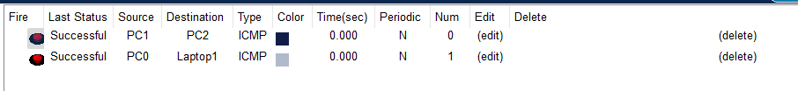

**Conclusion:**

In this assignment, we successfully demonstrated the installation and configuration of a Dynamic Host Configuration Protocol (DHCP) server on both Linux and Windows platforms. By setting up a DHCP server, we were able to automate the IP address assignment process and configure various network parameters for client devices on the network.