­­

|  |  |
| --- | --- |
| Student Name | Saurabh Khodke |
| SRN No | 2022004975 |
| Roll No | 33 |
| Program | Computer Eng. |
| Year | Third Year |
| Division | B |
| Subject | Computer Network Laboratory (BTECCE22506) |
| Assignment No | Three |

Assignment Number - 03

**Title :** Using a Network Simulator (e.g. packet tracer) Configure subnetting and supernetting

**Problem Statement** Studying the concept of Subnetting and Supernetting along with its implementation

Using cisco Packet Tracer.

**Theory :**

**Subnetting**

Subnetting is the process of dividing a larger network into smaller, more manageable sub-networks or subnets. This technique improves network performance, security, and efficiency by limiting broadcast domains and managing IP address allocation more effectively. For example, if an organization has a Class C IP address range (e.g., 192.168.1.0/24) with 254 available IP addresses, subnetting can divide this network into smaller subnets, such as four subnets with 62 hosts each (using subnet masks like 255.255.255.192). This allows different departments or groups within the organization to have their own subnets, improving network traffic management and isolating network segments for better security.

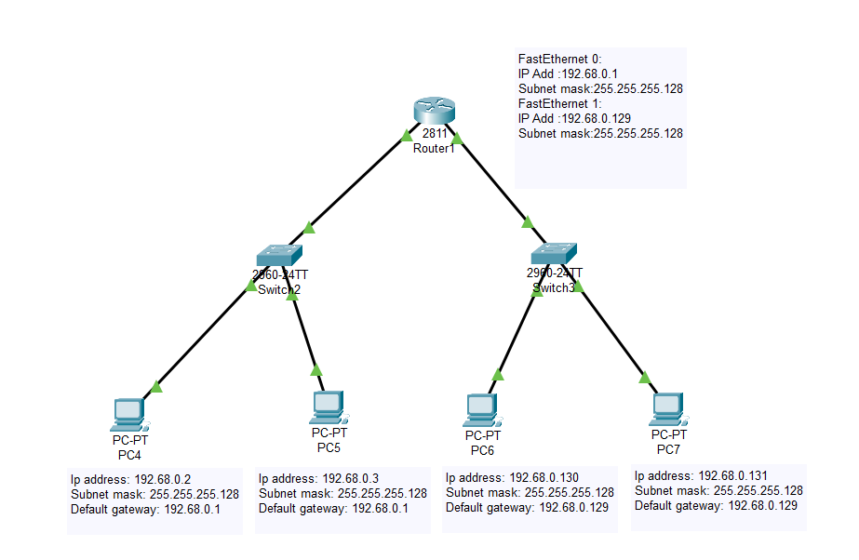

**Supernetting**

Supernetting, also known as route aggregation, is the opposite of subnetting; it combines multiple smaller networks (subnets) into a larger, single network. This technique is commonly used in network routing to reduce the size of routing tables, thereby improving efficiency and performance in larger networks like those of Internet Service Providers (ISPs). For instance, if an ISP manages four contiguous Class C networks (e.g., 192.168.1.0/24, 192.168.2.0/24, 192.168.3.0/24, and 192.168.4.0/24), supernetting can merge them into a single Class B network (e.g., 192.168.0.0/22) using a supernet mask of 255.255.252.0. This reduces the number of individual routes that need to be managed, simplifying network management.

**Conclusion :**

Both subnetting and supernetting are crucial techniques in network design and management. Subnetting divides a large network into smaller subnets to enhance performance, security, and efficient IP address utilization, while supernetting aggregates multiple smaller networks into a larger one to simplify routing and reduce the complexity of routing tables. Understanding these concepts allows network administrators to optimize network performance and effectively manage IP resources.