



|  |  |
| --- | --- |
| **Student Name** | **Saurabh Khodke** |
| **SRN No** | 202200497 |
| **Roll No** | 33 |
| **Program** | Computer Engg. |
| **Year** | Third Year |
| **Division** | B |
| **Subject** | Computer Network Laboratory (BTECCE22506) |
| **Assignment No** | Four |



Assignment Number - 04

**Title :** Configuration of router by using router commands and implementation of static routing

**Problem Statement** Using a Network Simulator (e.g. packet tracer) Configure routers for static routing

# Theory :

**Router –** Router is a network device that allows you to direct data traffic to an appropriate destination. Router maintain routing table that contain IP addresses of computers over the network. A router has different components that enable proper functioning.

# Cisco IOS supports various command modes, among those followings are the main command modes.

* User EXEC Mode
* Privileged EXEC Mode
* Global Configuration Mode
* Interface Configuration Mode
* Sub Interface Configuration Mode
* Setup Mode

|  |  |  |  |
| --- | --- | --- | --- |
| **Mode** | **Prompt** | **Command to enter** | **Command to exit** |
| User EXEC | Router > | Default mode after booting. Login | Use **exit** command |
| Privileged EXEC | Router # | Use **enable** command from user  exec mode | Use **exit** command |
| Global Configuration | Router(config)# | Use **configure terminal**  command | Use **exit** command |
| Interface Configuration | Router(config- if)# | Use **interface**  **type *number*** command from  global configuration mode | Use **exit** command to  return in global configuration |
| Sub-Interface  Configuration | Router(config- subif) | Use **interface type *sub interface***  ***number***command from global configuration mode or interface configure mode | Use **exit** to return  previous mode. Use **end** command to return in privileged |

# Some important router Command

|  |  |
| --- | --- |
| **Command** | **Description** |
| Router(config)#interface serial 0/0/0 | Enter into serial interface 0/0/0 |
| Router(config- Connecte to interface | Optional command. It set description on  interface that is locally significant |
| Router(config-if)#ip address 10.0.0.1  255.0.0.0 | Assigns address and subnet mask to |
| Router(config-if)#clock rate 64000 | DCE side only command. Assigns a clock |
| Router(config-if)#bandwidth 64 | DCE side only command. Set bandwidth for |
| Router(config-if)#no shutdown | Turns interface on |

**Configuration of static Routing**

# Code

**Basic Router Configuration – Static Routing**

**Router 1 Configuration**

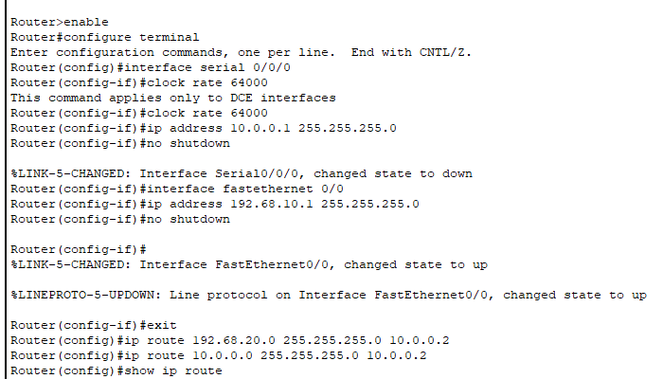

**Router2 Configuration**

**Runtime Simulation:**

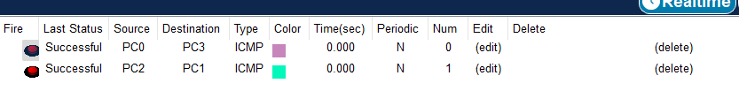

**Conclusion :** In conclusion, configuring static routing with two routers in a computer network provides a fundamental understanding of routing mechanisms. Through this setup, we were able to manually define routes between different network segments, ensuring proper communication across the routers. Static routing, while simple and reliable in small-scale networks, has limitations in scalability and adaptability to network changes. This exercise helped solidify concepts such as routing tables, next-hop addresses, and the flow of packets between routers. However, for larger and more dynamic networks, dynamic routing protocols would offer greater flexibility and efficiency.