NAME: Ruchir M. Adnaik

Roll: 08

Div: B

Srn: 202200282

DWDM LAB

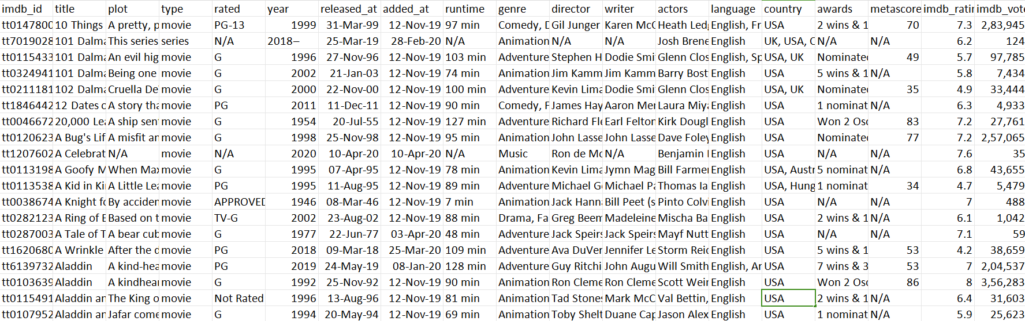

**FACTS AND DIMENSIONS:**

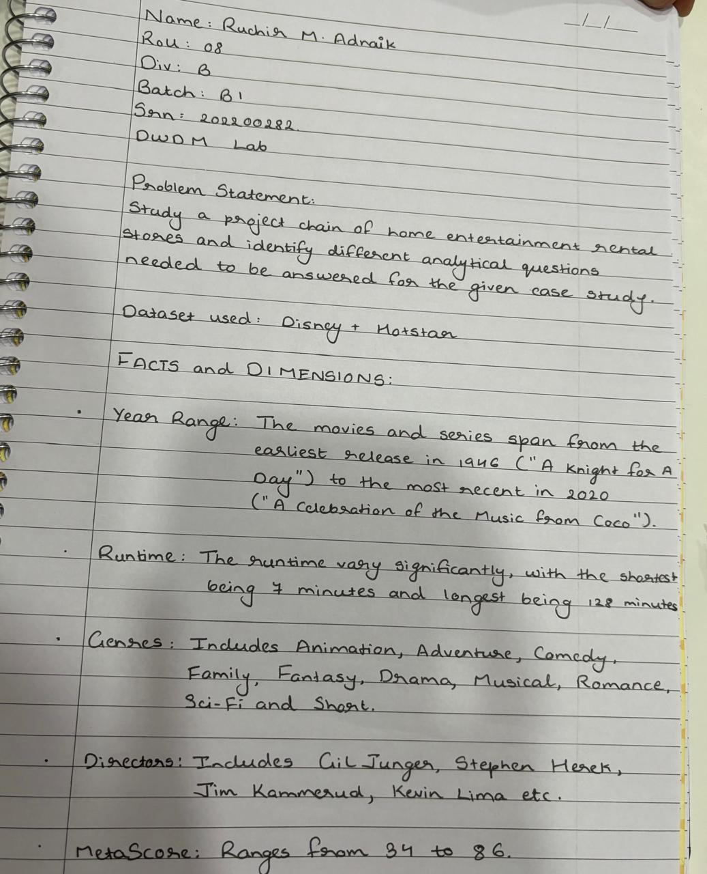

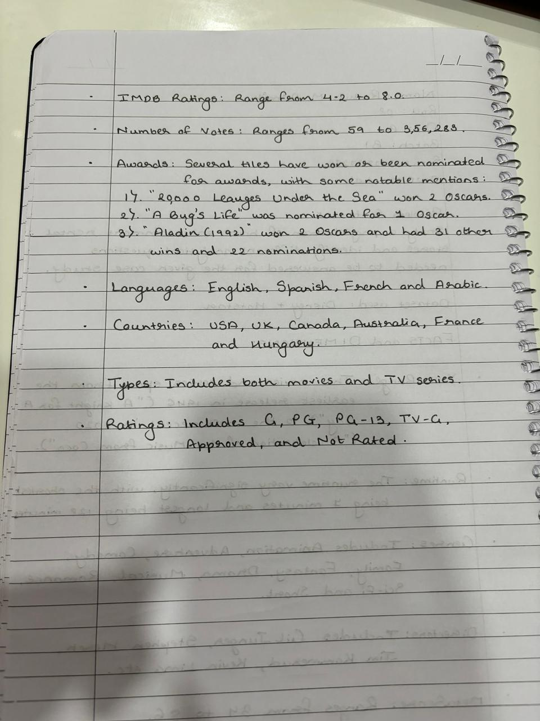

**QUESTIONS AND ANSWERS:**

