Ruchir Adnaik

202200282

8 B1

DWDM 3

1)Draw the star schema(s) showing the main attributes, including primary keys, foreign keys, and facts.

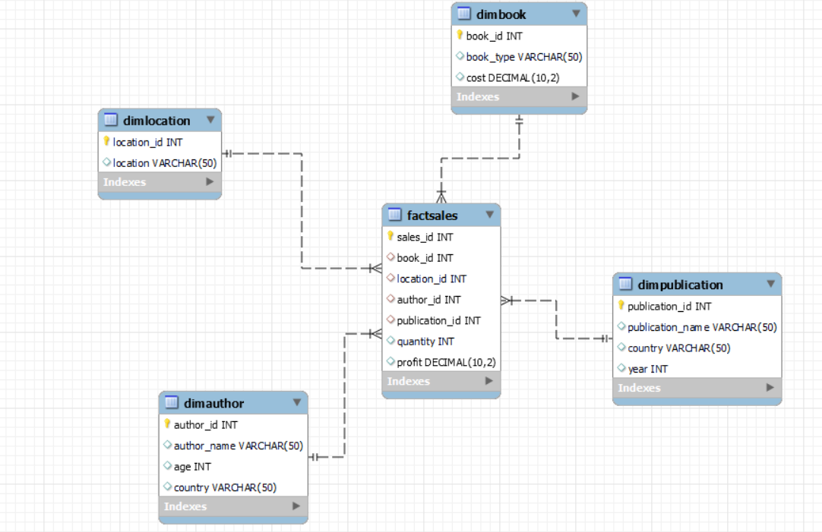

2) Insert appropriate values in the database. Write SQL statements that runs on your schema and returns the quantity and profit made per book type, location, author, and publication.

INSERT INTO DimBook (book_id, book_type, cost) VALUES

(11, 'Fiction', 10.00),

(12, 'Non-Fiction', 12.00),

(13, 'Science', 15.00),

(4, 'Fantasy', 8.00),

(5, 'History', 20.00),

(6, 'Biography', 18.00),

(7, 'Mystery', 11.00),

(8, 'Romance', 9.00),

(9, 'Thriller', 14.00),

(10, 'Children', 7.00);

INSERT INTO DimLocation (location_id, location) VALUES

(4, 'Sydney'),

(5, 'Paris'),

(6, 'Berlin'),

(7, 'Toronto'),

(8, 'San Francisco'),

(9, 'Rome'),

(10, 'Dubai');

INSERT INTO DimAuthor (author_id, author_name, age, country) VALUES

(11, 'J.K. Rowling', 55, 'UK'),

(12, 'George Orwell', 46, 'UK'),

(13, 'Isaac Asimov', 72, 'USA'),

(4, 'J.R.R. Tolkien', 81, 'UK'),

(5, 'Stephen King', 73, 'USA'),

(6, 'Jane Austen', 41, 'UK'),

(7, 'Agatha Christie', 85, 'UK'),

(8, 'Mark Twain', 74, 'USA'),

(9, 'Ernest Hemingway', 61, 'USA'),

(10, 'Dr. Seuss', 87, 'USA');

INSERT INTO DimPublication (publication_id, publication_name, country, year) VALUES

(11, 'Penguin Random House', 'USA', 1925),

(12, 'HarperCollins', 'USA', 1989),

(13, 'Simon & Schuster', 'USA', 1924),

(4, 'Hachette Livre', 'France', 1826),

(5, 'Macmillan Publishers', 'UK', 1843),

(6, 'Pearson', 'UK', 1844),

(7, 'Scholastic', 'USA', 1920),

(8, 'McGraw-Hill', 'USA', 1888),

(9, 'Cengage Learning', 'USA', 2007),

(10, 'Oxford University Press', 'UK', 1586);

INSERT INTO FactSales (sales_id, book_id, location_id, author_id, publication_id, quantity, profit) VALUES

(11, 11, 11, 11, 11, 100, 1000.00),

(12, 12, 12, 12, 12, 200, 2400.00),

(13, 13, 13, 13, 13, 150, 2250.00),

(4, 4, 4, 4, 4, 120, 960.00),

(5, 5, 5, 5, 5, 80, 1600.00),

(6, 6, 6, 6, 6, 90, 1620.00),

(7, 7, 7, 7, 7, 130, 1430.00),

(8, 8, 8, 8, 8, 110, 990.00),

(9, 9, 9, 9, 9, 140, 1960.00),

(10, 10, 10, 10, 10, 200, 1400.00);

