Name: Ruchir M. Adnaik

Srn: 202200282

Roll: 08

Batch: B1

DWDM ASSIGNMENT 05

Code:

**1)Make a star schema for hospital management system.**

create database DWDM_assig5;

use DWDM_assig5;

CREATE TABLE Dim_Patient (

Patient_ID INT PRIMARY KEY AUTO_INCREMENT,

First_Name VARCHAR(50),

Last_Name VARCHAR(50),

DOB DATE,

Gender VARCHAR(10),

Address VARCHAR(255),

Contact_Info VARCHAR(50),

Insurance_Provider VARCHAR(100),

Policy_Number VARCHAR(50)

);

CREATE TABLE Dim_Doctor (

Doctor_ID INT PRIMARY KEY AUTO_INCREMENT,

First_Name VARCHAR(50),

Last_Name VARCHAR(50),

Specialization VARCHAR(100),

Department VARCHAR(100),

Contact_Info VARCHAR(50)

);

CREATE TABLE Dim_Service (

Service_ID INT PRIMARY KEY AUTO_INCREMENT,

Service_Type VARCHAR(50),

Room_Number INT,

Bed_Number INT

);

CREATE TABLE Dim_Medication (

Medication_ID INT PRIMARY KEY AUTO_INCREMENT,

Drug_Name VARCHAR(100),

Dosage VARCHAR(50),

Frequency VARCHAR(50),

Start_Date DATE,

End_Date DATE

);

CREATE TABLE Dim_Date (

Date_Key INT PRIMARY KEY AUTO_INCREMENT,

Full_Date DATE,

Day INT,

Month INT,

Year INT

);

CREATE TABLE Dim_Date (

Date_Key INT PRIMARY KEY AUTO_INCREMENT,

Full_Date DATE,

Day INT,

Month INT,

Year INT

);

CREATE TABLE Fact_Treatment (

Treatment_ID INT PRIMARY KEY AUTO_INCREMENT,

Patient_ID INT,

Doctor_ID INT,

Service_ID INT,

Diagnosis_ID INT,

Medication_ID INT,

Date_Key INT,

Cost DECIMAL(10, 2),

Insurance_Claim DECIMAL(10, 2),

Amount_Paid DECIMAL(10, 2),

FOREIGN KEY (Patient_ID) REFERENCES Dim_Patient(Patient_ID),

FOREIGN KEY (Doctor_ID) REFERENCES Dim_Doctor(Doctor_ID),

FOREIGN KEY (Service_ID) REFERENCES Dim_Service(Service_ID),

FOREIGN KEY (Medication_ID) REFERENCES Dim_Medication(Medication_ID),

FOREIGN KEY (Date_Key) REFERENCES Dim_Date(Date_Key)

);

OUTPUT:

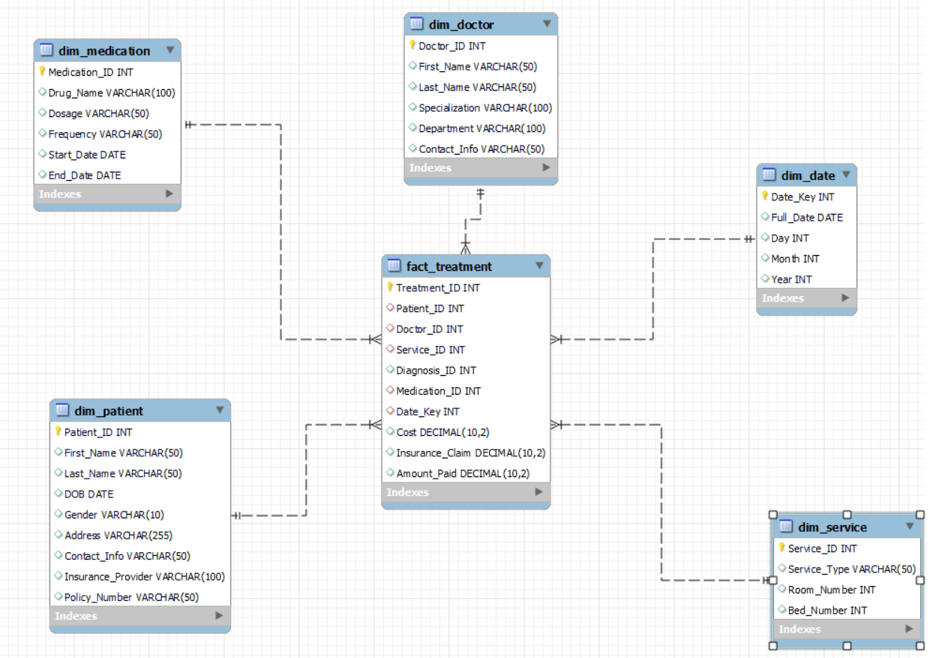

**2) Make a snowflake schema for hospital management system.**

To make this we just have to add few more queries in to main queries.

CREATE TABLE Dim_Specialization (

Specialization_ID INT PRIMARY KEY AUTO_INCREMENT,

Specialization_Name VARCHAR(100)

);

ALTER TABLE Dim_Doctor

ADD COLUMN Specialization_ID INT,

ADD FOREIGN KEY (Specialization_ID) REFERENCES Dim_Specialization(Specialization_ID);

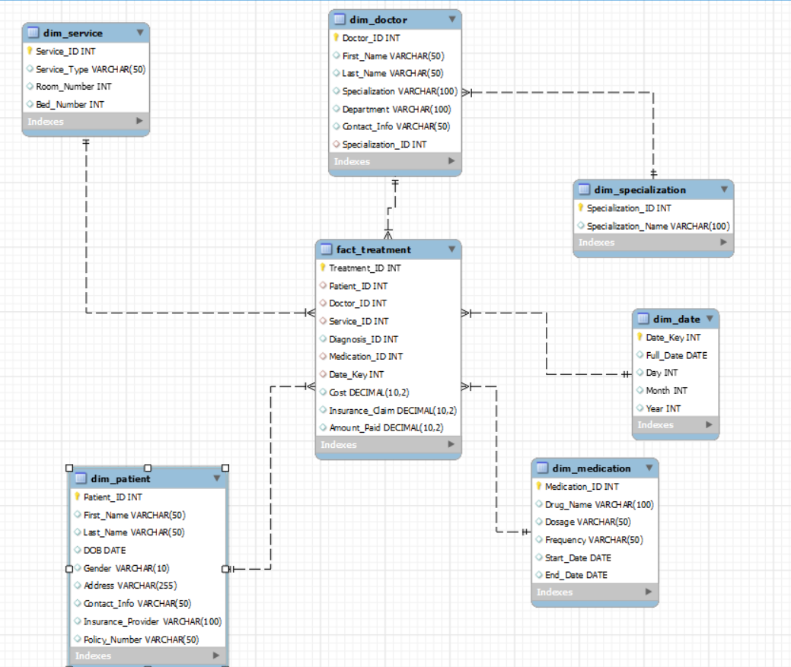

**3) Make a galaxy schema for hospital management system.**

CREATE TABLE Fact_Appointment (

Appointment_ID INT PRIMARY KEY AUTO_INCREMENT,

Patient_ID INT,

Doctor_ID INT,

Date_Key INT,

Appointment_Status VARCHAR(50),

Appointment_Cost DECIMAL(10, 2),

FOREIGN KEY (Patient_ID) REFERENCES Dim_Patient(Patient_ID),

FOREIGN KEY (Doctor_ID) REFERENCES Dim_Doctor(Doctor_ID),

FOREIGN KEY (Date_Key) REFERENCES Dim_Date(Date_Key)

);

-- Connect Fact_Appointment to Dim_Patient

ALTER TABLE Fact_Appointment

ADD CONSTRAINT fk_patient FOREIGN KEY (Patient_ID)

REFERENCES Dim_Patient(Patient_ID);

-- Connect Fact_Appointment to Dim_Doctor

ALTER TABLE Fact_Appointment

ADD CONSTRAINT fk_doctor FOREIGN KEY (Doctor_ID)

REFERENCES Dim_Doctor(Doctor_ID);

-- Connect Fact_Appointment to Dim_Date

ALTER TABLE Fact_Appointment

ADD CONSTRAINT fk_date FOREIGN KEY (Date_Key)

REFERENCES Dim_Date(Date_Key);

