**Saurabh Korade**

**Assignment 1 Report**

**Summary:**

In C using pthreads, I have implemented the Monte Carlo integration for function sin(x)/x. Following is the implemented formula for the Monte Carlo basic estimator

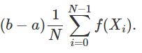

The code accepts a, b, N(number of samples), n(number of threads) as inputs and generates the output for

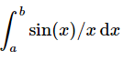

**Logic:**

1. I divide the range (a to b) and number of samples(N) into equal intervals of number of threads
2. Perform n_threads number of small integrations over the new range and number of samples.
3. I have used drand48_r() to generate random values as the function is thread safe and pseudo-random.
4. After computing several different integrals, I finally aggregate all of them to find the result.

Following are the graphs for efficiency and speedup.

