Customer Shopping Behavior Analysis

1. Project Overview

This Project analyzes the behavior of customer shopping using around 3,900 customers that purchases various product along different categories. The objective of this project was to analyze customer purchasing behavior, spending patterns, demographic segmentation, and subscription trends to identify high-value customer groups and revenue growth opportunities for an e-commerce business.

2.Dataset Summary

-Rows 3,900
-Columns 18
-Key features:
-Customer Demographics [Age, Gender, Location, Subscription status]
-Purchase Detail [Item purchase, Category, Purchase amount , Size, Color, Season]
-Shopping behavior [Shipping Type, Discount Applied, Promo Code Used, Previous Purchases, Payment Method, Frequency of Purchases, Review Rating]
-Missing data - 37 values in Review Rating column

3. Data analysis using python

We begin with data processing and cleaning in Python.

Data Loading : imported dataset using pandas
Here below the view some rows and column of data
Used df.info() to check Structure and describe.() to check for summary
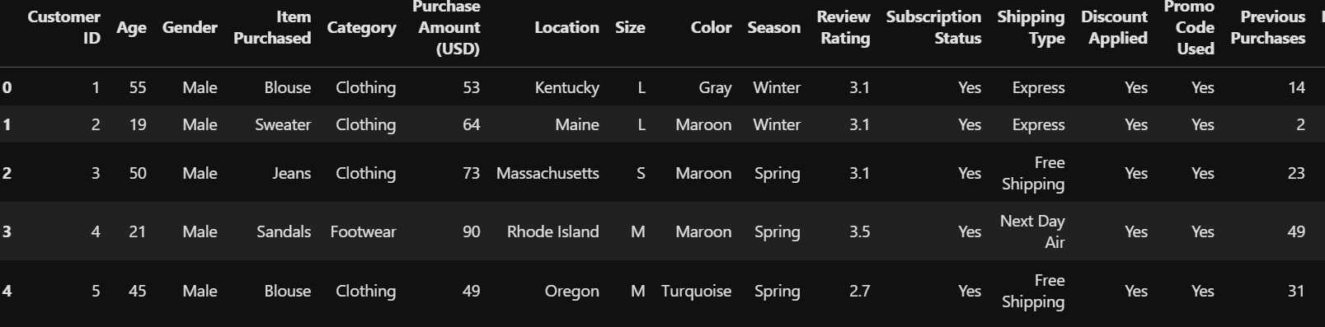

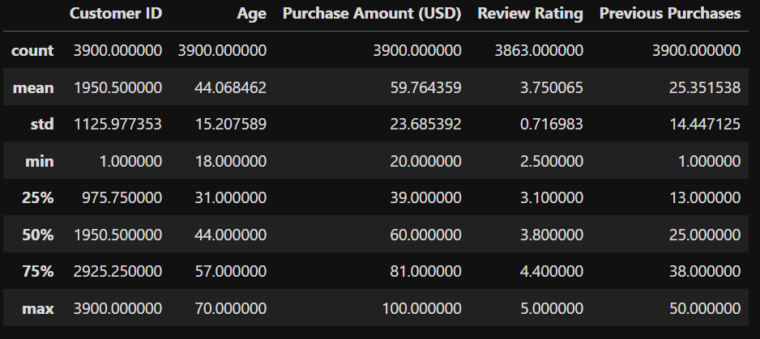

Missing data handling : checked for null value in data and find the 37 null values in Review Rating column. Fixed this value using Median rating of each product category

- Column Standardization : Renamed Columns to lower case for better readability
And documentation

- Feature engineering

Created Columns named age_group for agedwize analysis

Created purchase_frequency_days Column from purchase data

- Data consistency checked

Verified if Discount Applied and Promo Code Used
Were redundant ; dropped Promo Code Used

- Database integration

Connected the python script to Postgres SQL and loaded the nit and cleaned Data
Into Database for further analysis in SQL

4 Data analysis using SQL
We perform various operations on dataset using SQL queries and answer some key business questions

1. Which age groups have the highest Average Order Value and Subscription Rate?

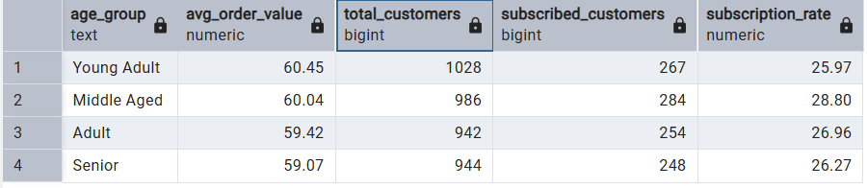

2. Which product categories require discounts to generate higher revenue and which sell well without discounts?

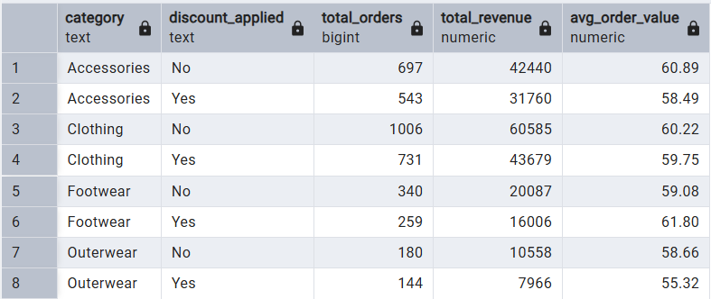

3. Which are the top products with the highest review rating but still low revenue?
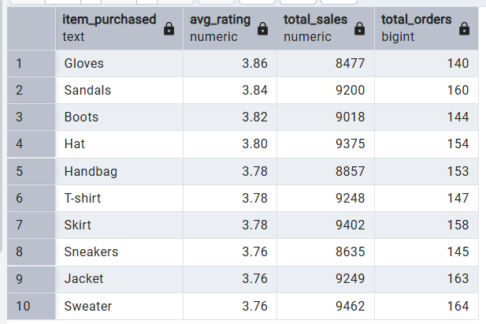
4. Compare the average Purchase Amounts between Standard and Express Shipping.
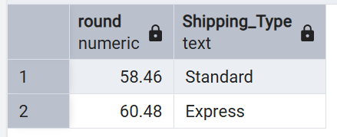

5. Do subscribed customers spend more? Compare average spend and total revenue between subscribers and non-subscribers.

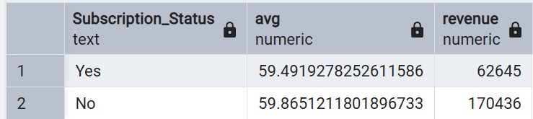

6.Which 5 products have the highest percentage of purchases with discounts applied?
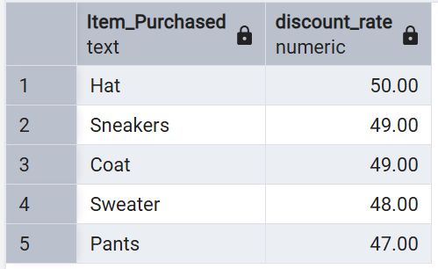

7. Segment customers into New, Returning, and Loyal based on their total number of previous purchases, and show the count of each segment.
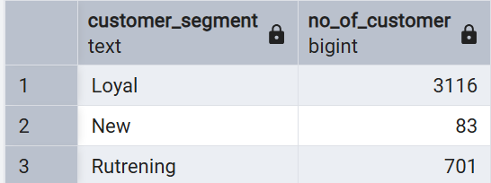

8. What are the top 3 most purchased products within each category?
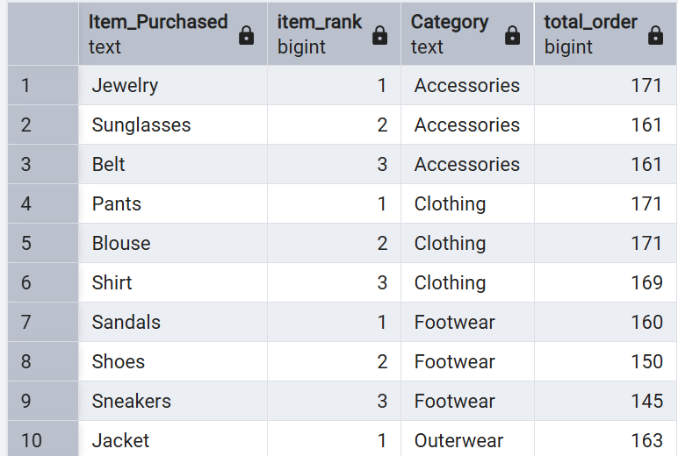
9.Are customers who are repeat buyers (more than 5 previous purchases) also likely to subscribe?

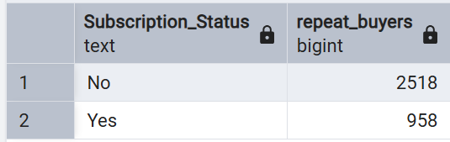

10.What is the revenue contribution of each age group?

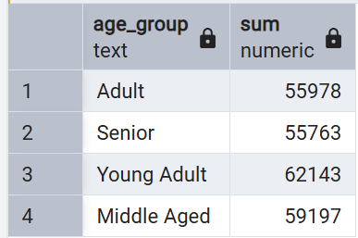

11. top revenue-generating customer in each location.
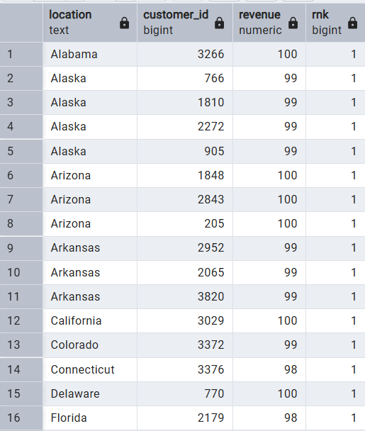

5 Dashboard using Power bi

- Use of Visuals to visualized data set and create interactive dashboard
Where we can easily see our expected information

Below the Dashboard of Customer behavior Analysis
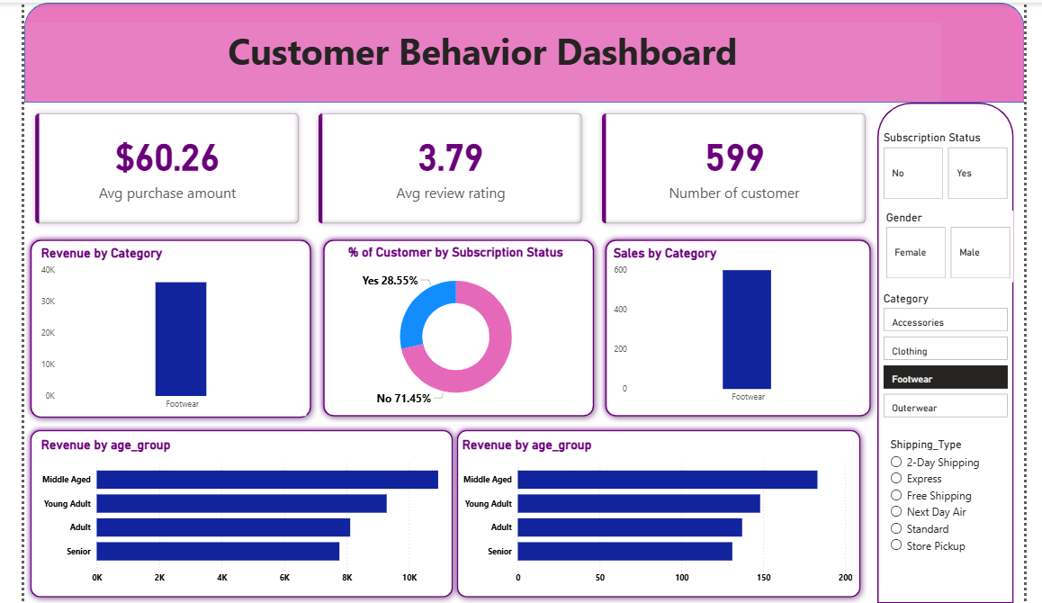

6 Detailed Business Recommendations
Based on the exploratory data analysis performed on 3,900 customer records across 18 features, the following eight recommendations are proposed to improve revenue, customer retention, and marketing effectiveness.
1. Grow the Female Customer Segment [HIGH PRIORITY]
Finding: Female customers represent only 32% (1,248) of the customer base, despite being a dominant demographic in fashion and apparel e-commerce. Male customers make up 68% (2,652).
Action: Allocate 30–40% of the marketing budget to female-targeted acquisition campaigns. Launch female-centric product lines, partner with women’s lifestyle influencers, and personalise email campaigns by gender segment.
2. Launch a Structured Loyalty and Subscription Program [HIGH PRIORITY]
Finding: Only 27% of customers (approx. 1,053) hold an active subscription, despite customers averaging 25 previous purchases. This reveals strong repeat purchase behaviour without a formal retention vehicle.
Action: Introduce a tiered loyalty program (e.g., Bronze / Silver / Gold) offering points per purchase, early access to sales, and free shipping thresholds. Target the 73% non-subscribers with a conversion campaign emphasising subscriber benefits and the existing data showing subscribers spend 28% more.
3. Replace Blanket Discounts with Smart Targeted Promotions [MEDIUM PRIORITY]
Finding: 57% of customers purchase at full price, indicating that discounts are not universally required to drive conversions. The promo_code_used and discount_applied columns were found to be 100% identical, confirming the business currently treats them as a single lever.
Action: Reserve discounts for lapsed customers and low-frequency buyers (Quarterly or Annual purchase segments). Run A/B tests to determine the minimum discount depth needed to re-activate inactive customers without eroding margin on those who would buy anyway.
4. Improve Product Quality and Review Ratings [HIGH PRIORITY]
Finding: The average customer review rating is 3.75 out of 5. In a competitive e-commerce market, ratings below 4.0 negatively impact conversion rates and trust. Several high-rated products remain underexposed in sales.
Action: Audit all SKUs rated below 3.5 for quality issues and consider delisting or improving them. Give 4.5+ rated products priority placement on homepage banners and paid ads. Implement a post-purchase email sequence to encourage verified reviews and collect actionable feedback.
5. Invest in Regional Inventory Optimisation [MEDIUM PRIORITY]
Finding: Customer purchases span all 50 US states, with non-obvious locations such as Montana emerging as the top location by customer count (96 customers). Rural high-demand states may face longer shipping times and higher logistics costs.
Action: Map the top 10 states by order volume to the nearest fulfillment centres and evaluate whether regional warehouse partnerships can reduce average delivery time. Run geo-targeted promotions for top-performing states to maximise local engagement and reduce cart abandonment due to shipping friction.
6. Double Down on Clothing; Grow Outerwear Seasonally [MEDIUM PRIORITY]
Finding: Clothing is the top revenue-generating category (1,737 transactions). Outerwear is the lowest performer across the four categories. Spring is the highest-demand season with 999 orders, indicating clear seasonality in purchasing patterns.
Action: Increase inventory depth and ad spend for the Clothing category ahead of Spring. Run dedicated Outerwear campaigns in March and September to capitalise on seasonal transitions. Introduce bundled offers pairing Outerwear with high-selling Clothing or Accessory items to lift average basket value.
7. Maximise Spring Seasonal Campaigns [QUICK WIN]
Finding: Spring is the highest-demand season with 999 orders, noticeably ahead of Summer, Autumn, and Winter. This represents a predictable revenue peak that can be planned for in advance.
Action: Front-load Q1 advertising budgets to build awareness ahead of Spring. Plan exclusive Spring product drops and limited-edition collections. Use off-peak seasons to re-engage dormant customers with targeted offers and new arrivals to level out demand distribution.
8. Optimise Size-M Inventory and Enable Size-Based Cross-Sells [QUICK WIN]
Finding: Size M is the most ordered size, accounting for 1,755 of 3,900 orders (45%). This concentration creates stockout risk and a potential revenue leak if M-size inventory is not prioritised across top product lines.
Action: Set M-size reorder points at 2x the threshold of other sizes across all core product lines. Use size-based personalisation in email and on-site recommendations to cross-sell accessories or complementary items to M-size buyers, increasing average order value.
Executive Summary of Recommendations
The business has a strong repeat-purchase base (average 25 previous purchases per customer) but three critical gaps are suppressing growth: a significant gender imbalance (only 32% female customers), a low subscription conversion rate (27%), and a mediocre average review rating (3.75/5). Addressing these three levers — through targeted female acquisition, a loyalty programme rollout, and product quality improvement — will deliver the highest compound impact on long-term revenue and customer lifetime value.

7 Project Limitations
• The dataset contains one record per customer, so transaction-level analyses such as RFM Analysis, Cohort Analysis, and Customer Lifetime Value (CLV) cannot be performed accurately.

• Purchase history over time is not available, making it impossible to analyze customer retention, repeat purchase behavior, or seasonal buying patterns.

• The dataset is static and does not include real-time or continuously updated customer transactions.

• Customer profitability and operational costs are not included, so profit margin analysis cannot be performed.

• Customer feedback is represented only by numerical ratings, without written reviews for sentiment analysis.

8 Future Scope

Use a transaction-level dataset with multiple purchases per customer to perform RFM Analysis.
Build a Customer Churn Prediction model using historical customer behavior.
Estimate Customer Lifetime Value (CLV) to identify high-value customers.
Perform Cohort Analysis to measure customer retention over time.
Develop a recommendation system to suggest products based on customer preferences.
Create an interactive Power BI dashboard connected to a live database for real-time reporting.
Incorporate external data such as holidays, promotions, and marketing campaigns to improve business insights.

