# **QuickPay**

**Project Description**

QuickPay is an Android app that allows **secure**, **instant** transfer of funds between **any** two bank accounts, for **free**.

**Problem statement**

* Most banks take **3 business days** to transfer funds to a beneficiary of **a different bank** and they don’t offer an instant payment service.
* Some **third party applications** allow instant transfer of funds between 2 different bank accounts but**, impose transfer limits** and charge a **transaction fee**.
* This system of banking makes it cumbersome for a person to transfer funds in the event of an emergency.

**Our solution**

* Though banks take a longer time to transfer money to a different bank’s account, most banks have an instant transfer mechanism for 2 accounts within the same bank.
* Use this feature to facilitate instant transfers between any 2 accounts, for free!

**How do we do it?**

* Install the app. Register a **username**, credit/debit card details and a **“Shareable amount”.**
* Once registered, the user can do instant transfers of up-to 5 times his configured Shareable amount.



Oh no, I need $1000 right away

**Snigdha, a Cornell student, forgot that her bill is due today**



How do I send her $$

**Her dad**

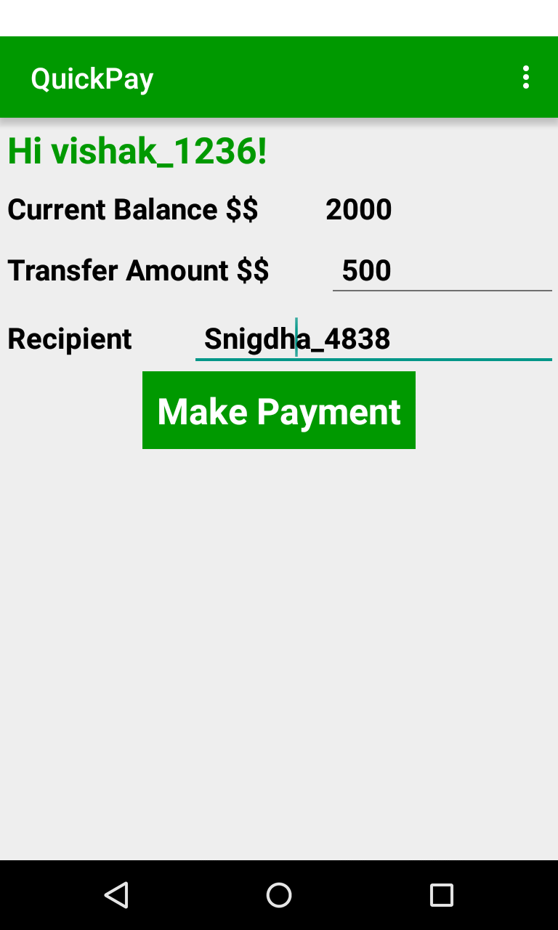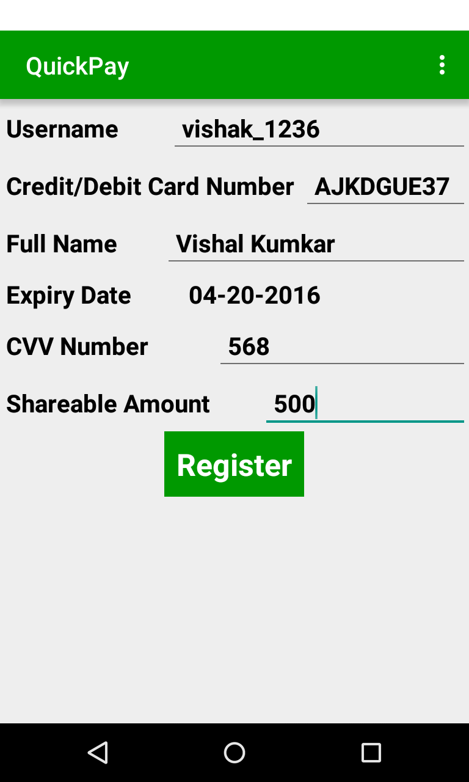



**Under the hood…**

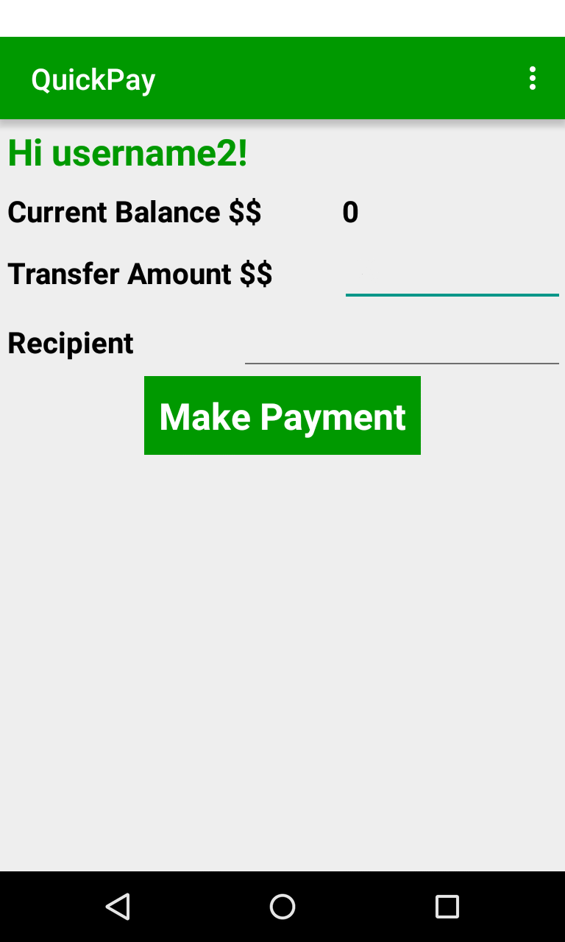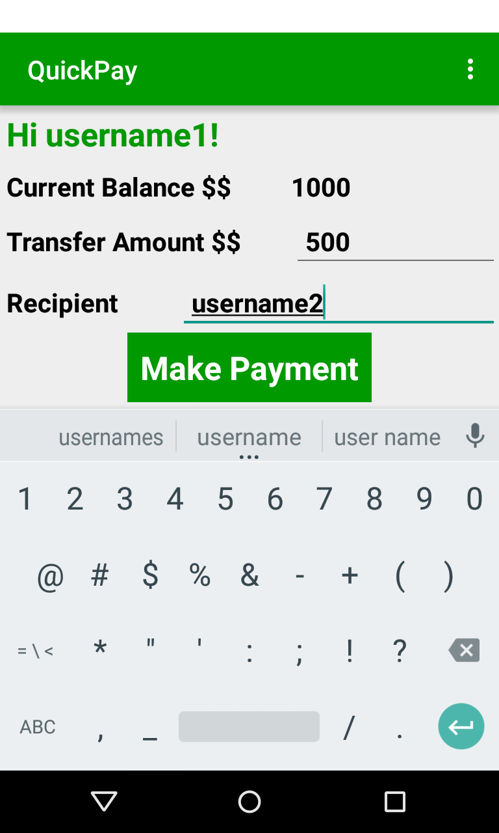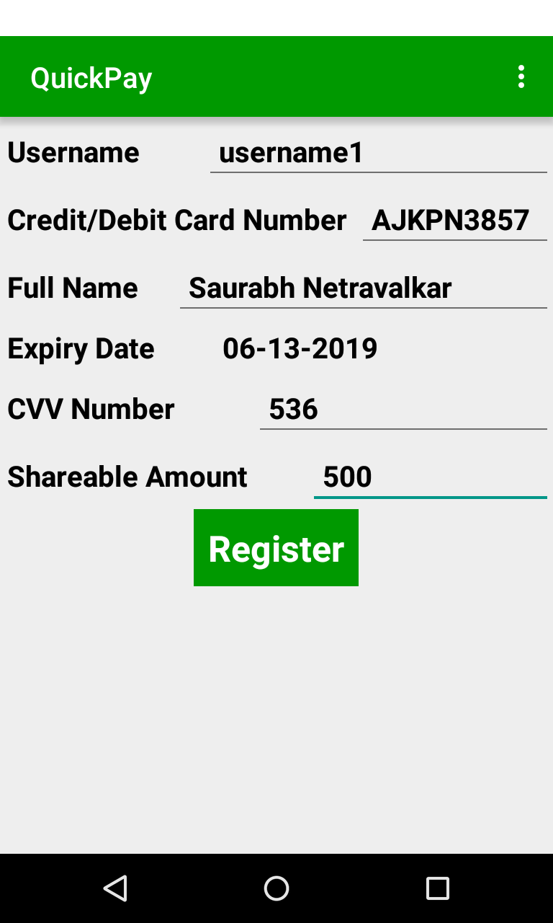

Username2 has no money

HTTP POST

QuickPay debits amount instantly



QuickPay pays username3 using regular inter-bank transfer

QuickPay intiates transfer instantly

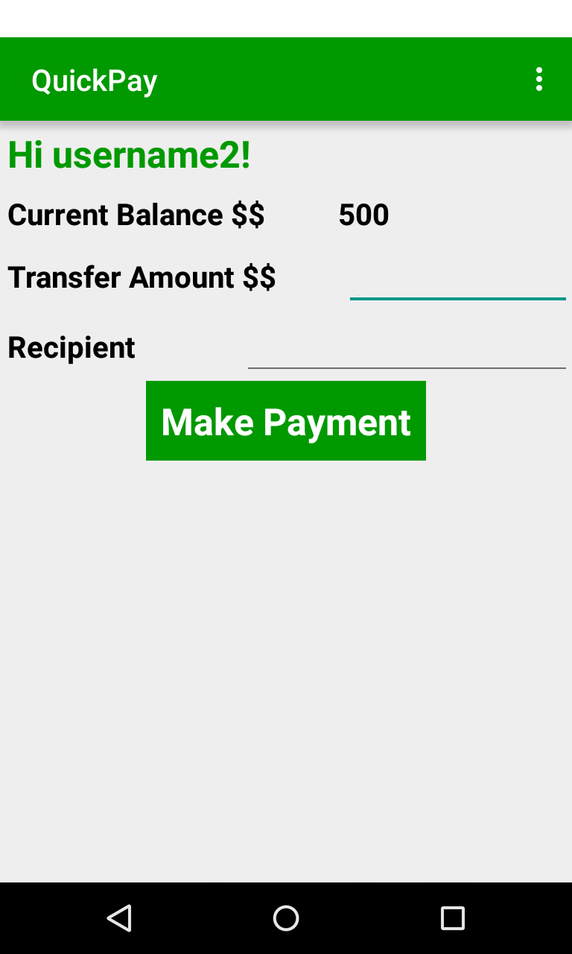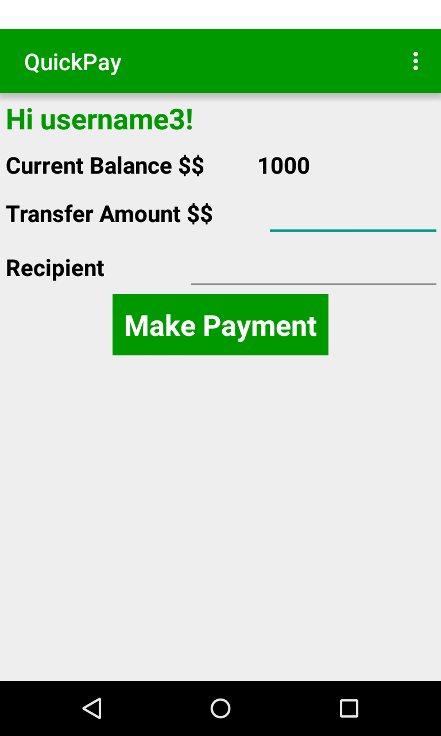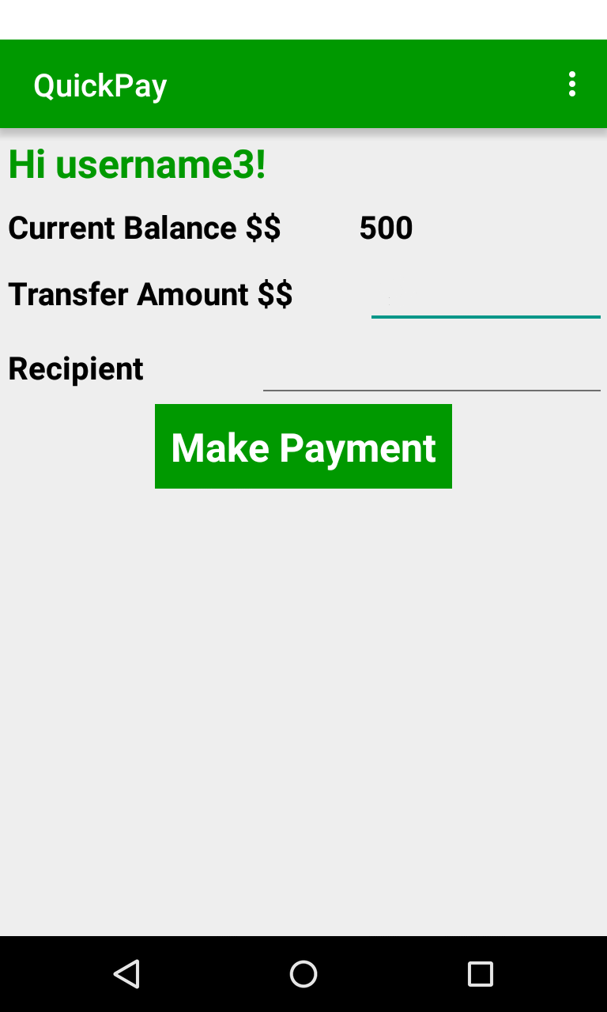

Find username2’s bank;

Server finds that username3 has an account at same bank

Username3has set

**Sharable amount** = $500

This is the max. amount that can be temporarily borrowed

QuickPay will transfer it to Username3 in 2 days.

Username2 receives **instant** credit

Username3 and Username2 have accounts in same bank

**Same bank transfers occur instantly**

This facilitates instant transfer

* The amount can be **CrowdSourced** from multiple intermediate accounts, if the transaction size is too large.
* Since a person can do instant transfers upto 5x times his configured “Shareable balance”, this encourages users to configure higher limits and hence, more “buffer” money becomes available to QuickPay for instant transfers.

**APIs and Technologies used**

* Amazon ElasticBeanstalk to deploy the application server on the cloud
* Android to develop the mobile app
* Capital One APIs to get customer debit card information, balance, account details, etc. and to find probable intermediate account holders.
* Java and Jersey framework to develop the server side application.

**URL**

[http://dataserver-env.elasticbeanstalk.com](http://dataserver-env.elasticbeanstalk.com/rest/transaction/getbalance/55e94a6cf8d8770528e617fa)

The application server has been configured to handle JSON requests and send JSON responses.

There is no server UI hosted at this URL.

**POST can be simulated with Postman as:**

[http://dataserver-env.elasticbeanstalk.com/rest/transaction/transfer](http://dataserver-env.elasticbeanstalk.com/rest/transaction/transfer" \t "_blank)

{

    "senderId" : "55e94a6af8d8770528e60e45",

    "receiverId" : "55e94a6af8d8770528e60e46",

    "bankName" : "Savings",

    "amount" : 1000

}

**Team members**

**Saurabh Netravalkar -** [**sn575@cornell.edu**](mailto:sn575@cornell.edu)

**Vishal Kumkar -** [**vkk22@cornell.edu**](mailto:vkk22@cornell.edu)

**Devi Snigdha -** [**dm754@cornell.edu**](mailto:dm754@cornell.edu)

**Harish Sethumadhavan –** [**hs643@cornell.edu**](mailto:hs643@cornell.edu)