Loyalytics Case Study

# Basic questions:

1. **Number of customers registered for the program**

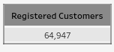

## Insights:

* + Total number of Registered Customers for Loyaltics Program are **64,647.**

# Total number of unique product category



## Insights:

* + Total number of Unique Product Categories is **18.**

# Find out the total sales and refund during the given period

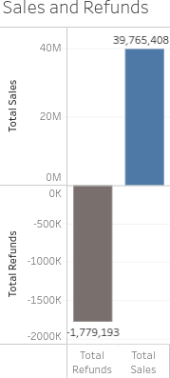

## Insights:

* + Total number of Sales done is **36,765,408.**
  + Total number of Refunds made is **1,776,163.**

# Percent sales contribution by each store city and store id to the total sales for the given period

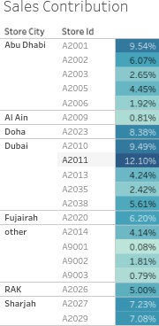

## Insights:

* + The highest sales contribution **12.10%** was done by a Dubai store A2011, generating sales alone of **4,812,764.**
  + Dubai Store city contributed to **33.86% (1,34,67,764)** of total sales.
  + Followed by Dubai, Abu Dhabi contributed to **24.63% (67,61,606)**of total sales.

# Total number of items refunded during the period

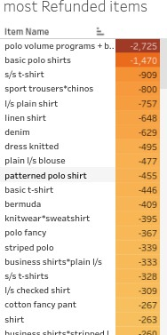

## Insights:

* + **16,476** items were refunded, polo volume programs + basic slim fit was the most refunded item with a Quantity of **2725**

# Total number of freebies given during the period

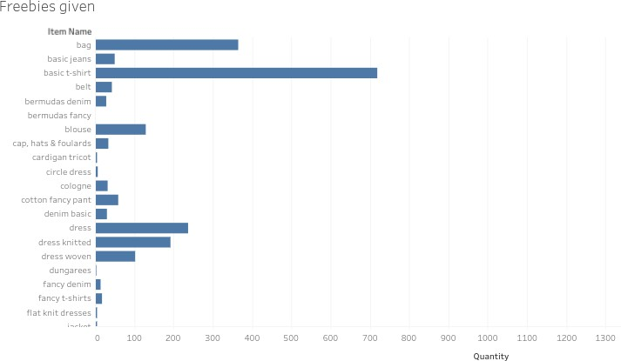

## Insights:

* + **6,617** items were given as freebies, watch was the mostly given freebie item with a Quantity of **1621**

# Get the month on month trend of customers registration for the program

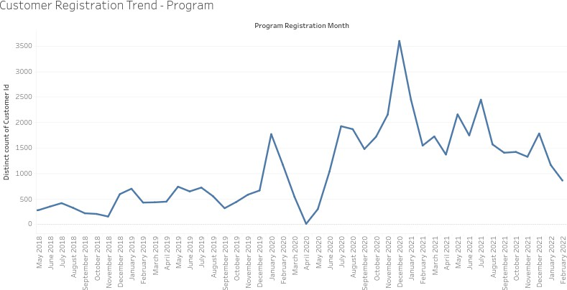

## Insights:

* + From **May 2020 onwards we can see a spike** in the number of customer registrations. The highest number of customer registrations was recorded in **December 2020**, 3,566 Customers registered for the program in this month.

# Get the month on month trend of customers registering on the app

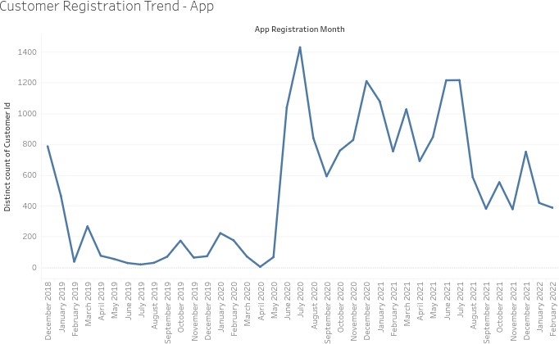

## Insights:

* + From **May 2020 onwards we can see a spike** in the number of customer registrations. The highest number of customer registrations was recorded in **July 2020**, 1,430 Customers registered for the app in this month.

# Monthly trend in number of transaction of registered customers by current tier.

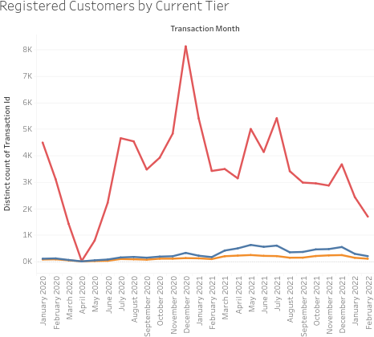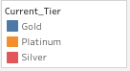

## Insights:

* + The number of registered customers appears to fluctuate throughout the observed period. There is a general upward trend from January 2020 to mid-2021, followed by a decline towards the end of the observed period.
  + The highest number of registered customers is observed in

mid-2021, while the lowest point appears to be in early 2020.

* + There seems to be some seasonality in the data, with

peaks occurring around mid-year and troughs in early and late parts of the year.

* + Customers in Silver Tier have higher transactions

compared to platinum and Silver

# Top 10 customer nationality by number of customer signing up for loyalty program..

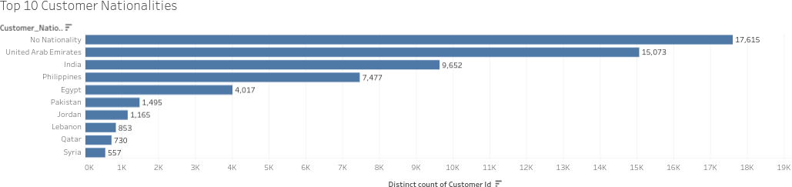

## Insights:

* + The chart reveals that the largest customer base (17,615) falls under the "No Nationality" category. This is a significant portion compared to other nationalities.
  + Following "No Nationality," the United Arab Emirates (15,073) and India (6,652) have the highest number of customers. This suggests a substantial expatriate population from these countries.
  + After the top three, there's a notable drop in customer

counts. The Philippines (7,477) occupies the third position, followed by Egypt (4,017) with a considerable gap.

* + From Pakistan (1,465) to Syria (557), the customer

numbers are relatively close, indicating a more evenly distributed customer base among these nationalities.

# Count of customer from each country and number of customers based on current tier

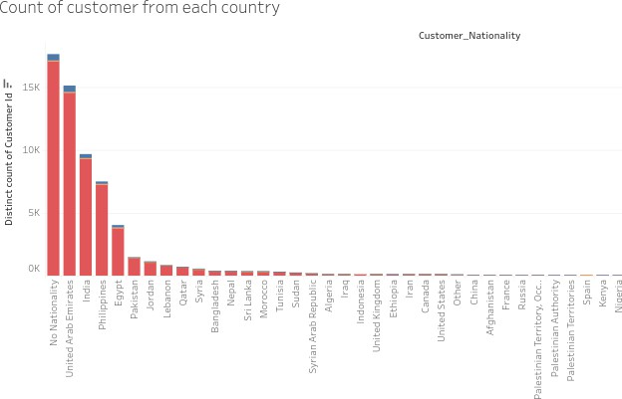

## Insights:

* + The high number of "No Nationality" customers could be due to missing or incomplete data during customer registration.
  + The majority of customers across all nationalities seem to be in the Silver tier, indicated by the red bars being the tallest for most countries.

# Trend in avg total spent by registered customers and not registered customers

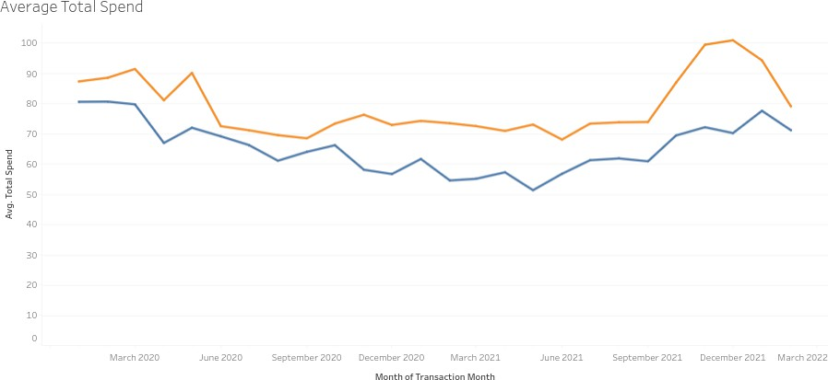

## Insights:

* + The average total spend for registered customers displays a general upward trend throughout the analyzed period (March 2020 to March 2022), with some fluctuations. There's a notable peak around September 2021, followed by a decline towards March 2022.
  + The average total spend for non-registered customers

exhibits a more volatile pattern. There's a significant drop from March 2020 to around June 2020, followed by a gradual increase until December 2020. Subsequently, it fluctuates with a downward trend towards March 2022.

* + Throughout the majority of the period, registered

customers consistently spend more on average compared to non-registered customers.

* + Both groups demonstrate some seasonal fluctuations in

spending, with potential peaks during certain months.

# Top 5 and bottom 5 items by number of transactions done

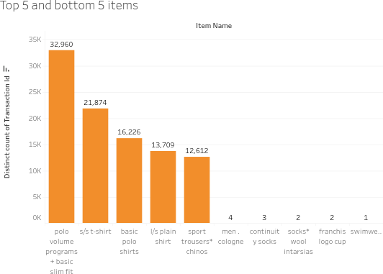

## Insights:

* + The item "polo volume programs + basic slim fit" stands out significantly, with a transaction count of 32,660, far surpassing any other item.
  + The bottom 5 items, including "continuit y socks," "socks* wool intarsias," "franchis logo cup," and "swimwear," have very low transaction counts, ranging from 4 to 1.

# Find items with most number of refunds

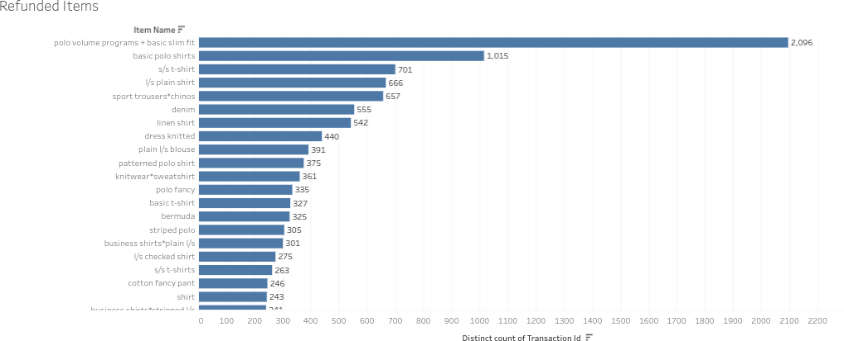

## Insights:

* + The graph provides a clear overview of the items with the highest number of refunds.
  + **Polo Volume Programs + Basic Slim Fit**- This item stands out with a significantly higher number of refunds compared to others. It's crucial to investigate the reasons behind this high refund rate.

# Trend in number of transactions over time

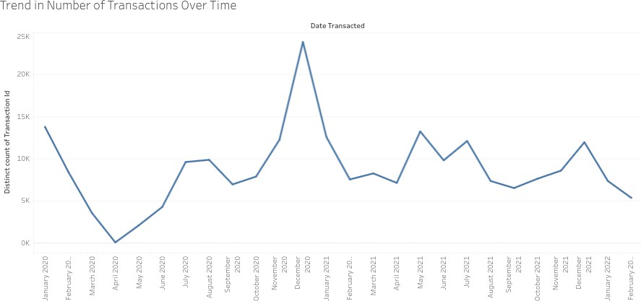

## Insights:

* + The number of transactions starts at a relatively high point in January 2020 and experiences a sharp decline in the following months, reaching a low point in March 2020.
  + From April 2020 onwards, there is a gradual recovery, with some months showing significant growth. Notably, a peak is observed in December 2020.
  + After the peak in December 2020, the transaction count fluctuates with periods of increase and decrease.
  + The initial drop in transactions might be attributed to external factors like the COVID-16 pandemic and its impact on economic activity.
  + The fluctuations throughout the graph could indicate seasonal trends or patterns influenced by factors like holidays, promotions, or economic cycles.

# Top 10 trending product categories by average total spent

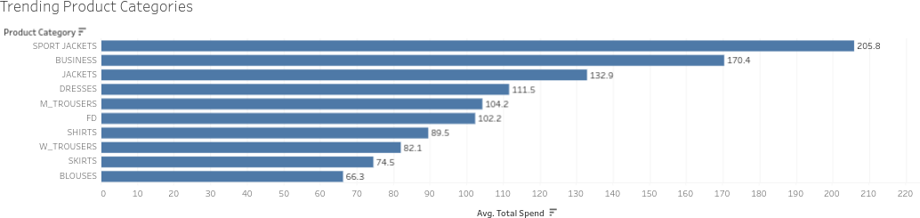

## Insights:

* + Sport Jackets occupy the top position with an average total spend of 205.8. This indicates a strong preference for this category among customers.
  + Business Jackets and Dresses secure the second and third spots, respectively, suggesting a significant demand for formal wear.
  + The graph highlights distinct spending patterns between men's and women's categories. Men's Trousers (M. Trousers) and Shirts rank higher than their female counterparts (W. Trousers and Skirts).

# Advanced questions:

1. **Percentage of registered customers signed up on app**

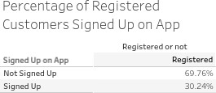

## Insights:

* + The graph indicates that 30.24% of registered customers have signed up on the app, while 66.76% have not.

# Find out what is the average time period difference between customers registration date and 1st transaction date

## Insights:

* + The average time period difference between customers registration date and 1st transaction date is 635.2.

# Percentage of registered customers where customer id is present but customer nationality is missing

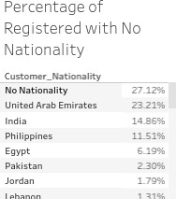

## Insights:

* + 27.12% of registered customers have no nationality associated with their accounts.

# Analyze percentage contribution to total sales for each year by customer registration date.

1. Example-find out what was the percentage sales contribution by customers who registered in 2013 for the years 2020,2021 and 2022 and so on.

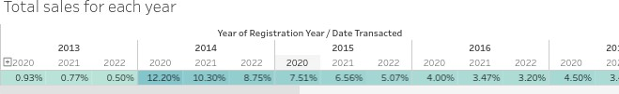

## Insights:

* + For each registration year, the percentage contribution to total sales generally decreases as the transaction year progresses. This indicates that the impact of older customer segments on sales diminishes over time.
  + Customers who registered in 2020, 2021 and 2022 have

shown higher contribution percentages in recent years (2020,2021 and 2022), suggesting that newer customer segments are driving sales growth.

# Find customer order frequency ie how many customers had done 1,2,3..N transactions.

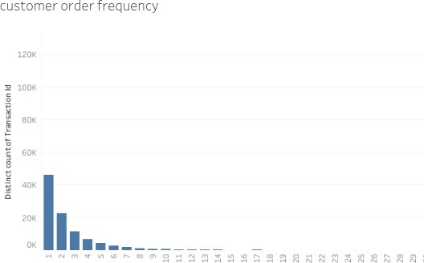

## Insights:

* + The above chart displays customer order frequency ie how many customers had done 1,2,3..N transactions.

# Year on Year customer retention who registered for the program.

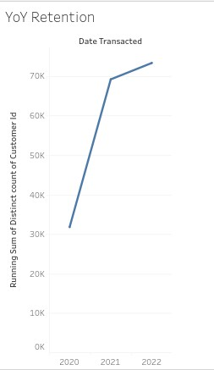

## Insights:

* + There's a substantial jump in the number of unique customers between 2020 and 2021. This indicates significant customer acquisition or retention efforts during this period.
  + While the growth rate from 2021 to 2022 is not as steep, there's still a positive trend, signifying continued customer acquisition or retention.
  + The chart doesn't show any decline in the number of customers, suggesting that there hasn't been a significant customer churn.

# Month on Month count of new customers and repeat customers

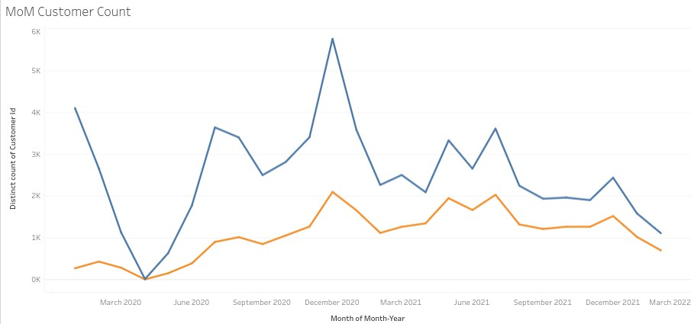

## Insights:

* + The data reveals a significant spike in new customer acquisition in December 2020.
  + Following this peak, there's a general downward trend in new customer additions until March 2022, with some fluctuations.
  + Notably, there's a slight uptick in new customers in September 2021.
  + The repeat customer count exhibits an overall upward trajectory throughout the analyzed period.
  + There's a notable increase in repeat customers coinciding with the peak in new customer acquisition in December 2020.
  + The growth in repeat customers appears more consistent compared to the fluctuating trend of new customers.

# Month on month average transaction value(revenue/# of transaction for given time period)

## Insights:

* + The average transaction value exhibits significant fluctuations throughout the analyzed period. There are periods of sharp increases and decreases, indicating varying customer spending patterns
  + From March 2020 onwards, the average transaction value

shows a general upward trend with several peaks and troughs.

* + There are notable peaks in average transaction value in

December 2020 and December 2021. These could be associated with festive seasons or promotional activities that influenced customer spending behaviour.

# Month on month trend in units sold per transaction(number of units sold/# of transaction)

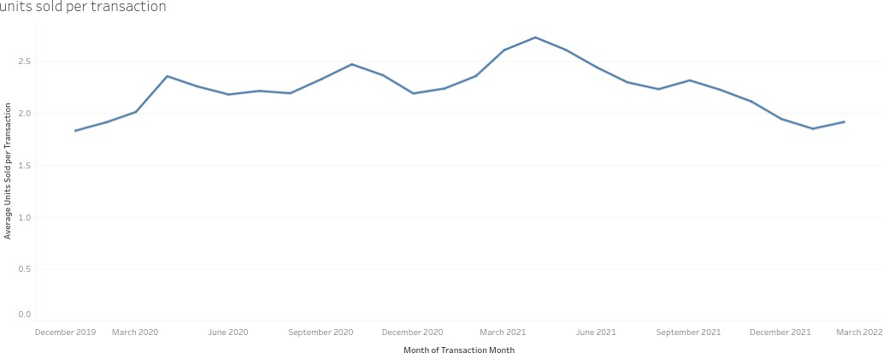

## Insights:

* + The graph highlights the dynamic nature of customer purchasing behaviour, with significant variations in average units sold per transaction over time.
  + There are notable peaks in average units sold per transaction in December 2020 and December 2021. These could be associated with festive seasons or promotional activities that influenced customer purchasing behaviour.

# Find out the basket size for each product category

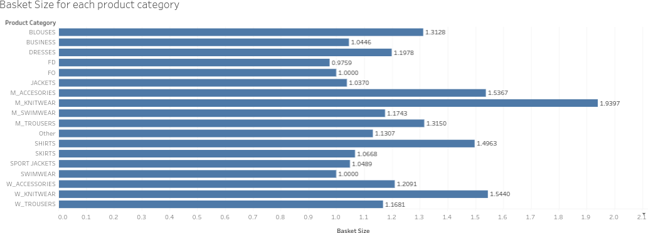

## Insights:

* + M Knitwear has the highest basket size at 1.6367, suggesting customers tend to purchase multiple knitwear items per transaction.
  + Following closely, with a basket size of 1.5367, customers also frequently buy multiple accessories together.