**Abstract, Scope, Class, Activity and Sequence Diagram**

**Problem Statement:**

To design a recruitment management system with various defined roles for the user and company.

**Abstract:**

This project is aimed at developing Recruitment Management System for user. This is a web based application that can be accessed throughout the web. This system can be used to add job, the user can search job based on certain parameters and company can search for candidates.

**Classes**

**Company**

1. companyId: Integer
2. name: String
3. emali: String
4. jobs: List

**Job**

1. jobId: Integer
2. Designation: String
3. qualification: String
4. minimumExperience: Integer
5. salary: Double
6. location: String

**User:**

1. userId: Integer
2. firstName: String
3. lastName: String
4. email: String
5. phoneNumber: String
6. Qualification
7. designation
8. yearsOfExperience

**Qualification:**

1. sscCgpa
2. hscCgpa
3. graduationDegree (Display user a dropdown with following options :**B.Tech, B.Sc, B.Com** , user can then select any one)
4. graduationCgpa

**For qualifications give a list to user using dropdown to select eg: 10,12,B.Tech,B.Sc,B.Com,....,M.Tech,M.Com,Phd(Once a user selects 10 remove it from the list so cant send it again)**

**Position we can give a list like software developer, analyst, fresher, etc...**

**Admin can generate list of placed users.**

**Company place jobs, candidates apply for it, company approves it(User can only get on job)**

**Functions**

Company:

1. boolean Register()
2. List<User> searchUserByQualification()
3. List<User> searchUserByPosition()
4. List<User> searchUserByExperience()
5. boolean addJob(Job job)
6. approve candidates for job(Once one person gets approved we should delete the job posting based on vacancy, for that we need to add vacancy in jobs)

User

1. register()
2. searchJobByQualification()
3. searchJobByPosition()
4. searchJobByExperience()
5. searchJobByLocation()
6. addResume() —> take form data and convert it to pdf using iText, then user can download it
7. modifyResume() —> take form data
8. (Upload pdf, then how to modify it)
9. downloadPdf()

Admin

1. Individuals placed in a month
2. Individuals placed in a company
3. Individuals placed in a designation

**Association**

User has one Address(One to One)

Company has one Address(One to One)

Company can post multiple Jobs (One to many)

User can apply for many jobs (One to many)

**Flow**

On login, enter credentials and you will be directed to user/admin or company page. Use login Id and password for login.

For registering provide two options: Register as a user and Register as a company.

Company will post jobs with designation and minimum required experience,

and qualification. Company can search for candidates.

Individual will register and enter his personal details, his qualification,

experience.

Search for jobs and apply.

Upload resume(pdf)

ModifyResume do it like update we did in product management and then create a pdf

<----Modify resume---->(Upload a new pdf/ User can update details and then create new pdf using

IText)(Save pdf on server and give path in database)

**Validations:**

1. Company
   1. name(A-za-z )
2. Job
   1. designation(A-Za-z0-9 )
   2. qualification - choose one from drop list eg: B.Tech, B.Com, B.Sc
   3. minimumExperience - less than 99 years and greater than 0
   4. salary - double
3. User
   1. firstName(A-Za-z)
   2. lastName(A-Za-z)
   3. emailId
   4. phoneNumber - should be 10 digits
   5. yearsOfExperience - greater than 0 and less than 99
4. Address
   1. city(A-Za-z)
   2. state(A-Za-z)
   3. country(A-Za-z)
   4. Pincode - 6 digits long
5. Qualification
   1. cgpa - Float value less than 10.

**Out of Scope**

(Create a qualification object with degree, cgpa, year of passing and then user multiple objects based on his highest degree)

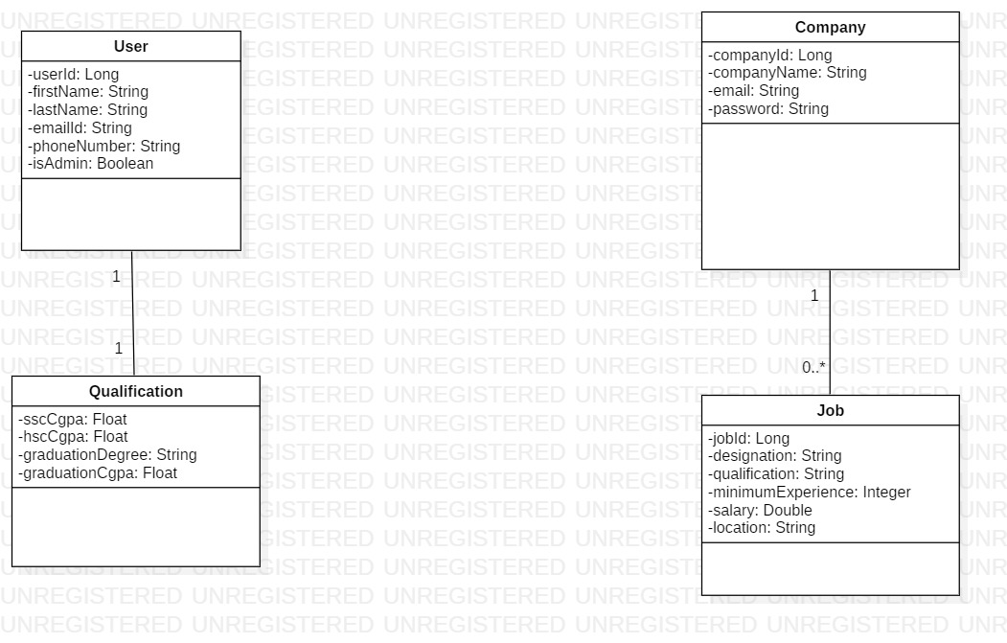**Class Diagram**

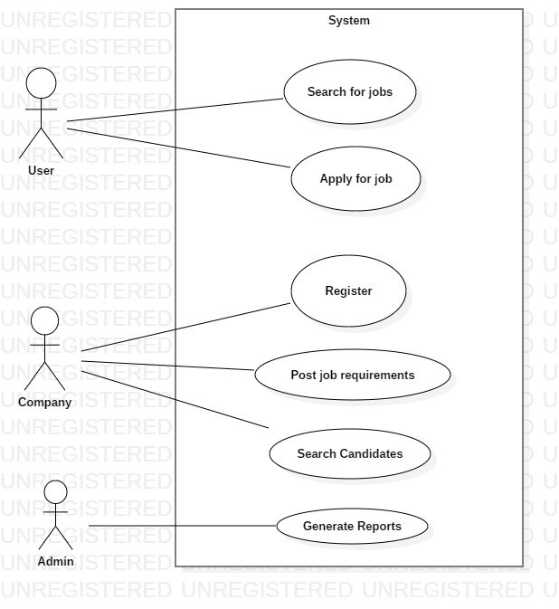

**Use case Diagram**

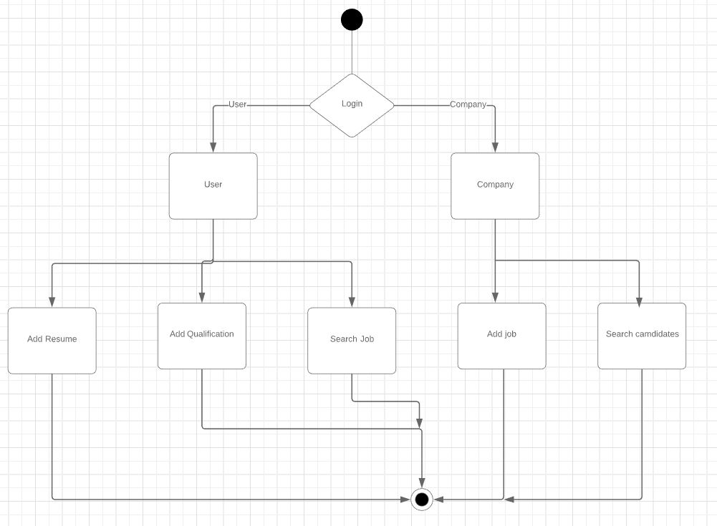

**Activity Diagram**