**RELAY AND RELAY DRIVER CIRCUIT:**

Relay is an electromagnetic switch; consist of a coil, 1 common terminal, 1 normally closed terminal, and one normally open terminal.

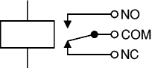

Circuit symbol for a relay

The relay's switch connections are usually labeled COM, NC and NO:

COM = Common, always connect to this, it is the moving part of the switch

NC = Normally Closed, COM is connected to this when the relay coil is off.

NO = Normally Open, COM is connected to this when the relay coil is on.

Relays allow one circuit to switch a second circuit, which can be completely separate from the first. For example a low voltage battery circuit can use a relay to switch a 230V AC mains circuit. There is no electrical connection inside the relay between the two circuits; the link is magnetic and mechanical.

**DRIVER CIRCUIT FOR THE RELAY:**

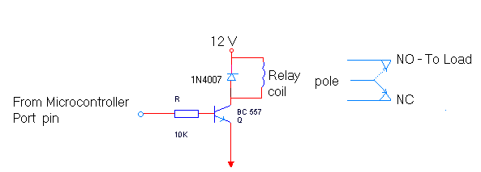

In our project two SPDT Relays (Single Pole Double Throw Relay) are used. Relay is driven by the micro controller as per system requirements .One of them is used to cut off the power supply when balance goes to zero and other relay is for off hook or on hook notification to MSEB.

Advantages of relays:

* Relays can switch AC and DC, transistors can only switch DC.
* Relays can switch high voltages, transistors cannot.
* Relays are a better choice for switching large currents (> 5A).
* Relays can switch many contacts at once.

It is on/off switch. Which uses 12V supply? It is use make the switch on or off. Here we use 12v single change over relay. These relays are connected to the µC via a relay driver ULN 2803.The relays require an current of 50 ma at the time of switching. The µC cannot provide that much amount of current that’s why we connect a relay driver in between so that the current requirement can be fulfilled.

It operates in two modes:

* Normally Open
* Normally Closed

Different devices can be controlled i.e. they can be turned On/Off whenever required.