Prime Power RTL:

In modern designs with high clock or sensitive cell switching frequency, glitch power contributes to around 10 to 50 percent of total power but might not be detected in early RTL stage. To address these problems, Prime Power RTL.

Prime Power RTL power analysis supports most of the Prime Power analysis capabilities, such as dynamic power, leakage power, peak power, delay-shifting, cycle-accurate peak power, or multi voltage power.

The Prime Power RTL tool performs a fast synthesis on the RTL designs and runs power estimation on the
RTL blocks, subsystems, and full SoCs.

It also provides early and accurate power analysis to shorten the design cycles.

Core Steps in Prime Power RTL
- Read the Design
  - Load RTL files (.v/.vhd), libraries (.lib), constraints (.sdc), and power intent (.upf).
- Run Fast Synthesis
  - Perform a quick synthesis to map RTL to gates for early power estimation.
- Propagate Activity
  - Use SAIF (from simulation) to annotate switching activity across the design.
- Estimate Power
  - Calculate dynamic and static power using annotated activity and cell data.
- Power Exploration & Debugging
  - Analyze hotspots, optimize clock gating, refine power domains, and prepare for ECOs.

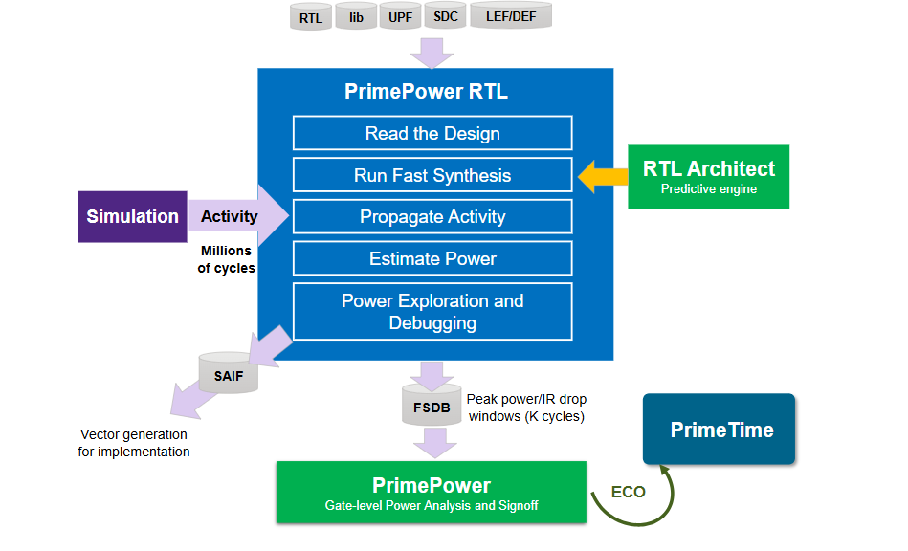

Basics of RTL Power Analysis

- “RTL-level analysis (PrimePower RTL)
- Gate-level signoff (PrimePower + PrimeTime)
So while PrimePower RTL itself does not require DEF, the downstream tools like PrimePower (gate-level) and PrimeTime do use DEF for:
- Accurate parasitic extraction
- IR drop analysis
- Peak power window identification
- ECO placement guidance “s

You must have a PrimePower-RTL license to enable RTL Architect features for performing RTL power analysis in pwr_shell.

PrimePower RTL automatically executes the commands in the. setup files. The setup files contain commands that perform basic tasks, such as initializing application options and setting GUI options. You can add commands and Tcl procedures to the setup files in your home and project directories.

Before performing RTL power analysis in pwr_shell, you must specify the location of the RTL Architect tool. To do this, use the set_rtl_architect_shell command. For example:
pwr_shell> set_rtl_architect_shell full_path_to/rtl_shell

You must also specify the directories in which PrimePower searches for designs, logic libraries, and other design data using the search_path variable. For example:
pwr_shell> set_app_var search_path ". /test/libs"
Before you perform RTL power analysis, you must read the design and logical data, and specify the reference library list for RTL synthesis.

Use the set_synth_ref_libs command to specify NDM reference libraries for RTL synthesis.
pwr_shell> set_synth_ref_libs A_ff.ndm B_ff.ndm

The following example specifies the use of different library files a.db and b.db for power analysis using the -power_libs option, and the a_full.ndm and b_full.ndm files for RTL synthesis.
pwr_shell> set_synth_ref_libs -power_libs { a.db b.db } a_full.ndm \
b_full.ndm

The following example reads in two Verilog files.
pwr_shell> set_synth_rtl_files -top_module top top.v alu.v

The following example specifies a VCS file list file to read in.
pwr_shell> set_synth_rtl_files -top_module top -format vcs -list_file manifest.f \
-top_rtl full_path_to/top.v

The following example specifies an LEF technology file for RTL synthesis.
pwr_shell> set_synth_phy_tech_file full_path_to/techfile.tech

Use the set_rtl_activity_file command to specify a VCD, FSDB or SAIF activity file for RTL power analysis.

By default, the names in the FSDB file are specified in Verilog format. Use the -systemverilog option if the names are in the SystemVerilog format. Use the -strip_path option to specify the prefix to strip out from the signal net names in the activity file.

The following example shows how to specify a SystemVerilog RTL FSDB file for power analysis.
pwr_shell> set_rtl_activity_file -format fsdb -strip_path tb/top \
-systemverilog -time {10 20} rtl.fsdb

The following example shows how to specify an RTL SAIF file for power analysis.
pwr_shell> set_rtl_activity_file -format saif -strip_path top rtl.saif

By default, PrimePower RTL saves all temporary files and analysis results to the output directory, named PP_WORKSPACE. To change the output directory, use the set_synth_output_dir command.

The following example sets the output directory to PP_WORKSPACE.
pwr_shell> set_synth_output_dir PP_WORKSPACE
PP_WORKSPACE is a relative path to the current working directory.

A scenario is a combination of a corner and mode used to perform timing analysis and optimization

Before you start working with a block, you must define the modes, corners, and scenarios that are used for the block, as well as the delay calculation model and routing layers to use. The routing layer information you specify is used for RC estimation during timing analysis

A scenario contains a set of operating conditions and operation modes for an RTL design.

There might be multiple scenarios in an RTL design. To accurately estimate how much power is consumed in different operating conditions and modes, you must use the set_power_scenario command to specify a scenario for power analysis.
For example, assuming you define two scenarios, func.fast and func.slow, for your RTL using the set_synth_options command and the current scenario is func.fast, run the following command to specify the func.slow scenario for power analysis.
pwr_shell> set_power_scenario func.slow

You can use set_essential_map to write out the essential and non-essential mapping files in the PrimePower RTL tool.

Essential mapping file: Contains mapping for all essential design nodes such as primary inputs, sequential outputs, memory, instantiated clock gate cell outputs and black-box pins.

Non-essential mapping file: Contains map info only for design nodes that underwent a name change.
The default is true, the RTL Architect tool writes out an essential mapping file. When set to false, the RTL Architect writes out the non-essential map file.

Example:
Use the following syntax to write out the essential mapping file.
pwr_shell> set_essential_map true

The PrimePower RTL tool reads in RTL designs, performs a fast synthesis on the RTL designs using the predictive gate modeling engine from the RTL Architect tool, and runs power estimation on the RTL blocks, subsystems, and full SoCs.

By working seamlessly with the RTL Architect tool, PrimePower RTL provides early and accurate power estimate for physical- and timing-aware RTL performance, power, and area (PPA) and deep power analysis, including glitch.

Hybrid RTL power analysis flow starts in the RTL Architect tool (rtl_shell) and finishes in PrimePower RTL (pwr_shell); both RTL Architect and PrimePower RTL tools are run separately and manually.

When RTL power analysis is complete, run the report_power command to create a power report.

Specify other options with the report_power

Total power
Internal power
Switching power
Leakage power
Glitch power
Register power
Memory power
Combinational power
Clock power
Clock-gating efficiency statistics

Mnemonics | Situations
NA_CP0 | The toggle rate for root clock is zero
NA_GCP0 | The toggle rate for gated clock pin is zero
NA_Q0 | The toggle rate for Q pin is zero
NA_Q>CP | The toggle rate for Q pin is greater than clock pin
NA_GC>C | The toggle rate for gated clock pin is greater than root clock
NA_NOREG | No registers in the hierarchy
NA | Any other reason

When RTL power analysis is finished, you can report power metrics for logical hierarchies, registers, or clocks using the report_rtl_metrics command in the following ways:

To report power metrics for logical hierarchies, use the following syntax:
pwr_shell> report_rtl_metrics -view hier

To report power metrics for registers, use the following syntax:
pwr_shell> report_rtl_metrics -view register

To report power metrics for clocks, use the following syntax:
pwr_shell> report_rtl_metrics -view clock

To generate power metrics reports in .csv format, use the -csv option.
pwr_shell> report_rtl_metrics -csv

pwr_shell> start_gui
To view RTLPower Hier view,
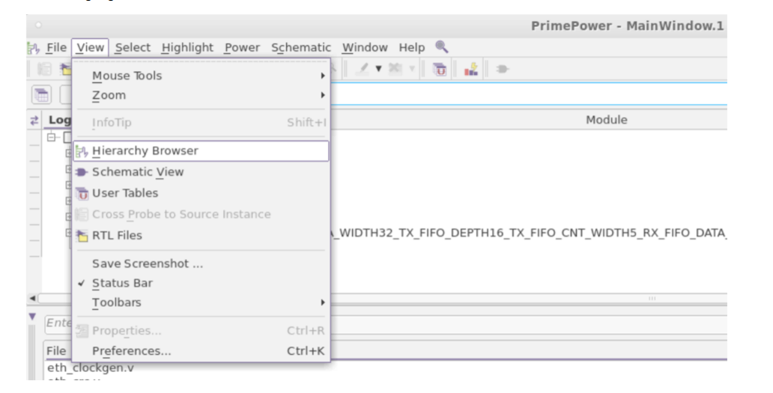

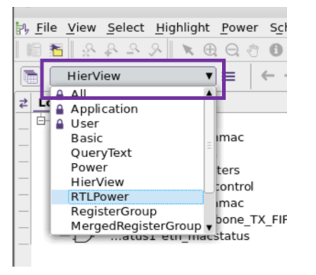
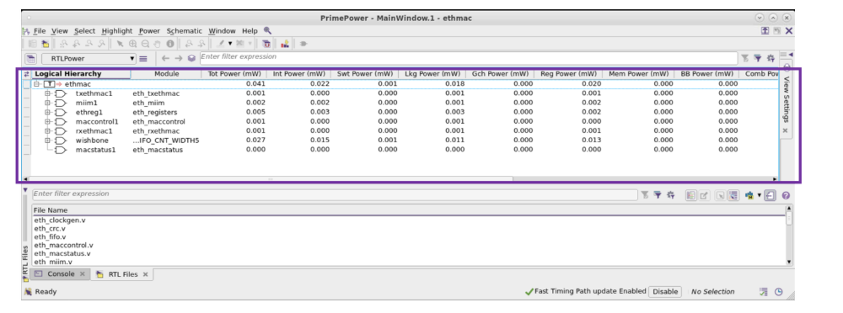

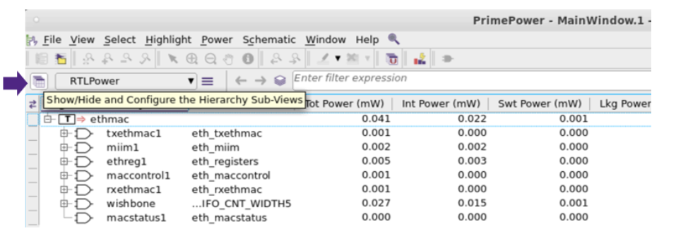

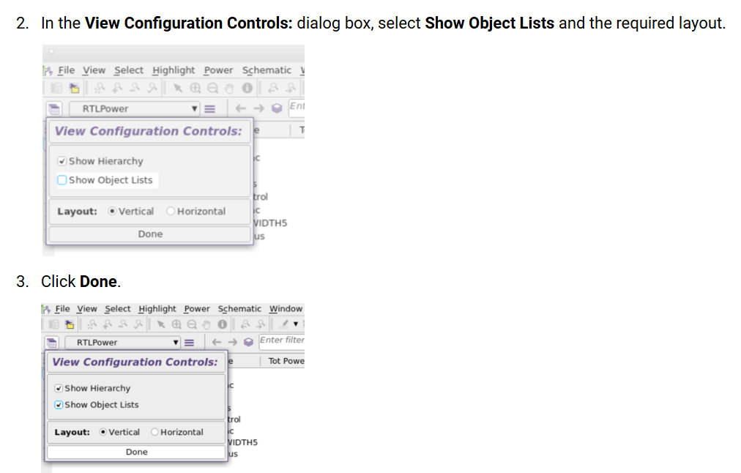

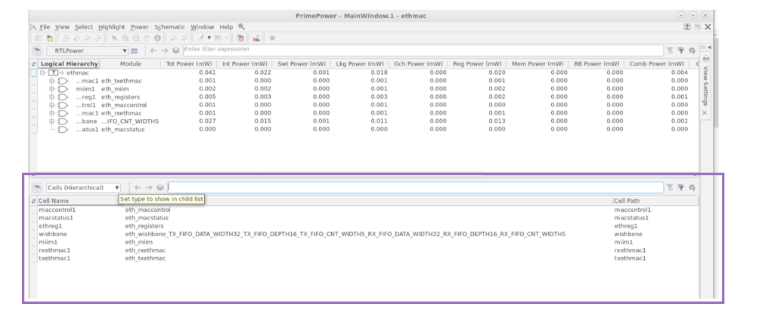

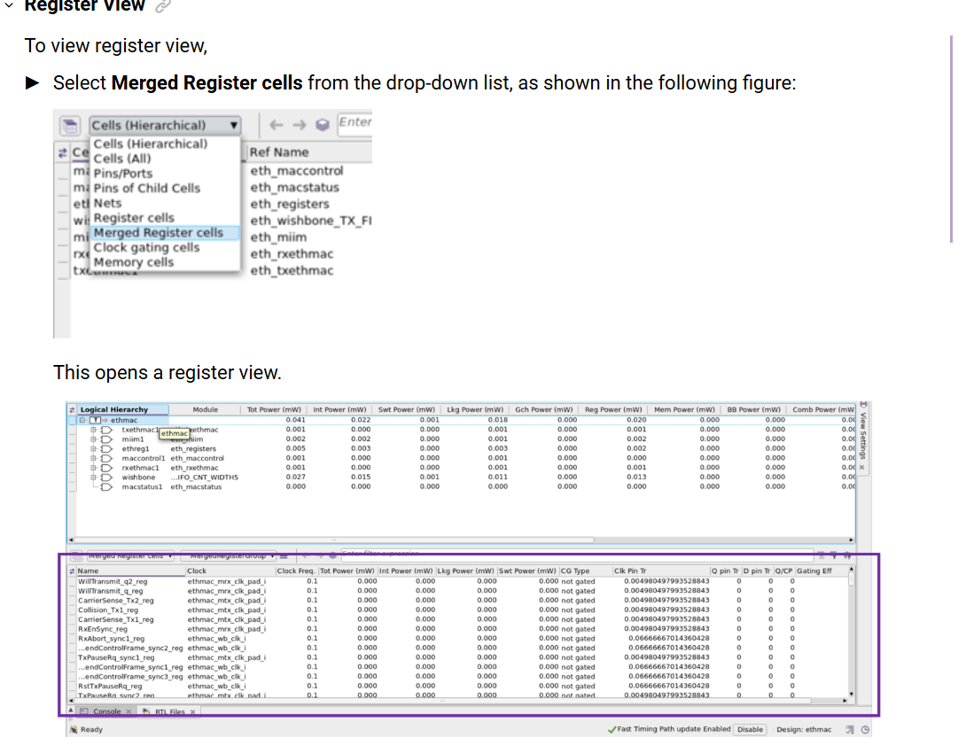

Clock-Gating View
To view clock-gating view,
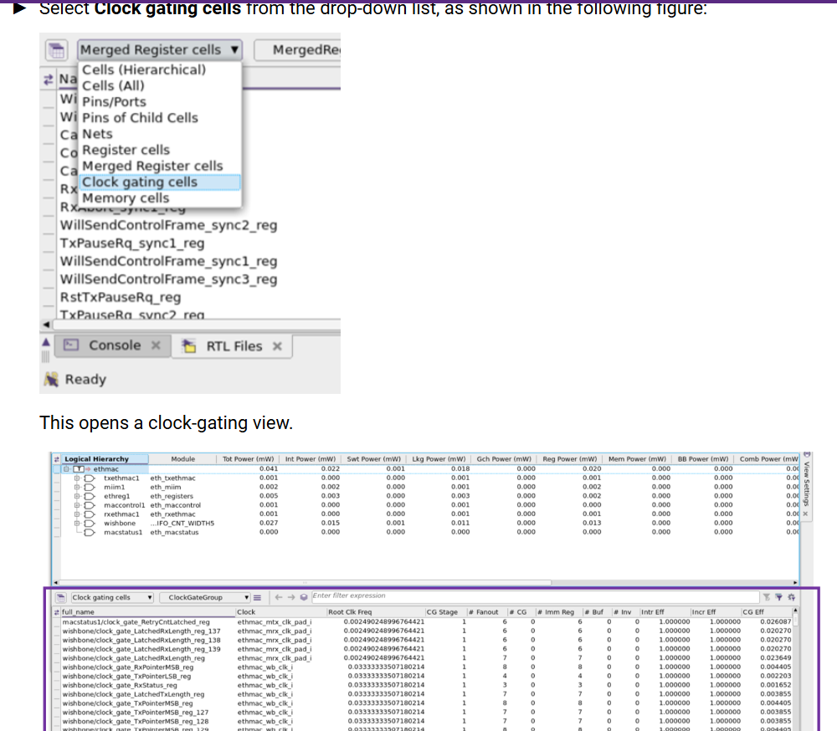

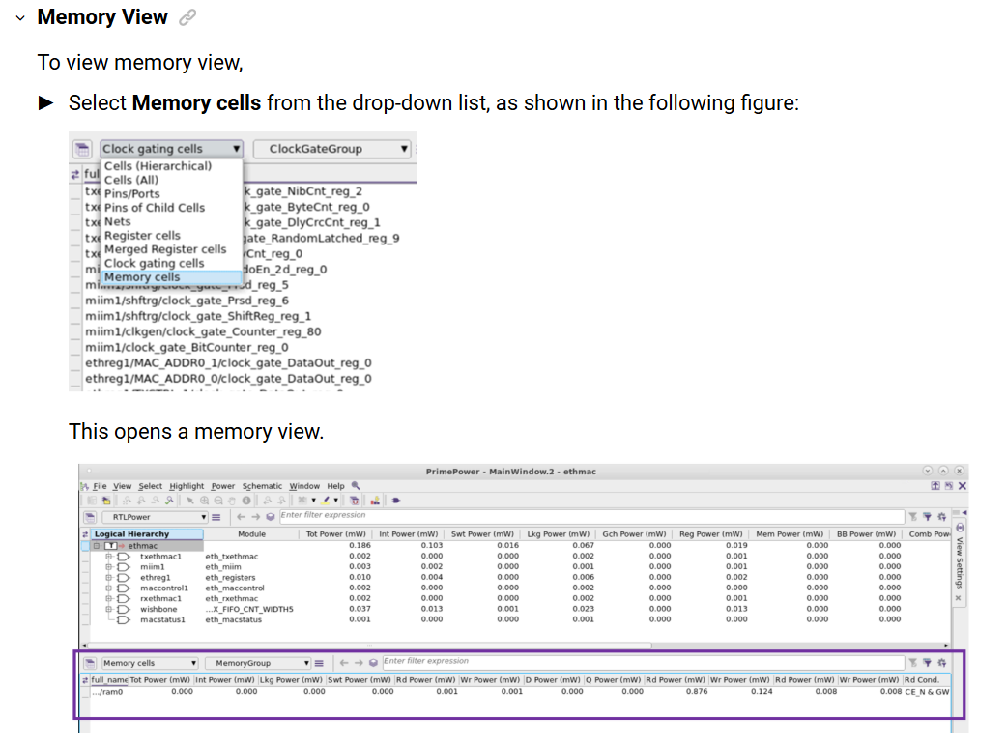

To visualize RTL power metrics and possible power problems in your design in the GUI,
Cross Probing

Glitches, in electronics, are undesired transitions
These unwanted transitions can cause the circuit to malfunction and consume power.
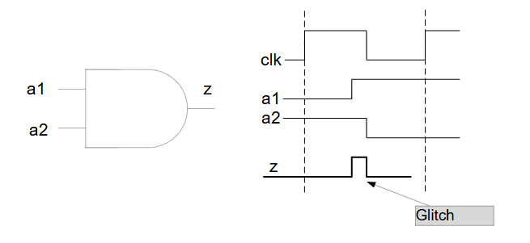

Identifying Redundancies
Reporting Lint Check Violations
Reducing RTL Power

PrimePower RTL supports the save_session and restore_session commands to save the current state of a PrimePower session and later restore the same session.
When the compute_metrics -power command run is complete, use

the save_session and restore_session commands to save the current state of a PrimePower RTL session to a named directory and then restore it later for continued use. The saved session includes design data, as well as parameters that are required for running PrimePower RTL analysis.

Configuring PrimePower RTL Flow With set_pprtl_flow_options Command

In today's fast-paced design environment, power efficiency is paramount, and early detection of potential power issues can significantly streamline the design process. PrimePower RTL (Empower Base) emerges as a cutting-edge solution, offering early power estimation capabilities that provide accurate power analysis at the RTL level. This proactive approach allows designers to identify and address power concerns before transitioning to the more resource-intensive gate-level analysis, ultimately saving time and costs.

PrimePower RTL (Empower Base) Introduction

Prime Time:
The PrimeTime Suite performs full-chip, gate-level static timing analysis, an essential part of the design and analysis flow for chip designs.
Static timing analysis is a method of validating the timing performance of a design by checking all possible paths for timing violations.
Another way to perform timing analysis is to use dynamic simulation, which determines the full behavior of the circuit for a given set of input stimulus vectors. Compared to dynamic simulation, static timing analysis is much faster because it is not necessary to simulate the logical operation of the circuit.
