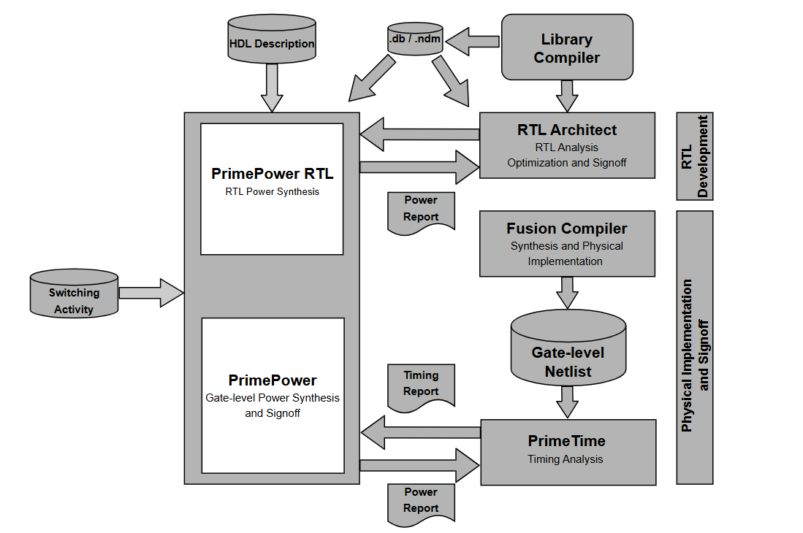

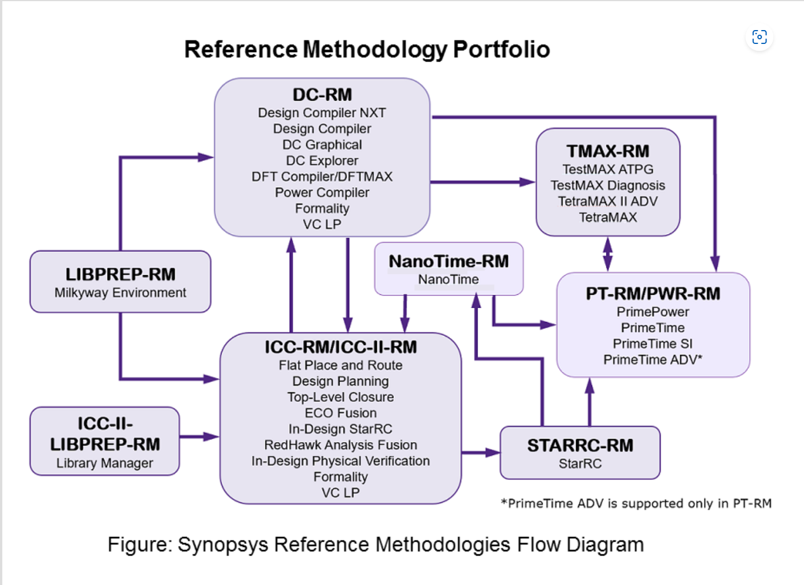

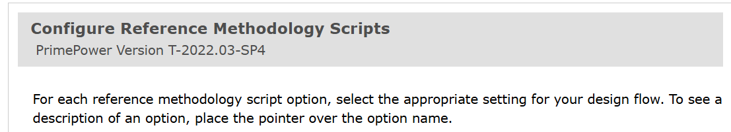
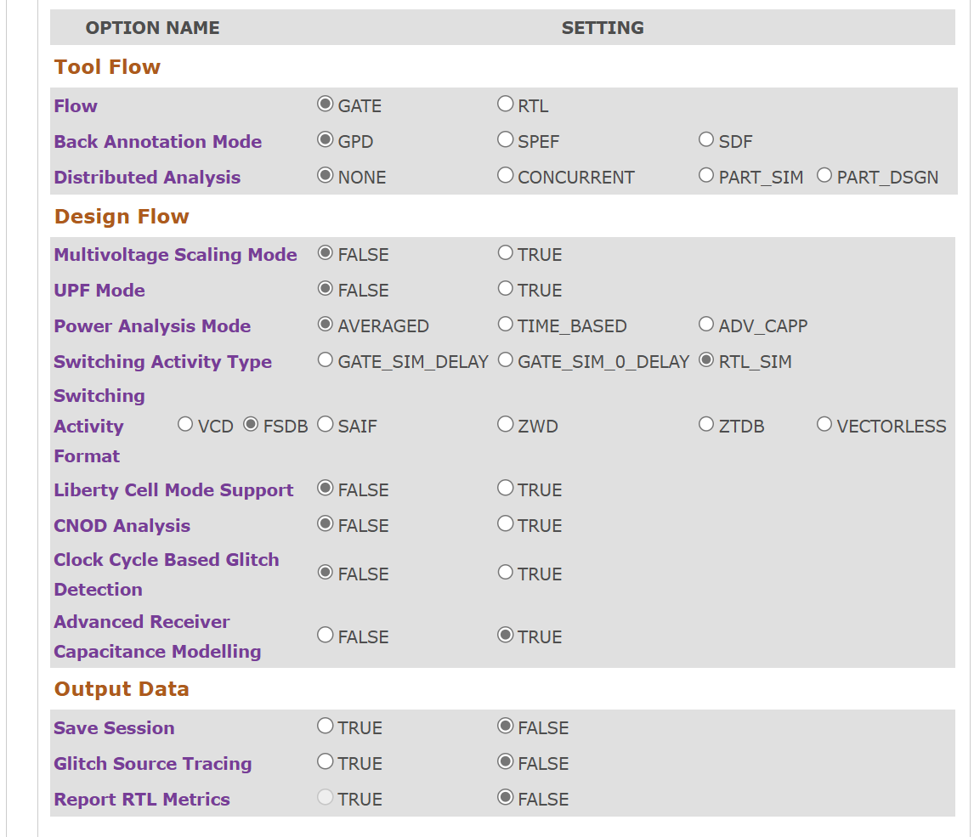

Vectors_name(no of thread /thread mask).fsdb / can be generate from pnr netlist
.power_window
.perf_summary

Inputs

Tech node=sec5lpe
Family=family_netrani
Top=Q6V71HC_1_top

netlist= .V
do file= .dofile (
upf file= topname.prime.upf
ptsi session= need to load to check for correctness of session ( There can be multiple
session for different corners) / inside cmdlog, libmap, n no of mod, readme and lenenc
prime time version – required to load session.
inforept=info.rpt
fsdb dir=
fsdb list=

steps to follow

pt session (need to load) => prime power

Need to check frequency:
ptpx always runs for TP(typical corner) cornec e.g func_0.750v_tt_25c_cn_tpsi_pocv, has clock name and frequency (.funcmap file)s

Fsdb clk freq check to match {QDSP6_clk 1248.43945069 MHz} main clock

Pt session frequency check (same value should be there. Otherwise cannot run prime power)

Verdi is a tool where we use to read fsdb.
New wave form {symbol} – open file {path shows} – getsignals [G] -- put strip path (scope) --- signal (clk name) – select apply & okay – x1fs [change here] – ns – zooming the wave form – one clock period “select last – first clock period numbers” near arrow symbol is there – 1/clkperiod – x1000 – clk frequency

Loading pt session > restore session
> echo $NET
> report_clock
> report_power_domain
>echo $CUSTOM_SCRIPT_DIR
>load_upf ///
>save_session (this session should be there at loading file)

Sta {dir} – topname – vectors – sta.log

Dynamic Energy – uW/MHz
Leakage – mW

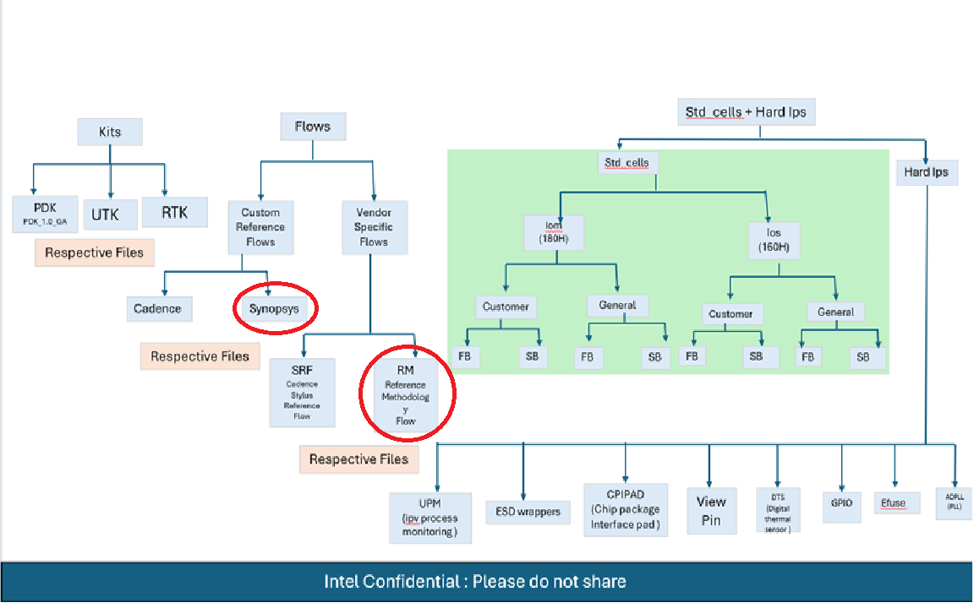
Path for RM SNPS script area: newgrp intel_slt_users
/slt/intel/intel18A/

- Dynamic fundamentals
- Example functional clock gating.
Taken example of AND gate. Where output is the same, we will apply clock gating there. To save power.
500MHz frequency for all flop
And 250Mhz frequency for clock gating flop to save power.
- Suppose we have netlist and want to do power analysis. So we will require, spef, Activity file, upf and what percentage of flop are clock gated.

Day 1: Core Concepts & Syntax
- Understand Tcl’s command structure: everything is a string
- Practice basic commands: set, puts, expr, if, foreach, proc
- Learn quoting and substitution: $var, [command], {braces}
- Explore lists and string manipulation

Day 2: Practical Scripting & Regex
- Work with file I/O: open, gets, puts, close
- Use regexp and regsub for pattern matching
- Write simple automation scripts (e.g., parsing logs, filtering constraints)
- Explore escape sequences and dynamic command construction

Problem statement:
Write a TCL code for given problem statement : Given a SDC file that may use ns, ps, or fs, convert all timing values example-period and -delay values to ns. Keep other lines untouched.

Code:
set Input_file "/proj/accenture/aces_dev/users/saurabhra/TCL/input_sdc_file.sdc"
set Output_file "/proj/accenture/aces_dev/users/saurabhra/TCL/updated_sdc_file.sdc"
set input_sdc [open $Input_file r]
set updated_sdc [open $Output_file w]
set pattern {(-period|-delay|-min|-max)\s+(\d+\.?\d*)\s*(fs|ps|ns)}

while {[gets $input_sdc line] >= 0} {
set updated_lines $line

# Match and convert all timing units while preserving the full line
while {[regexp $pattern $updated_lines match flag value unit]} {
switch $unit {
"fs" { set ns_Value [expr {$value / 1000000.0}] }
"ps" { set ns_Value [expr {$value / 1000.0}] }
"ns" { break } ;# No conversion needed
}

# Build original and updated strings
set original "$flag $value $unit"
set replacement "$flag $ns_Value ns"

# Replace only the matched fragment, keeping everything else
regsub -- $original $updated_lines $replacement updated_lines
}

puts $updated_sdc $updated_lines
}

# Close files
close $input_sdc
close $updated_sdc

Input file:
#Clock Definitions
create_clock -name clk_1 -period 500 ps -waveform {0 250}
create_clock -name clk_2 -period 1200 fs -waveform {0 600}

# Timing Constraints
set_input_delay -max 250 fs -clock clk_1 [get_ports {in_data}]
set_output_delay -min 150 ps -clock clk_2 [get_ports {out_data}]

Explanation:
(-period|-delay|-min|-max) → $flag
(\d+\.?\d*) → $value
(fs|ps|ns) → $unit
\s+ Matches one or more whitespace characters between the flag and value. This includes tabs or spaces.
\s* allows for zero or more spaces between the value and unit.

(\d+\.?\d*) — Captures a number: means give examples
- \d+ → one or more digits (e.g. 250, 7, 2024)
- \.? → optional decimal point (matches . if present)
- \d* → zero or more digits after the decimal (e.g. .001, .5, or just .)
Together, \d+\.?\d* matches a wide variety of number formats.

set pattern {(-period|-delay|-min|-max)\s+(\d+\.?\d*)\s*(fs|ps|ns)}

while {[gets $input_sdc line] >= 0} {
set updated_lines $line
gets $in line: Reads one line from the input file channel ($in) and stores it in the variable line.
>= 0: Keeps reading until gets returns -1, which means end of file.
So this loop processes every line from your input file sequentially.
You're making a copy of line into updatedLine.

why we are using while in code?
You're using while in your Tcl script to repeatedly process each line in your input file

why we are using while two times in code?
while {[gets $input_sdc line] >= 0} {
set updated_lines $line
This loop reads the SDC file line by line, using gets.
Each line gets stored in updated_lines (your working copy).
It ensures your script doesn't load the entire file at once—great for memory and performance.

Second while Loop: Handling Multiple Matches Within a Single Line

why we use regexp ?
You use it to:
Scan the line ($updated_lines) for timing constraints like -max 250 fs.
Extract the three key parts:
$flag → constraint type (-max, -period, etc.)
$value → numeric value (250)
$unit → time unit (fs, ps, ns)

while {[regexp $pattern $updated_lines match flag value unit]} {
This begins a loop that continues as long as the regex pattern matches something inside updated_lines.
regexp applies your pattern to the current line

why there is match ?
- match stores the entire substring that matched your pattern from the line.
- Example: If the input line contains -max 250 fs, then:
  - $match = "-max 250 fs"
  - $flag = "-max"
  - $value = "250"
  - $unit = "fs"
So while $flag, $value, and $unit hold individual groups

if i dont give this line what will happen et original "$flag $value $unit" set replacement "$flag $ns_Value ns" ??
Then your script won't know what to replace or what to replace it with, even though the conversion logic runs correctly. Here's why they matter:

Original
-max 250 fs
Replacement
-max 0.00025 ns
Together, they tell regsub

on this line of code why there is extra updated_lines regsub -- $original $updated_lines $replacement updated_lines ??
regsub -- $original $updated_lines $replacement updated_lines
Search for $original inside $updated_lines, replace it with $replacement, and store the result back into updated_lines.

is it necessary to give -- after regsub ??\
This is important because regsub has options like -all, -nocase, etc. If your $original starts with a hyphen (like -max), Tcl might wrongly think it’s an option rather than a pattern.

puts $updated_sdc $updated_lines
Writes the fully updated line to your output file (updated_sdc).

Informative:
Variable Substitution using $var
Command Substitution using [command]
Literal Text with {braces}

literal means will it do addition in expr 3 + 4 ??
in {braces} in Tcl—like {expr 3 + 4}—it's treated as literal text, meaning Tcl won't evaluate it. It sees it as just a string: not a command, not a math expression, nothing to compute.

and what about this "fs" { set ns_Value [expr {$value / 1000000.0}] } ??
{ set ns_Value [expr {$value / 1000000.0}] }: The outer {} means Tcl won't evaluate this immediately—it stores the whole thing as literal code.
BUT inside that literal block, it includes [expr {...}] which is still ready for evaluation when this block is executed.

To catch unexpected units (like typos or unsupported units): ??
switch $unit {
"fs" { set ns_Value [expr {$value / 1000000.0}] }
"ps" { set ns_Value [expr {$value / 1000.0}] }
"ns" { set ns_Value $value } ;# No conversion needed, but value must still be assigned
default {
puts "Warning: Unknown unit '$unit' in line: $line"
continue
}
}

regexp: Pattern Matching
regsub: Pattern Substitution

