**Installing Redis OSS:**

We added Remi’s RPM repository on Oracle Linux 8, reset the default Redis module, enabled the remi-7.0 stream, and installed Redis 7 via dnf install redis.  
Then we enabled and started the Redis service with systemctl enable --now redis, verified the version with redis-server --version, and confirmed connectivity with redis-cli ping returning “PONG.”

*sudo dnf update -y*

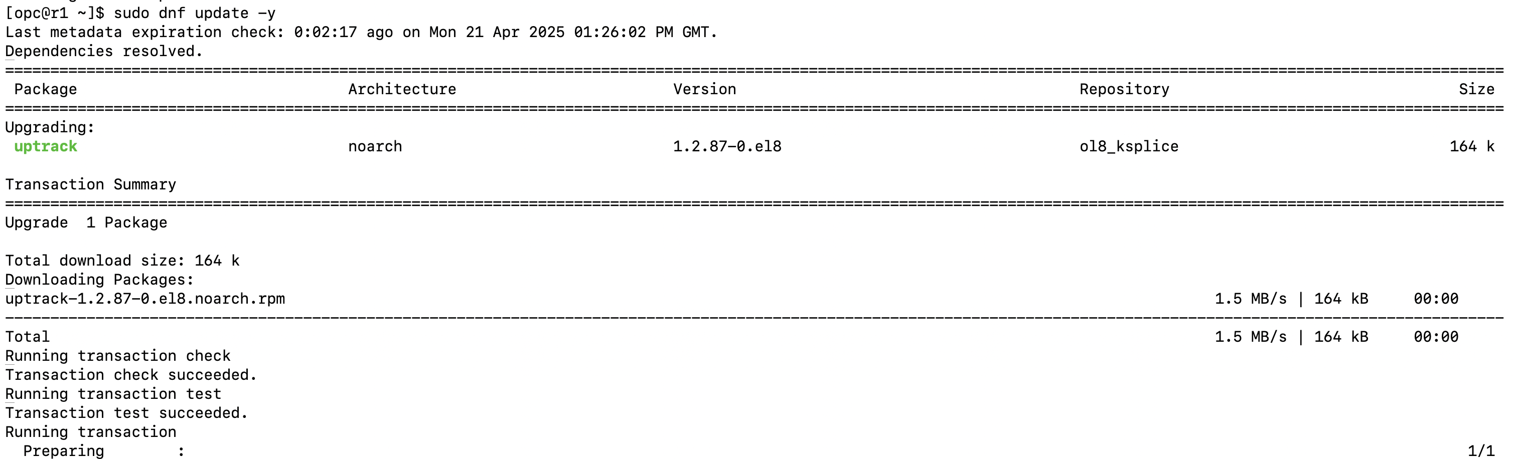

*sudo dnf install https://rpms.remirepo.net/enterprise/remi-release-8.rpm -y*

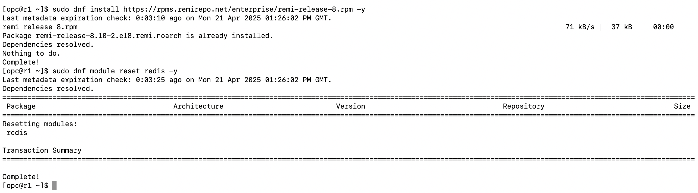

*sudo dnf module enable redis:remi-7.0 -y*

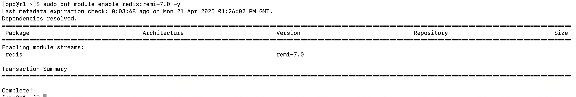

*redis-server –version*

Redis server v=7.0.15 sha=00000000:0 malloc=jemalloc-5.2.1 bits=64 build=2539154d11bf479d

**Installing Redis Enterprise:**

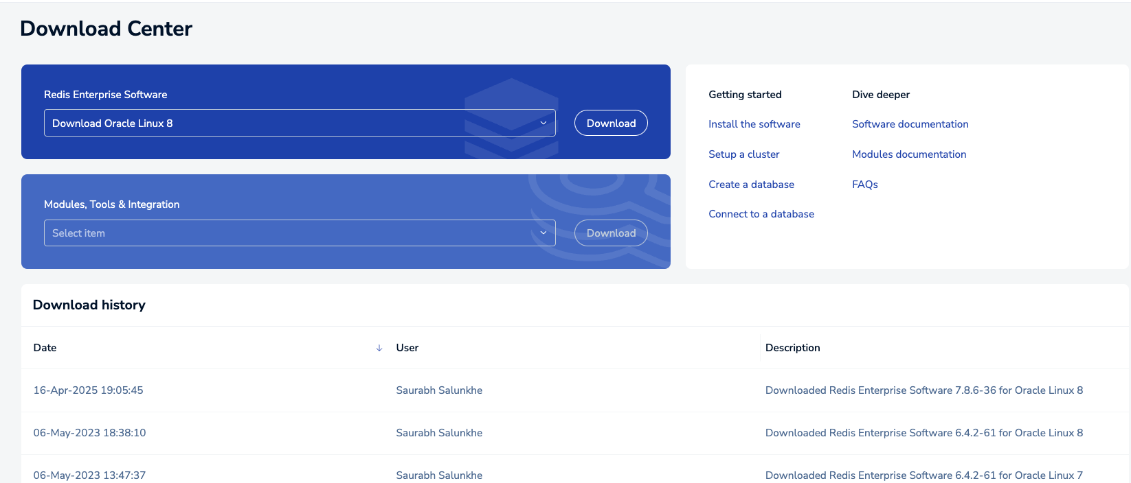

*tar xvf redislabs-7.8.6-36-rhel8-x86_64.tar*

*sudo ./install.sh -y*

*sudo /opt/redislabs/bin/rladmin status databases*

**

Enable Replication from the Redis console

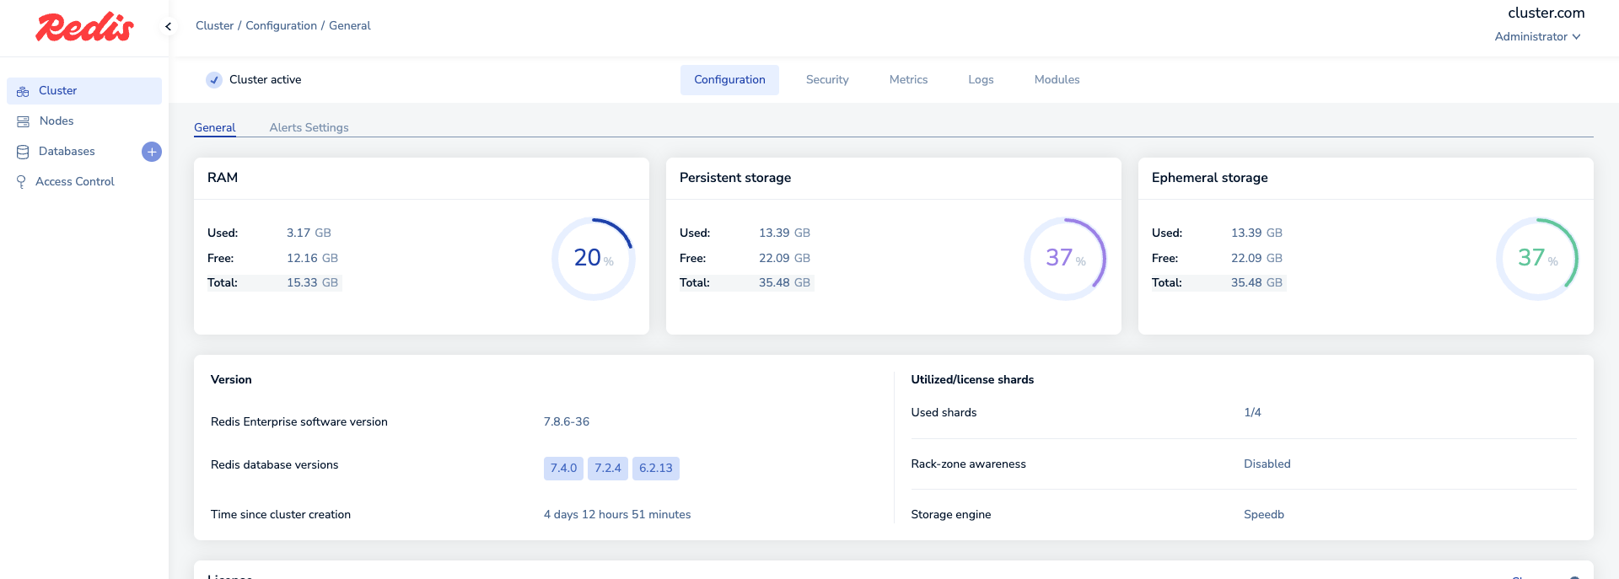

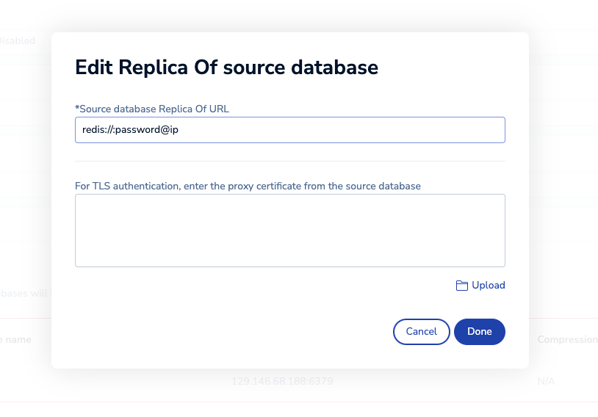

Using Redis Insight to visualize the results

