As per our understanding we need to create multilingual for Koerber System (Customer Login and MSP login), so here are our assumption and estimation accordingly:

1. We will display a dropdown section to change website language from login section.
2. We will cover all static text and labels text to convert into selected language except third party plugins and the text which are generated by scripts.
3. Database values will not be changed according to selected language like below.

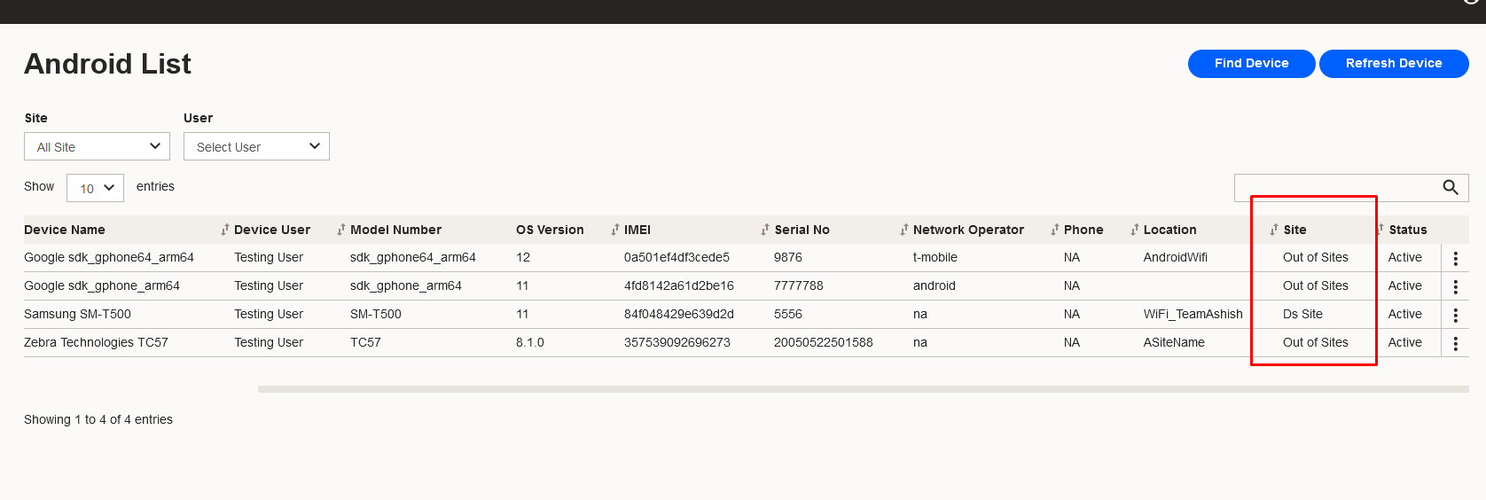

So we will not change any data according to selected language in given estimation.

1. Messages (On Add/Edit/Delete/Error messages) will be changes as per the selected language.

Estimation:   
Website - 6 Weeks  
API - 1 Week (Data string only)  
Mobile – 1 Week (Per Application)

Question: There are some master data coming from database like mentioned above in attached screenshot with point no. 3.  
 So if you want to control these types of data according to selected language then we have to make changes into database level as well which would be big change for current System.  
So please let us know do you require language control on data as well so that we can re-estimate the complete estimation.