**Suggestions doc: Primehangout**

To meet the user’s growing expectations & requirements, platform needs to be updated constantly, and we have a few suggestions, as follows:

1. **About Section:** Several features can be added in the About Section, such as:

* Contact Information like contact no., skype name.
  + User can update their contact information in the about section so that friends can know about their contact information.
  + Users can set the privacy setting on the contact information. Users can decide who can see their contact information.

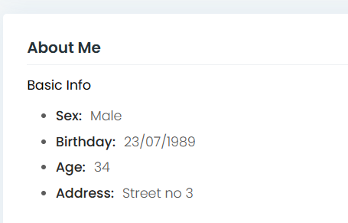

* Places lived
  + Users can update the information about the places they lived for colleges, jobs, etc.
* Other names
  + If the user is known by many other names, then the user can add those aliases, so that their friends can easily search them.

**DS =>**

1. **We can provide a separate tab in Edit Profile for some extra information about user like: Nick name, Employment, Study, Living etc. with privacy settings(Public, Private, Friends).**
2. **Show some information in user profile according to privacy settings.**

**Estimation: 16 hrs.**

1. **Notification:** Users should be notified of all activities happening in their circle. Thus, users will be notified in the following cases:

* Whenever any friend/connection will upload the image or video
* If any friend comments or likes any post.
* User can enable/disable notification for each post.

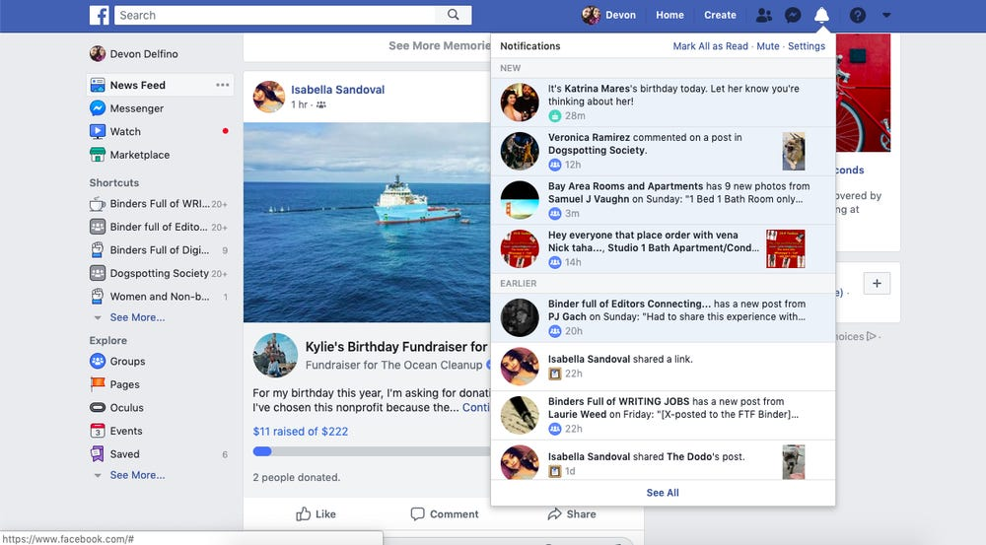

**DS=>**

1. **Provide notification count for each post like: Create a post, Post image, Post link, Post Video, Comment, Like/Unlike, Tag/Untag and Current birthday.**
2. **Show the details for each notification and when click on each then send to details page.**

**Estimation: 32 hrs.**

1. **My likes:** Users can view posts that they have liked or commented.

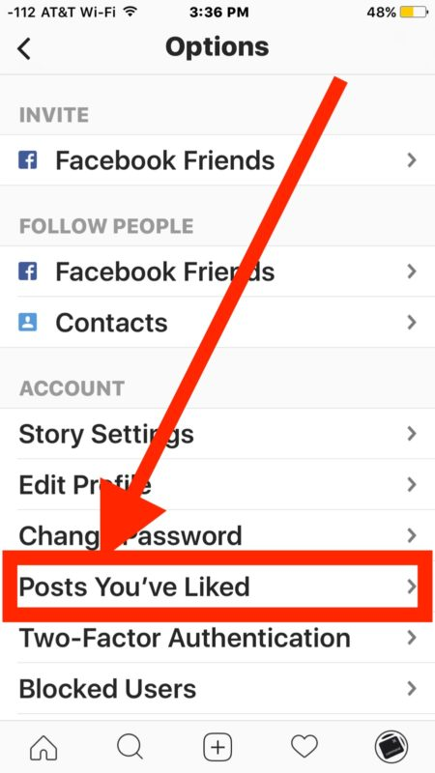

**DS=>**

1. **We can show recent Liked posts of user ex. Last 15/30 days.**
2. **Provide view/edit facility.**

**Estimation: 18 hrs**

1. **Repost:** User can repost/share any post with their connections on the platform. Now that post will be visible on user’s profiles and their connections can view the post in their feed as shared by the user.

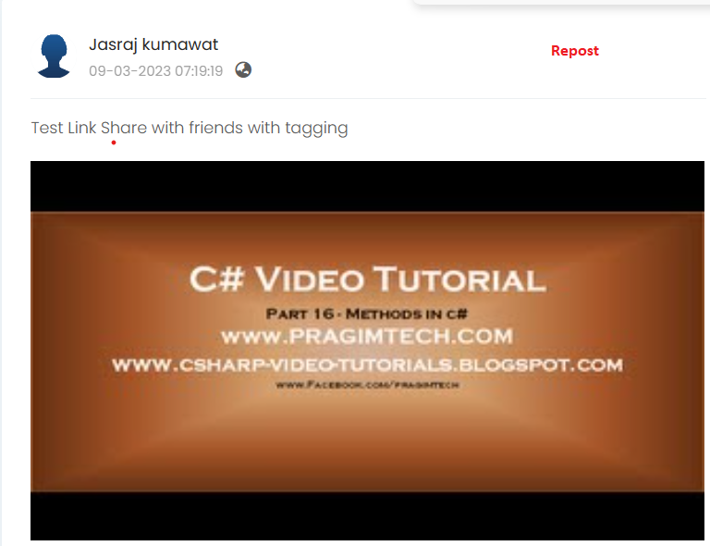

**DS=>**

1. **We provide the option of Repost to current user and any friend’s post with privacy settings like: Public, Private, Friends.**
2. **show the this Repost on their time line.**

**Estimation: 16 hrs.**

1. **Blogs:** Users can post/write blogs on the topic they are interested. Users can share blogs with their connections.

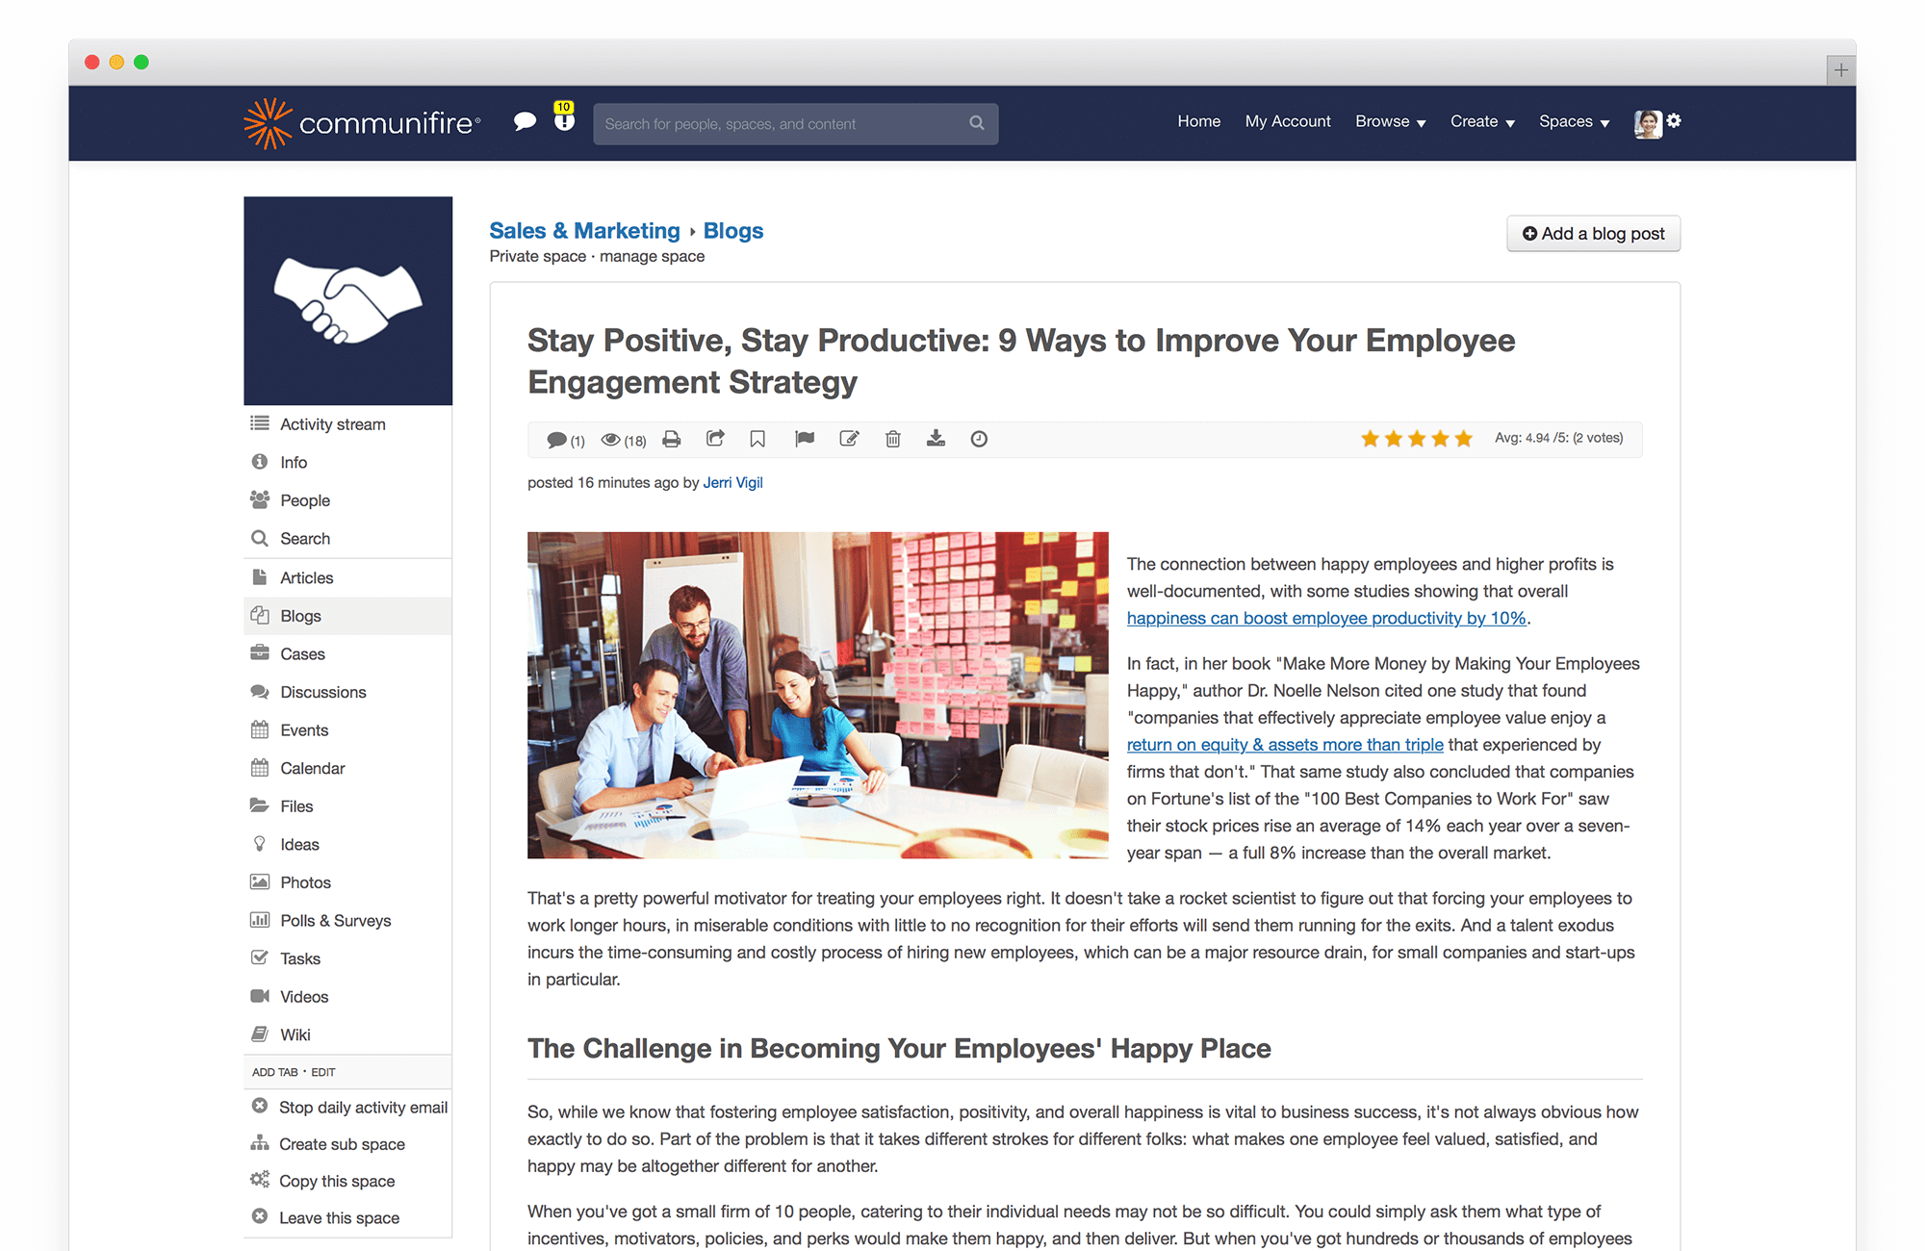

Pros of Blogs:

* Every blog is sharing, exposure and influence opportunities. Each blog has its title and content to back it up, when it is shared others see it, read it, share it, and give it their endorsement.
* User writes blogs to share their passion and to educate others. When users have content to share with their connections. User will receive instant feedback.
* Increases user engagement & traffic on the platform.

Cons of not adding Blogs:

* Users need to search for the content on other platforms.
* A total of 81 percent of Online Holiday Shoppers Read

Research says:

* [According to the survey, 47% find new blogs by Googling, the next most prevalent way is social media (33%) and links in other blogs (33%).](https://www.researchgate.net/publication/301695615_BLOGS_IN_A_CHANGING_SOCIAL_MEDIA_ENVIRONMENT_PERSPECTIVES_ON_THE_FUTURE_OF_BLOGGING_IN_SCANDINAVIA)
* [Results indicate that blogs are a means for bloggers to disclose aspects of themselves through the blog narrative. Readers develop ties with both the blog and the blogger, while homophilic traits are relevant to explaining readers’ choice of blog affiliation. Commercial intervention on blogs generates buzz if aligned with the blog’s language, if the message content fits the blog’s narrative, and if the product is close to the blog’s subject of interest.](https://link.springer.com/article/10.1057/dddmp.2013.45)

1. **Sent Birthday Card:** Users can send the birthday card to their friends on their birthday. Few templates of the card will be available to the user.

Also, we can add a **Birthday Story feature**, which will allow a user’s friends, family and everyone in their community to add digital birthday cards, photos or videos to a story celebrating the day.

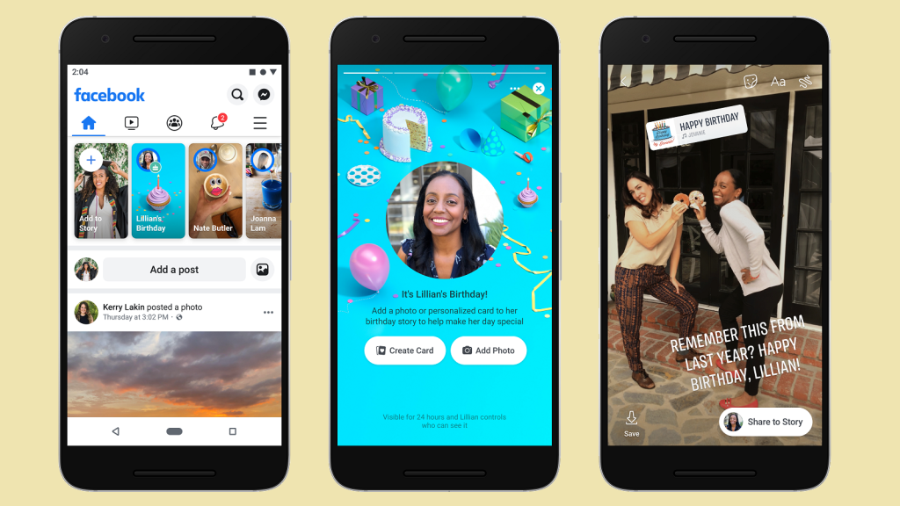

**DS=>**

**Birthday cards:**

1. **We provide the additional option of send birthday wishes with some birthday templates and preview with selected birthday image.**
2. **Show the birthday wish with selected template.**

**Estimation: 24 hrs.**

**Story:**

1. **We provide a option of Add a Story(Image/videos) on Dashboard. Where user can select image/video for story.**
2. **Display the story(with internal paging and next/prev.) on dashboard and user can like and comment on this.**

**Estimation: 36 hrs.**

1. **Message Request:**

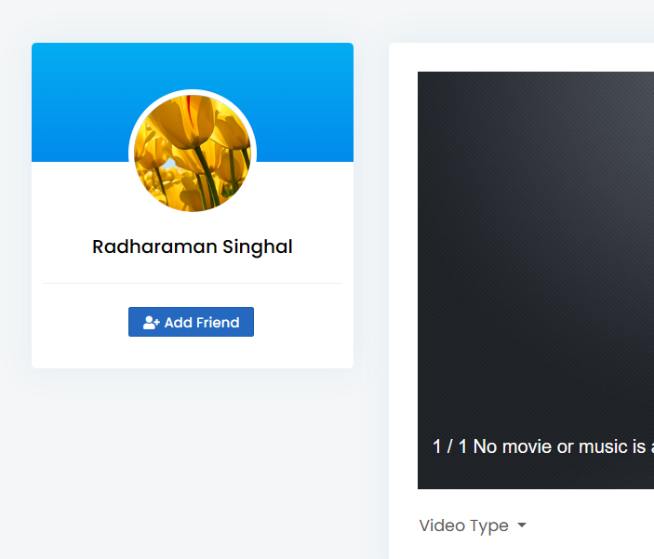

* Ability to send message to a user how is not in your friend list. This will help people to connect personally who have same interest  or want to add a personal note while sending friend request.
* For the above feature: Message Request from users who is not in your friend-list. This is where the platform sends all the missives from people you are not currently friends with.

**DS=>**

1. **We provide a text box with friend request where user can type the option message to requested friend.**
2. **Requested friend can see the friend request with message and take action accordingly.**

**Estimation: 12 hrs.**

1. **Extra security while user Login:**

**Enable Two-Factor Authentication**. It's a good idea to implement (Opens in a new window) 2FA on all your accounts. That means if someone wants to access your account on a new device, they'll need your password and a code generated by an authenticator app or sent via text.

**Get alerts about unrecognized logins**. If somebody logs in to your account from an unrecognized device or browser, system can let you know.

**Pros**: Two factor authentication can prevent unauthorized parties from accessing your accounts.

DS=>

pending

1. **Save Posts for Later:** It’s to impossible to go back and find something that you whizzed past during a recent scroll. User can save the post to “watch later”. 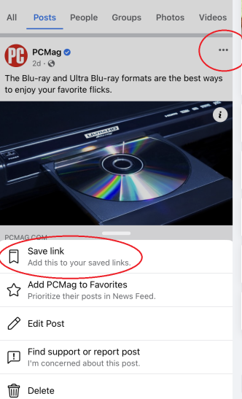

User can anytime view the post to from “Saved” folder.

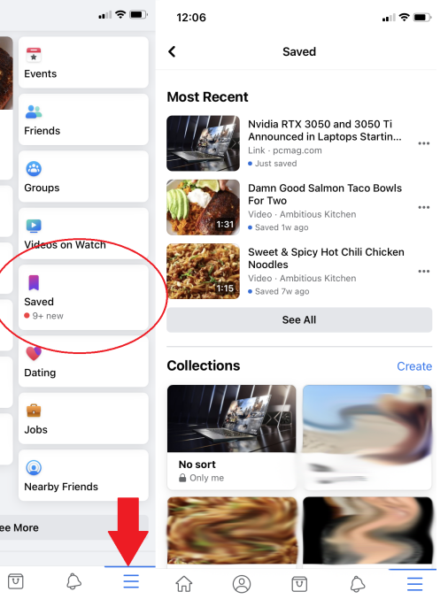

**Ds=>**

1. **We provide a option of Save to watch later, where user can add/delete it’s post’s references in save to watch later.**
2. **We can show the option for showing the Save to watch later items with delete option from in this list.**

**Estimation: 24 hrs.**

### **Pin your most relevant content**

User can pin a post from his account to keep it top-of-mind for visitors/friends. Try pinning an announcement, a promotion, or a high-performing post that your audience already loves.

**How it will work:**

1. Click on the **ellipsis button** in the post’s top right corner.

2. Select **Pin to top of Page.**

[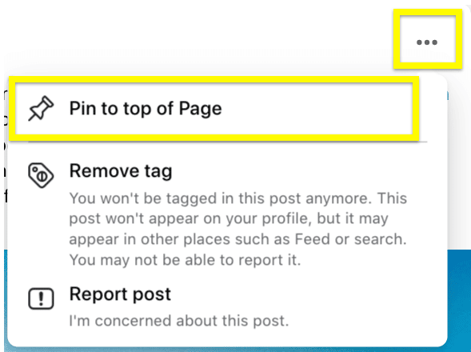](https://blog.hootsuite.com/wp-content/uploads/2022/06/Facebook-tricks-3.png)

**DS=>**

1. **We provide a option to set Pin to top for the post, if it sets then show the post on top of the page of all posts, user can set unpin also. User can set single post on top at a time.**

**Estimation: 10 hrs.**

1. **Download – Family tree**

Option for user to download his/her Family tree.

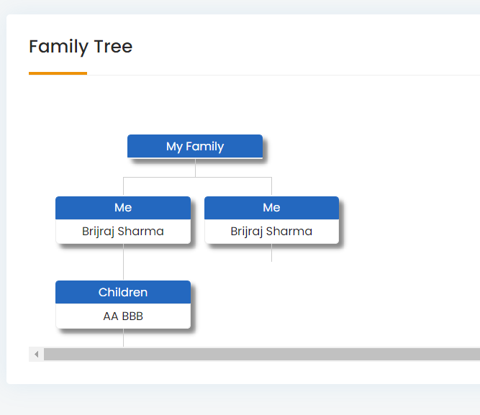

1. **Add family member picture in genealogy option:**

Option to add image in while making family tree. This will enhance the look of Family tree.

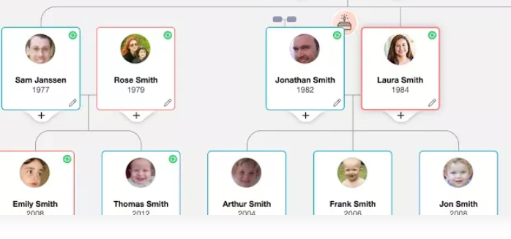

**DS=>**

1. **Need to create the design of new family tree and replace with existing tree and show some new information.**
2. **Provide option to download the display family tree in pdf format.**

**Estimation: 16 hrs.**

1. **Adding Stories: The power of stories cannot be underestimated.**

Stories are very user-friendly – both for creator and viewer

User can create 15 Seconds long stories and post on profile. Stories will be visible in his account for 24 hours.

User can now share stories with friends and see what other friends have been up to for the past 24 hours.

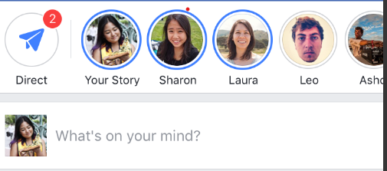

24 hours, posts in your story disappear forever.