1. **sClassified =>**
2. Change Payment Gateway from PayPalto the new payment gateway. The new payment

gateway interface code will be sent separately.

DS Comment = We will provide the estimation after testing Authorize.net payment gateway.

1. No Ad is allowed to be displayed until payment is made.

Estimated Time = **4 hrs**.

1. Every feature of sClassified is expected to work as originally designed.

DS Comment = We do not disturb the previously working code, it will working as it is.

1. sClassified fully paid for are allowed to be displayed on users’ walls as explained in section

“D” below (D :- will be following as the heading for all sClassified Ads expected to display 3 Ads per about 45 seconds interval.). This is in addition to the internal current flow of sClassified Ads. Same as sClassified App.

DS Comment = 1. we will do design work for displaying ‘sclassified ads’ just like ‘promotional ads’ to show on dashboard and profile page.

1. all ads can be see one by one as working in ‘promotional ads’.
2. If click on any ad then open the ‘Available Job’ page for clicked job, where can apply the particular job.

Estimated Time = **12 hrs**.

Note: design and slide duration of ‘sClassified ads’ are same as ‘promotional ads’

1. **Display Ad to Promote Your Business =>**
2. Change Payment Gateway from PayPal to the same as sClassified.

DS Comment = We will provide the estimation after testing Authorize.net payment gateway.

1. Video ads must be allowed to play video from YouTube, privately recorded, or in any other format. **This was previously developed and working fine. Somehow, it is not working anymore. We do not need 12hrs for this.**

DS Comment = according to you it’s working fine then We do not disturb the previously working code, it will working as it is.

1. Text-only ads are only allowed to display the first 2- or 3-lines, allowing users to click “More” to see the rest.

**The logic for this was just developed. Implementing this in another section of PrimeHangout should not require 4 hours again. We are not reinventing the wheels here.**

DS Comment = the logic was developed but it’s in new page changes and perform testing accordingly, so some code level changes required to done.

Estimated Time = **4 hrs**.

1. **News/Message on User’s Wall =>**
2. The message must be allowed to display without having to click “More” to see the rest.
3. Current and previously posted messages can display all the time for users to see everything without clicking “More.”

DS Comment = we will remove the more button and show next post while scrolling down of mouse on Dashboard and Profile page.

Estimated Time = **6 hrs**.

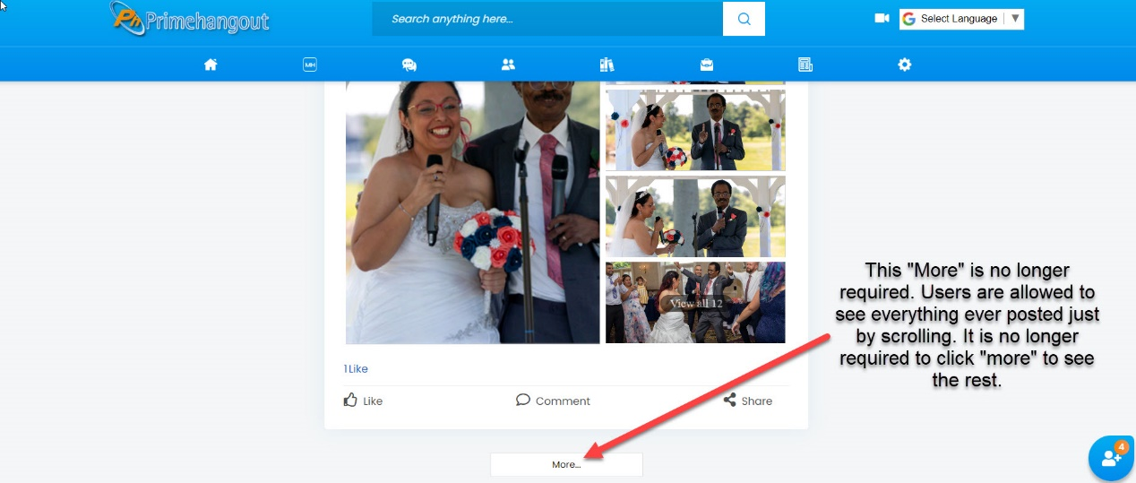

1. **Users’ Wall** (Re-arrange the right side of the users’ wall to show the following) =>
2. “Advertise Here” link at the top of the column on the right, followed by.

Estimated Time = **2 hrs**. (will change the design and css work for responsive)

1. Promotion as the heading for all Display Ads .

Estimated Time = **2 hrs**. (will change the design and css work for responsive)

1. Classified will be following as the heading for all sClassified Ads expected to display 3 Ads per about 45 seconds interval.

DS Comment = we show all available job(paid) as working in ‘Promotional ads’.

Estimated Time = covered in above sClassified changes.

1. “People You May Know” will be displayed on the left under the Profile picture.

Estimated Time = **2 hrs**. (will change the design and css work for responsive)

**Total Estimation is 32 working hrs.**

**Note: Regrading Payment Gateway changes, Estimation are excluded.**