**Claim :**

1. **Change of “policy Number” showing below fields value using java script :**

**Web Resource Name** : Rising Edge Events

**Function Name** :claimCoverageOnChanged

Child Policy Number (A)

Child Policy Number (B)

Policy Year

Policy Start Date

Policy End Date

Policy Aggregate Limit

Primary/Excess

AffectedPolicy

SIR

Insured Name

Claimant Name

Claim Date Notified

Premium Settlement Date

Rising Edge Share

Broker Company

Claim Currency

Date of Declinature

Type of Denial

Denial Value

Denial Indicator

Policy Limit

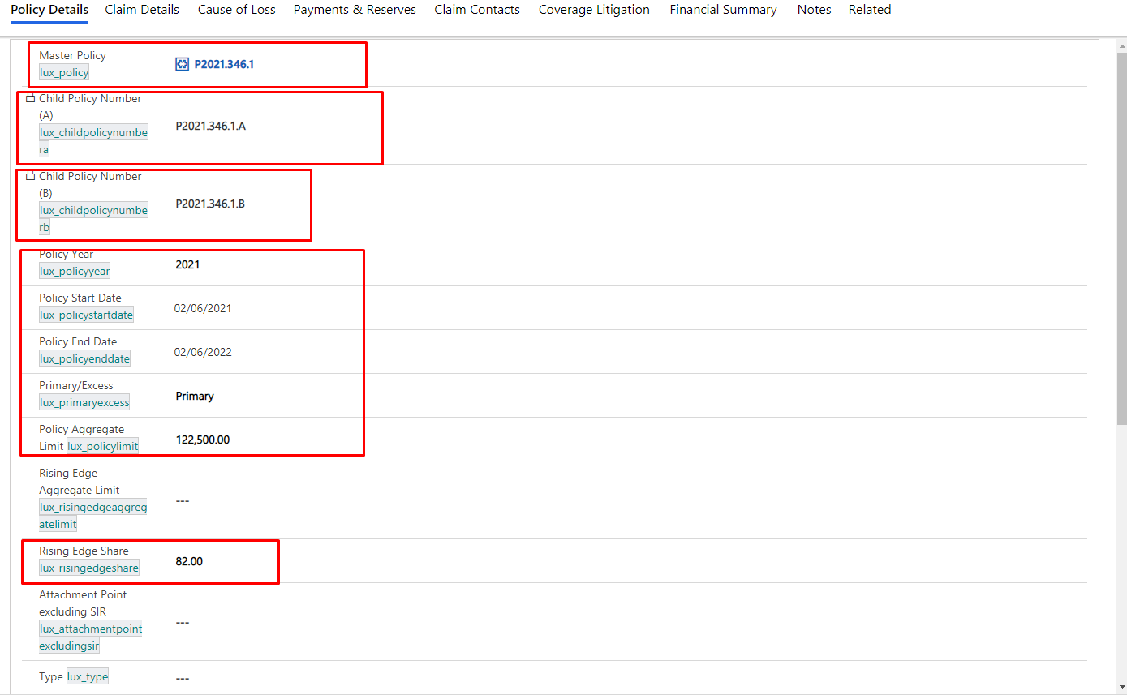

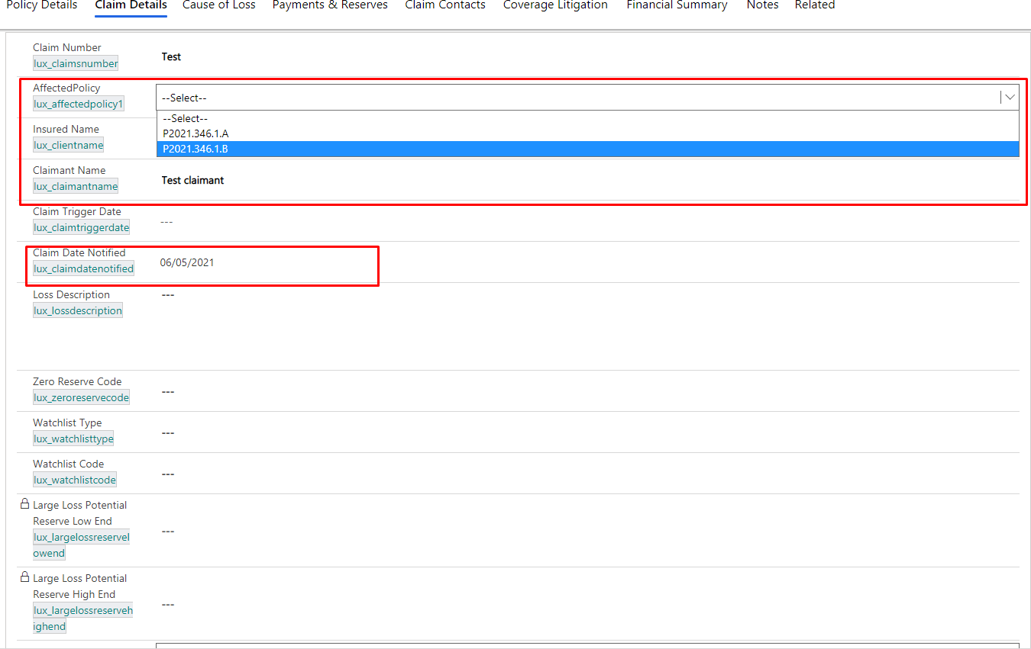

**2. Change of “Litigation Applicable” hide and show fields using java script :**

**Web Resource Name** : Rising Edge Events

**Function Name** :LitagiationOnChaged

Showing following fields if “Litigation Applicable” yes and hiding if no:

Litigation Country

Litigation State

Dispute Amount

Dispute Currency

Dispute Narrative

Venue

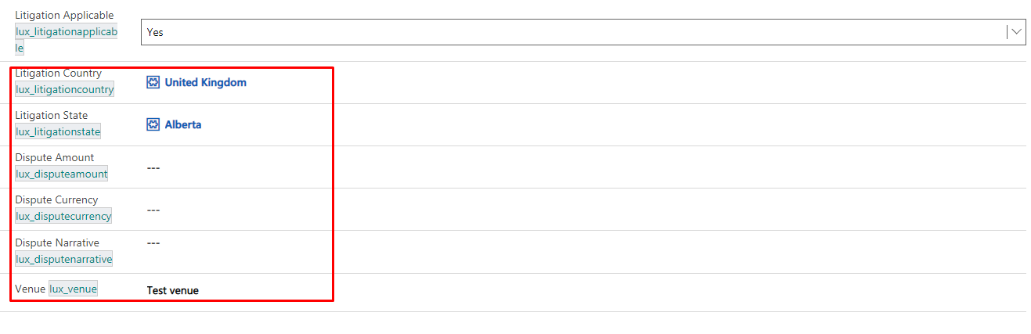

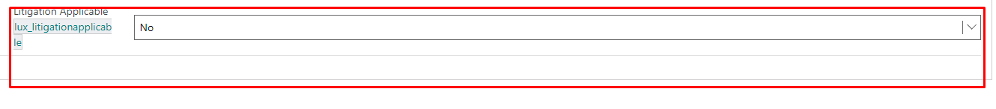

**3. Change of “Claim Declined” hide and show Fields using java script :**

**Web Resource Name** : Rising Edge Events

**Function Name** :claimDeclOnChanged

Showing following fields if “Claim Declined” yes and hiding if no and blank:

Date of Approval for Declination Received Date Show (if Claim Declined is No and Blank )

Denial Value

Denial Indicator

Declined Value Currency1

Date of Declinature

Type of Denial

Declined Comments

Date of Declinature

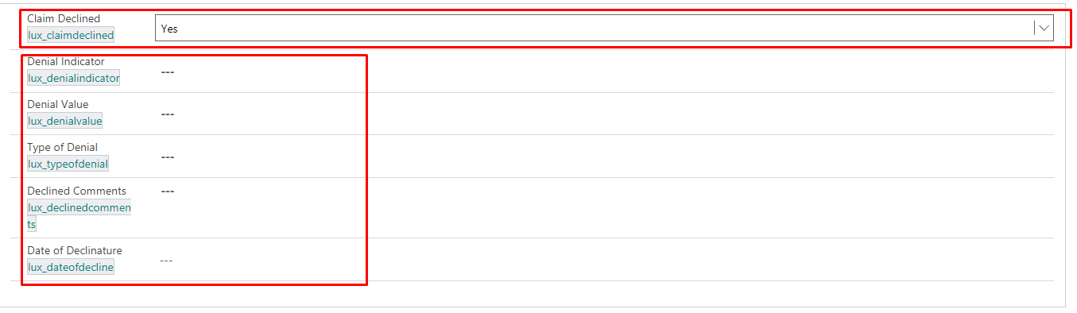



**4. Rename subgrid header on "Payment & Reserves Tab" using java script :**

**Web Resource Name** : Rising Edge Events

**Function Name** :onLoadClaim

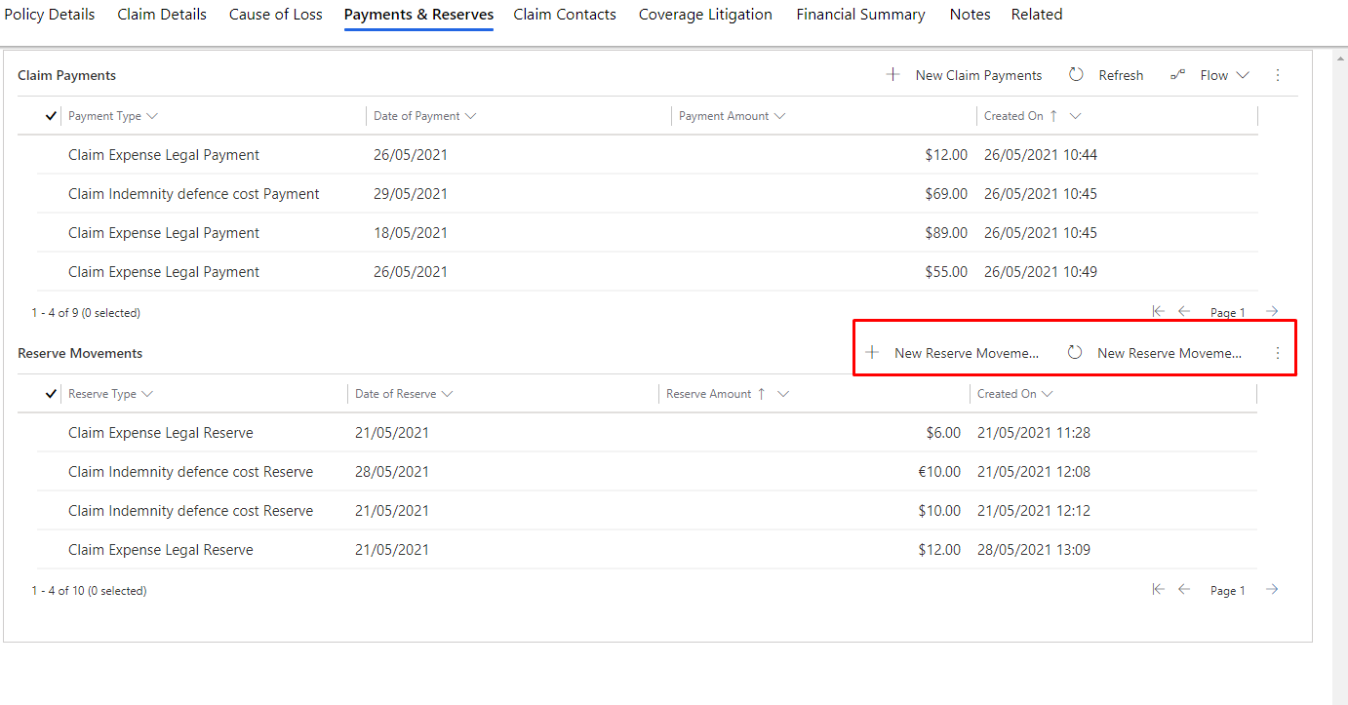

**5. Reserve movement subgrid showing “Total Reserve Amount” using java script :**

**Web Resource Name** : Rising Edge Events

**Function Name** :reservePaymentTotal

**6. For “Summary Tab” using java script showing “Reserve Type, Total Payment,Last Update” using java script :**

**Web Resource Name** : summaryjs

**Function Name** :claimSummaryTotal

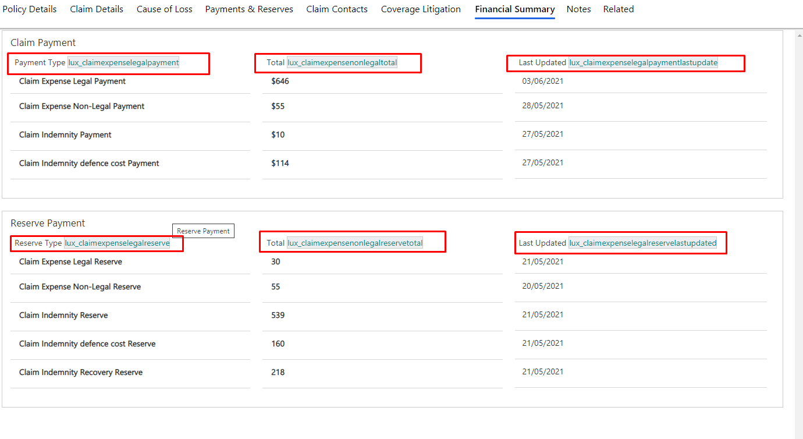

**7. When we create a claim record then “Claim Date Notified” set default to current date using java script:**

**Web Resource Name** : Rising Edge Events

**Function Name** :onLoadClaim

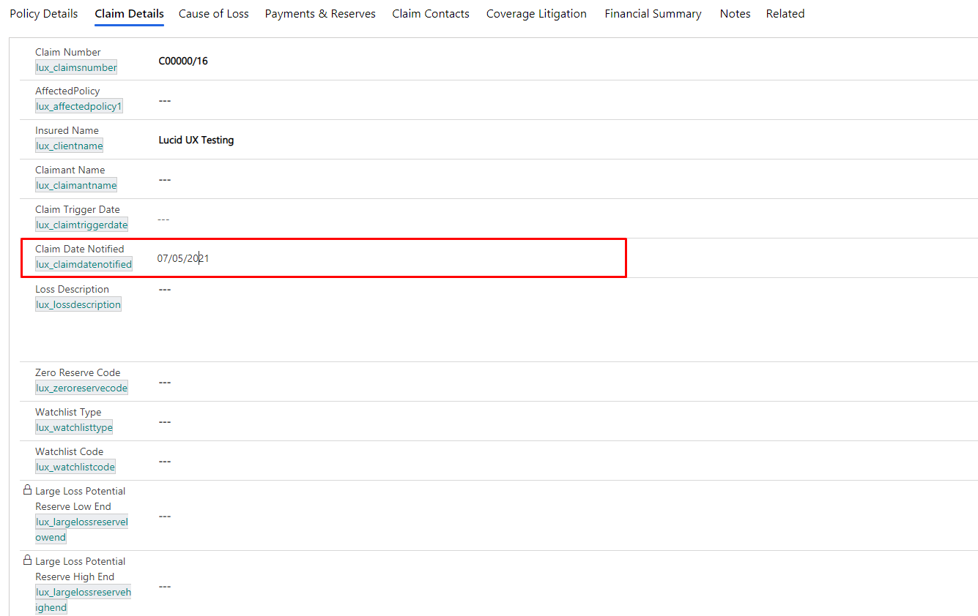

**8. When we create a claim record then “Original Close Date” set default to current date when Claim status is “Reopened” using java script:**

**Web Resource Name** : Rising Edge Events

**Function Name** :onLoadClaim

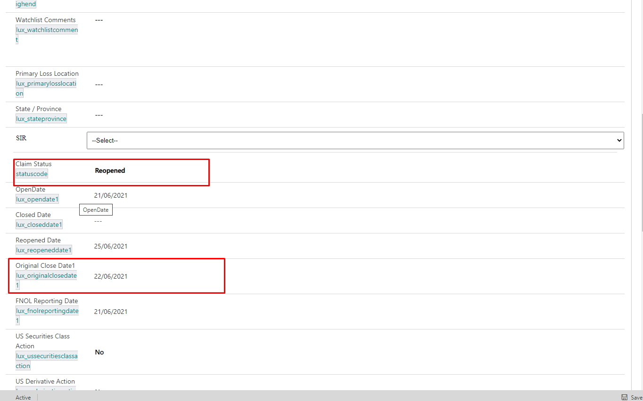

**9. Change of “Affected Policy” showing “Claim Number” using java script :**

**Web Resource Name** : Affected Policy Option Web Resource

**Function Name** :policyAffectedOnChanged

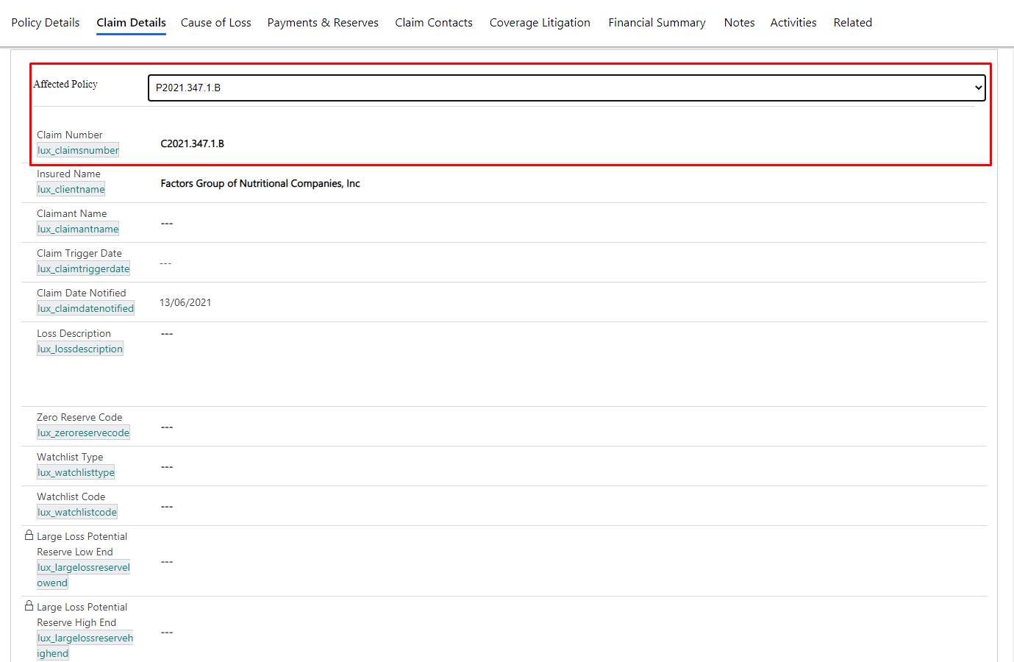

**10. “Claim Date Notified” default set current date using java script :**

**Web Resource Name** : Rising Edge Events

**Function Name** :onLoadClaim

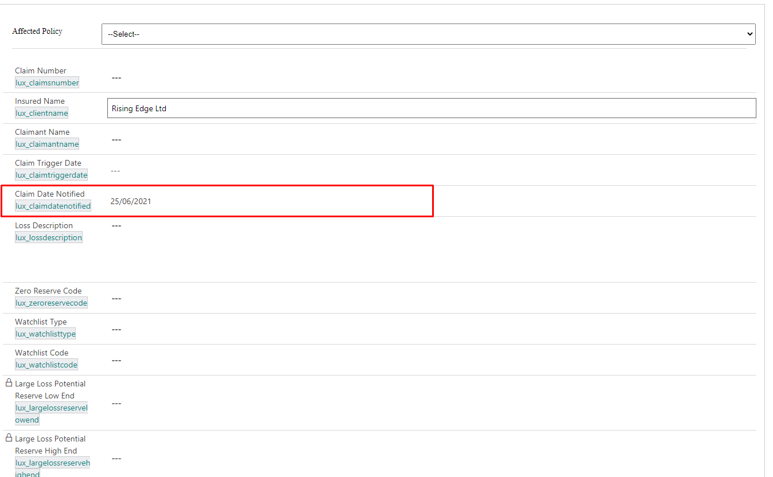

**11. “A policy record has a Quote Entry Record related. In the Quote Entry record, there is a field for Rising Edge Participation. This value is set against the **Rising Edge Share** field in Claims using javascript.**

**Web Resource Name** : Rising Edge Events

**Function Name** :claimCoverageOnChanged

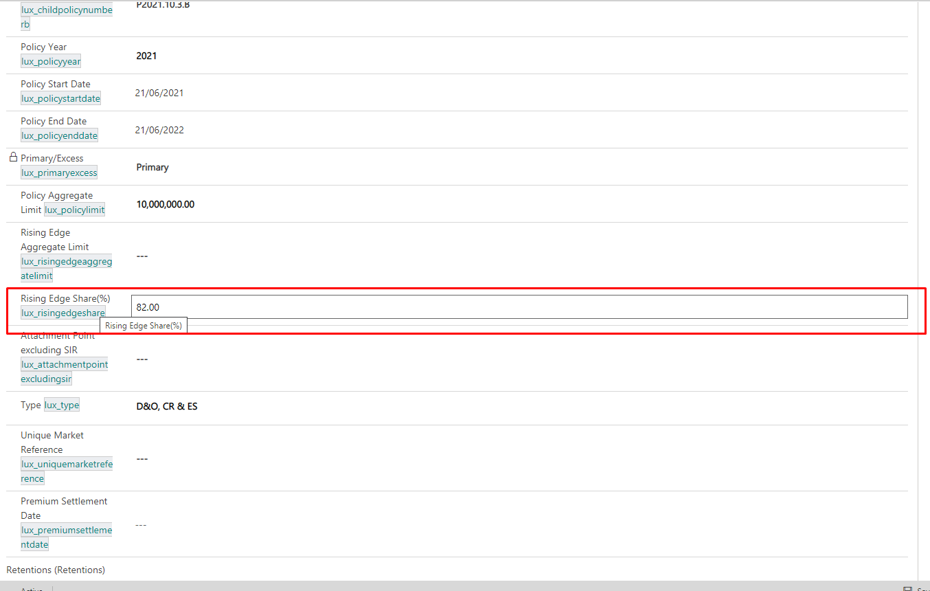

**10. Showing “Retentions” in claim related to quote entry Dynamically :**

**Web Resource Name** : Quote Retention Details

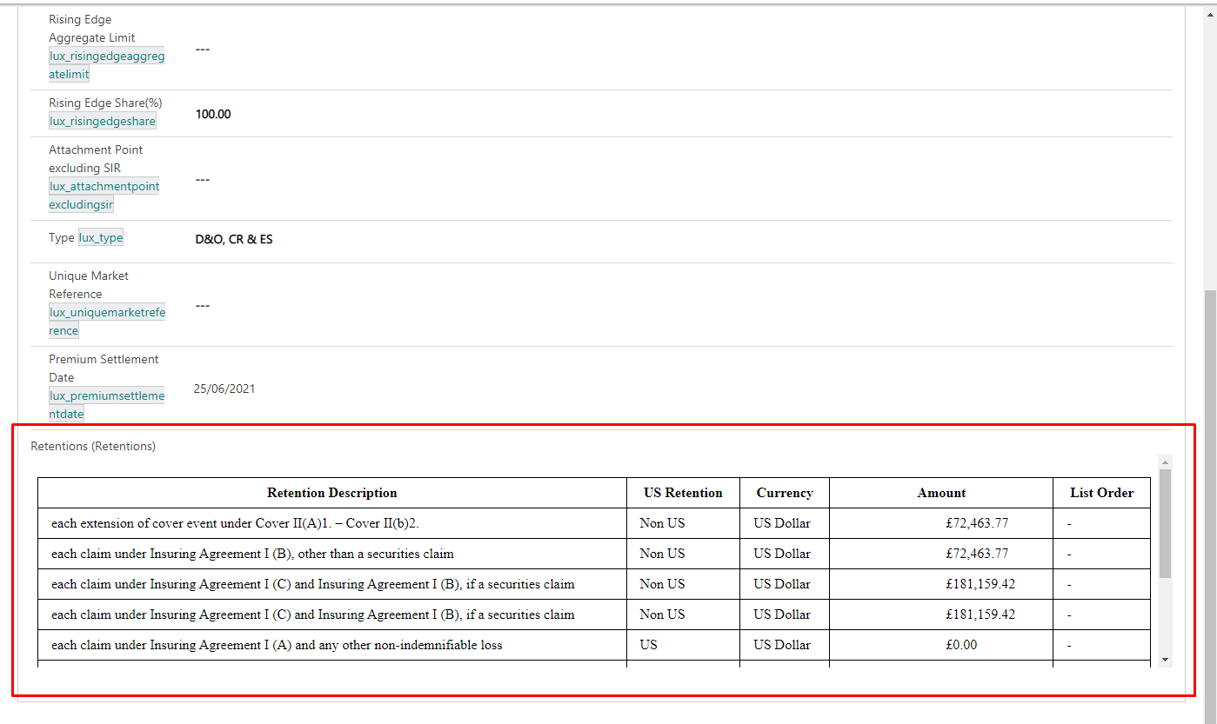

**New Fields :**

1. Field Name; Monitoring Counsel-lux_monitoringcounsel

Field Type: Single line of text (200 chars)

2. Field Name: Broker Reference -lux_brokerreference

Field Type: Single line of text (100 chars)

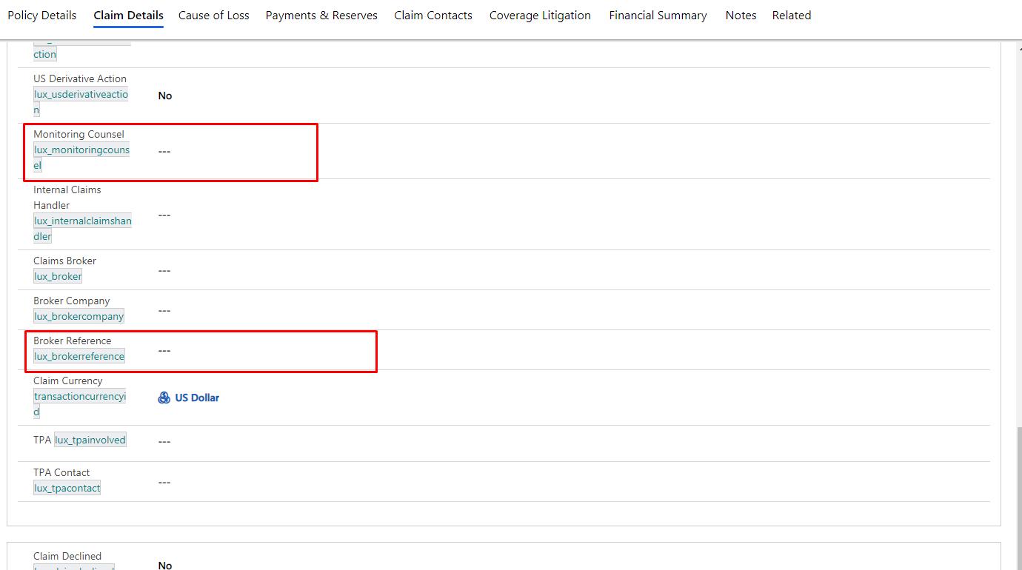

3.Field Name: Original Close Date - lux_originalclosedate

Field Type: Date

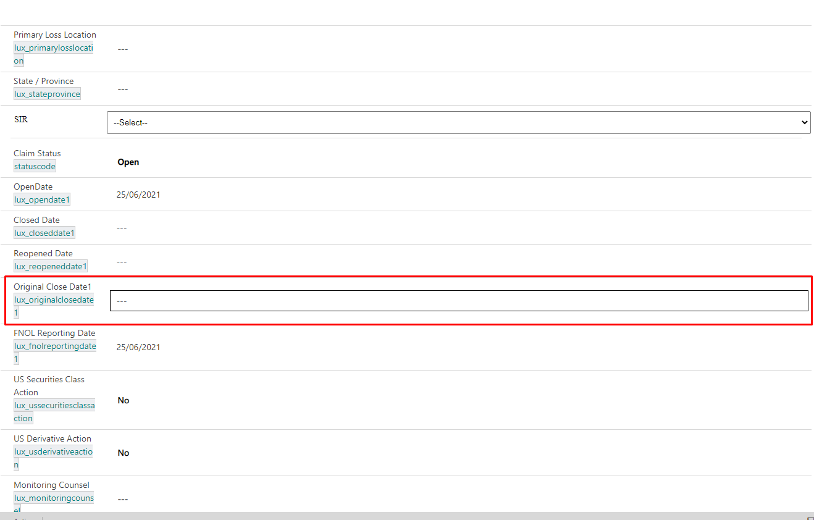

4.Field Name: FNOL Reporting Date - lux_fnolreportingdate

Field Type: Date

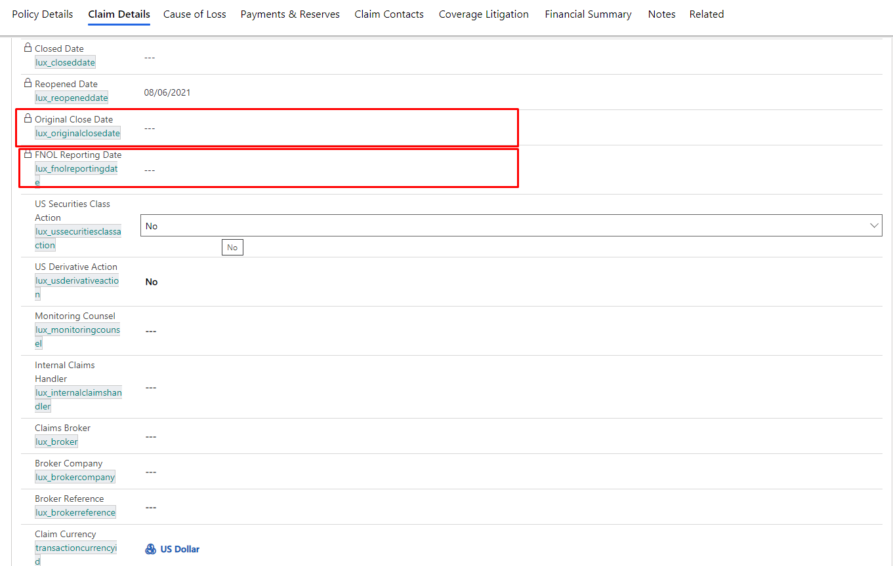

1. Field Name: Underlying Limits - lux_underlyinglimits

Field Type: Single line of text (200 chars)

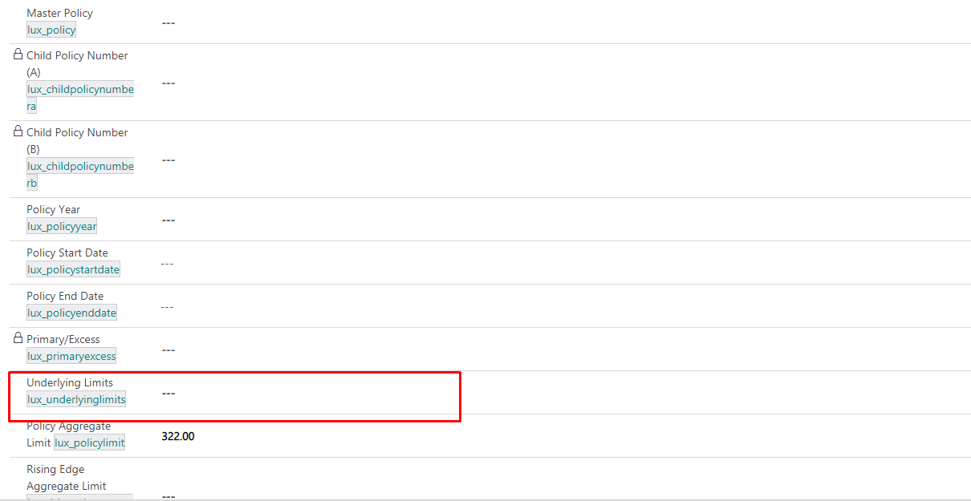

**Section :**

1. New section create “Coverage Litigation”in “Claim” form and add fields in this section.

- Litigation Country

- Litigation State

- Dispute Amount

- Dispute Currency

- Dispute Narrative

- Venue

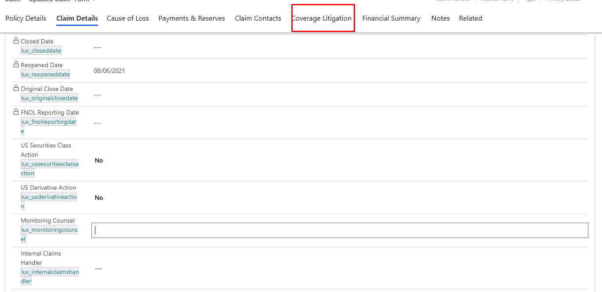

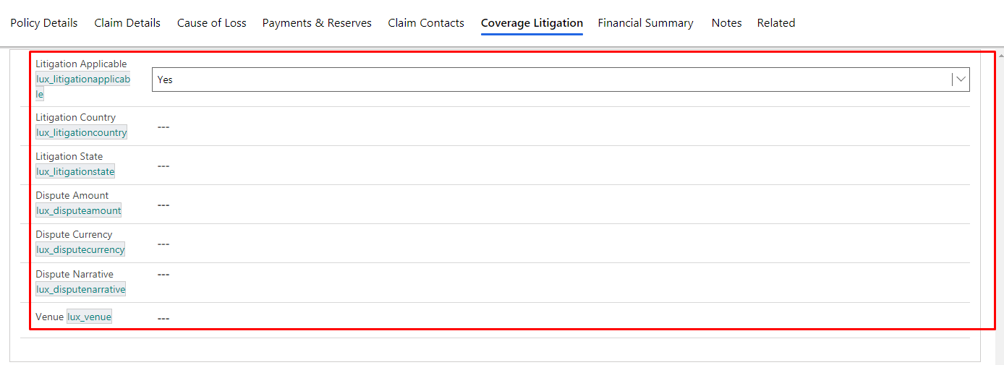

1. New section create “Claims Summary Report”in “Claim” form and add fields in this section.

- Claims Details / Background

- Financial Impact Details

- Current Status (Cover / Liability / Litigation / Other

- Next Steps / Resolution Strategy

- Request for Authority-

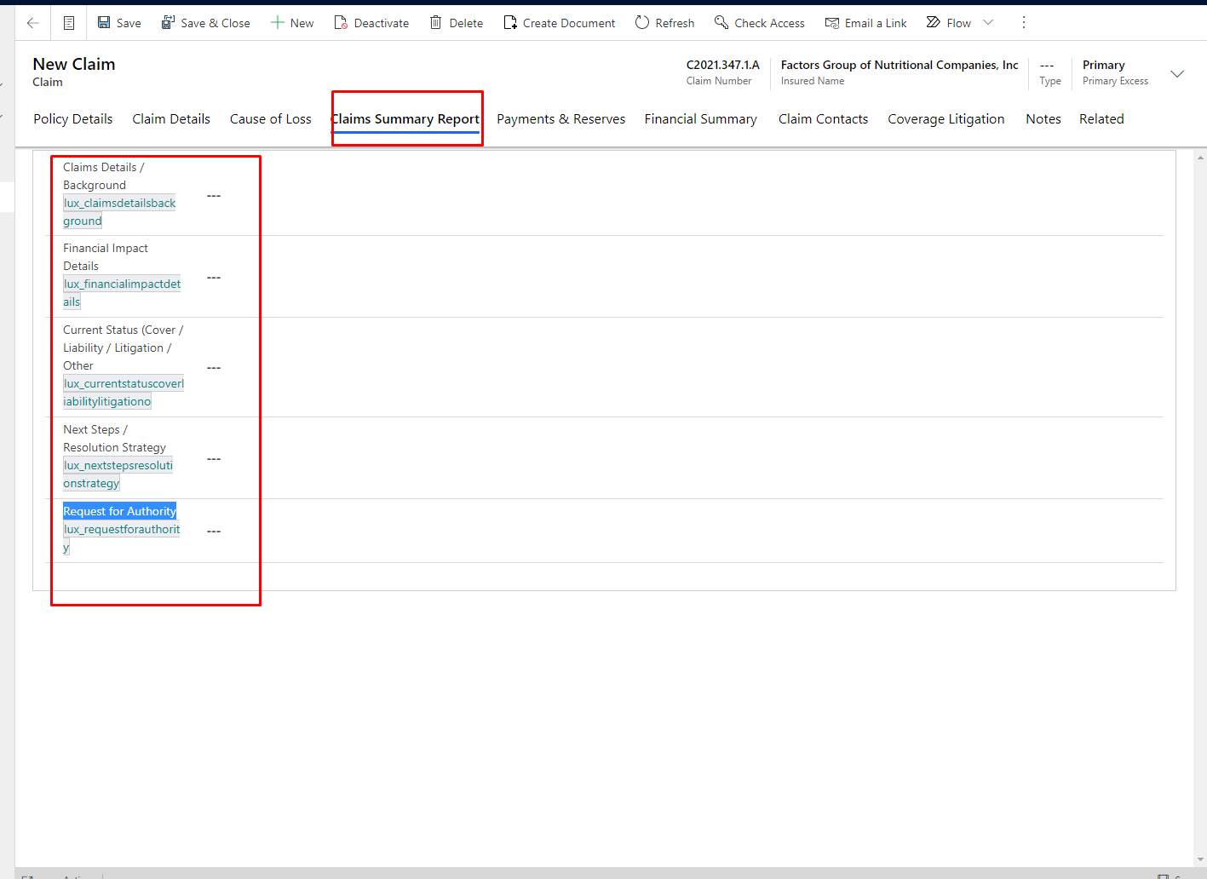

**Remove Fields**

1 US Securities or Derivities Class Action -lux_ussecuritiesorderivitiesclassaction

**Report :**

1. Report “Claim BDX Report” using report in claim.

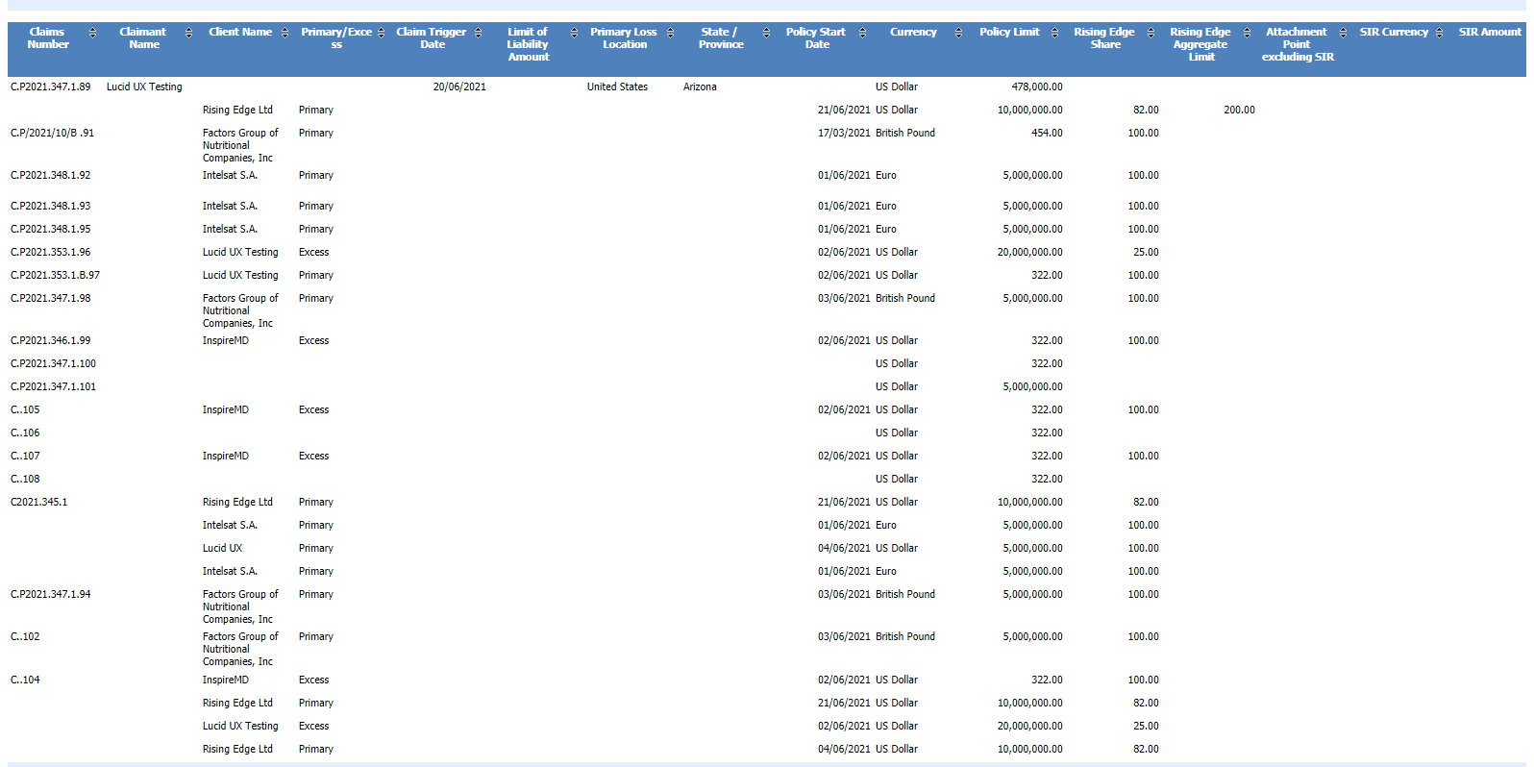

1. Report “Quarterly Large Loss Bordereaux ” using report in claim.

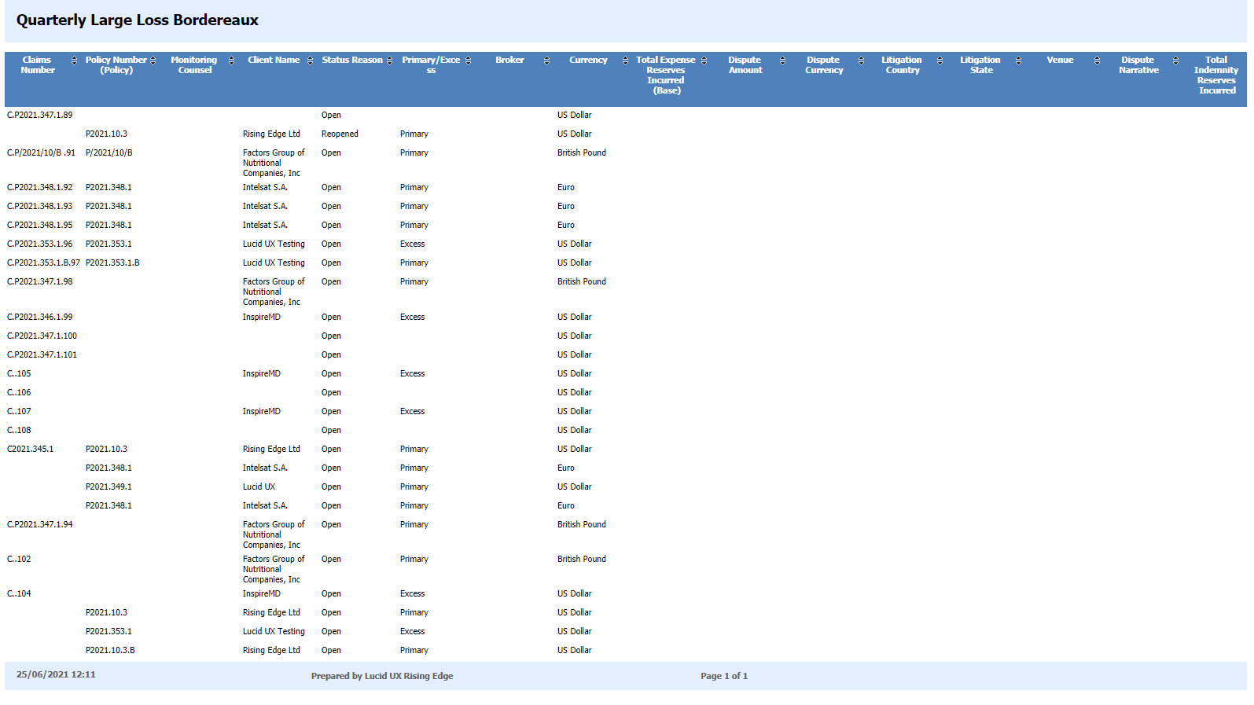

1. Report “Monthly Litigation Bordereaux Report” using view in claim.

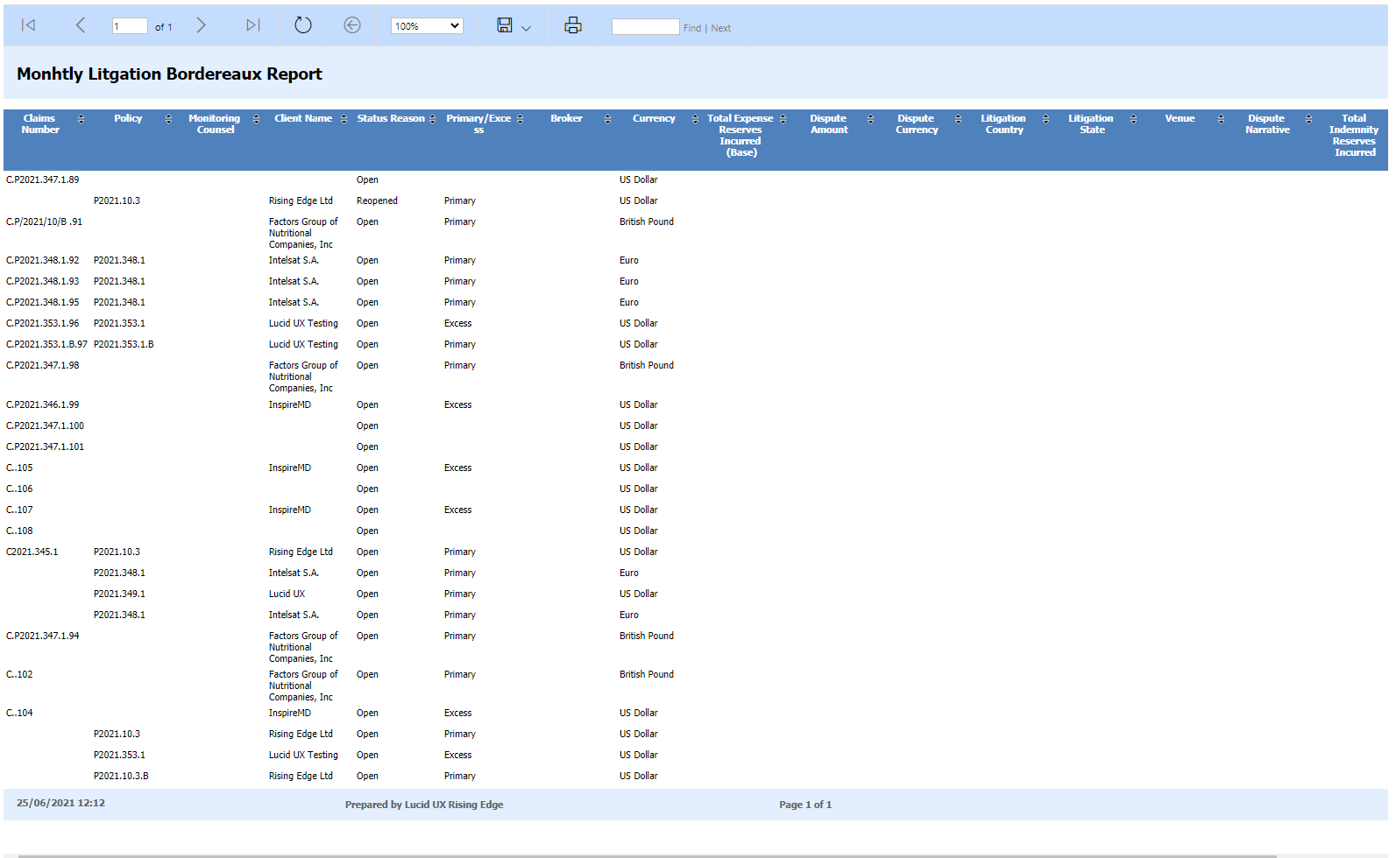

1. Report “FNOL (First Notice of Loss)Report” using report in claim.

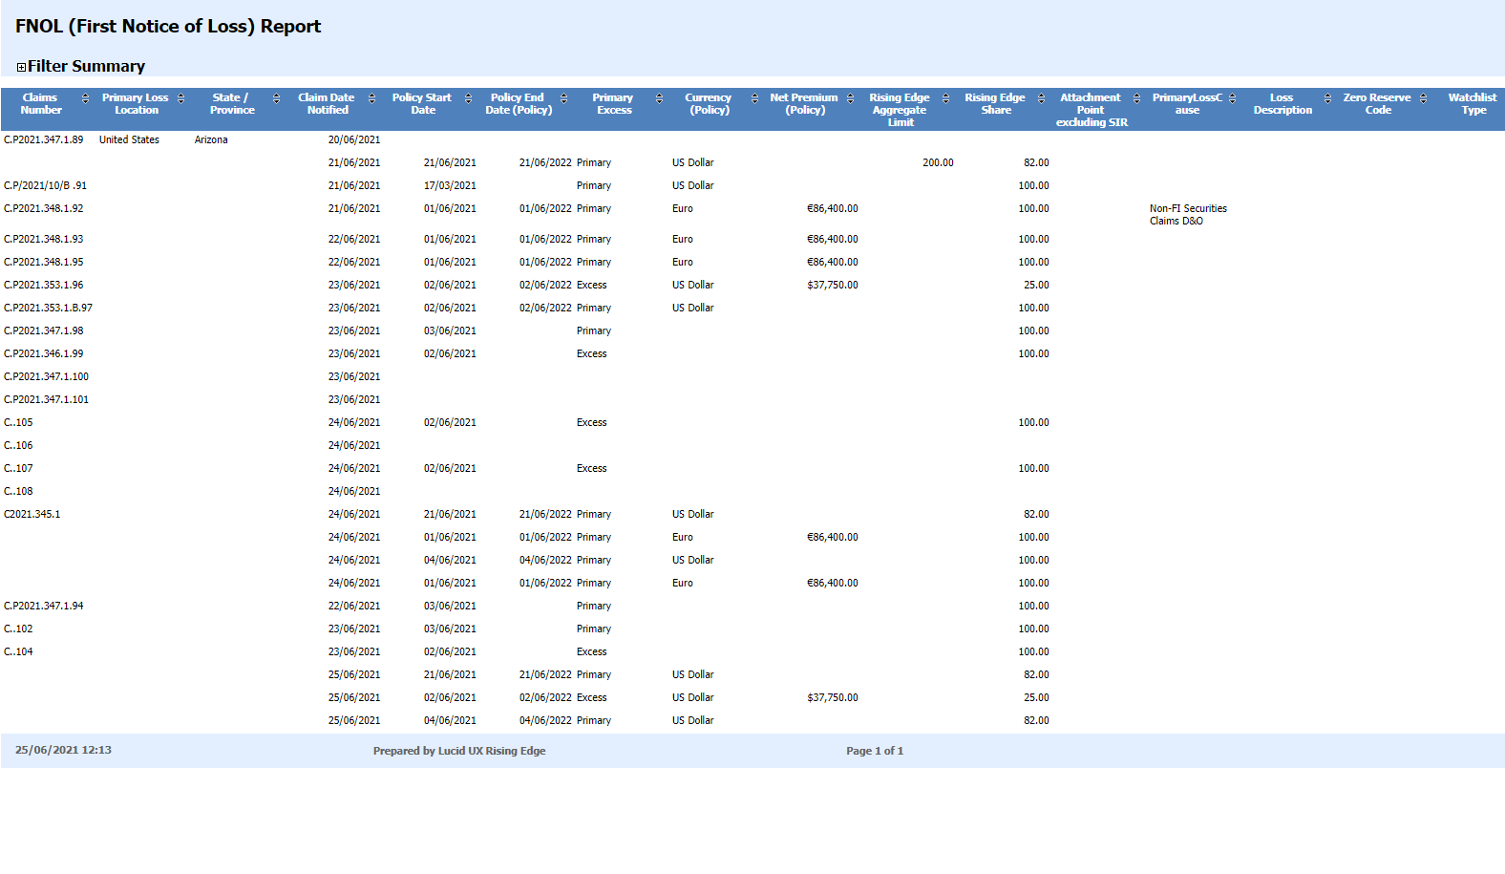

1. Report “Monthly Declinatures Bordereaux ” using report in claim.

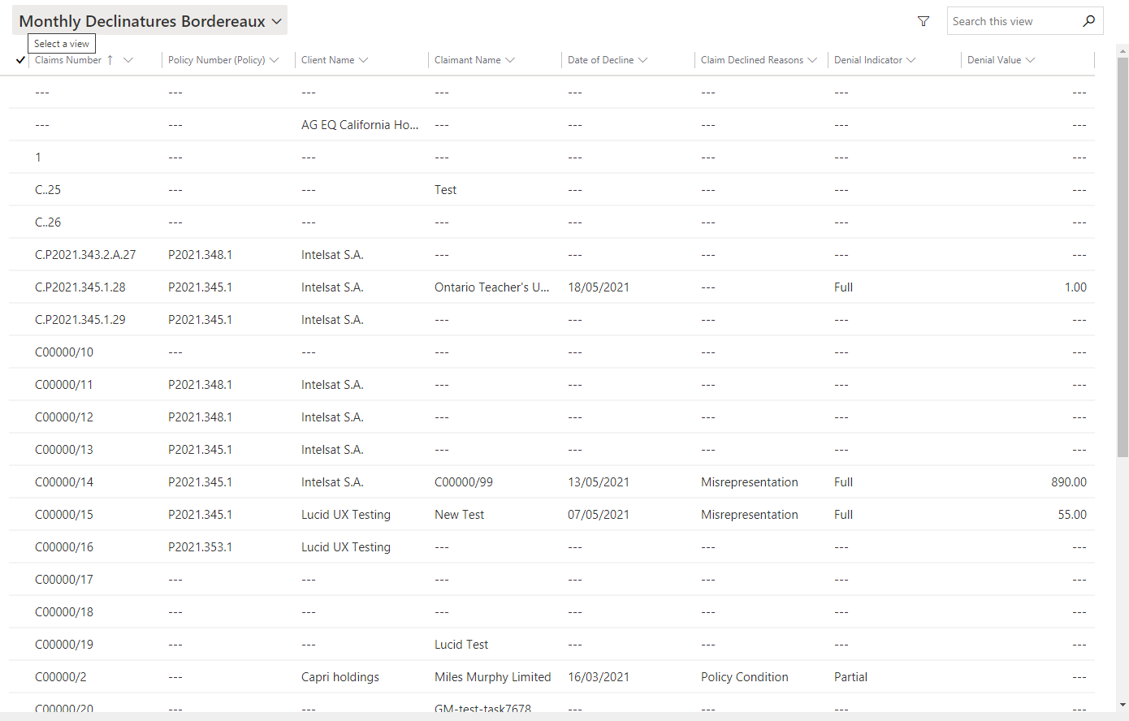

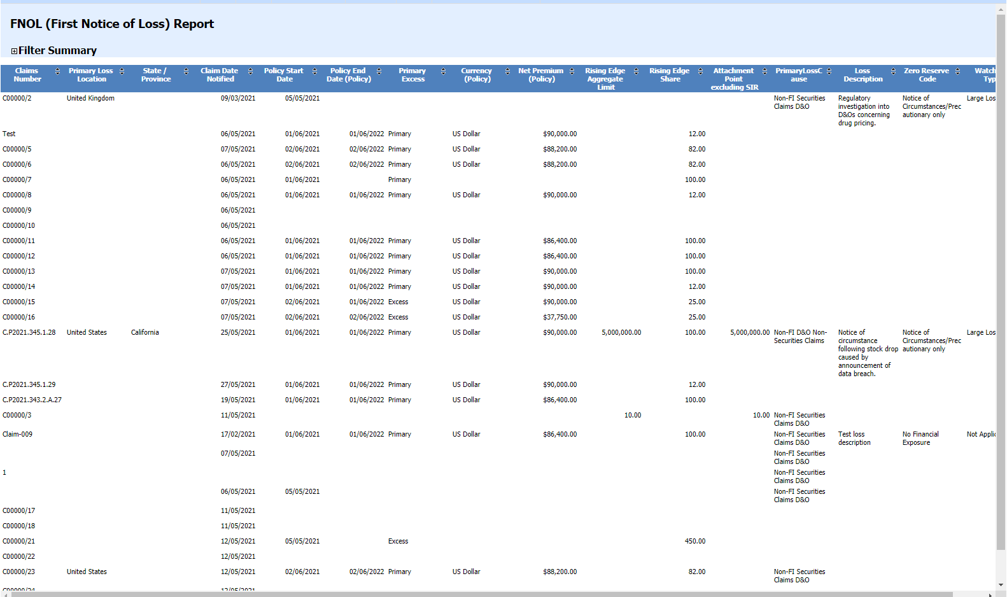

1. Report “Active Claims” Showing Fields using view in claim.

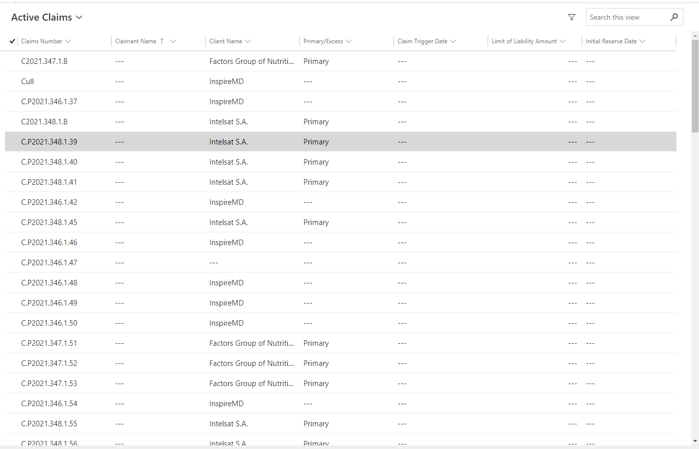

7.In Policy Lookup show “Policy Number” and “Client Name” using view.

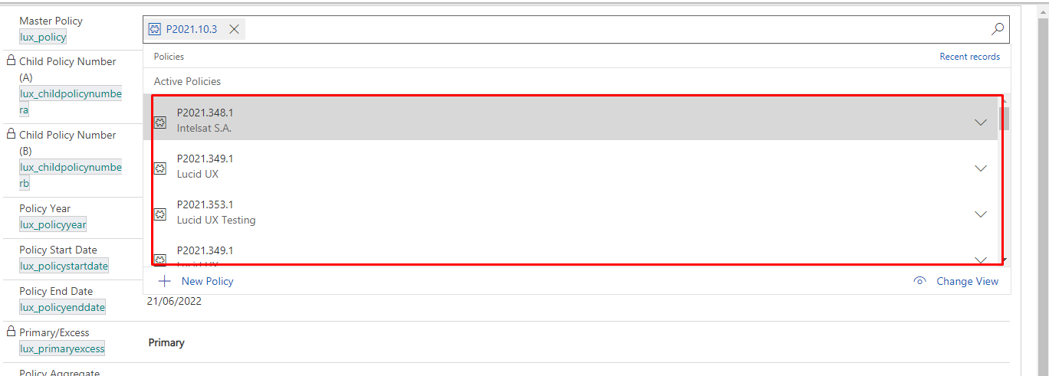

**Workflow:**

1. **Workflow Name:- ”SYSTEM-CLAIM ACTIVITY APPOINMENT”**

**Work :** When create a new claim then automatically generate 10 Follow up of 3 months Appointment create.

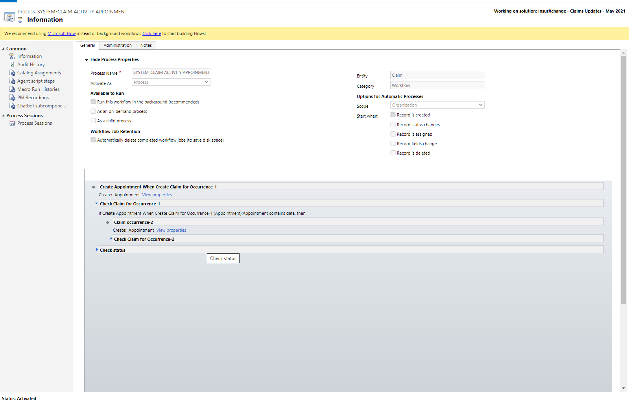

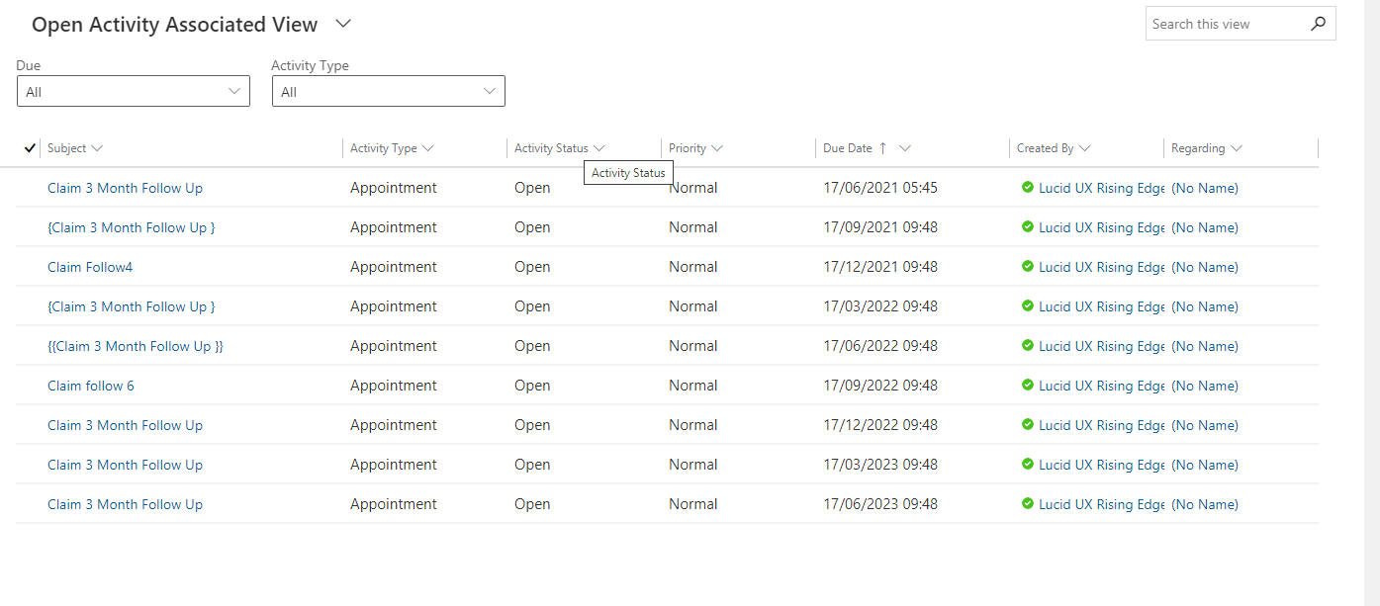

**QuoteEntry :**

**1. If “Rising Edge Participation” has data “Signed Lines (%)**” and “**Written Lines (%)**”Default set using java script **:**

**Web Resource Name** : Rising Edge Events

**Function Name** :risingparticipation

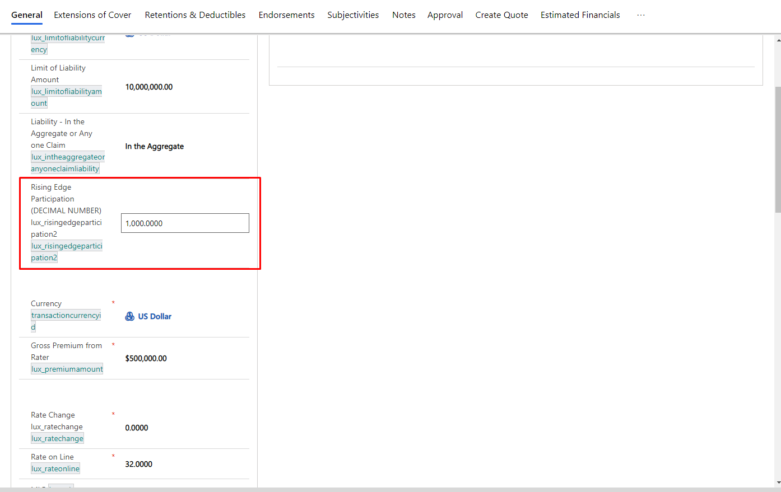

1. **If “Standard Commission Percentage (NEW)” has data then label showing “Standard Commission Percentage (NEW) (%)” else label show without percentage “Standard Commission Percentage (NEW)”** using java script **:**

**Web Resource Name** : Rising Edge Events

**Function Name** :removeLabelText()

onChangeEvengHandler(executionContext,percentageFieldDef);

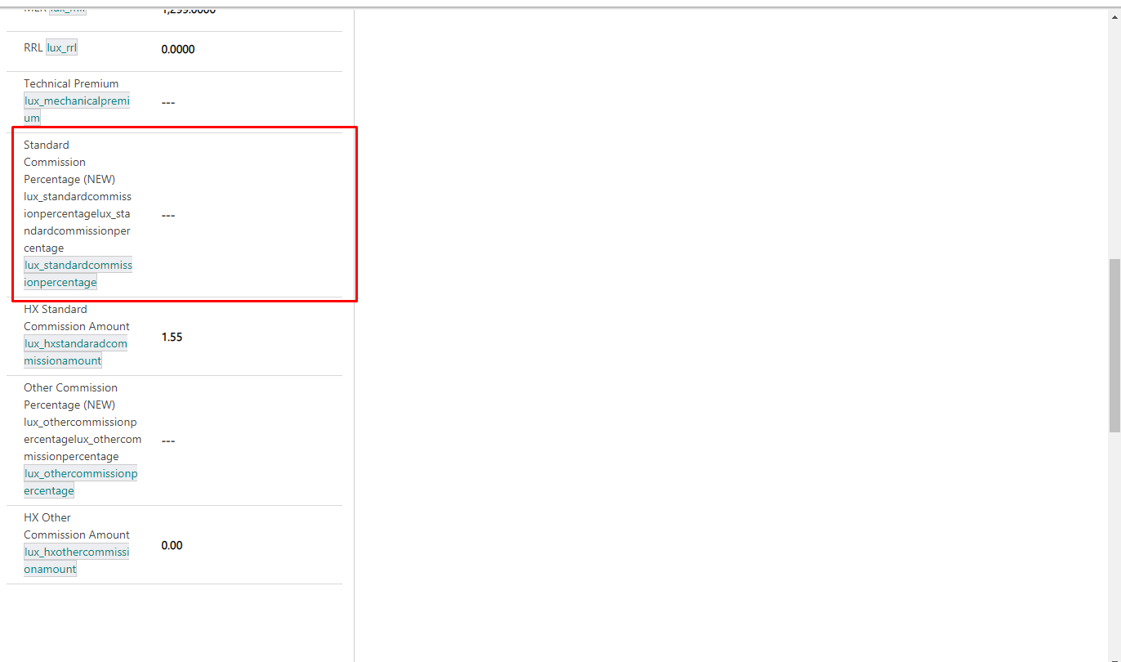

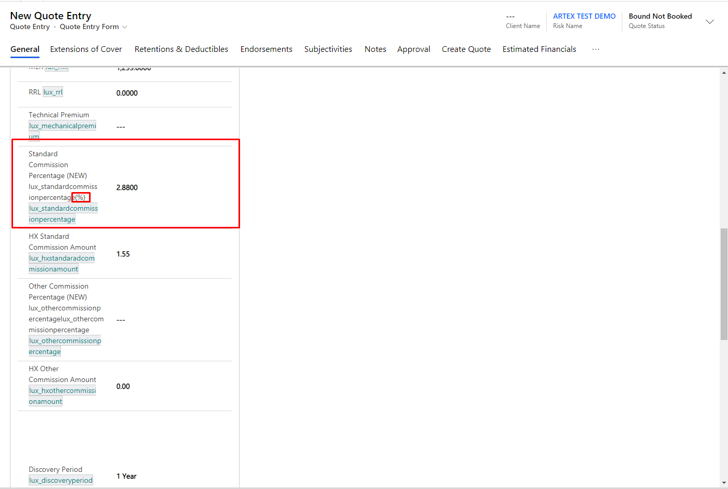

**New Fields :**

1. Field Name: Bound Premium Rate On Line (%) - lux_rateonline1  
   Field Type: Decimal Number - Calculated   
   Calculation: bound premium / limit of Liabaility amount
2. Field Name: Bound Premium RRL (%)  
   Field Type: Decimal Number - Calculated   
   Calculation: Bound premium / mechanical premium

3.Field Name: Bound Premium MLR (%)  
Field Type: Decimal Number - Calculated   
Calculation: quoted mlr * quoted premium / bound premium

**Report :**

1. Quote Entry - Report

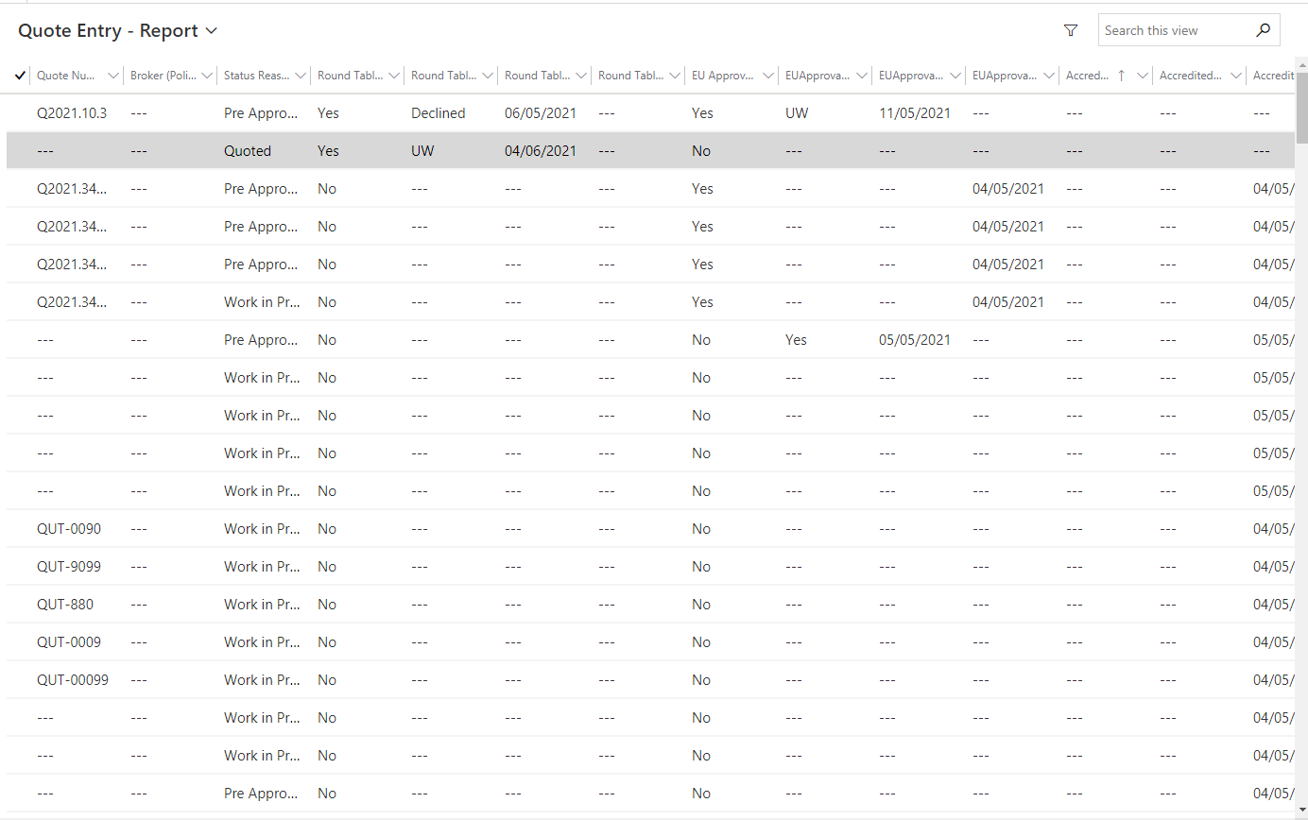

**Workflows:**

1. **Workflow Name:- ”SYSTEM-Quote Entry-AccreditedApprovalReceived”**

**Work :** Update Accredited Date Received(If Insurer Approval Required= Yes Then Insurer Approval Date Received Automatic update Today Date).

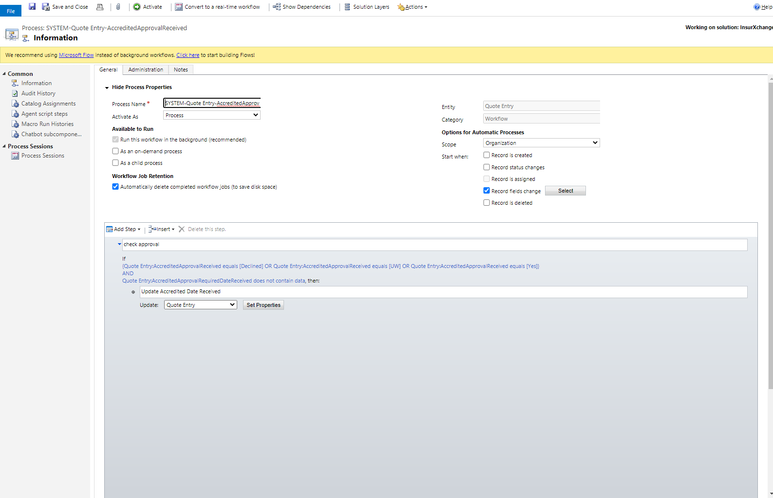

1. **Workflow Name:- ”SYSTEM-Quote Entry-Approval Received”**

**Work :** update Approval Received Date (If EU Approval Required= Yes Then EU Approval Date Received Automatic update Today Date).

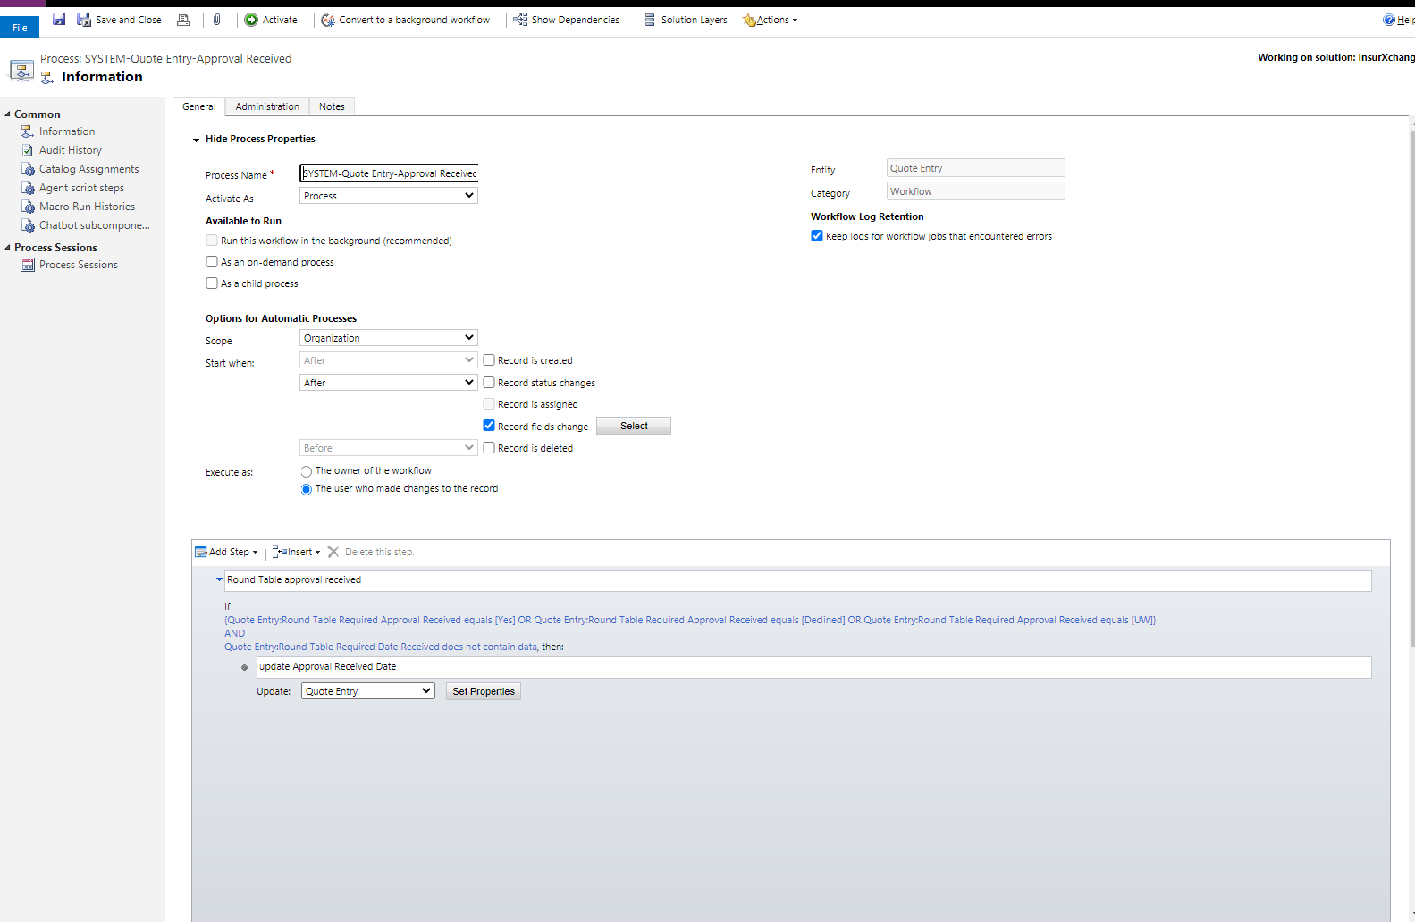

1. **Workflow Name =”SYSTEM - Policy - Create Financial Transactions Duplicate”**

**Work :**Stop workflow(If policy bound status = “Bound and Booked” then stop workflow)

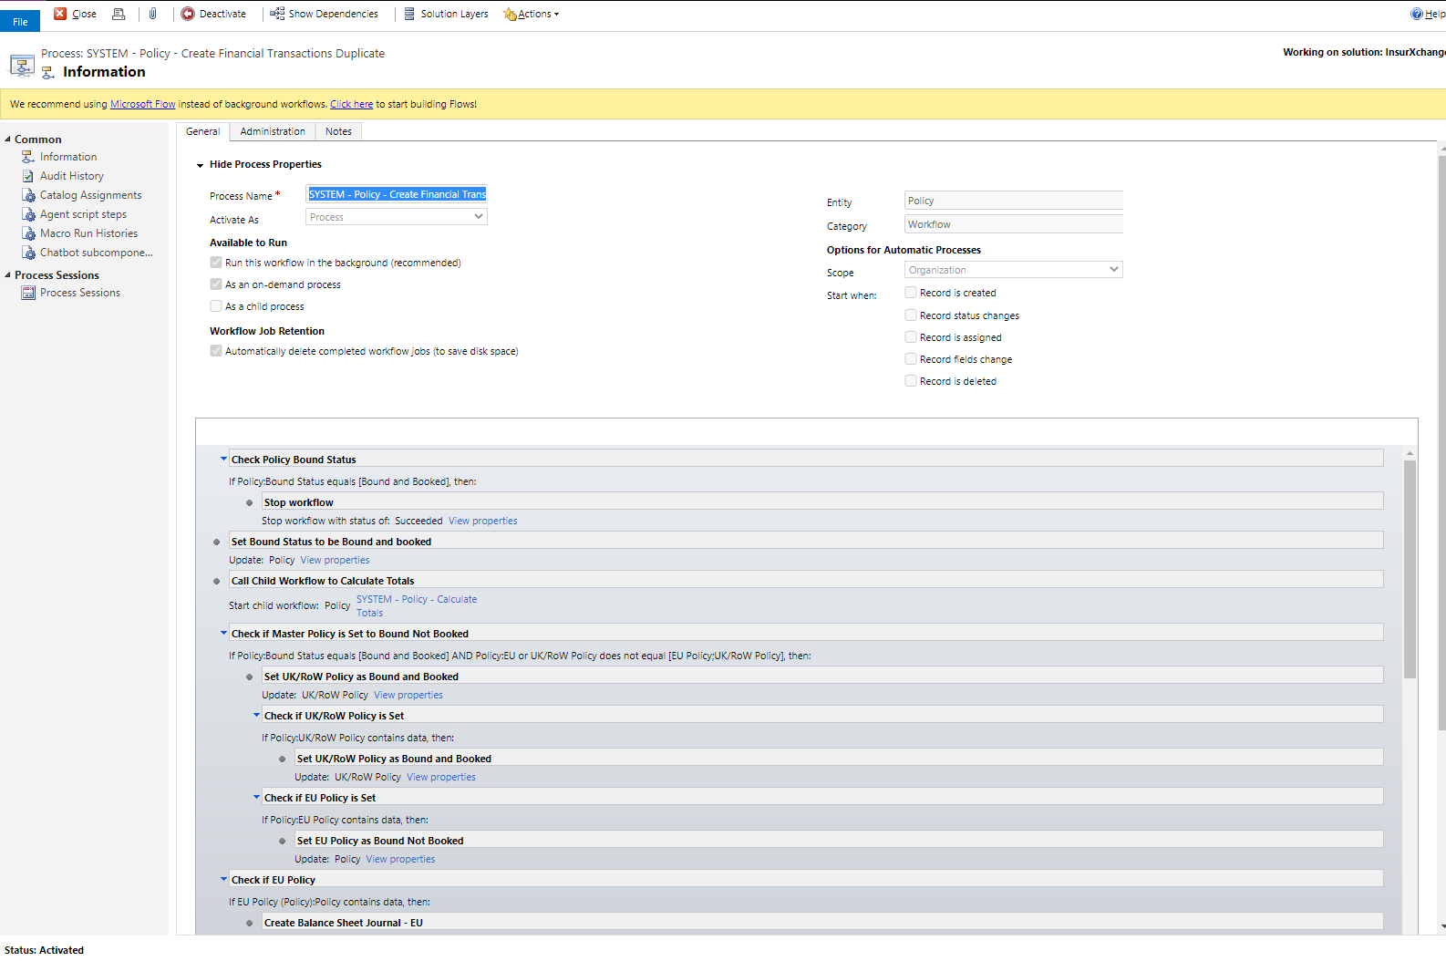

Quote Entry Tabs

Extensions of Cover

Button : Create Extensions Of Cover

Description

1. Add Web resource of ( WebResource_createextensionsofcover ) Html to create button
2. Calling Workflow Id ( 68B3BDFE-87E7-44A0-8323-CDF4522A8E38 )

To Create Extension of cover.

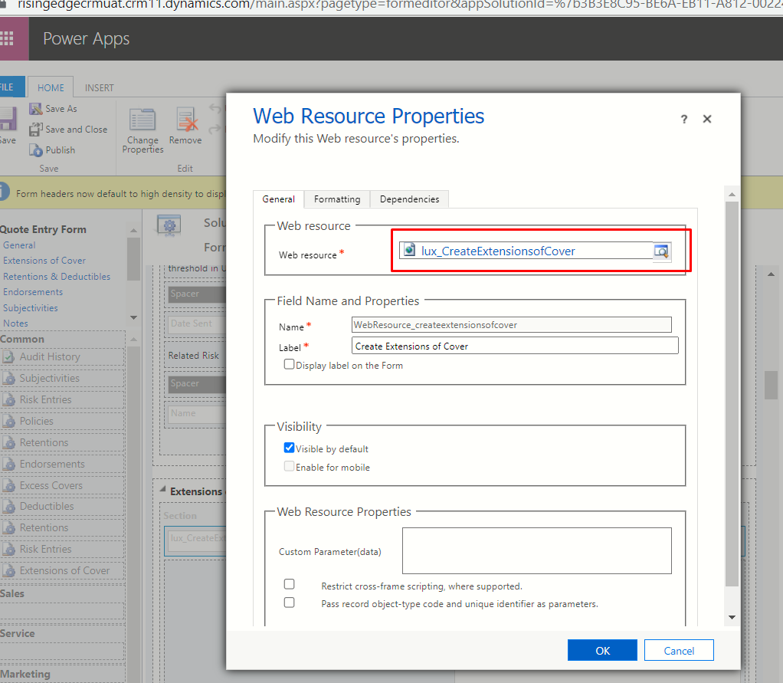

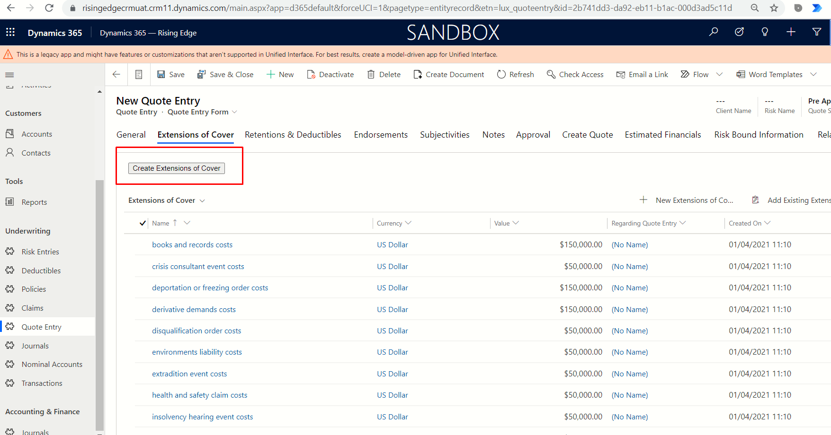

Retentions & Detuctibles

Button : Create Retentions

Description

1. Add Web resource of ( WebResource_createretentions ) Html to create button

2. Calling Workflow Id ( BC0C83BB-6578-4F3F-9B48-33AF050B8F70 )

To Create Retentions.

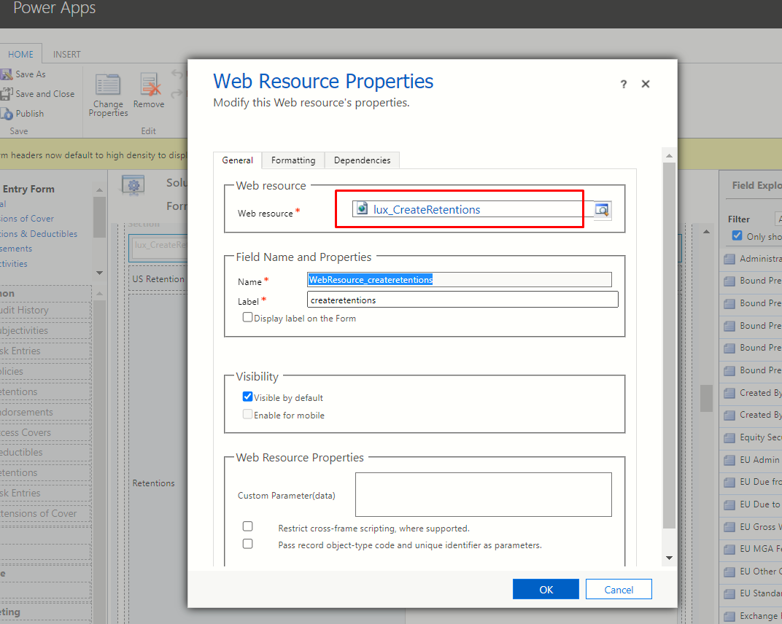

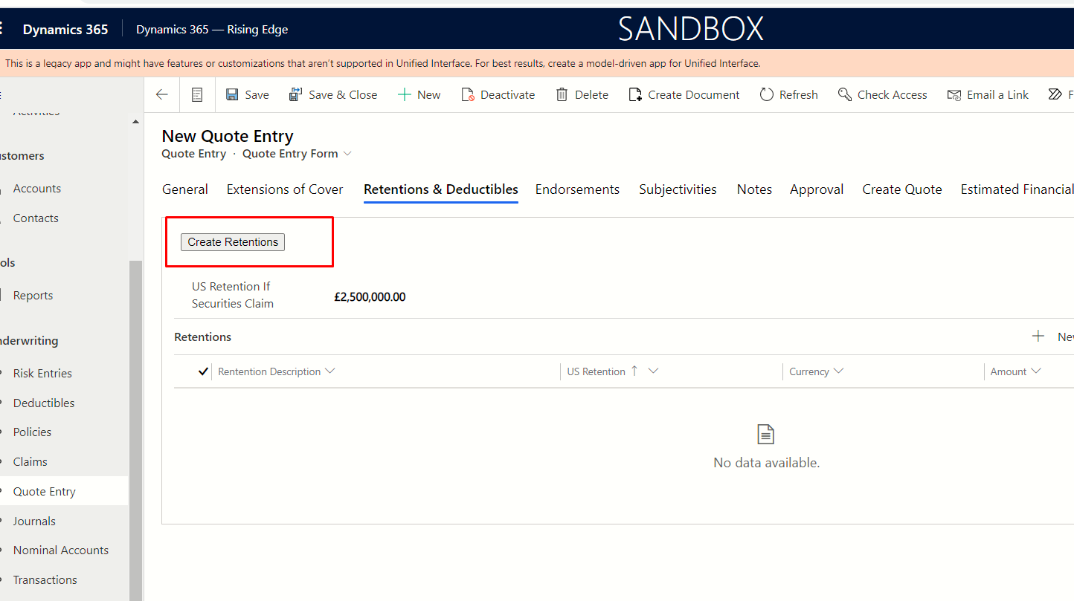

Approval

**Workflow Name =”SYSTEM - Quote Entry - Quote Status New :**

**Work :** If **“**Update Quote Status Automatically” Field is Yes then “Quote Status” not change manually else “Quote Status” change manually.

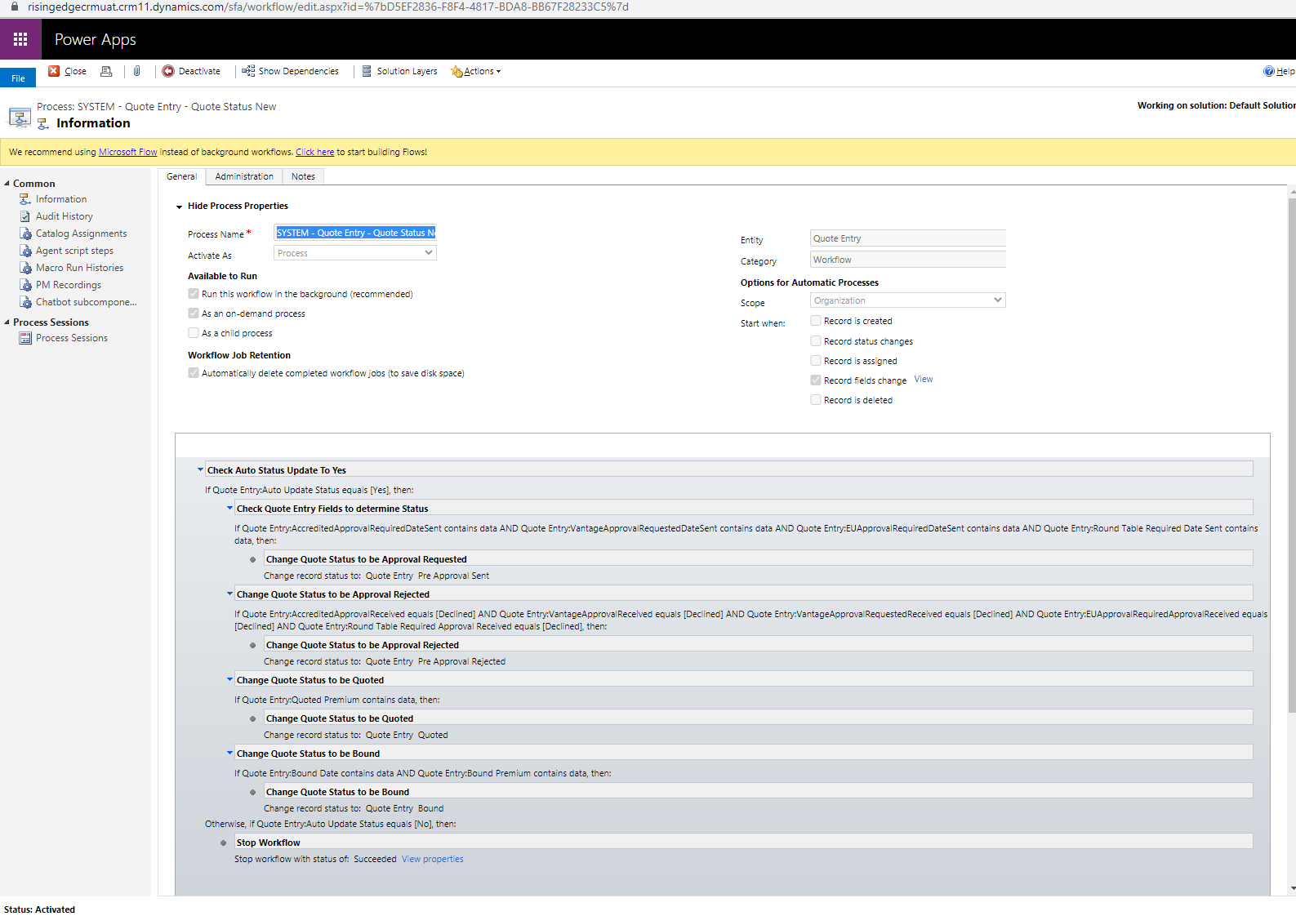

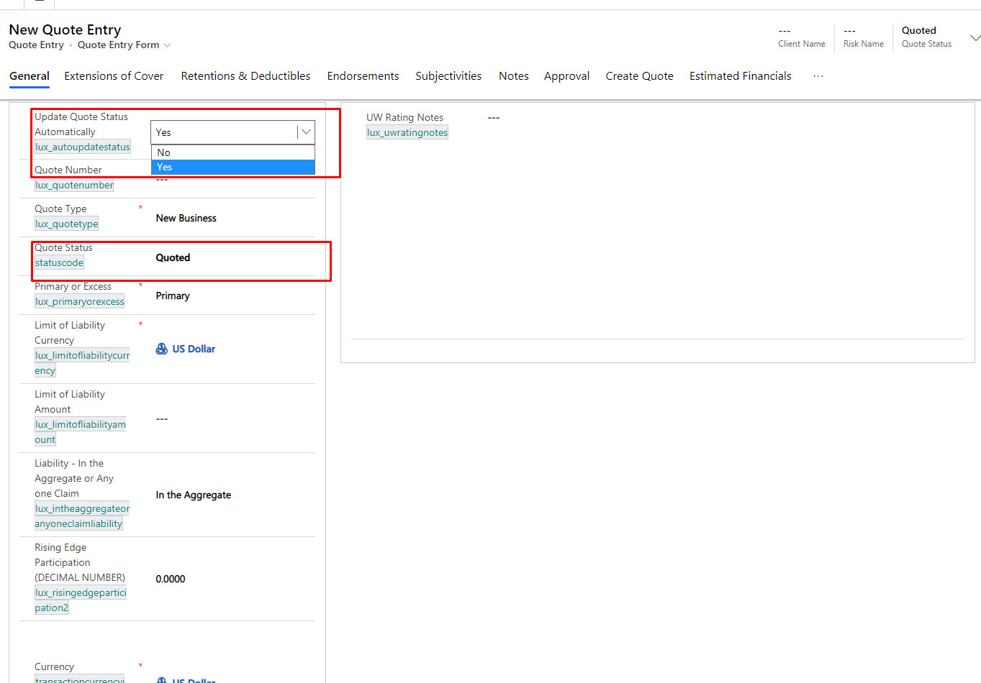

**Workflow Name =”SYSTEM - Quote Entry - Create a Policy:**

**Work :** If click “Generate Policy” button in quote entry when create a policy. And showing new policy Start and end date copy from related to risk entry expiry and inception date.

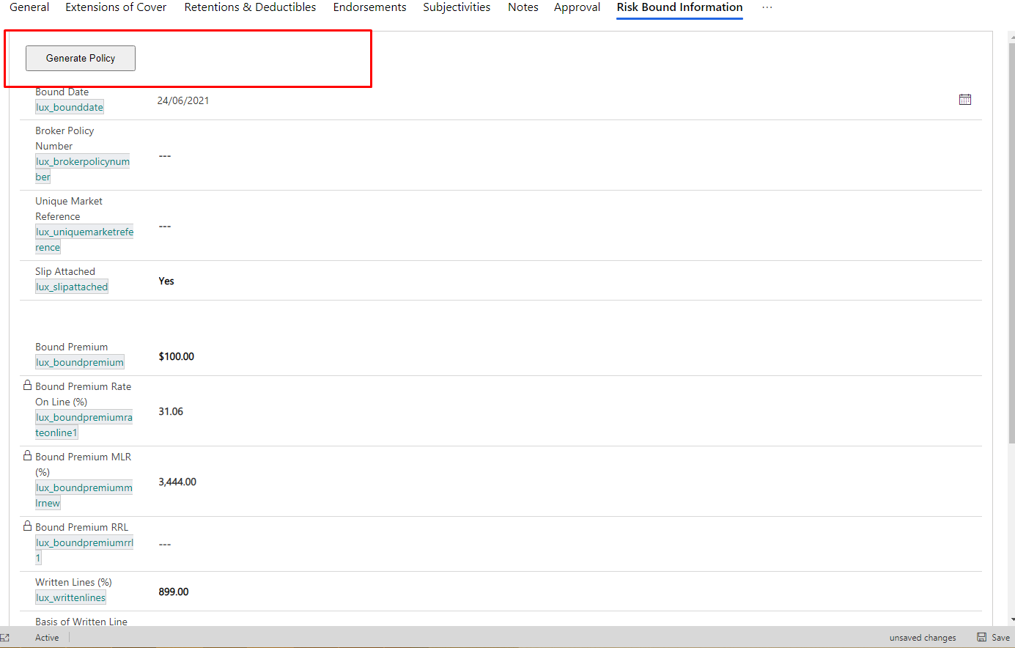

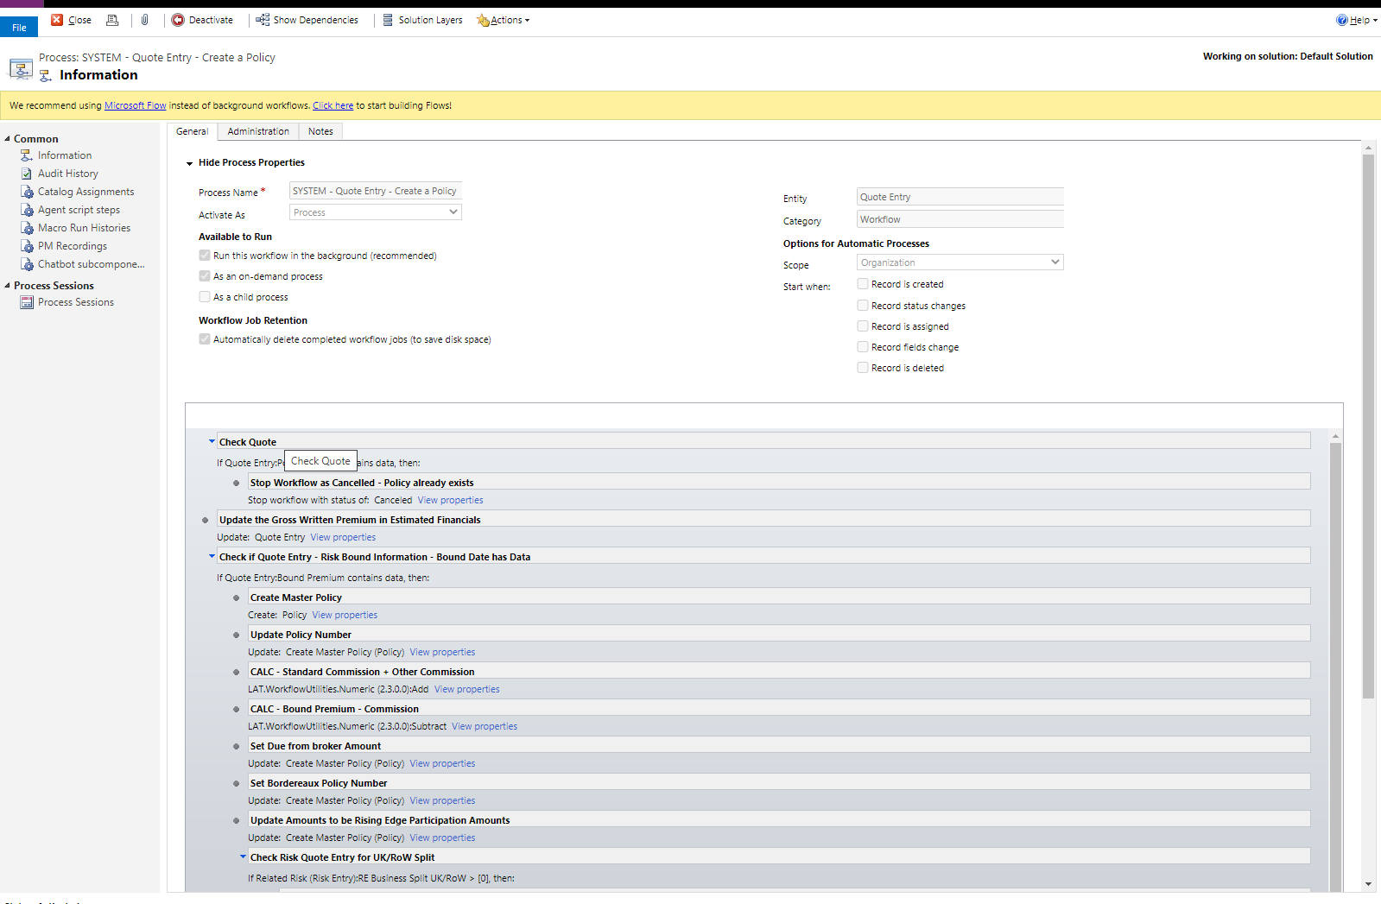

**Risk Entry**

**1 . Change of “Policy Wording” hide and show fields using Business Rule :**

Business Rule Name : Hide policy wording fields

Showing following fields if “Policy Wording” Other and hiding if any selection:

Policy wording other

Nuclear Exclusion

War Exclusion

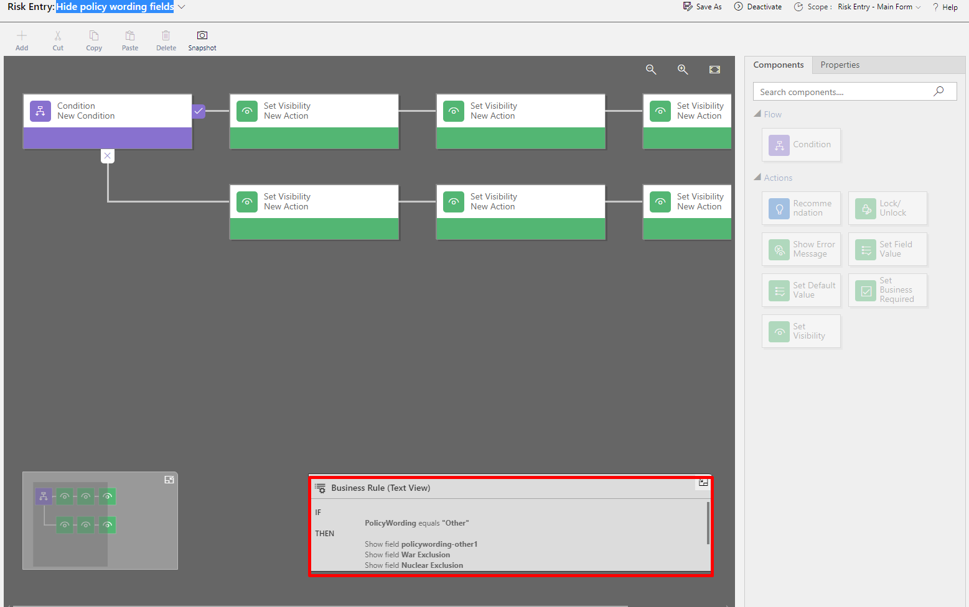

**2 . Change of “Other Potential” Issues hide and show fields using java script :**

**Web Resource Name** : Rising Edge Events

**Function Name :** changelux_otherpotentialissues

Showing following fields if “Other Potential” =Other and hiding if any selection:

Other Potential Issues Descriptions

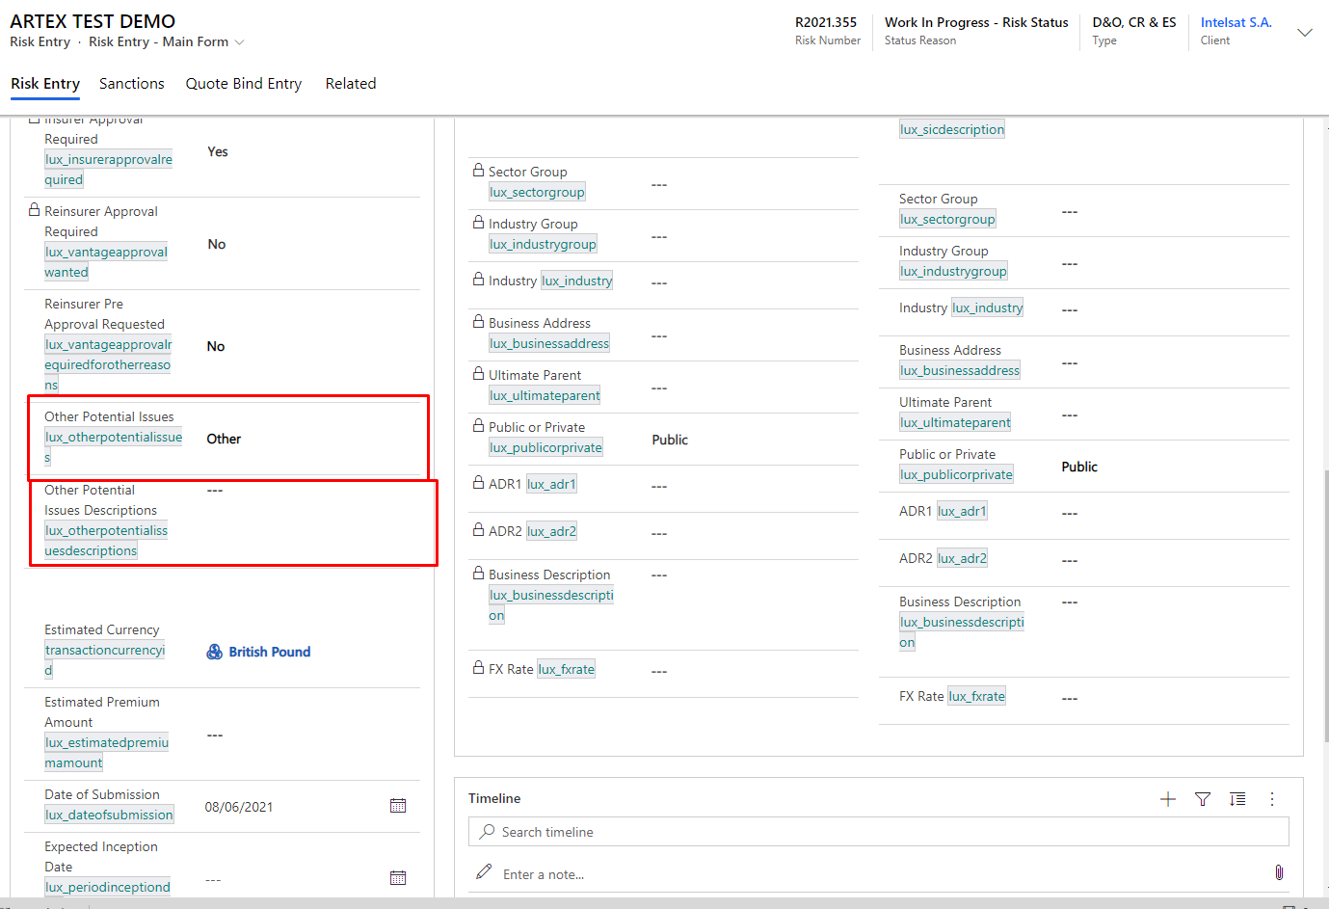

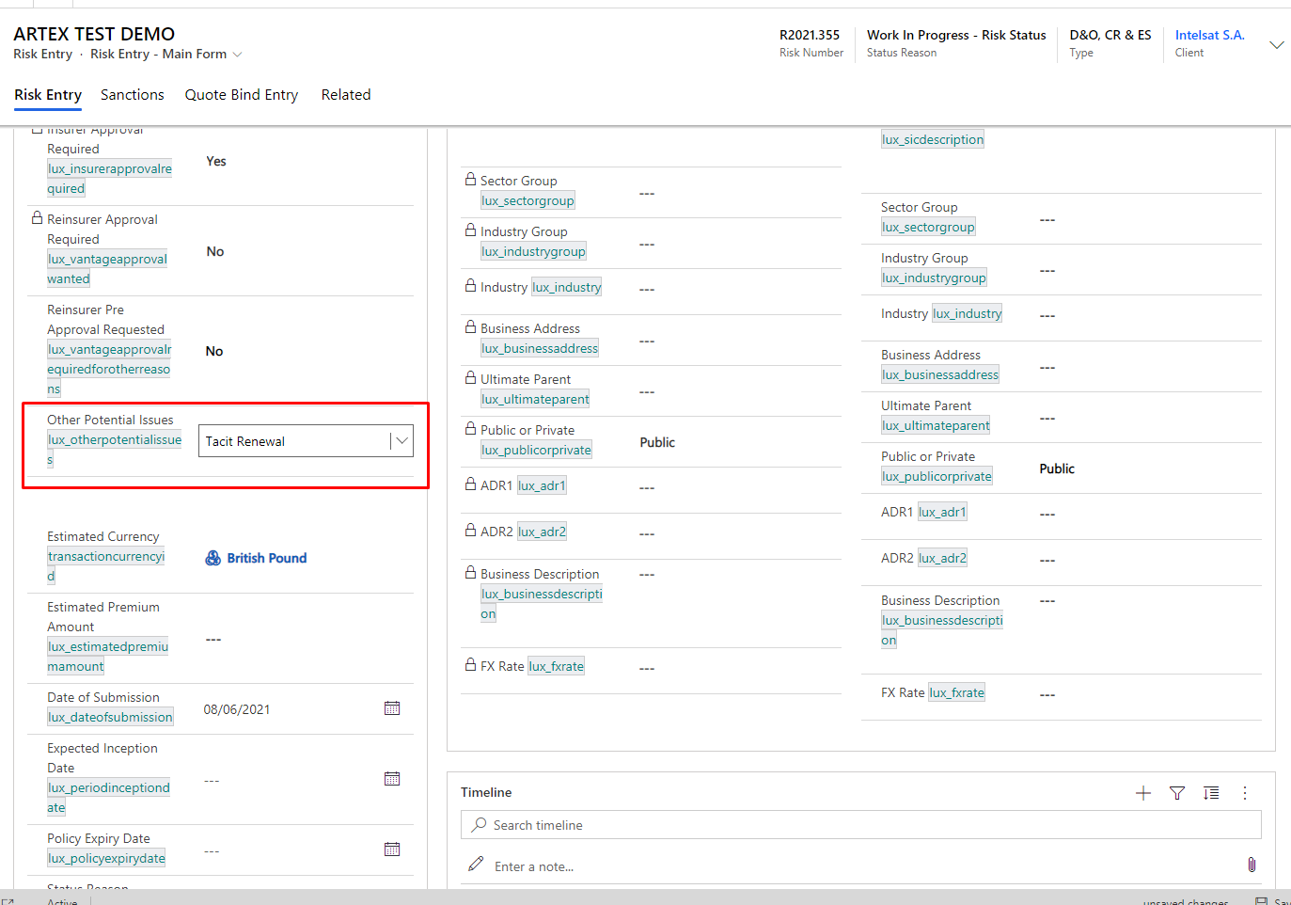

**3.Change of “Stock Exchange Tracker” showing below fields value using java script :**

**Web Resource Name** : Rising Edge Events

**Function Name :** onStockExChange

If “Stock Exchange Tracker” =NYSE OR NASDAQ then “Us Listed Or Traded Company” =CDU

Else “Us Listed Or Traded Company” =CDN

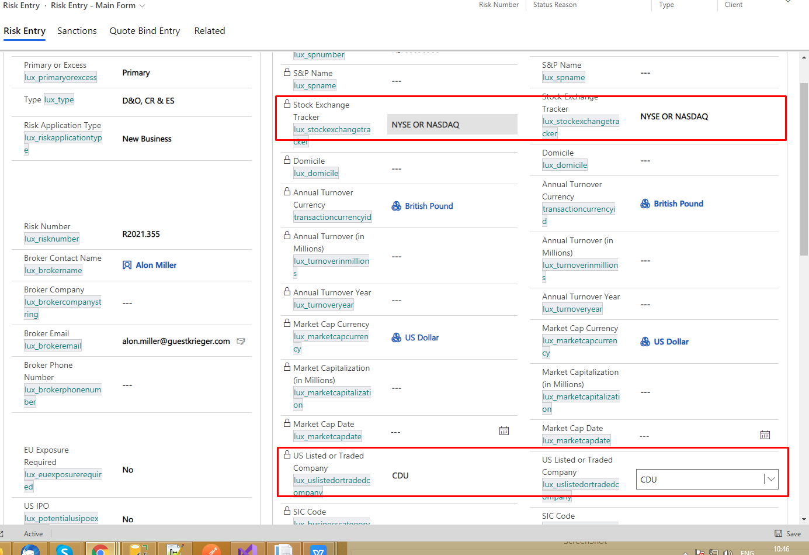

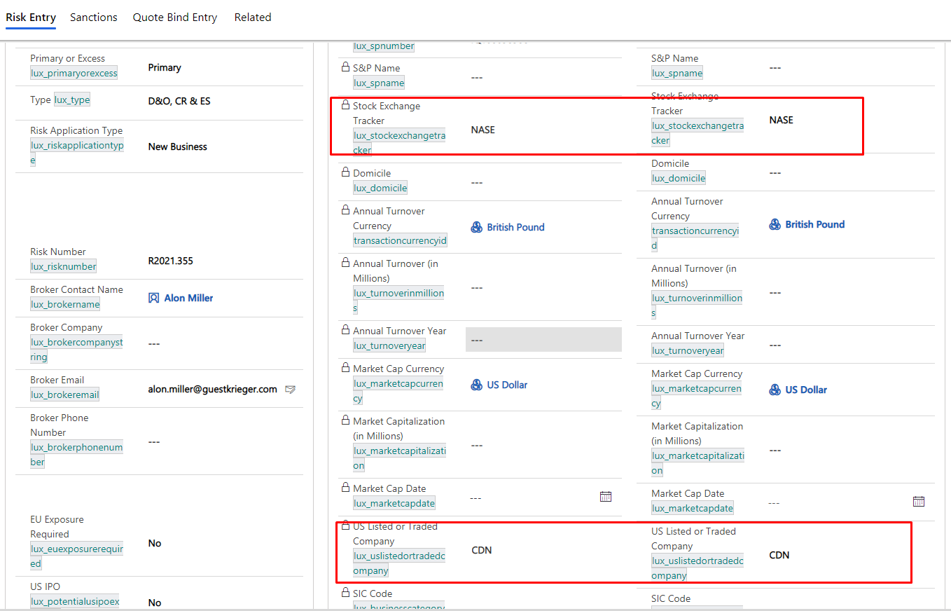

1. **Change of “Claim Declined” hide and show Fields using business rule :**

Business Rule Name - “**Risk Entry:Previous Year Premium- Renewal”**

Showing following fields if “Risk Application type”= Renewal and hiding if New Business:

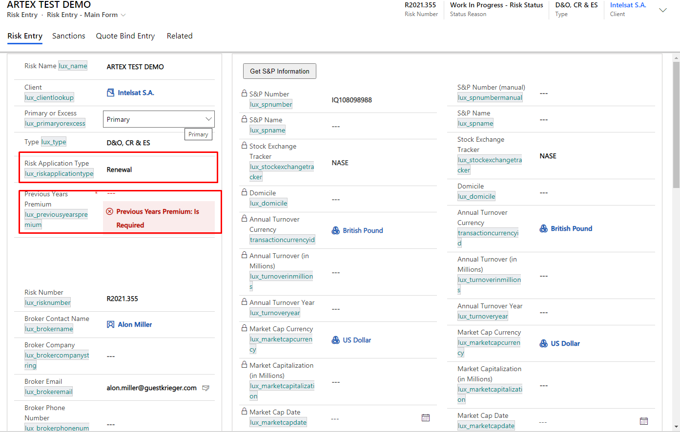

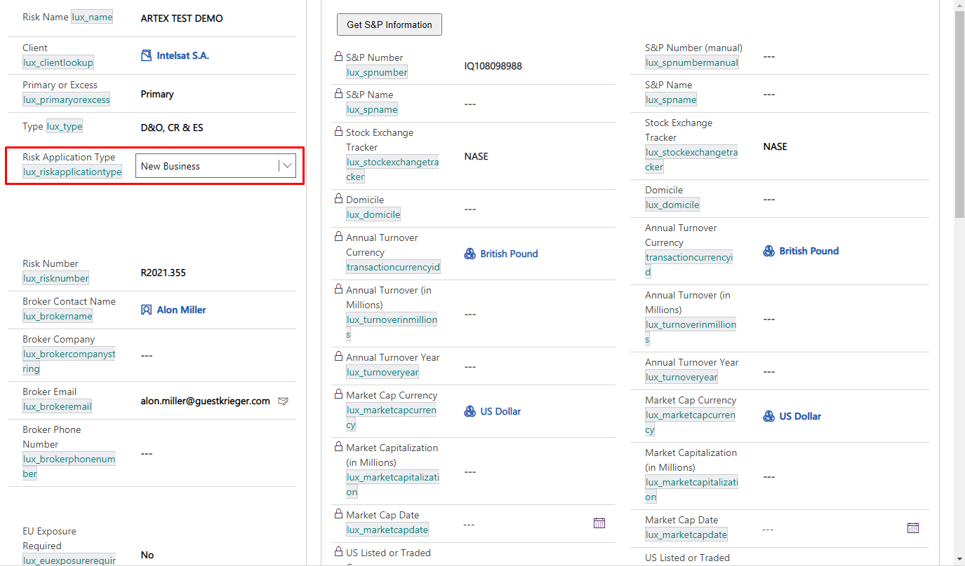

**New Field :**

1.Sector Group - lux_sectiongroup

2. Industry Group - lux_industry

3. Business Address - lux_businessaddress

4. Business Description - lux_businessdescription

5.Ultimate Parent - lux_ultimateparent

6. War Exclusion - lux_warexclusion

7. Nuclear Exclusion- lux_nuclearexclusion

8.Turnover Currency- lux_turnovercurrency

9.Turnover-InMillions- lux_turnoverinmillions

10.Annual Turnover Year- lux_turnoveryear

11.ADR1- lux_adr1

12.ADR2- lux_adr2

13.Policy Wording - Other - lux_policywordingother1

14.Risk Application Type - lux_riskapplicationtype

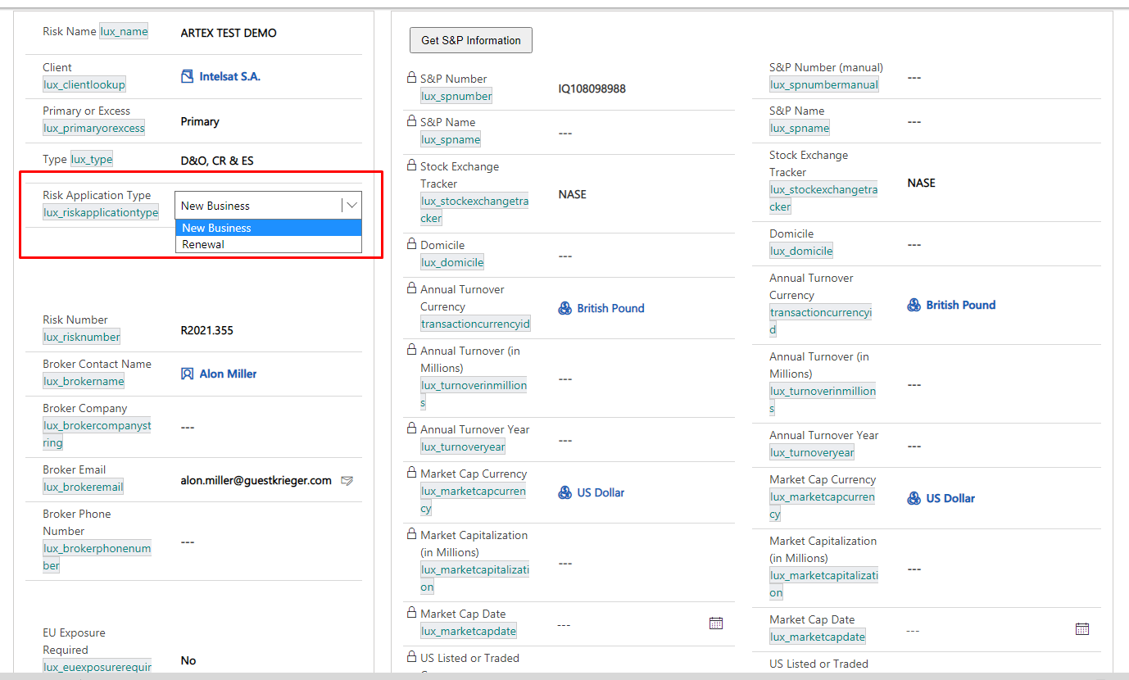

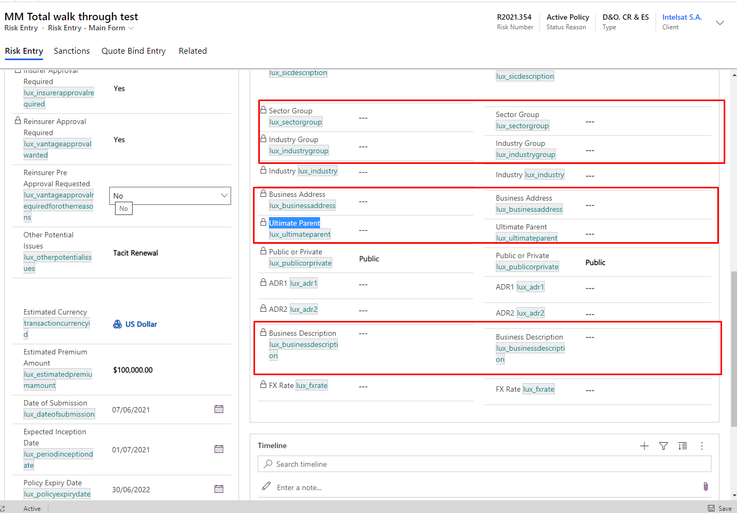

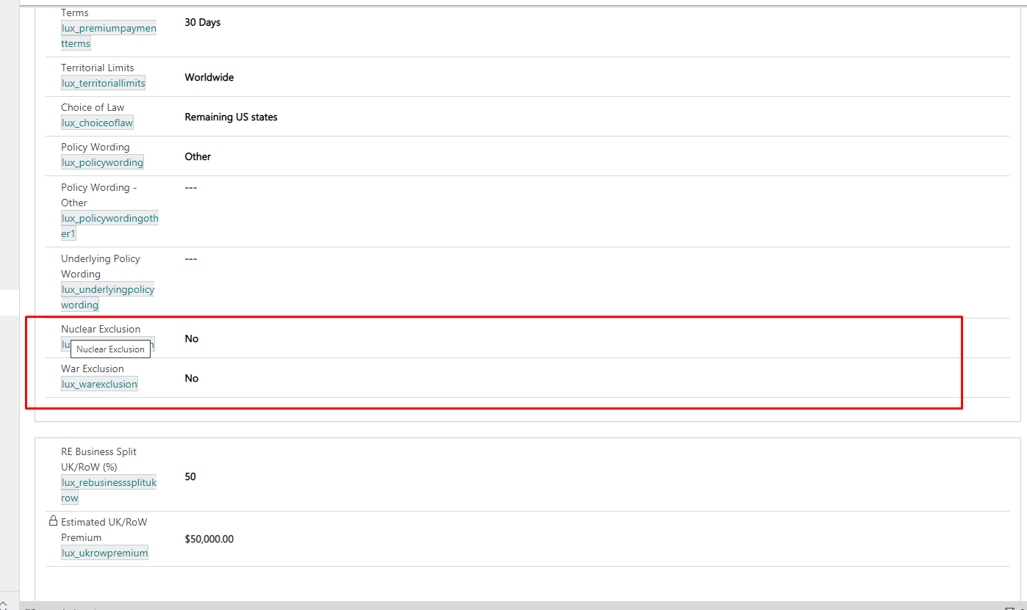

**WorkFlow :**

1. Workflow Name - “SYSTEM - Risk Entry - Duplicate Record”

Work : Duplicate record(If select record and run this workflow then automatically create duplicate record)

