**LockerdMe**

1. **Project Details**

All the details are mentioned bellow.

* Initially there is a welcome screen in which user will see the welcome message and developer name
* Then user is asked to enter “S” to start further.
* Then certain options will display like
  + Display files (Display in ascending order)
  + Other options
  + Exit (To exit from the program and close the complier to take further Inputs.
* After selecting other options there are more options like
  + To add a file (If not exist otherwise shows file already exist)
  + To Delete a file (If exist otherwise shows file does not exist)
  + To search a file (shows exist If exist otherwise shows file does not already exist)
  + To move back to main menu

1. **Developer Details**

I Saurabh Singh created this project solo.

1. **Sprint**

This project is Done only in 1 Sprint. In this single sprint bellow written tasks are completed.

* Creating a flow Chart of the application.
* Learning of different packages used in the project
* Creating Java Project and Code the project.
* Creating different Inputs and Outputs.
* Checking the bugs and errors in the code.
* Creating GitHub repository and pushing files.

1. **Core Concepts Used**

Here is the list of core concepts used in this projects.

* File Handling like Path and Files
* Sorting to sort the list of files inside the Main Directory
* Searching to search a File in a Main Directory
* Scanner Class to take User Input
* Try-catch to handle the exceptions inside the project
* Loops to run options with the help of switch cases.

P.T.O

1. **Flowchart**

There is also a flowchart ppt in the name of flowchart.ppt for clear view

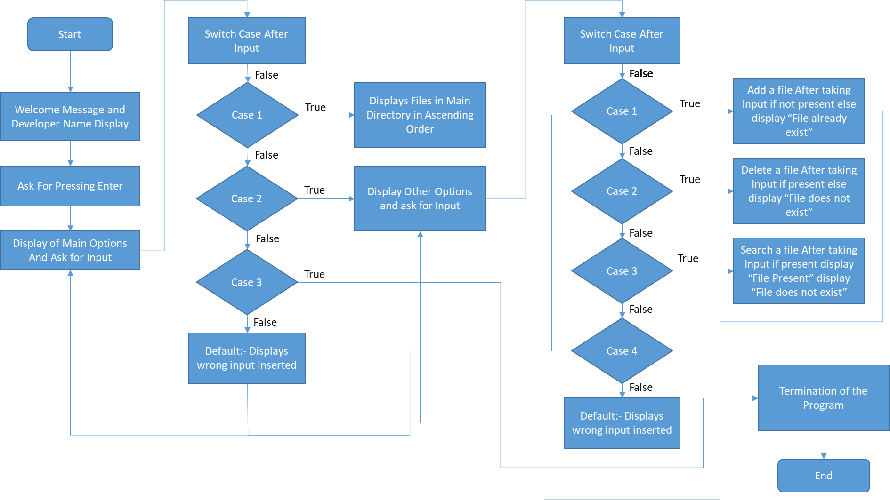

**Unique Selling Points of the Application**

1. The application is designed to keep on running and taking user inputs even after exceptions occur. To terminate the application, appropriate option needs to be selected.
2. The application is used to work on Main directory and also files are used which can use file without space otherwise it does not take input.
3. This application allowed us to use several operations which can be done without knowing a commands like on command prompt or terminal
4. This application requires no previous knowledge of commands.
5. We can Delete, add, search and display files Infinite number of times.
6. User can switch between Main options and Other Options Infinite number of times.
7. There is only simple coding used without any tough coding or concepts used.

**Conclusion**

Further improvements are which can be done in continuation are: -

* We can add any files whether exist in another location.
* We can User that in which format they want to view whether ascending or descending.
* Asking user about the number of files they want to see like the max limit not a min limit.
* Display many other details like size of the file, last modification of file, creation of file date.
* Confirmation at the time of creation, or deletion of file whether confirm to delete or not.
* Add other directories inside the Main directory

**GitHub Link: -**

* [**https://github.com/SaurabhSinghCS/Assignments/tree/main/assessment1**](https://github.com/SaurabhSinghCS/Assignments/tree/main/assessment1)