**Sporty Shoes**

1. **Project Details**

This Project is basically depending on the Admin side of an E-commerce Website for Sporty Shoes.

In this project admin can: -

* Change password
* See logged in Users list and also can search Users by either First Name or by Last Name
* Can see list of Products in which Admin will able to Add, Update or Delete products.
* Can see list of Orders done by users and of what product. In this Admin can also filter results by Date and Category also either single filter or both filters at a time.

Working view is in point 5 please view.

This project is Done only in 1 Sprint. In this single sprint bellow written tasks are completed

1. **Developer Details**

I Saurabh Singh created this project solo.

1. **Sprint**

This project is done only in 2 sprints.

Sprint 1

* Plaining of projects
* Admin Login view and working
* Password Change view and working
* Logout working
* Product view along with Add, Delete and Update product view and working

Sprint 2

* Users view and working
* User search working and result view
* Order view and working
* Order filtering view and working
* Creating GitHub link and pushing code
* Creating Flow Chart and Documentation

1. **Concepts Used**

MVC Architecture

Hibernate

Annotations

Java collections

1. **Working**
2. Initial login page if not previous login is not in 2 dates or logged out or if changed password

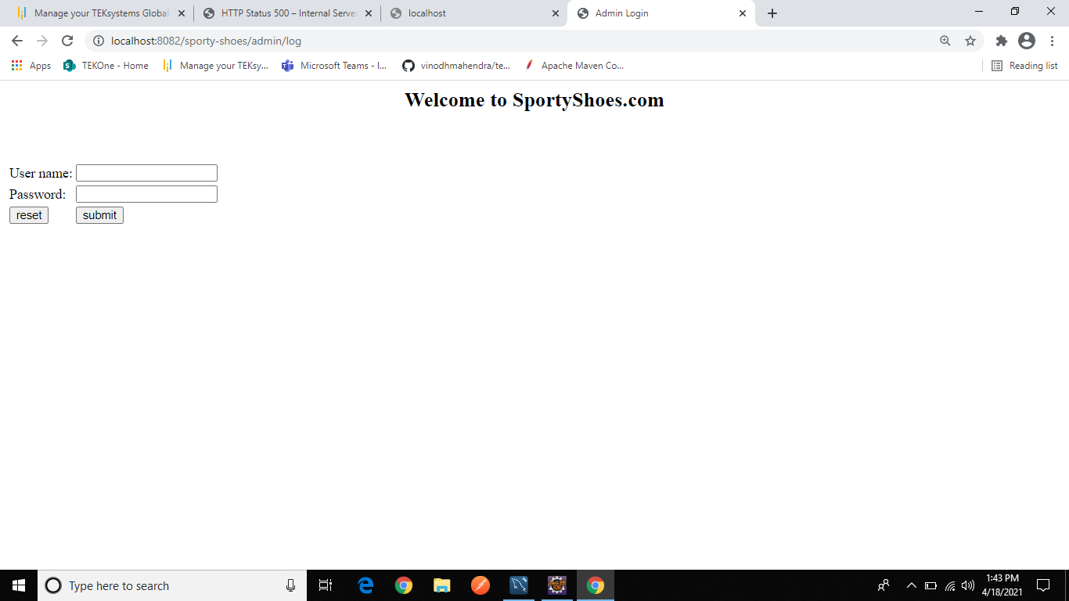

1. If Login is successful or Already Logged in

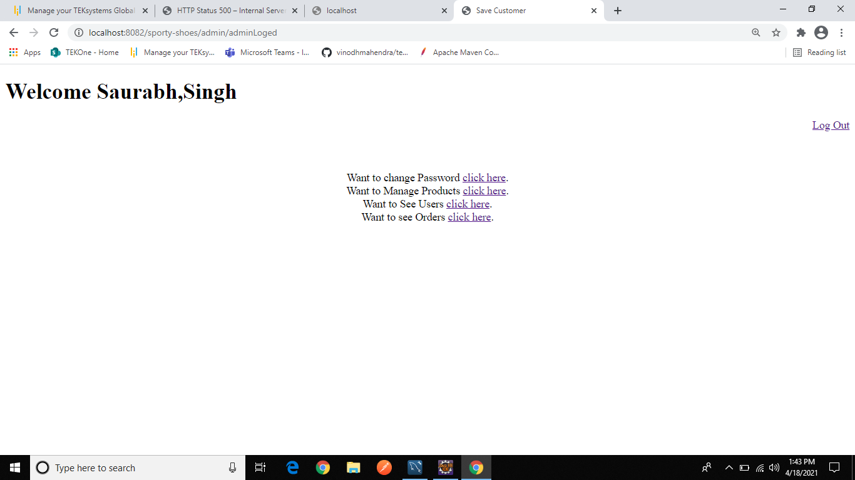

1. If clicked on Change Password then move to this page if both passwords are not same then again we move to same page

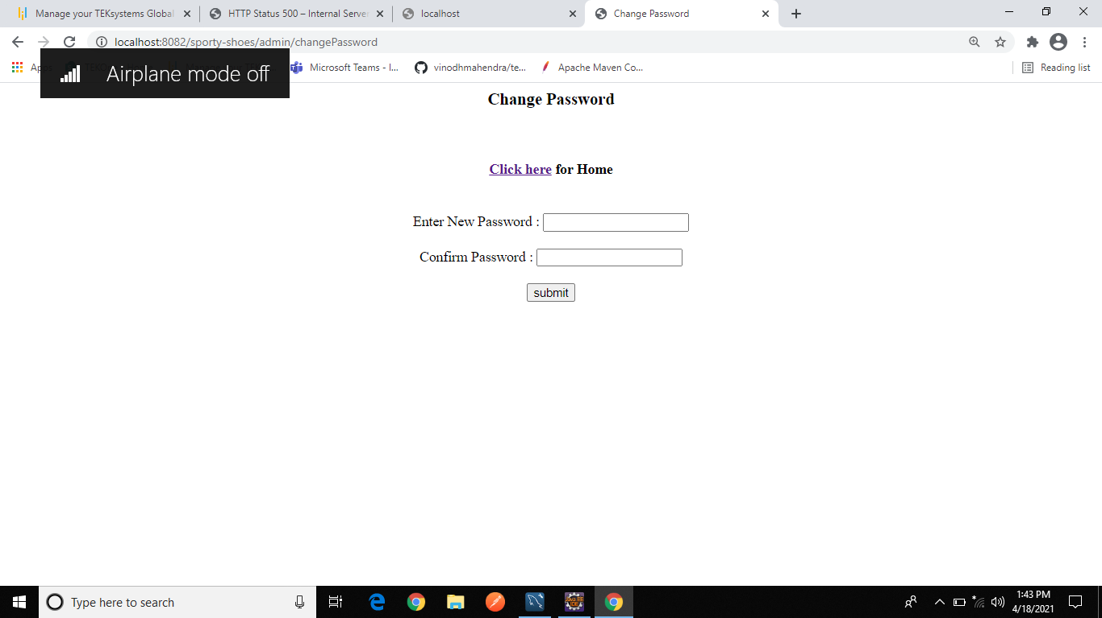

1. If password is successfully changed then moved to this page after this on clicking on **click here** we move to page on point a.

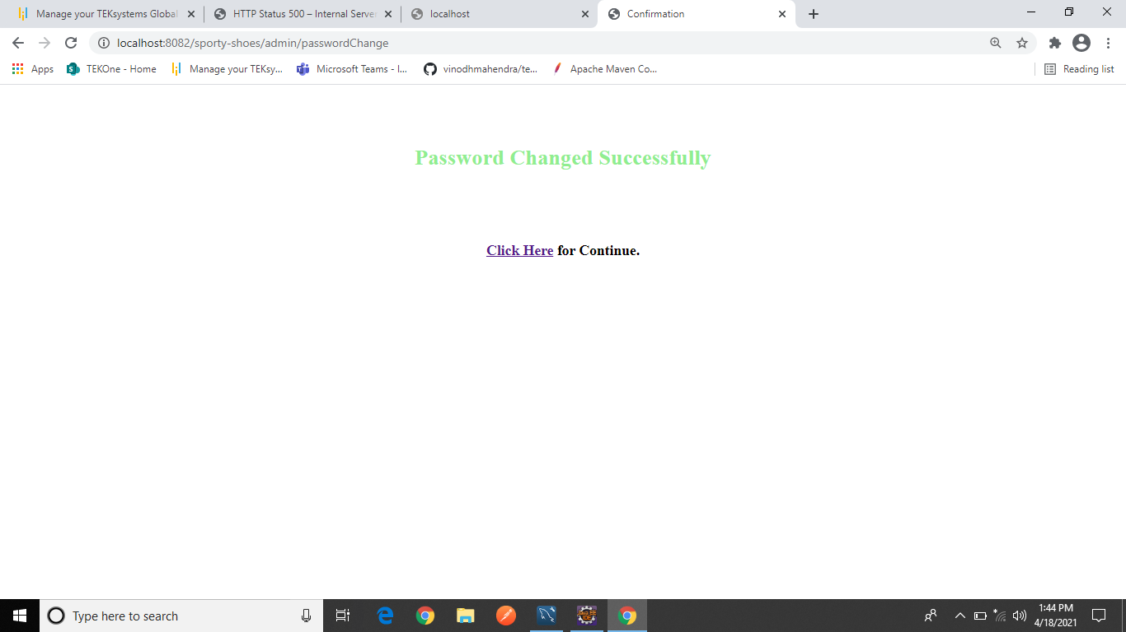

1. Before changing password data base have values

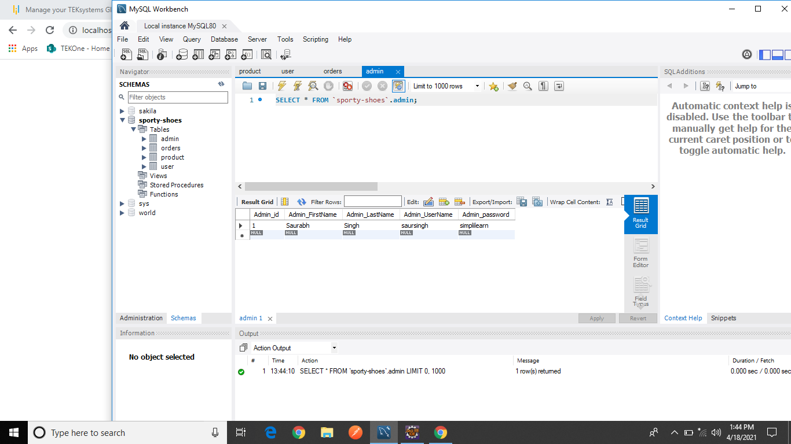

1. After changing password data base values are

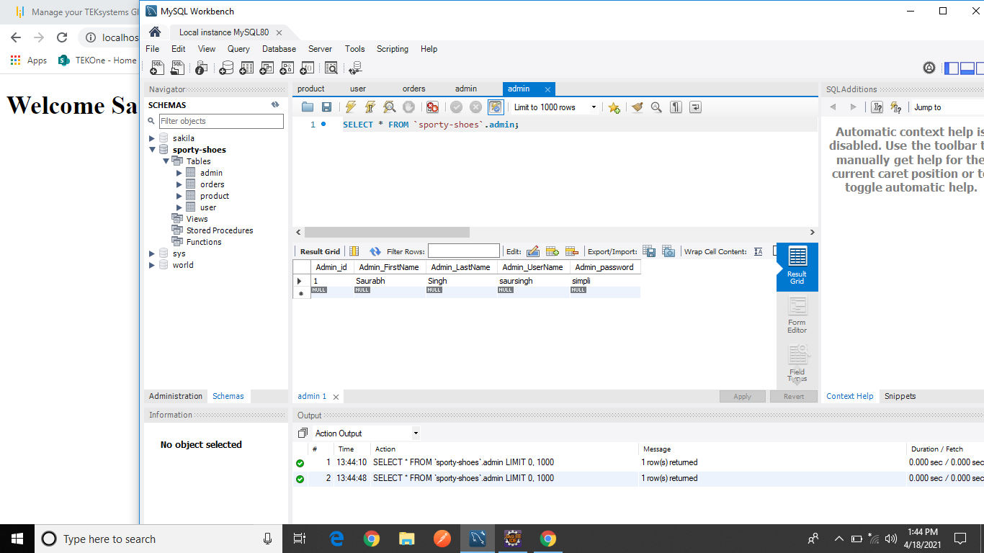

1. If User click on manage product in point b, then this is viewed

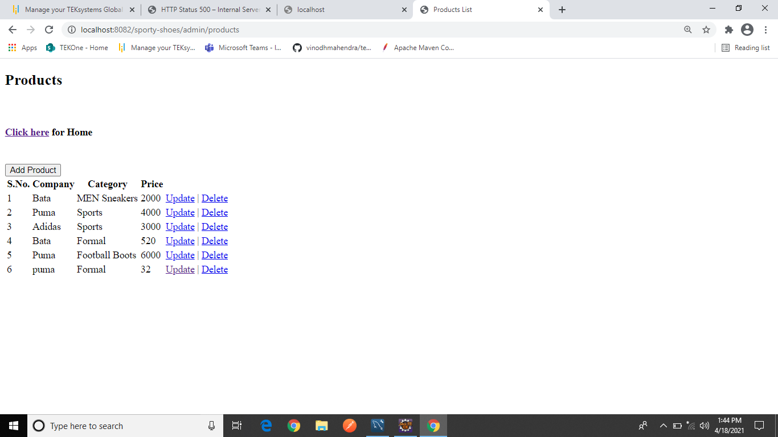

1. In numbering **g** if user clicks on add product

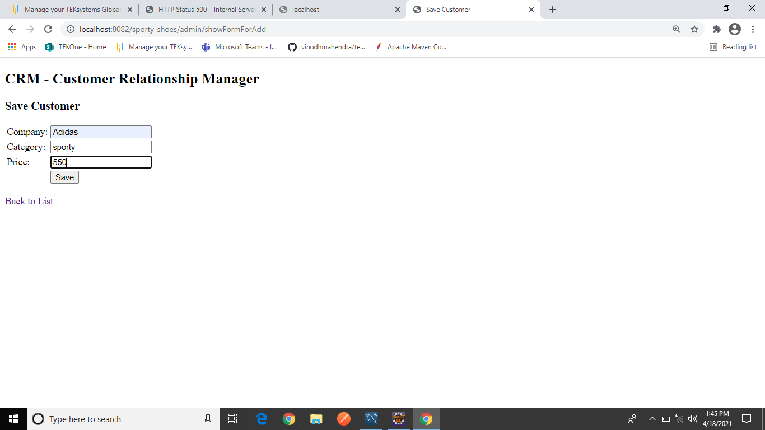

1. After adding product entering data in empty fields we get list as and after liking on delete we can delete the product

We can also update any product

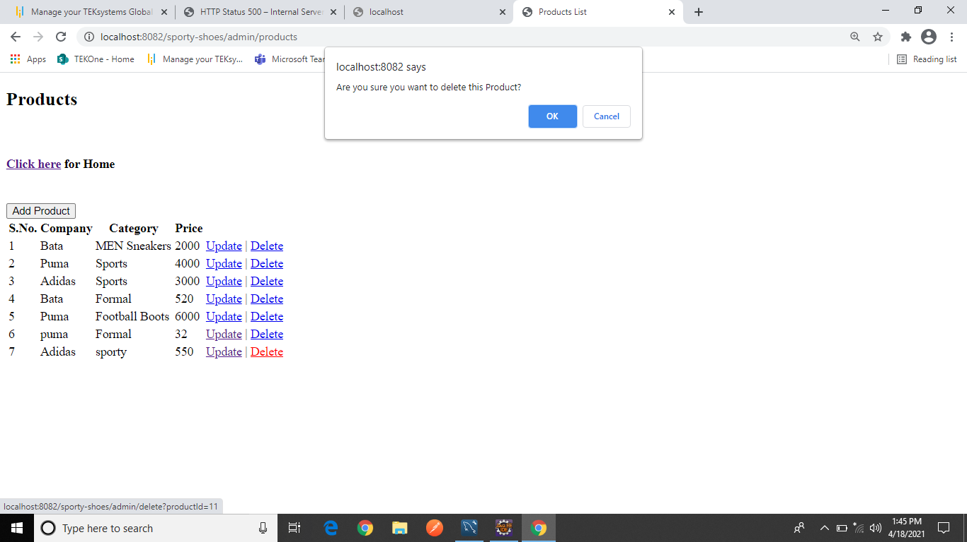

1. On clicking see users on point b we see

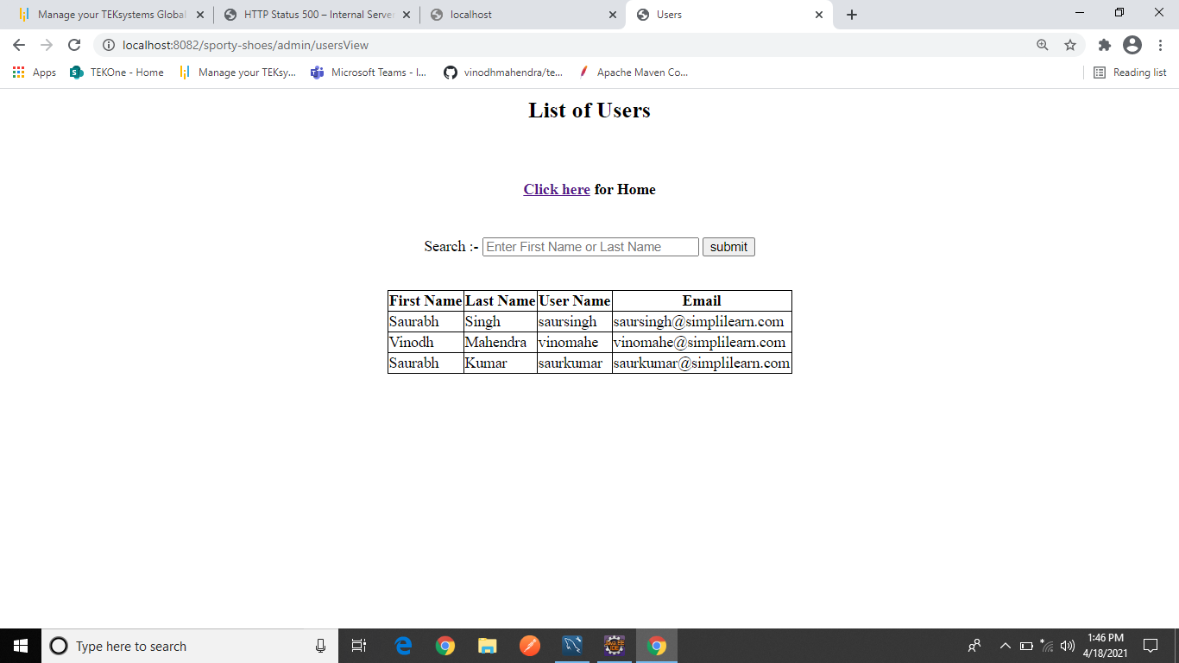

1. If we want to search then we can First name or Last name

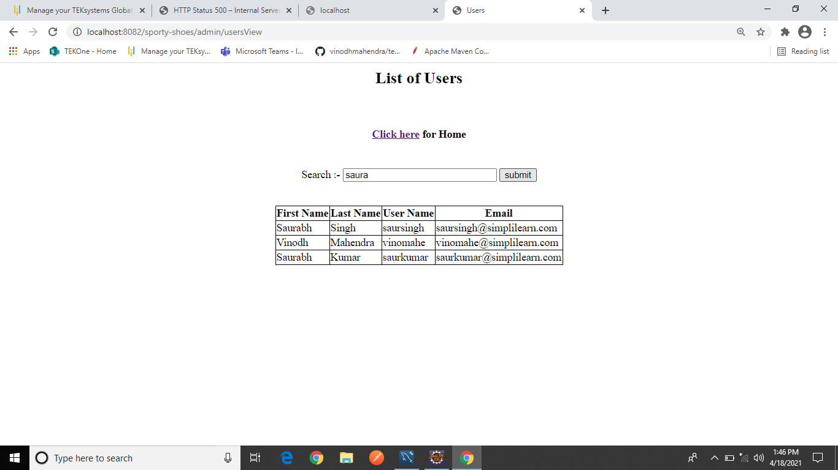

1. After search we get results like this

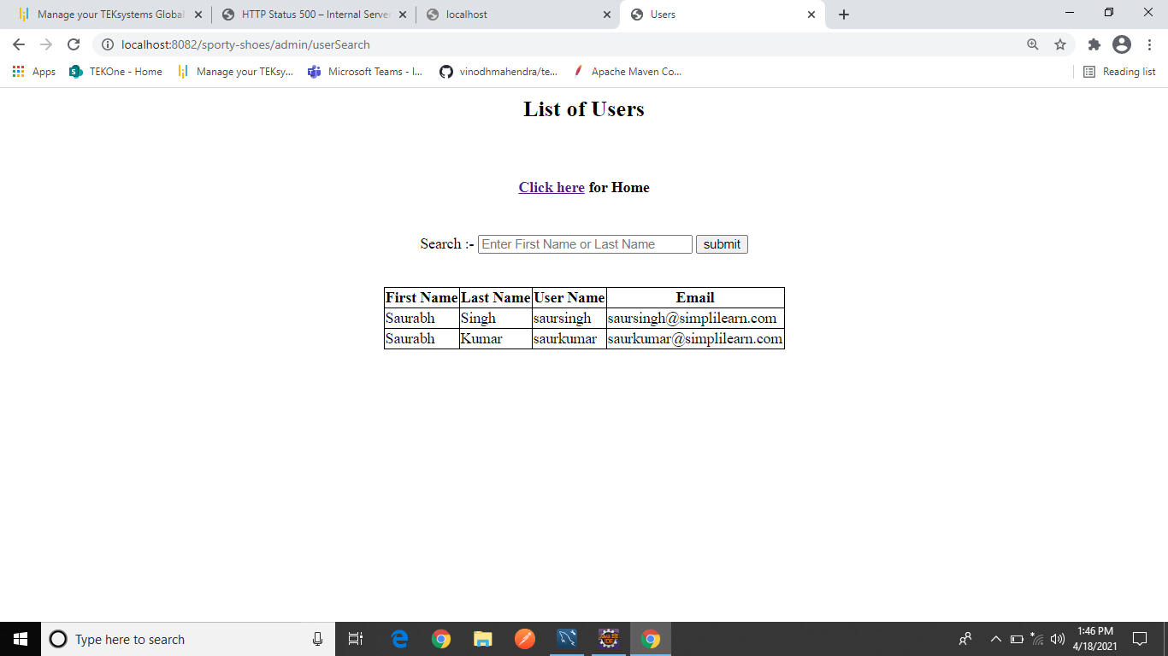

1. In point b if we want to see orders then we see like this in this we can filter according to Date or category we can also use both to filter

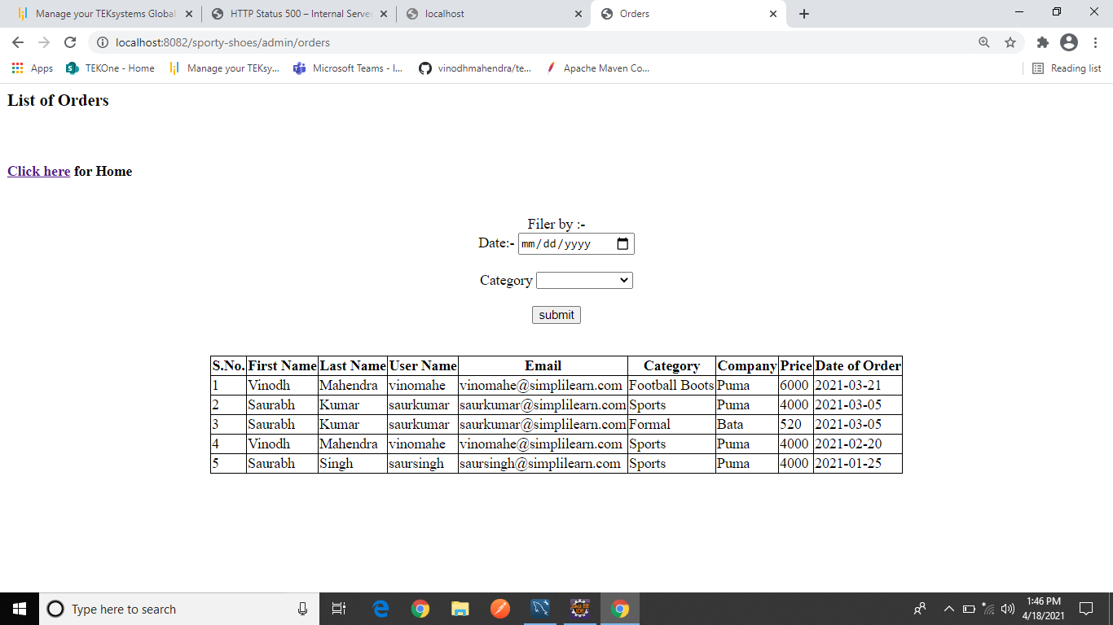

1. If we click on Logout in page of point b then we move to

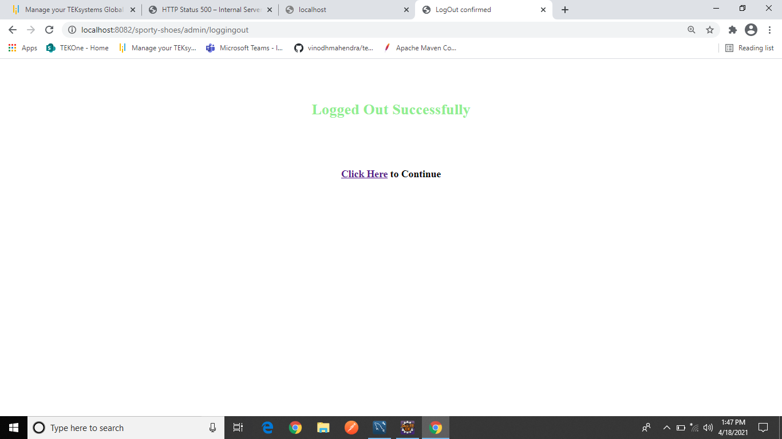

1. **Databases data**
   1. Admin database values are



* 1. Orders database values are

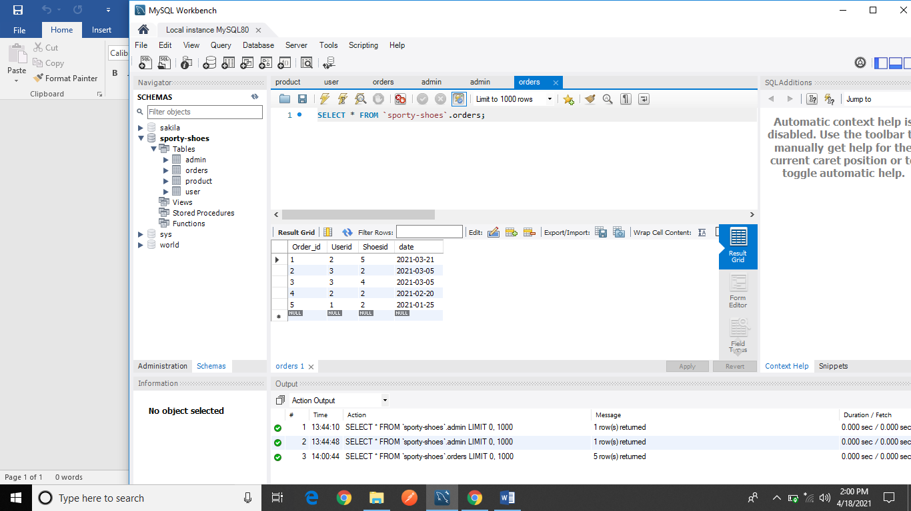

* 1. Users Database values are

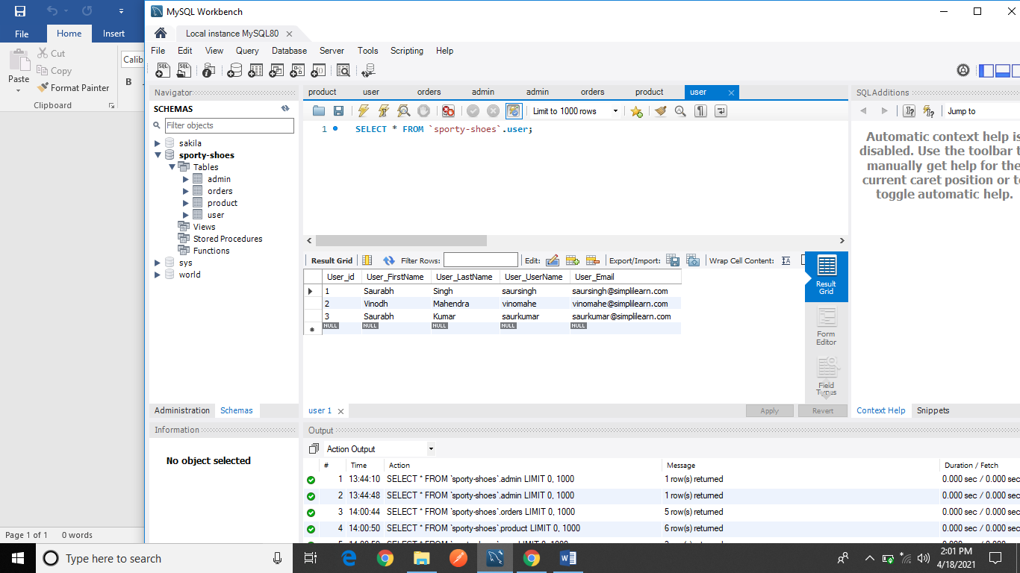

* 1. Products database values are

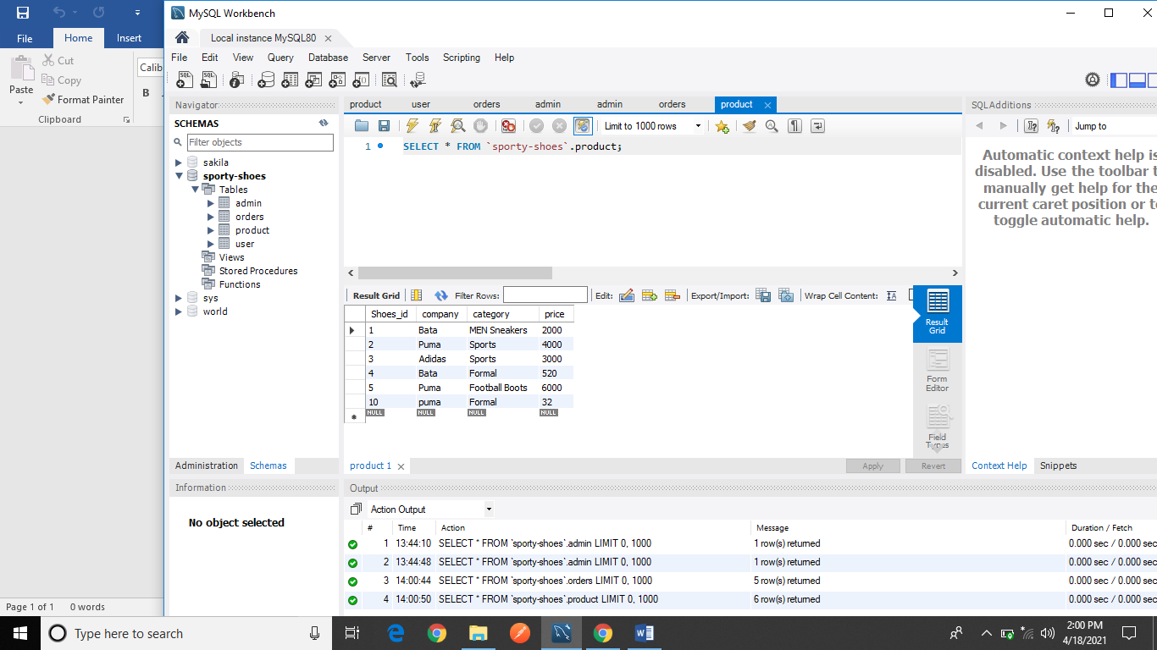

1. **Flowchart of this application are**

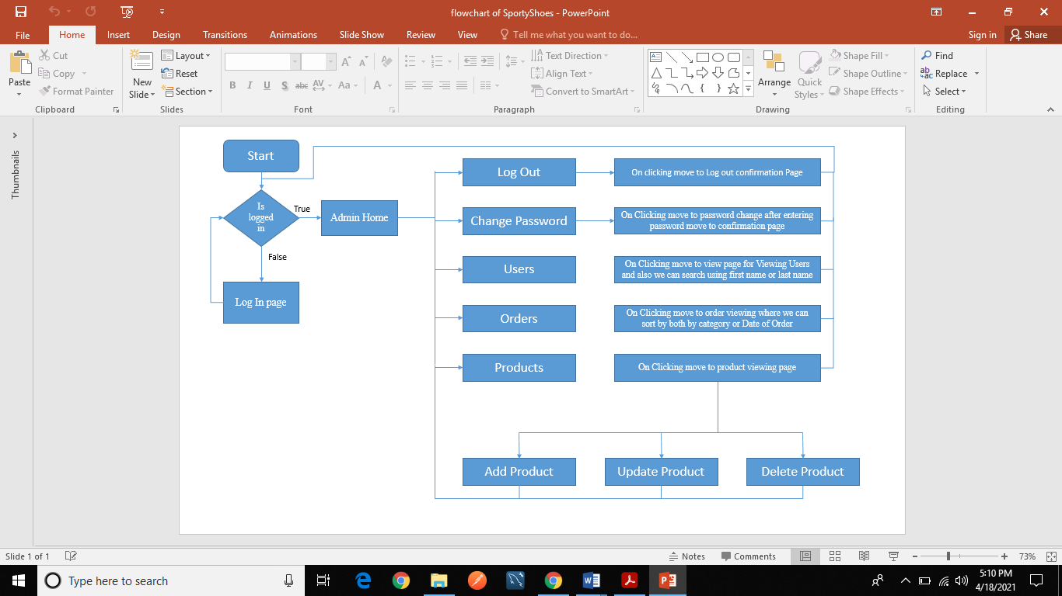

1. **GitHub link**

* **<https://github.com/SaurabhSinghCS/Phase-3-Sporty-Shoes>**