**Vedas College**

**Department of Computer Science and Information Technology**

College Logo(square not enlarged)

**Project Proposal on:**

Your Topic

**Submitted by:**

Your Name (TU roll no)

Vedas College

Department of Computer Science and Technology

Jawalakhel, Lalitpur

**Submitted to:**

Vedas College

Department of Computer Science and Technology

Jawalakhel, Lalitpur

**July 2021**

# TABLE OF CONTENTS

ABSTRACT i

TABLE OF CONTENTS ii

LIST OF FIGURES iii

LIST OF TABLES iv

LIST OF ABBREVIATIONS v

1. INTRODUCTION 1

1.1 Sub-heading 1 – Background Introduction 1

1.2 Sub-heading 2 – Other related topics (e.g. Scope and Application) 1

2. PROBLEM STATEMENT 2

3. OBJECTIVE 3

4. METHODOLOGY 6

4.1 Requirement Identification 6

4.1.1 Study of Existing System / Literature Review 6

4.1.2 Requirement Analysis 6

4.2 Feasibility Study 7

4.2.1 Technical Feasibility 7

4.2.2 Operational Feasibility 7

4.2.3 Economic Feasibility 7

4.2.4 Schedule Feasibility 7

4.2.4.1 Gantt Chart 7

4.2.2 Operational Feasibility 7

8. EXPECTED RESULT 9

REFERENCES 10

# 

# LIST OF FIGURES

Figure 6‑1:Name of Figure 6

Figure 6‑2: Name of Figure 6

Figure 6‑3: Block Diagram of Abc 6

# LIST OF TABLES

Table 1: Gantt Chart 8

Table 2: Time Estimation 9

# LIST OF ABBREVIATIONS

|  |  |
| --- | --- |
| AC | Alternating Current |
| ADC | Analog to Digital Converter |
| API | Application Programming Interface |
| BCM | Broadcom |

**Chapter 1: Introduction**

* 1. **Introduction**

Write introduction about your project work in a paragraph.

## Sub-heading 1 – Background Introduction

Your introduction here. Your introduction here. Your introduction here. Your introduction here.

## Sub-heading 2 – Other related topics (e.g. Scope and Application)

Your introduction here. Your introduction here. Your introduction here. Your introduction here.

**Chapter 2: Problem Statement**

* 1. **Problem Definition**

Specify what actually your project title (problem definition).

**Chapter 3: Objectives**

* 1. **Objectives of the project**

Write objectives about your project work in a paragraph.

-To ……………..

-To …………….. etc.

**Chapter 4: Literature Review**

# Introduction

**(Contains all the existing works that have already been carried out in the field related to your project topic. You have to explain each of the works as a separate subtopic with following details:**

* **What is the work of existing/researched related topic?**
* **How it is done? used methods, techniques, technology, algorithms and any new innovations of existing/researched related topic)**
* **Its importance or applications existing/researched related topic**
* **drawbacks and limitations existing/researched related topic**
* **Criticize the work of existing/researched related topic**
* **Link these criticisms on the existing/researched related topic to the motivation explained in previous chapter. )**

Your literature review here. Your literature review here. Your literature review here. Your literature review here. Your literature review here. Your literature review here. Your literature review here. Your literature review here [1].

## Sub-heading 1

Your literature review here. Your literature review here. Your literature review here. Your literature review here. Your literature review here. Your literature review here. Your literature review here. Your literature review here [2].

## Sub-heading 2 and so on

Your literature review here. Your literature review here. Your literature review here. Your literature review here. Your literature review here. Your literature review here. Your literature review here. Your literature review here [3].

**Chapter 5: Methodology**

**5.1 Methodology**

**(It may contain the explanation in details in a particular sequence in which you have done your work along with detail algorithms that you are going to use, procedures, circuit diagrams or others which illustrate the “*how”* part details).** Different methods and algorithms, tools, etc.

* + 1. **Algorithms used**
    2. **Different Tools and Techniques**
    3. **Flow chart**

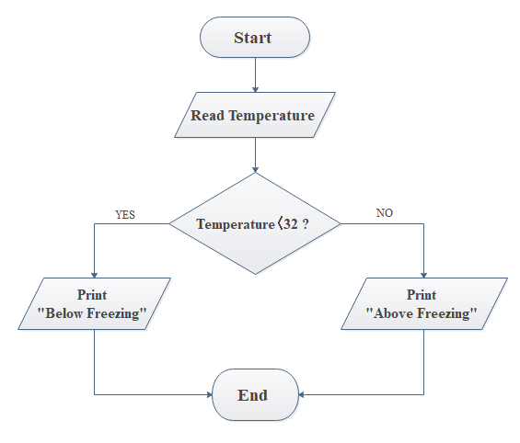

Figure 6‑3: Block Diagram of Abc

* + 1. **Time Schedule**
       1. **Gantt chart**

Table 1: Gantt Chart

|  |  |  |
| --- | --- | --- |
|  |  |  |
|  |  |  |

**Chapter 6: Expected Result**

* 1. **Result and Conclusion**

What are the expected results and conclusions?

User Interface Diagram.

**References**

Write references according to IEEE formatting and citation be also in IEEE. Study about the IEEE references and citation.

Follow the guidelines for IEEE formatting.

(Use ………….. format as follows. Note: This is auto generated reference, do not try to type manually.)

|  |  |
| --- | --- |
| [1] |  |
| [2] |  |
| [3] |  |
| [4] |  |
| [5] |  |
| [6] |  |
| [7] |  |
| [8] |  |

**Guidelines for writing project work proposal.**

1. Language must be English Language.
2. You must use **“Times New Roman”** font with **“Bold”** and*“Italic”*variants whenever needs (except in exported image/diagrams, screenshot of tables etc.).
3. Page margin must be 1.25” at left and all other of 1”.
4. All Headings must be Left Justified.
5. All normal paragraphs must be left and right justified that is fully justified.
6. All the tables and figures must be centered justified.
7. Page size must be standard A4 size.
8. Prefatory pages (before INTRODUCTION) should be numbered in Arabic numbers (i, ii, iii…) and body part should be numbered in style (1, 2, 3…)
9. You can start the numbering from second page but **must not number the cover page**.
10. Line spacing must be 1.5
11. Heading=16pt, sub-heading=14pt and sub-sub-heading=12 also the paragraph’s text’s size=12.
12. Citation must be IEEE, don’t follow APA formatting. APA is for internship report.
13. Numbering of tables, figures and equations must be consecutive, without repetition of numbers throughout the text. Numbering can be 1, 2, 3, etc., or by chapter, i.e., 1.1, 1.2, 1.3. The numbers must be consistent.
14. All the figures, tables, charts, equations etc. used in the document must be numbered using insert caption under reference of MS Word.
15. Figures must be captioned centered below the picture.
16. Tables must be captioned centered above the table.
17. Reference must be used in ascending order (It means if you use [1] reference in page 5 and reference [2] in page 6 then you must not use reference [3] in page 5) using IEEE format.
18. Reference should not be numbered as chapter.
19. The name of the University, Institute and Campus must be in uppercase letters.
20. The title of the project must be 1st letter capitalized(no UPPERCASE).