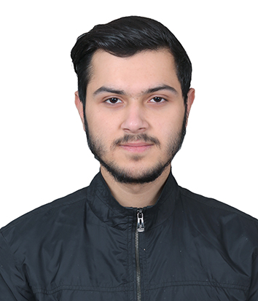

**Tuition Institute :**

iTutorNepal – (2022 Running)

Working as a Founding Member of the Organization where I designed Banners, Logo and Adverts.

**Affiliate Marketing :**

Worked as a Affiliate Personnel on a US Based company – (2019 Dec - 2021)

Worked as a Online Affiliate for a year.

**Other Information**

**Two-Wheeler Vehicle :**

YES

**Two-Wheeler License :**

YES

**Plus 2 (Science):**

Liverpool Int’l College – 2017-2019

Studied Physical and Computer Science

**BSc.CSIT (TU):**

Swastik College – 2019 Running

Studying Computer Science & Information Technology (CSIT)

**Education**

English 90%

Nepali 95%

Hindi 70%

**Languages**

Teaching

Playing Futsal

Music and Movies

Communication and Interaction.

**Hobbies**

**Experience**

**Shiwam Paudel**

IT Student

* Figma
* Canva
* MS Word and PowerPoint
* Documentation
* UI/UX Designer

**Skills**

**Phone:**

9843468715

**Email:**

[paudel.shiwam@gmail.com](mailto:paudel.shiwam@gmail.com)

**Address:**

Balkot, Bhaktapur

**Contact**