AI Agent Management Console Prototype
Interactive prototype: https://bend-mirror-32622206.figma.site/

Prototype overview
The AI Agent Management Console prototype demonstrates a central workspace for discovering, monitoring, and governing enterprise AI agents. Its primary feature, the Agent Search tab, brings agent ownership, platform, status, risk level, and recent activity into a single searchable inventory. Users can locate agents by name, ID, owner, or purpose; filter the inventory; and quickly identify high-risk, ownerless, or unused agents.
Selecting an agent opens a persistent details panel for further investigation. The prototype also demonstrates bulk governance actions, including assigning owners, blocking, and retiring agents, with previews and results to support informed decisions. It uses sample enterprise data to illustrate these workflows.

Agent Search inventory
The All agents view presents the searchable inventory and its main governance attributes in one place.
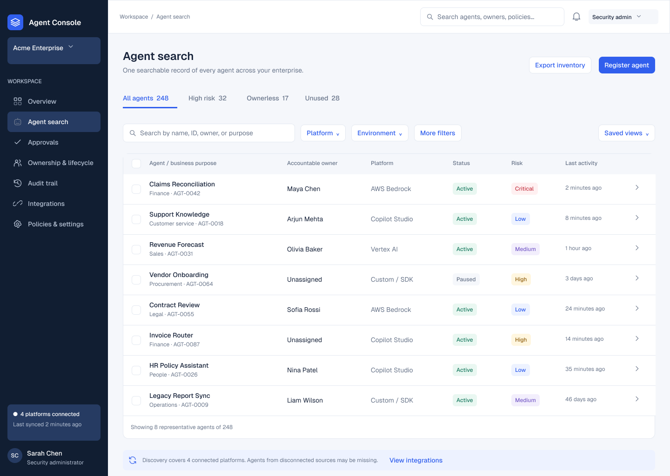
Figure 1. Centralized agent inventory showing ownership, platform, status, risk, and recent activity.

Risk based filtering
The High risk view narrows the inventory to agents that require closer attention, supporting prioritization before further investigation.
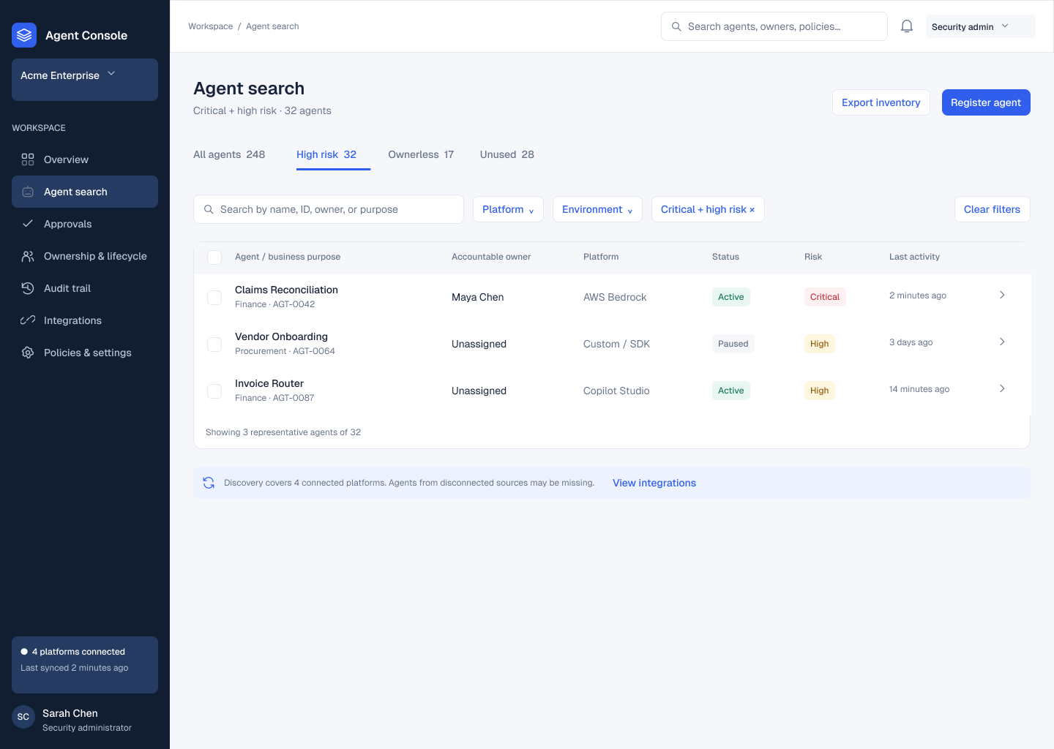
Figure 2. Filtered inventory highlighting agents that require risk assessment and follow-up.

Agent details within the inventory
Selecting Claims Reconciliation opens a persistent details panel alongside the inventory, allowing investigation without losing the search context.
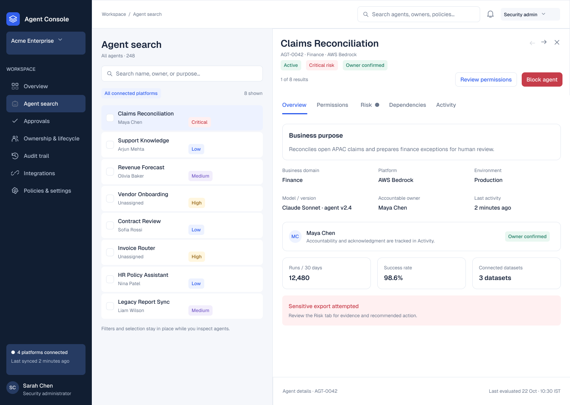
Figure 3. Agent details displayed alongside the inventory for focused investigation.

Reviewing a bulk action
The preview checks three selected agents. Two are eligible for automatic blocking, while one requires manual control.
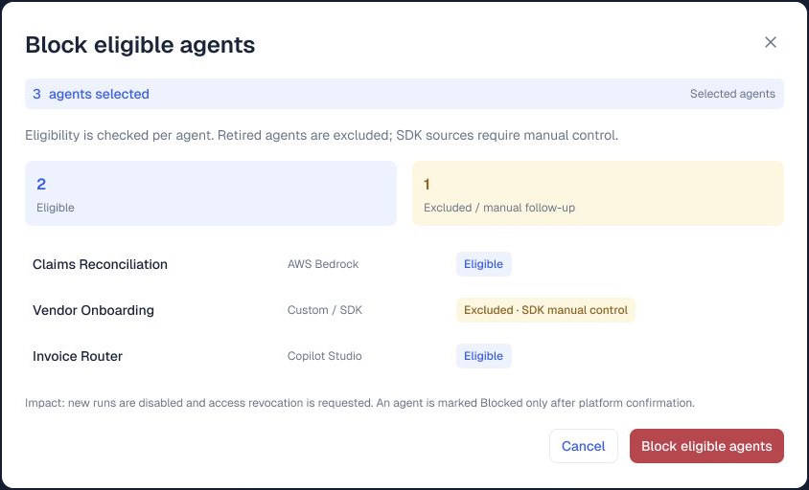
Figure 4. Three selected agents reviewed for eligibility before the bulk-block action.

Bulk action results and follow up
The results show one confirmed block, one provider timeout, and one skipped agent requiring manual control. Failed actions can be retried.
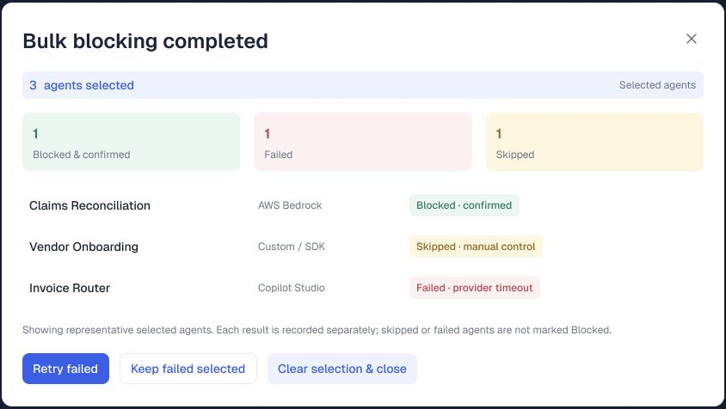
Figure 5. Separate outcomes and a retry option support follow-up after partial completion.

