

**INTRODUCTION**

**PureKart is an e-commerce company started in 2023, offering a wide range of products across categories like furniture, electronics, and home essentials. It is designed to provide a seamless shopping experience with easy navigation, efficient product management, and secure transactions.**

**With a strong focus on quality, affordability, and reliability, PureKart connects customers with trusted suppliers, ensuring they get the best products at competitive prices. Whether you're looking for home essentials, tech gadgets, or stylish accessories, PureKart makes online shopping simple and hassle-free.**

**OBJECTIVE :-**

1. **Customer Insights & Engagement:**
   * Analyze customer purchase behavior, repeat transactions, and high-value customers.
   * Identify customer retention patterns and engagement levels.
2. **Sales & Revenue Analysis:**
   * Track revenue trends, best-selling products, and seasonal demand variations.
   * Identify high-revenue categories and supplier contributions.
3. **Order & Shipment Optimization:**
   * Monitor order fulfillment times and detect shipment delays.
   * Identify bottlenecks in logistics and improve delivery efficiency.

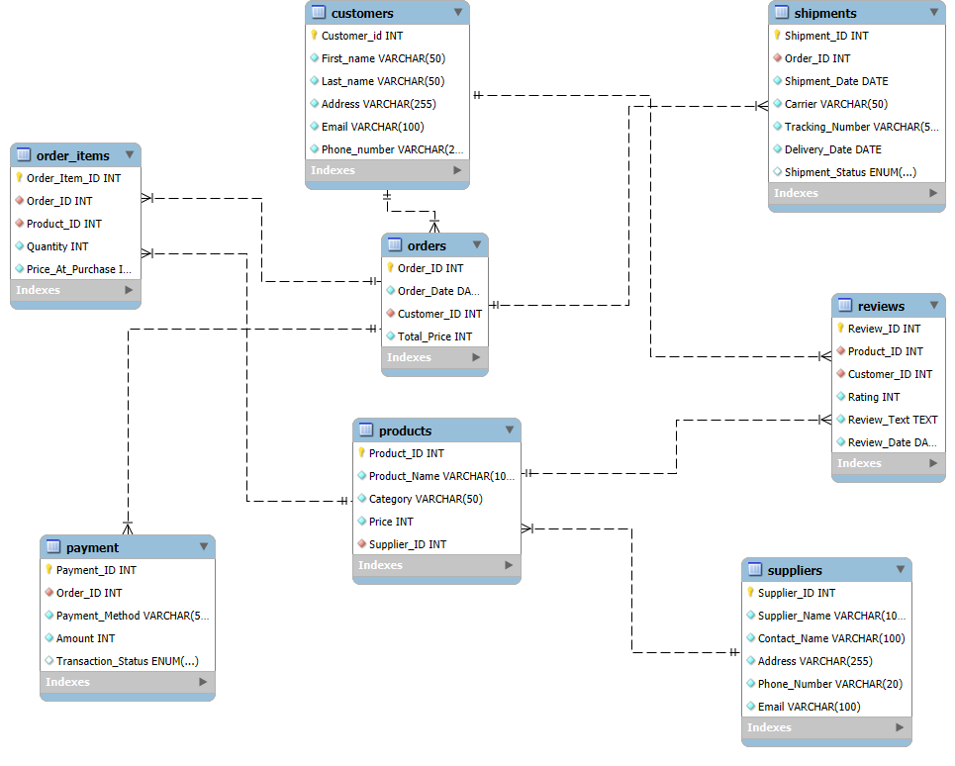

1. **Insights**

**1. Customer Insights & Engagement**

* High-Value Customers: The top 10 customers have spent between 16,000 and 20,000.
* Repeat Transactions: Many customers have made only two purchases, suggesting low repeat transaction rates and potential for improvement in customer retention.

**2. Sales & Revenue Analysis**

* **Revenue Trends:** Sales **peak in November** ($4.1M), showing strong **seasonal demand** during the holiday period.
* **Best-Selling Products:** **4K Monitors, Air Purifiers, and Standing Desks** are top sellers, highlighting demand for **electronics and home essentials**.
* **Category Performance:** **Electronics ($13.5M) and Home & Kitchen ($10.3M)** are the highest revenue-generating categories.
* **Supplier Contributions:** Some suppliers, such as **Next Level Systems and Modern Tech Enterprises**, generate **high revenue**, while **several suppliers contribute significantly less**.

**3. Order & Shipment Optimization**

* **Carrier Performance:** **UPS, DHL, and FedEx** have similar **average delivery times (4.5 days)**, but DHL has the **highest number of pending shipments**.
* **Logistics Bottlenecks:** A **high number of pending shipments** suggests **inefficiencies in supply chain management** and possible issues with carrier performance.

**Recommendations**

**1. Customer Insights & Engagement**

* **Loyalty Program:** Introduce **reward points, exclusive deals, or discounts** to encourage repeat purchases and increase customer retention.
* **Personalized Engagement:** Identify **inactive customers** and send targeted promotions, reminders, or re-engagement emails.
* **Subscription or Membership Model:** Introduce **subscription-based services** for high-demand products to encourage frequent purchases.

**2. Sales & Revenue Analysis**

* **Seasonal Promotions:** Launch **targeted marketing campaigns** before peak months (October–December) to **maximize seasonal revenue**.
* **Stock Optimization:** Ensure **high-demand products are always available** by improving inventory management and forecasting.
* **Supplier Performance Review:** **Negotiate better contracts** with top-performing suppliers and reconsider partnerships with **underperforming** suppliers.

**3. Order & Shipment Optimization**

* **Optimize Order Processing:** Improve **warehouse efficiency** and **automate order fulfillment** to minimize shipment delays.
* **Carrier Performance Monitoring:** **Analyze shipment delays with DHL** and **shift shipments** to faster carriers if necessary.
* **Predictive Demand Planning:** Use **historical data to forecast demand** and align logistics accordingly to prevent shipment backlogs.
* **Customer Communication:** Notify customers **proactively about delays** and offer **compensation (discounts, free shipping, faster replacements)** to maintain customer satisfaction