A report on

**TRAVEL PLANNING WEBSITE**

Submitted by

**SAURABH BALKE (20BCS201)**

**SHIVAM AGRAHARI (20BCS205)**

**SARTHAK JAIN (20BCS198)**

**C.S.E. 2021(2nd Year)**

Submitted to

**Prof. Pritee Khanna**



**PDPM INDIAN INSTITUTE OF INFORMATION TECHNOLOGY, DESIGN AND**

**MANUFACTURING JABALPUR, INDIA**

**November 16th , 2021**

**INTRODUCTION-** This project is basically an application which helps friends, colleagues or relatives who live at far off places (generally in another country) plan a trip together to a place in optimal budget.

* Find new places
* Hassle free trip
* Know more about you trip
* Always be at ease
* Know the real truth (reviews)
* To utilize tech
* Easy to understand interface

**PURPOSE & SCOPE-** The purpose of the website is to provide advice on which destinations, attractions, accommodations, and so on, are worth a visit and providing information on how to access them. It can also be called as a digital form of a traditional travel guide.

Travel Planner sites are a platform to display destination management companies that provides local travel services. You can reserve transportation, day tour services, restaurants, hotels, etc.

The purpose of travel sites is to provide information related to local or international tourists’ destinations and to get a personalized day by day plan for your vacation.

A travel agent's role is to help people plan, choose and arrange their holiday. They will usually work to a budget set out by whoever is planning the holiday. They also offer advice and opinions on where to go and local tourist attractions, events and customs.

**USERS-** Users of the Websites are peoples of any age group who needs a platform to get some information about the travel destinations, find New Places for vacations, Want to Know the real Truth about Their destination and many more.

**PROJECT DESCRIPTION:**

1. The factors to be included in calculating the budget can be customized.
2. The application can act as single solution to cater to all needs of the trip like giving information about flight details, hotel details, stay and food expenditures, Tourist places details and give some combo offers etc.
3. Feedback about the trip can be taken after the trip from the user which can be shown to future users for their ready reference.

**MODULES:** For better management the project is divided in 7 modules.

1. Sign up / Sign in

2. Home

3. Our Packages

4. Flight Availability

5. Hotel Details

6. Contact Us

7. Payment

**MODULE DESCRIPTION:**

1. **Sign up /Sign in:** Users can log in their account or create a new account if not already present

2. **Home:** Describes the general functionality of the site. Details about the popular Destinations. Useful for new users.

3**. Our Packages**: Users can view some Combo packages.

4. **Flight Availability**: Show Information about the flights availability between Destination and Starting point.

5. **Hotel Details**: User can view details about the Hotels in the Destination

6. **Contact Us:** User can post any query/problem about anything on the website or about any packages.

7. **Payment:** User can complete payment using credit/debit card for their selected or customized packages.

**SYSTEM FEATURES AND REQUIREMENTS:-** We develop the Trip Planner Database Management System for the administrator and traveller(user).The admin can store /update data about the packages of the Trip and the user can view and book them

accordingly.

**FUNCTIONAL-REQUIREMENT:-**

**1.Registration:**

Our software gives the tourist the option of self registration, while

empowering the admin to make a new admin for the system.

**User registration:** The user is empowered to register himself by providing

his/her name, email, address and password.

**Admin Registration:** The admin can register new admin with name and password.

**2.Packages:**

The admin can create a new package as well as delete old packages .

On the other hand the user can view all the package details and can

book them.

**3.Bookings:**

The admin can view all the bookings of the user and the user can

make bookings according to his choice .The user has the option

selecting the travel date, travel destination, and their Optimzed Budget.

**4.View Information:**

The admin can view the information of all the users and the user can

view all the details of different packages.

**EXTERNAL INTERFACE REQUIREMENT:-**

**User Interface:** The software provides a good graphical interface for the user an administrator can operate on the system, performing the required tasks.

**Hardware Interface:**

Operating system : window

Hard disk :50 GB

RAM : 256 MB

Processor : Pentium(R)Dual-core CPU4.

**Software Interface:** XAMPP, A web browser.

**Communication Interface**: As this is a web based application so the

communication between the user can be done from any web browser.

**NON-FUNCTIONAL REQUIREMENT:-** The nonfunctional requirements of the trip planner system include the security, reliability, portability and scalability, and maintainability of the system.

The security of the user is ensured through passwords which are themselves being stored as hashed values so that even if someone gets into the database he can’t get the password which implies security at a high level.

**TECHNOLOGIES:**

**FRONT-END**

* HTML
* CSS
* JAVASCRIPT
* BOOTSTRAP (FRAMEWORK)

**BACK-END**

* PHP
* MYSQL

**ER- DIAGRAM :**

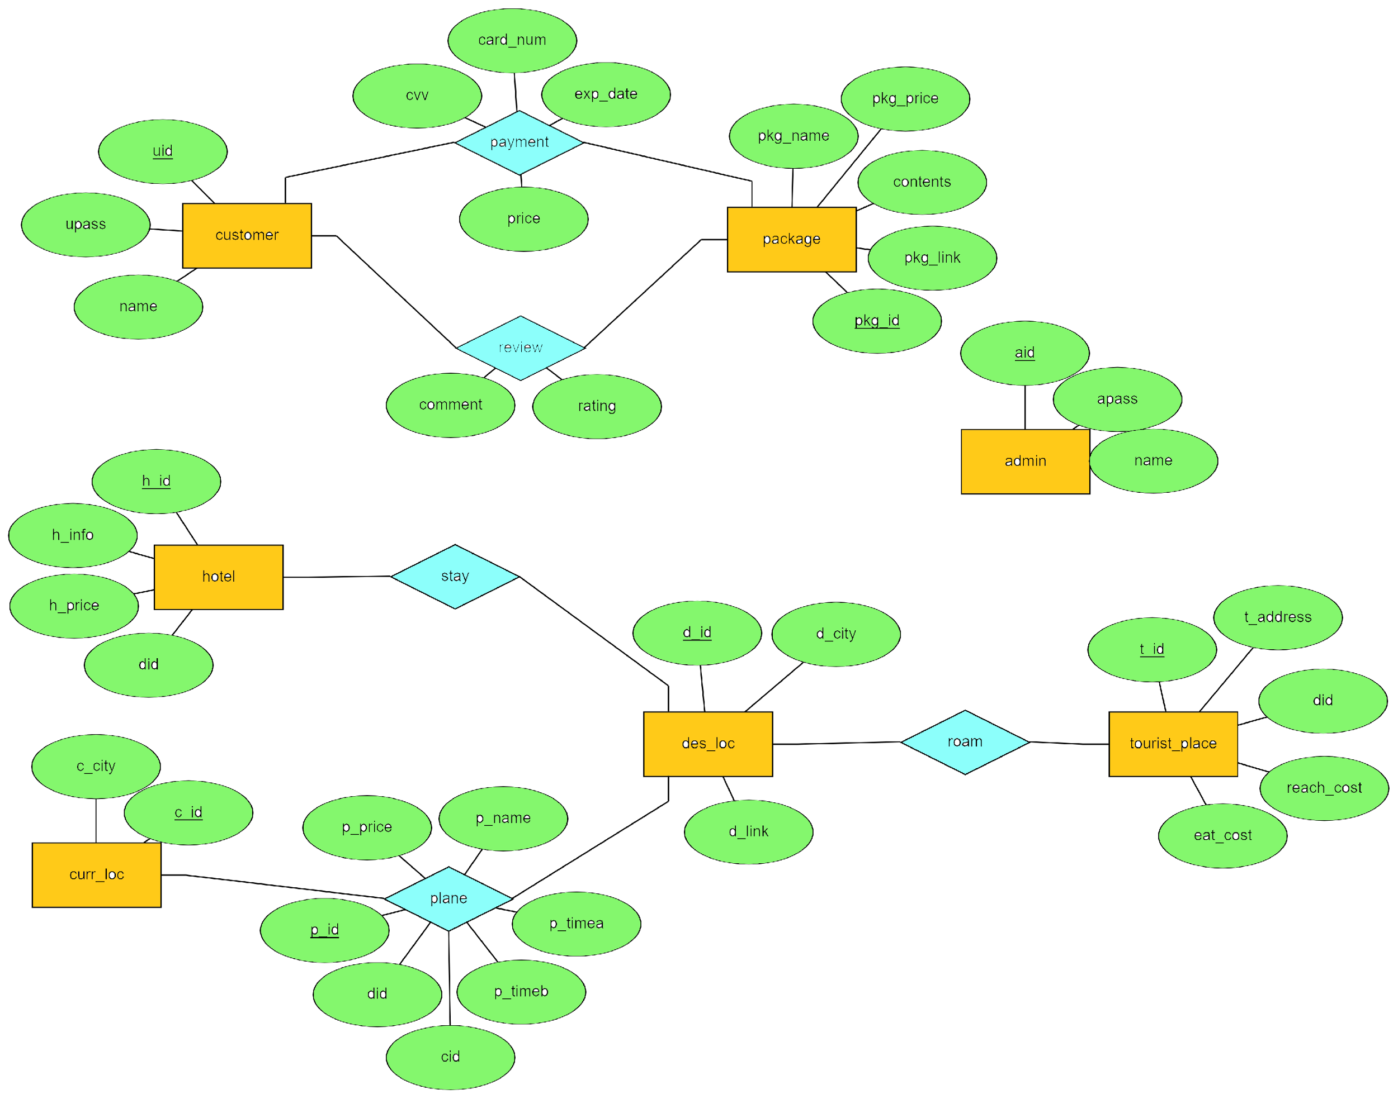

**USER INTERFACE :**

