**Assignment 1**

Name: Saurabh Bramhankar

**1. Discuss the prototyping model. What is the effect of**

**designing a prototype on the overall cost of the**

**project?**

Answer :

Prototyping is defined as the process of developing a working replication of a product or system that has to be engineered. The Prototyping Model is one of the most popularly used Software Development Life Cycle Models (SDLC models). This model is used when the customers do not know the exact project requirements beforehand. In this model, a prototype of the end product is first developed, tested and refined as per customer feedback repeatedly till a final acceptable prototype is achieved which forms the basis for developing the final product. In this process model, the system is partially implemented before or during the analysis phase thereby giving the customers an opportunity to see the product early in the life cycle.

The process starts by interviewing the customers and developing the incomplete high-level paper model. This document is used to build the initial prototype supporting only the basic functionality as desired by the customer. Once the customer figures out the problems, the prototype is further refined to eliminate them. The process continues until the user approves the prototype and finds the working model to be satisfactory.

There are four types of models available:

**A) Rapid Throwaway Prototyping –**   
This technique offers a useful method of exploring ideas and getting customer feedback for each of them. In this method, a developed prototype need not necessarily be a part of the ultimately accepted prototype. Customer feedback helps in preventing unnecessary design faults and hence, the final prototype developed is of better quality. 

**B) Evolutionary Prototyping –**   
In this method, the prototype developed initially is incrementally refined on the basis of customer feedback till it finally gets accepted. In comparison to Rapid Throwaway Prototyping, it offers a better approach which saves time as well as effort. This is because developing a prototype from scratch for every iteration of the process can sometimes be very frustrating for the developers. 

**C) Incremental Prototyping –** In this type of incremental Prototyping, the final expected product is broken into different small pieces of prototypes and being developed individually. In the end, when all individual pieces are properly developed, then the different prototypes are collectively merged into a single final product in their predefined order. It’s a very efficient approach that reduces the complexity of the development process, where the goal is divided into sub-parts and each sub-part is developed individually. The time interval between the project’s beginning and final delivery is substantially reduced because all parts of the system are prototyped and tested simultaneously. Of course, there might be the possibility that the pieces just do not fit together due to some lack of ness in the development phase – this can only be fixed by careful and complete plotting of the entire system before prototyping starts.

**D) Extreme Prototyping –**This method is mainly used for web development. It is consists of three sequential independent phases:

**D.1)**In this phase a basic prototype with all the existing static pages are presented in the HTML format.

**D.2)**  In the 2nd phase, Functional screens are made with a simulated data process using a prototype services layer.

**D.3)** This is the final step where all the services are implemented and associated with the final prototype.

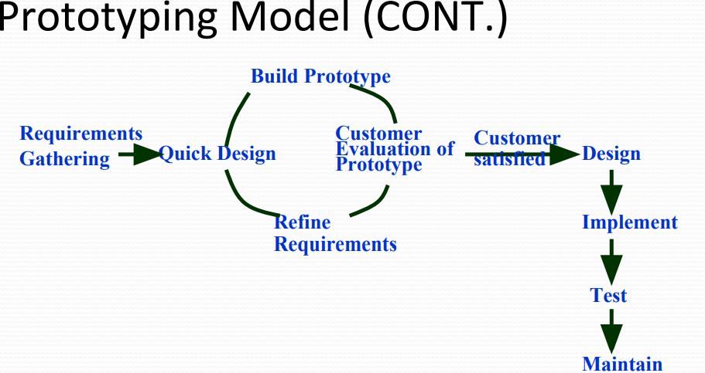

**2. Compare iterative enhancement model & evolutionary process model.**

Answer:

**Iterative Enhancement Model:**

This model has the similar phases as the waterfall model, but with fewer restrictions.

In general the phases occur in the same order as in the waterfall model but these may be conducted in several cycles.

A utilizable product is released at the end of the each cycle with each release providing additional functionality.

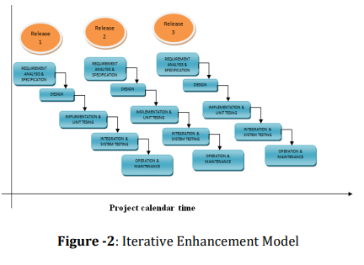

**Evolutionary Development Model**:

Evolutionary development model bear a resemblance to iterative enhancement model.

The similar phases as defined for the waterfall model occur here in a cyclical fashion.

This model is different from iterative enhancement model in the sense that this doesn't require a useable product at the end of each cycle.

In evolutionary development requirements are implemented by category rather than by priority.

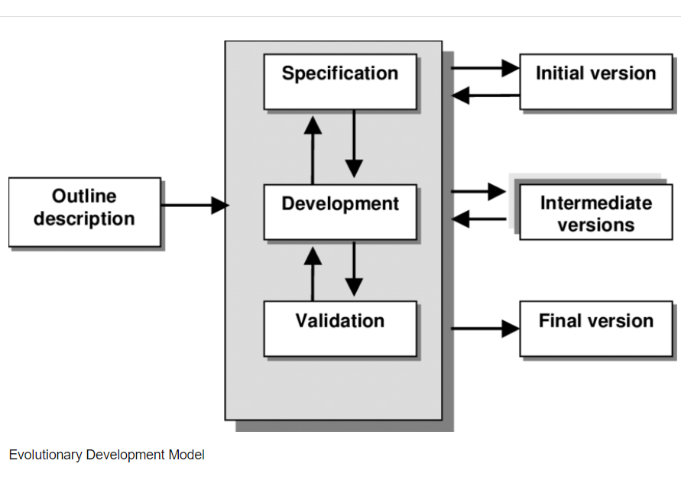

**3. As we move outward along with process flow path of**

**the spiral model, what can we say about software**

**that is being developed or maintained.**

Answer:

As work moves outward on the spiral, the product moves toward a more complete state and the level of abstraction at which work is performed is reduced (i.e., implementation specific work accelerates as we move further from the origin).

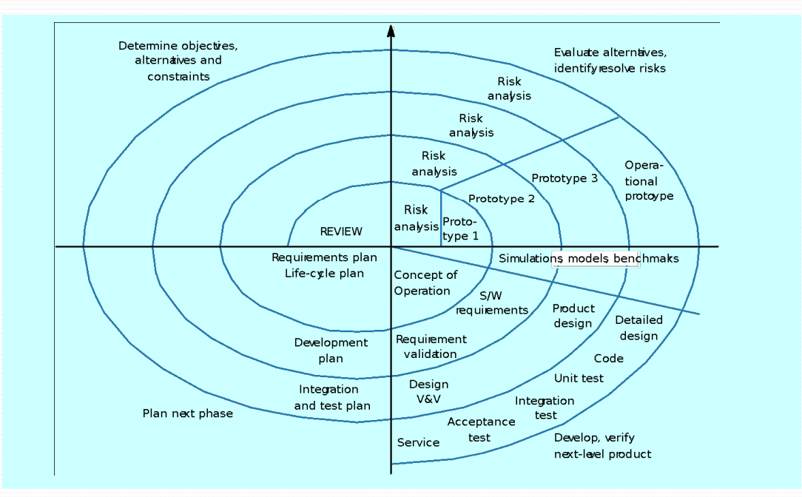

**4. Explain the Scrum Agile methodology.**

Scrum is an [agile development methodology](https://www.digite.com/agile/agile-methodology/) used in the development of Software based on an iterative and incremental processes.  Scrum is adaptable, fast, flexible and effective agile framework that is designed to deliver value to the customer throughout the development of the project. The primary objective of Scrum is to satisfy the customer’s need through an environment of transparency in communication, collective responsibility and continuous progress. The development starts from a general idea of ​​what needs to be built, elaborating a list of characteristics ordered by priority (product backlog) that the owner of the product wants to obtain.

##### ****Different Roles in Scrum****

In Scrum, the team focuses on building quality software. The owner of a Scrum project focuses on defining what are the characteristics that the product must have to build (what to build, what not and in what order) and to overcome any obstacle that could hinder the task of the development team.

**The Scrum team consists of the following roles:**

**Scrum master:** The person who leads the team guiding them to comply with the rules and processes of the methodology. Scrum master manages the reduction of impediments of the project and works with the Product Owner to maximize the ROI. The Scrum Master is in charge of keeping Scrum up to date, providing coaching, mentoring and training to the teams in case it needs it.

**Product owner (PO):** Is the representative of the stakeholders and customers who use the software. They focus on the business part and is responsible for the ROI of the project. They Translate the vision of the project to the team, validate the benefits in stories to be incorporated into the Product Backlog and prioritize them on a regular basis.

**Team:** A group of professionals with the necessary technical knowledge who develop the project jointly carrying out the stories they commit to at the start of each sprint.

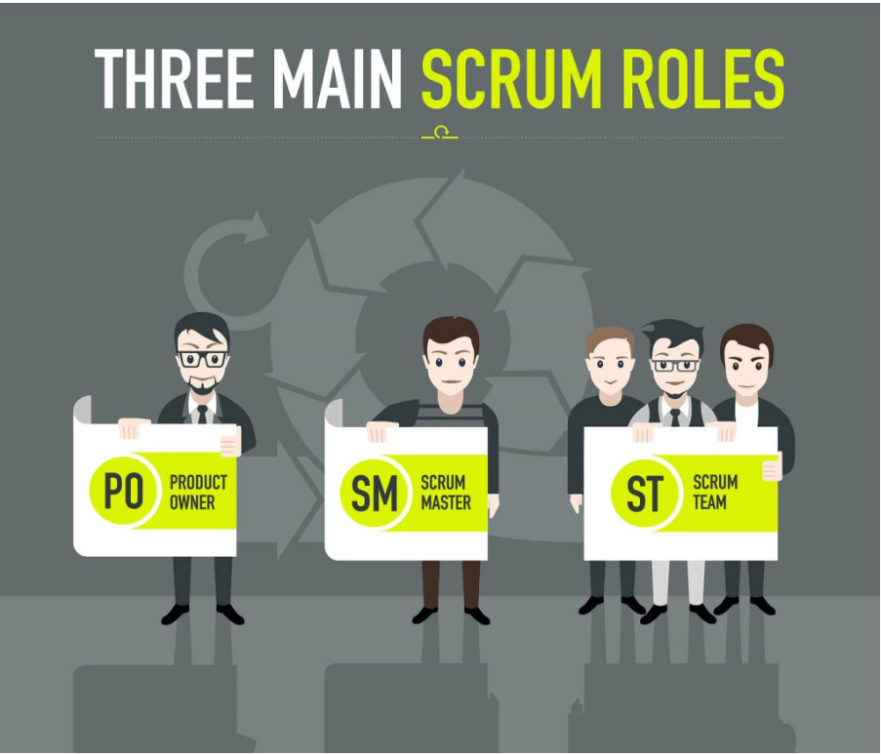

**Benefits of Scrum Methodology**

Scrum has many advantages over other agile development methodologies. It is currently the most used and trusted framework of reference in the software industry. Below are some of the known benefits of Scrum:

**Easily Scalable:** Scrum processes are iterative and are handled within specific work periods, which makes it easier for the team to focus on definite functionalities for each period. This not only has the benefit of achieving better deliverables in line with the needs of the user, but also gives the ability to the teams to scale the modules in terms of functionality, design, scope and characteristics in an orderly, transparent and simple manner.

**Compliance of expectations:** The client establishes their expectations indicating the value that each requirement/ history of the project brings, the team estimates them and with this information the Product Owner establishes its priority. On a regular basis, in the sprint demos, the Product Owner verifies that the requirements have been met and transmits feedback to the team.

**Flexible to changes:** Quick reaction to changes in requirements generated by customer needs or market developments. The methodology is designed to adapt to the changing requirements that complex projects entail.

**Time to Market reduction:** The client can start using the most important functionalities of the project before the product is completely ready.

**Higher software quality:** The working method and the need to obtain a functional version after each iteration, helps to obtain a higher quality software.

**Timely Prediction:**  Using this methodology, we know the average speed of the team by sprint (story points), with which, consequently, it is possible to estimate when a certain functionality that is still in the backlog will be available.

**Reduction of risks:**  The fact of carrying out the most valuable functionalities in the first place and of knowing the speed with which the team advances in the project, allows to clear risks effectively in advance.

**Share**

**TweeShare**

**Share**

* **Shar**

**5. Explain the utility of Kanban CFD reports.**

**Cumulative Flow Diagram** is an analytical tool, fundamental to KABAN METHOD. It allows teams to visualize their effort and project progress. When there's an impediment about to occur within the process - the CFD is where you'll see it first. Instead of the graph staying smooth and rising gently, there will be a bump, a sudden ascend or descend. So, where being able to predict problems is concerned, this is the very graph you need.

**What does it show?**

The CFD visualises how tasks mount up over time, together with their distribution along the process stages. The graph is built from different coloured bands of tasks gathered in various columns. One colour represents one column - so that each band shows how many tasks sit at what stage of the process, in a given time - the horizontal value.

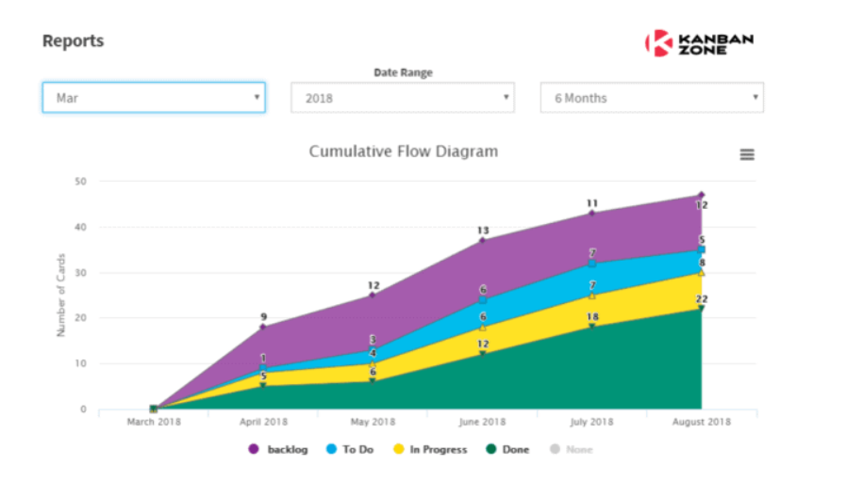

**The major benefits of CFD Kanban are as follows** :

1. It is a compact chart that covers a large amount of data such as in months or years to check and analyse the data.

2. It is a great visual aid to look at the data such as WIP for understanding the general workflow management.

3. It is a great tool to identify the workflow issues upfront such as blockers and work on solving them head-on to prevent major delays or burnout.

4. The steady CFD is the stable and smoothly rising curve from left to right.

5. If the WIP is inflated then it indicates that it will lead to missed deadlines and more meetings.

6. The WIP increases only when resources are added to the WIP Put WIP limits to get rid of the blockers earlier in the stages so that there are no blockers created.