1. HTML Basics

|  |  |
| --- | --- |
| Goals | * Understand the process of creating an HTML page and viewing it in a browser window. * Learn to apply physical or logical character effects. * Learn to manage document spacing |
| Time | 45 minutes |

## 1.1: Create HTML Page

Create a web page to display the text ‘This is the first html page created’.

Solution:

**Step 1:** Click the **Start** button**.** On the **Programs** menu, navigate to the **Accessories** submenu.Click **Notepad.**

**Step 2:** Write the below HTML program in Notepad.

<!DOCTYPE html>

<html>

<head>

<title>This is the first html page</title>

</head>

<body>

This is the first html page created

</body>

</html>

**Step 3:** Save the file with extension *.html*. Save it in the *lab1* directory as *firstpage.html*.

**Step 4:** From Internet Explorer, on the **File** menu, click **Open**. **Open** dialog box appears. Click **Browse** toselect the file you have just saved. Refer to the figure that follows.

**Step 5:** Once you have selected the file, click **OK** in the **Open** dialog box. Output appears as shown in the figure that follows.

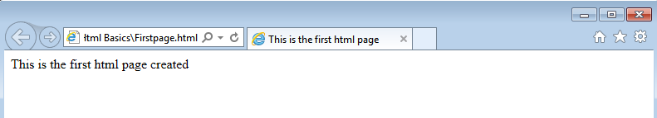

Figure : First.html in a browser

## 1.2 Example: MyFirstPage.html

<!DOCTYPE html>

<html>

<head>

<title>My First Page</title>

<meta [http-equiv] [contents=n]>

<meta http-equiv=refresh content=60>

<!---will refresh the current document after every 60 seconds.-->

<meta http-equiv=refresh content=”20;url=c:/html/html34.htm”>

<--will load secified file after 20 seconds. 🡪

<base href=“c:/mydir/html/”>

<!-- you to use shortcuts in your URLs if you must reference several files from the same location.-->

</head>

<body> Hello World!! </body>

</html>

Example : MyFirstPage.html

Output of the above HTML code is:

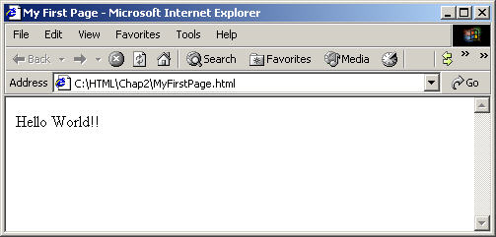

Figure : MyFirstPage.html Output

## 1.3 Example: Headers.html

<!DOCTYPE html>

<html>

<head><title>This is the first html page</title>

<body>This is the first html page created

<h1>This is level 1 heading</h1>

<h2>This is level 2 heading</h2>

<h3>This is level 3 heading</h3>

</body>

</head></html>

Example : Headers.html

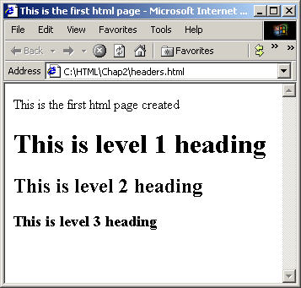

Figure : Headers.html Output

## 1.4 Example: Address.html

<html>

<head>

<title>Address Example</title>

</head>

<body>

<font size="2">Your address:</font><br>

Abc Xyz<br>

<address>b/102 royal palms,</address>

<address>off. s. v. road,</address>

<address>Andheri-West,</address><address>Mumbai.</address>

</body>

</html>

Example : Address.html

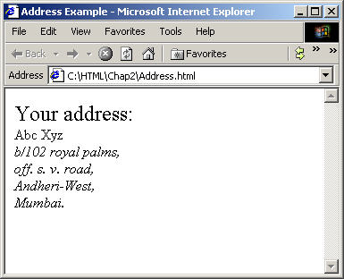

Figure : Address.html Output

## 1.5 Example: PreFormattedText.html

<!DOCTYPE html>

<html>

<head><title>

PREFORMATTED TEXT EXAMPLE

</title></head>

<body>

<h3>GROSS SALE WITH PREFORMATTING</h3>

<hr>

<pre>

<b>GROSS SALES</b>

SALESMAN SALES RANKING

TIM $10,000 2<BR>

TOM $ 5,000 5<BR>

TAMMY $20,000 1<BR>

Each line has a carriage return after it.

</pre>

<h3>GROSS SALE WITHOUT PREFORMATTING</h3>

<p><hr>

<b>GROSS SALE<b>

SALESMAN SALES RANKING

TIM $10,000 2<BR>

TOM $ 5,000 5<BR>

TAMMY $20,000 1<BR>

</body>

Example : PreFormattedText.html

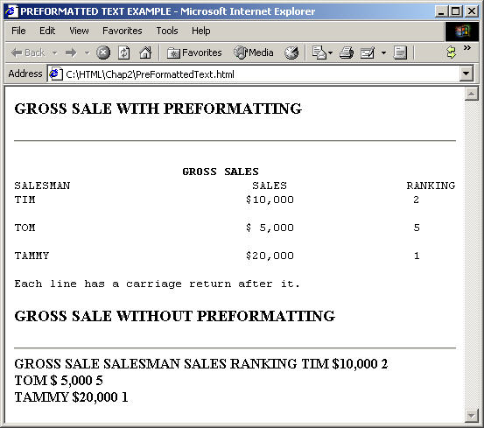

Figure : PreFormattedText.html Output

Problem 1: Resume Creation <<To Do>>

Problem Statement:

Create your resume page as per the format shown in the figure that follows.

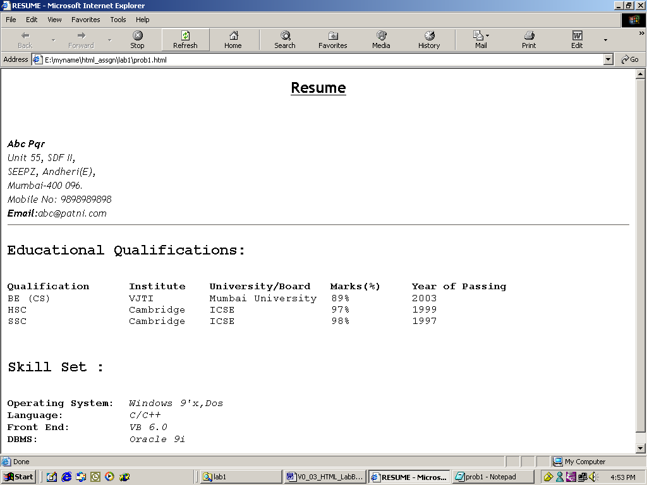

Figure : Resume Page

Solution:

1. Open **Editor**. Type the code and save the file.
2. Use Heading 2 for the headings “Educational Qualifications” and “Skill Set”.
3. Use font size *3* for data pertaining to educational qualifications and skill set.
4. Display details against categories under *Skill Set* in *italics*.
5. Start the Internet Explorer. On the **File** menu, click **Open**. **File** open dialog box appears. Click the **Browse** button and select *prob2.html file*.
6. Check if the output is as per the requirement.
7. Creating Tables

|  |  |
| --- | --- |
| Goals | At the end of this lab session you will understand:   * Attributes of a Table * Table Headers * Table Data * Table Formatting * Control Table Borders * Grouping of Columns |
| Time | 90 minutes |

## Problem 1: Fun with Food

Problem Statement:

Create a web page, which uses a table with columns *Fruit, Color* and *Cost* *per pound* as shown in the figure that follows.

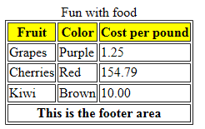

Figure : Fruits Table

Solution

**Step 1:** Write the following code in **Notepad** and save the file*.*

<! DOCTYPE html>

<html>

<head>

<title>Fruits Table</title>

</head>

<body>

<table border="1" >

<caption>Fun with food</caption>

<colgroup>

<col>

</colgroup>

<colgroup>

<col align="center">

<col>

</colgroup>

<thead>

<tr>

<th style="background-color:yellow">Fruit</th>

<th style="background-color:yellow">Color</th>

<th style="background-color:yellow">Cost per pound</th>

</tr>

</thead>

<tbody>

<tr>

<td>Grapes</td>

<td>Purple</td>

<td>1.25</td>

</tr>

<tr>

<td>Cherries</td>

<td>Red</td>

<td>154.79</td>

</tr>

<tr>

<td>Kiwi</td>

<td>Brown</td>

<td>10.00</td>

</tr>

</tbody>

<tfoot>

<tr>

<th colspan="3">This is the footer area</th>

</tr>

</tfoot>

</table>

</body>

</html>

Example : Fruit Table

**Step 2: Open** the file page in the browser to check the required output.

## Problem 2: Table Heading << To Do>>

**Problem Statement:** Create a html page*.* When this page is opened in a browser, it should appear as shown in the following figure

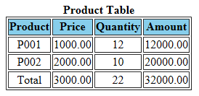

Figure : Product table

Note: Table heading - Background color is: navy and font color is: white.

Solution

1. Open **Editor**. Type the code and save the file.
2. Open the page in browser
3. Check the page shown in the browser and verify that it is as per the requirement.

## Problem 3: Calendar <<To Do>>

Problem Statement:

Design a web page to display a calendar for a month using html table.

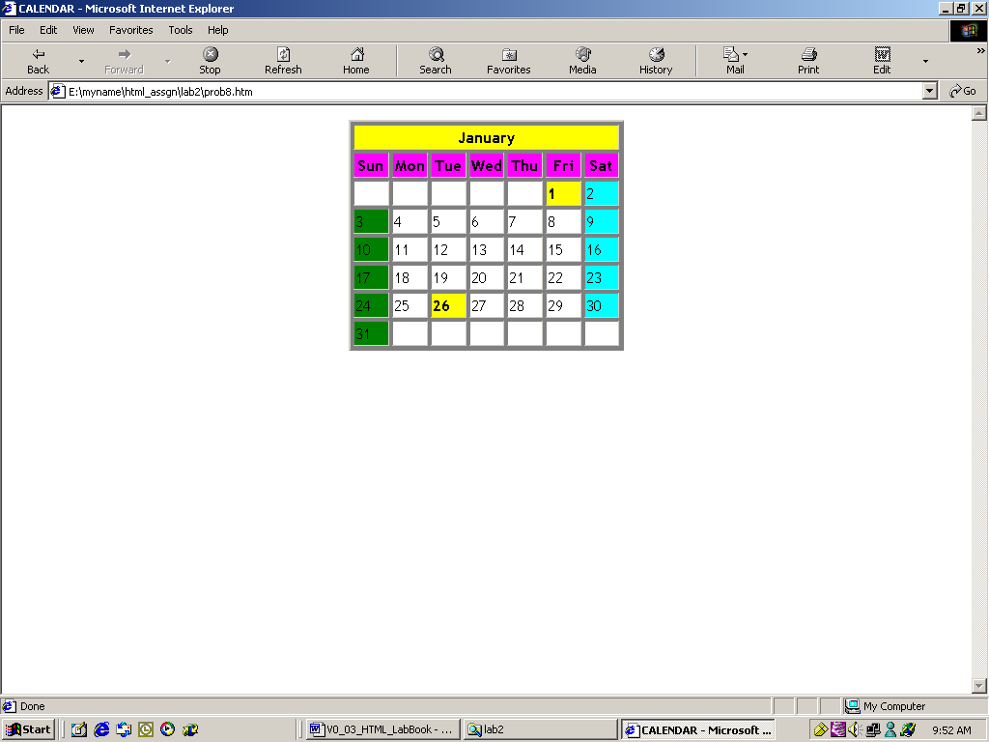

Figure : Calendar

**Note:** Background colors to be used: For all the Sundays: green, for all the Saturdays: aqua, for 1, 26 Jan: yellow

Solution

1. Open **Notepad**. Type the code and save the file.
2. Open the page in browser.
3. Verify that the output is as per requirements.
4. Working with Lists

|  |  |
| --- | --- |
| Goals | At the end of this lab session you will be able to use following types of lists:   * Numbered List * Bulleted List * Directory List * Glossary List |
| Time | 30 minutes |

## Problem 1: Types of Lists

Problem Statement:

Design a web page as shown below

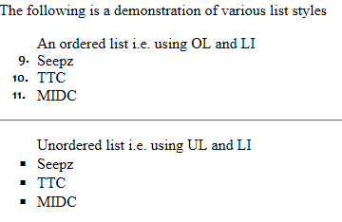

Figure : List

Solution

Step 1: Write the following code in Notepad and save.

<!DOCTYPE html>

<html>

<head>

<title>Working with Lists</title>

</head>

<body>

<p>The following is a demonstration of various list styles

<ol start="3">

An ordered list i.e. using OL and LI

<li>Seepz

<li value="10">TTC

<li>MIDC

</ol>

<hr>

<ul style="list-style-type: square">

Unordered list i.e. using UL and LI

<li>Seepz

<li>TTC

<li>MIDC

</ul>

</body>

</html>

Example : Types of Lists

**Step 2:** Check the page shown in the browser and verify that it is as per the requirement.

## Problem 2: Subjects <<To Do>>

Create a web page to display a list as shown in the figure that follows.

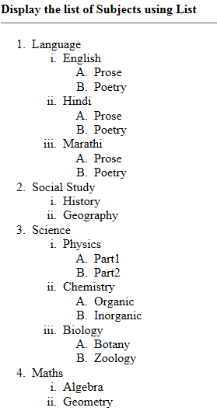

Figure : Subject list

Solution

1. Open **Notepad**. Type the code and save the file.
2. Open the page in browser.
3. Check the page shown in the browser and verify that it is as per the requirement.
4. Working with Links

|  |  |
| --- | --- |
| Goals | At the end of this lab session you will be able to:   * Create links to web documents. * Create links to email. * Create hyperlinks for lists and table data. * Provide target for hyperlink. |
| Time | 30 minutes |

## Problem 1: Welcome to Big Company

Problem Statement:

Design a simple home page for a company with a heading and 3 links – About, Products, Contact as given in the figure below.

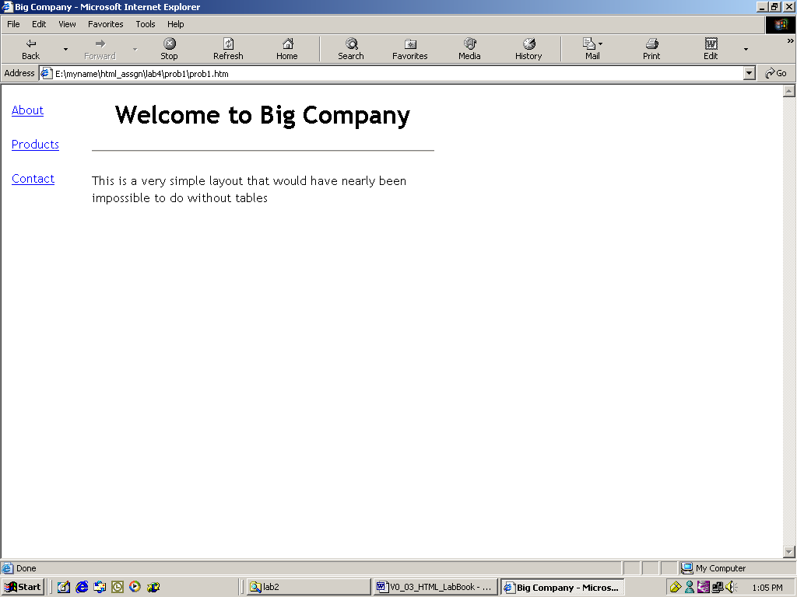

Figure : Big Company home page

When you click the “About” hyperlink, following page should be displayed.

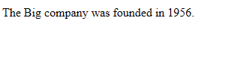

Figure : About

When you click the **Back** button on the browser toolbar, they should be redirected to the page *prob1.html*. Click the “Products” hyperlink to reach the following page:

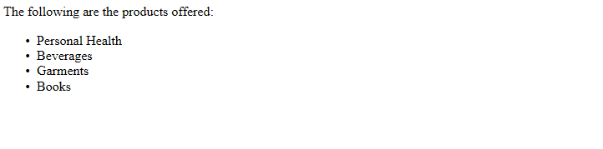

Figure : Products

When you click the **Back** button on the browser toolbar, they are redirected to page *prob1.html*. Click the “Contact” hyperlink. It opens Outlook Express and the e-mail address given in the *To* field, which is [lnd.in@capgemini.com](mailto:lnd.in@capgemini.com) in the following illustration, is displayed in the New message window. This email address is specified in the *mailto* attribute.

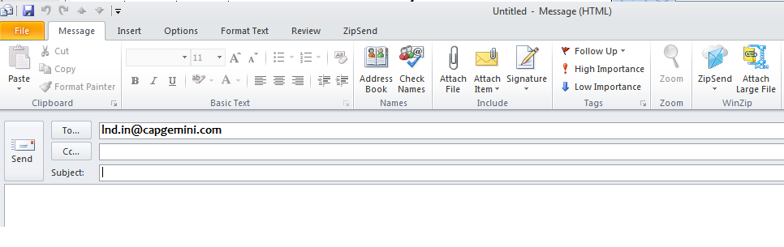

Figure : Contact

Solution

**Step 1:** Write the following code in **Notepad** and save the file*.*

<!DOCTYPE html>

<html>

<head>

<title>Big Company</title>

</head>

<body>

The Big company was founded in 1956.

</body>

</html>

Example : Big Company

**Step 2:** Write the following code in **Notepad** and save it as the file.

<!DOCTYPE html>

<html>

<head>

<title>Products</title>

</head>

<body>

The following are the products offered :

<ul>

<li>Personal Health </li>

<li>Beverages </li>

<li>Garments </li>

<li>Books </li>

</ul>

</body>

</html>

Example : Products

**Step 3:** Write the following code in **Notepad** and save the file.

<!DOCTYPE html>

<html>

<body>

<table>

<tr>

<td>

<a href="about.htm">About</a><br><br>

<a href="products.htm">Products</a><br><br>

<a href="mailto:lnd@capgemini.com">Contact</a><br><br>

</td>

<td>

<h1>Welcome to Big Company</h1>

<hr>

<p>This is a very simple layout that would have nearly been impossible to do

without tables</p>

</td>

<td><br></td>

</tr>

</table>

</body>

</html>

Example : Welcome to Big Company

**Step 4:** Start the Internet Explorer. On the **File** menu, click **Open**. **Open** dialog box appears. Click the **Browse** button and open the page with links file. Verify if the links on the page are working as per the requirement.

## Problem 2: Employee Details <<To Do>>

Problem Statement:

Design a simple home page for a company to display employee details as given below.

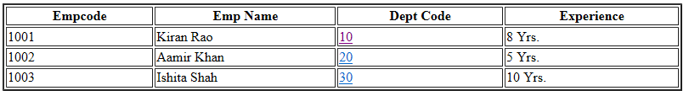

Figure : EmployeeDetails

When you click the department code “10” hyperlink, page with following content should be displayed.

This is Sales department located at Mumbai...

Figure : Sales Department

When you click the department code “20” hyperlink, page with following content should be displayed.

This is training department located at Pune...

Figure : Training Department

When you click the department code “30” hyperlink, page with following content should be displayed.

This is accounts department located at Chennai...

Figure : Accounts Department

1. Image Handling

|  |  |
| --- | --- |
| Goals | At the end of this lab session you will be able to:   * Understand the use of inline images. * Attributes of an inline image. * Text and image aligning. * Use of an image as a hyperlink. |
| Time | 30 minutes |

## Problem 1: Images with Clickable Areas <<To do>>

Problem Statement:

Create a web page with some images as shown in following figure:

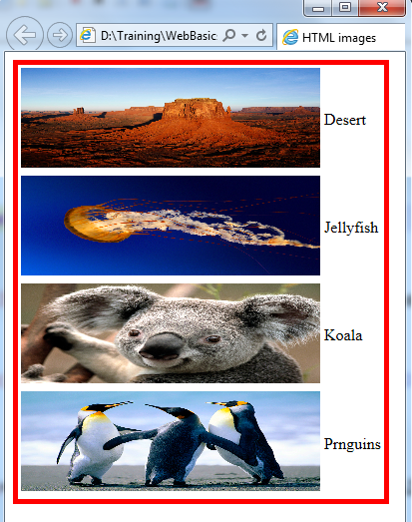

Figure : Images

1. Working with Frames

|  |  |
| --- | --- |
| Goals | At the end of this lab session you will be able to:   * Understand the need for frames in web pages. * Create and work with frames. * Manage large content with frame. |
| Time | 30 minutes |

## Problem 1: Frames

Problem Statement:

Create a web page which allows you to click on 2 hyperlinks courses, menu in the frame on the left. When you click a link, the details are displayed in the frame on the right. The file layout.html is loaded in the frame on the left.

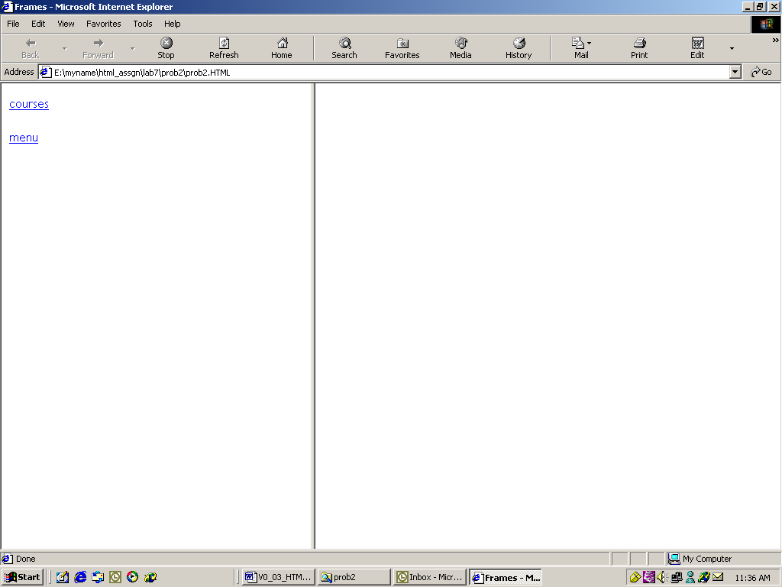

Figure 1: Frames

When you click the link “courses”, the details are displayed in the frame on the right.

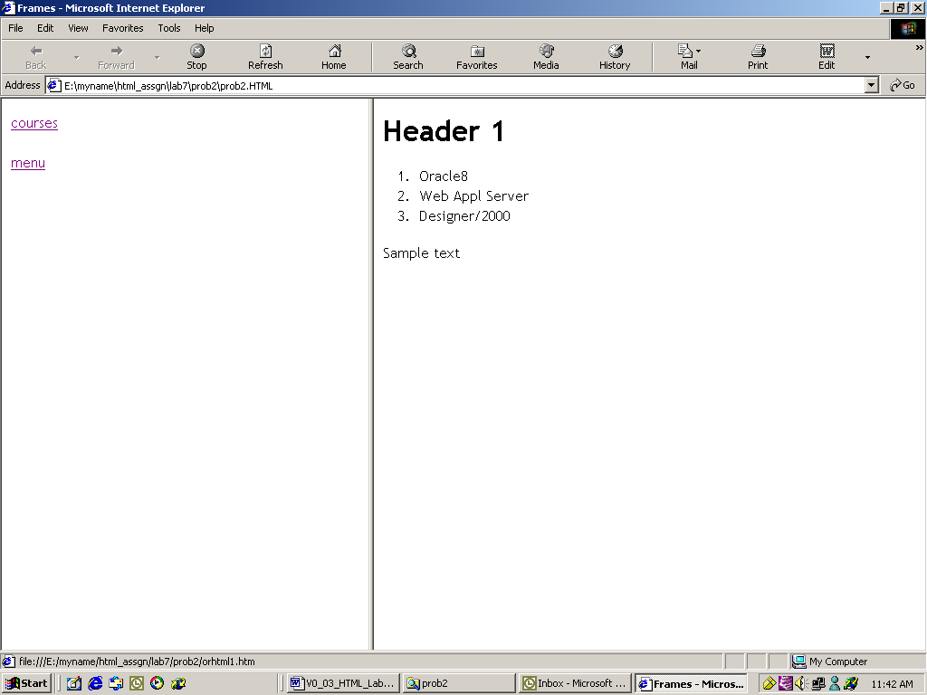

Figure 2: Courses

When you click the link “menu”, the details are displayed in the frame on the right

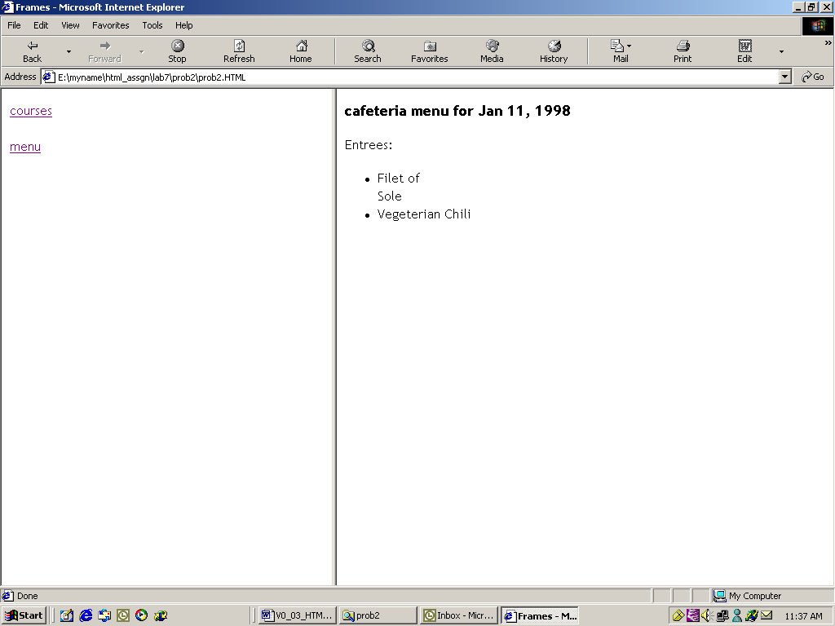

Figure 3: Menu

Solution

**Step 1:** Write the following code in **Notepad** and save the file.

<!DOCTYPE html>

<html>

<head>

<title>Frames</title>

</head>

<body>

<iframe src="content.html" width="100"></iframe>

<iframe name="side-2" width="1000"></iframe>

</body>

</html>

Example : Frames (1)

**Step 2:** Write the following code in **Notepad** and save it as *lab6\prob1\layout.html*.

<!DOCTYPE html>

<html>

<body>

<a href="courses.html" target="side-2"> courses </a><br><br>

<a href="menu.html" target="side-2"> menu </a>

</body>

</html>

Example : Frames (2)

**Step 3:** Write the following code in **Notepad** and save.

<html>

<head>

<title>Sample Page</title>

</head>

<body >

<h1>Header 1</h1>

<ol>

<li>Oracle8</li>

<li>Web Appl Server</li>

<li>Designer/2000</li>

</ol>

Sample text

</body>

</html>

Example : Courses

**Step 4:** Write the following code in **Notepad** and save.

<html>

<head>

<title>Cafeteria Menu Application</title>

</head>

<body>

<h3>cafeteria menu for Jan 11, 1998</h3>

<p>

Entrees:<br>

<ul>

<li>Filet of <br>Sole

<li>Vegeterian Chili

</ul>

</body>

</html>

Example : Menu

**Step 5:** Open the file prob1\layout.html in the browser and check if the page works as per the requirement.

1. HTML Forms for User Input

|  |  |
| --- | --- |
| Goals | At the end of this lab session you will be able to:   * Understand the role of forms in web pages. * Understand various HTML elements used in forms. * Develop HTML forms in web pages. |
| Time | 45 minutes |

## Problem 1: Form

Problem Statement:

Design a web page *prob1.html* in the directory *lab7*. When *prob1.html* is opened in the browser, the page is displayed as shown in the figure that follows.

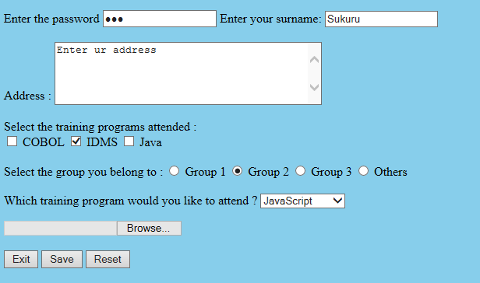

Figure 4: Forms

Solution

**Step 1:** Write the following code in **Notepad** and save it as *lab6\prob1.html*.

<!DOCTYPE html>

<html>

<head>

<title>Form Methods</title>

</head>

<body style="background-color:skyblue">

<form action="mailto:lnd.in@capgemini.com" name="ab" method="post"

enctype="multipart/form-data">

<p>

Enter the password

<input type="password"name="USERNAME" size="20" value="abc" tabindex="3">

<input type="hidden" name="coname" value="PCS">

Enter your surname:

<input type="text" name="surname" SIZE="20" readonly value="Sukuru" tabindex="2" maxlength="30"> <br> <br>

Address :

<textarea name="addr" Rows="5" cols="40" tabindex="0" accesskey="A">Enter ur address </textarea>

<br> <br> Select the training programs attended : <br>

<input type="checkbox" name="s-cobol"> COBOL

<input type="checkbox" name="s-idms" checked> IDMS

<input type="checkbox" name="s-java"> Java <br> <br>

Select the group you belong to :

<input type="radio" name="s-grp" value="grp1"> Group 1

<input type="radio" name="s-grp" value="grp2" checked> Group 2

<input type="radio" name="s-grp" value="grp3"> Group 3

<input type="radio" name="s-grp" value="oth"> Others <BR> <BR>

Which training program would you like to attend ?

<select name="pref">

<option value="JS">JavaScript </option>

<option value="CORBA">CORBA </option>

<option value="VB6">Visual Basic 6 </option>

</select>

</p>

<input type="file" name="fnm"> <br><br>

<input type="button" name="but" value="Exit">

<input type="Submit" Value="Save" name="s-but">

<input type="reset" Value="Reset">

</form>

</body>

</html>

Example : Forms

**Step 2: Open** *prob1.html* in the browser and verify if the form is displayed as per the requirement.

## Problem 2: Employee Details <<To Do>>

Problem Statement:

Design a web page *prob2.html* to accept the following employee details:

* Employee Name (Max 20 characters).
* Employee Code (Max 4 characters).
* Department (Use radio buttons).
* Date of Join (Use the format dd/mm/yyyy).
* Address.
* Training programs attended (Use check boxes).
* Training programs need to attend (Use select box).
* Send the information at [empinfo@capgemini.com](mailto:empinfo@capgemini.com).

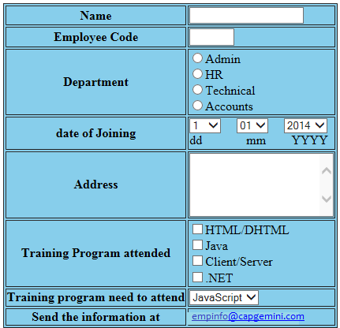

Figure 5: Employee Details

Solution

1. Open **Editor**. Type the code and save the file as lab7\prob2.html.
2. Open the page in the browser.
3. Verify if the output is as per the figure.
4. New Form Elements

|  |  |
| --- | --- |
| Goals | At the end of this lab session, you will be able to:   * Develop web pages using HTML5 enhanced form elements |
| Time | 120 minutes |

## Problem 1: Form

Problem Statement:

Design a web page *prob1.html* in the directory *lab8*. When *prob1.html* is opened in the browser, the page is displayed as shown in the below figure

Solution

**Step 1:** Write the following code in **Notepad** and save it as *lab8\prob1.html*.

<! DOCTYPE html>

<html>

<head>

<meta name="viewport" content="height=device-height,width=device-width,user-scalable=no" />

<meta charset="UTF-8">

<title>New Form Elements</title>

</head>

<body>

<form name="Formelements" action="index2.jsp">

<table>

<tr>

<td><label for="demo">Placeholder : </label></td>

<td><input id ="demo" name="demo" placeholder="Enter Numbers Only" /></td>

</tr>

<tr>

<td><label for="nameauto">Autofocus : </label></td>

<td><input id ="nameauto" name="nameauto" type="text" autofocus/></td>

</tr>

<tr>

<td><label for="range">Range : </label></td>

<td><input id="range" name="range" type="range" min="0" max="50" value="10" /><td>

</tr>

<tr>

<td><label for="search">Search : </label></td>

<td><input id="search" name="search" type="search" placeholder="Search..." /><td>

</tr>

<tr>

<td><label for="date">Date : </label></td>

<td>

<input id="date" name="date" type="date" min="2010-08-14" max="2014-08-14" value=""/></td>

</tr>

<tr>

<td><label for="date">Week : </label></td>

<td><input id="date" name="date" type="week" value=""/></td>

</tr>

<tr>

<td><label for="date">Month : </label></td>

<td><input id="date" name="date" type="month" value=""/></td>

</tr>

<tr>

<td><label for="date">Time : </label></td>

<td><input id="date" name="date" type="time" value=""/></td>

</tr>

<tr>

<td><label for="number">Number : </label></td>

<td>

<input id="number" name="number" type="number" step="1" min="-5" max="10" value="0" />

<td>

</tr>

<tr>

<td><label for="required">Required : </label></td>

<td><input id="required" name="user" type="text" required /></td>

</tr>

<tr>

<td><label for="email">Email:</label></td>

<td><input id="email" name="email" type="email" required/></td>

</tr>

<tr>

<td><label for="color">Color : </label></td>

<td><input id="color" name="color" type="color" placeholder="e.g. #bbbbbb" /><td>

</tr>

<tr>

<td><label for="country_name">Country : </label></td>

<td><input id="country_name" name="country_name" type="text" list="country" /></td>

<td><datalist id="country">

<option value="Afghanistan">

<option value="Albania">

<option value="Algeria">

<option value="Andorra">

<option value="Angola">

<option value="Car">

<option value="Cat">

<option value="City">

<option value="Cup">

<option value="Clip">

</datalist></td>

</tr>

<tr><td colspan="2"><audio controls >

<source src= "god.mp3" type="audio/mpeg" />

<source src= "1vs0_JuniorGroove.ogg" type="audio/ogg"/>

</audio></td></tr>

<!-- audio code works on Firefox and opera .ogg format only -->

<tr>

<td colspan="2"><video src="http://upload.wikimedia.org/wikipedia/commons/7/79/Big_Buck_Bunny_small.ogv" controls width="300" height="250">

</video></td></tr>

<!-- Video code works only on Firefox. .ogg format. various ogg file extension are

.ogx, .ogv, .oga, .spx. -->

</table>

<table>

<tr>

<td align="right"><button type="submit" name="submit" value="Submit">Submit</button></td>

<td align="left"><button type="reset" name="reset" value="reset">Reset</button></td>

</tr>

</table>

</form>

</body>

</html>

Example 5: Code for New Form Elements

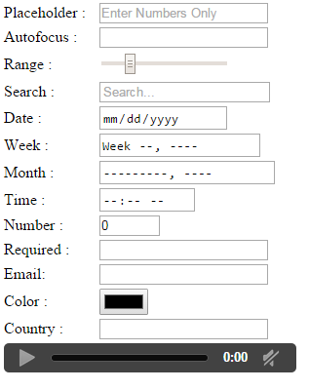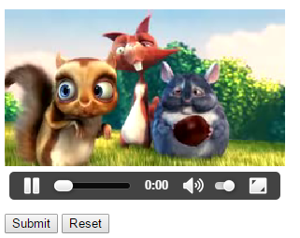

Figure 6: New Form Elements

## Problem 2: Candidate Details <<To Do>>

Problem Statement:

Design a web page StudentInfoForm.html to accept the following student details:

1. Name (Accept only characters , Max 15 characters )
2. Password (Max 15 characters)
3. Phone number(Accept 10 digits)
4. Gender (Make use of radio button)
5. Date of Birth (Make use of date field and date of birth should not be greater than current date)
6. Email (Accept valid Email)
7. Highest Qualification (Make use of datalist to populate data like B.Tech, M.Tech, MBA, MCA, MSc, MA, BSC..)
8. Courses interested in (Make use of check box)
9. Comments to mention regarding Degree / External Certificates (Make use of textarea)
10. Uploading Degree / External certificates (Make use of file input type)
11. Use Placeholders to describe the type of input.
12. All fields marked (*) are mandatory

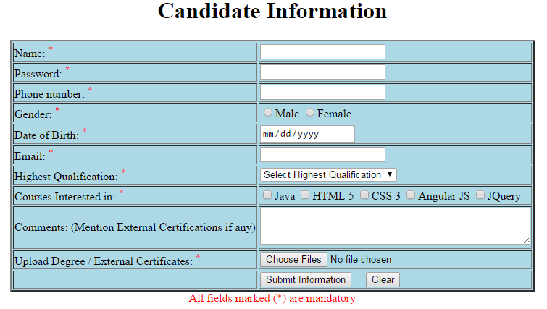

Figure 7: Candidate Details

Solution

1. Open **Editor**. Type the code and save the file as lab7\prob2.html.
2. Open the page in the browser.
3. Verify if the output is as per the figure.

# Appendices

## Appendix A: HTML Standards

Key Things To Keep In Mind:

* HTML standards help you reach the widest possible audience.
* There are many technologies that are associated with HTML because they are used on a Web page or in conjunction with HTML. But these technologies are not HTML:
* CGI (Common Gateway Interface)
* Java
* JavaScript(JavaScript is also not Java)
* Dynamic HTML (DHTML)
* XML ( Extensible Markup Language)
* A variety of other emerging technologies
* For each of it, please follow the coding conventions, specified by that technology.
* Sometimes you need to break the rules and use non-standard syntax for good reasons. Try to keep this to a minimum.

How to Follow HTML Standards

Identify which version of HTML you are using in your document through the DOCTYPE line at the top of your file.

See the W3C site for more information on document types and DOCTYPE statements.

The important thing to remember is that a DOCTYPE statement is essential to assist validation software in checking your document.

* Use tools (supported by W3C) that support standards. In particular, install and use the *Tidy* program or *Tidy GUI* on your computer.
* Use W3C validation markup service to check the syntax of documents you create.
* Refer to W3C for technical and syntax information.

Some Simple HTML standards:

* The names of HTML files should always end with the ".html" extension.

Example:  
*Good:* foo.html  
*Bad:* foo.bar

* Always include a <HTML> tag at the very beginning and a </HTML> tag at the very end of your HTML documents.
* Always use the <HEAD> and </HEAD> tags to define a header section in your HTML documents.
* Always give your documents a title by using the <TITLE> and </TITLE> tags in the header section of your HTML documents.
* Always use the <BODY> and </BODY> tags to define the body in your HTML documents, which is everything in your document between the <HTML> and </HTML> that is not contained in your header section.
* Use the horizontal line tag <HR> to place a horizontal line beneath any prominent headers in your documents to help them stand out from the surrounding information.

Example:  
<H1>My Document's Title</H1>

<HR>

* Always include a LINK with REV="MADE" in the header section of your HTML documents identifying you as the author.

Example:  
<LINK REV="MADE" HREF="mailto:your_logonid@cs.niu.edu">

* Reasonable line lengths (no greater than 80 characters).
* Attributes associated with tags must be enclosed in quotes.

Example:  
<img src="/images/gelogo.gif" width="200" height="100" alt="My Logo">

* Code is written in a consistent case. All command tags should be completely capitalized, in order for the tags to stand out better from the surrounding text.

Example:  
Good: This text is <EM>emphasized</EM>.  
Bad: This text is <Em>emphasized</em>.

* All code should include comment tags for readability, particularly when nested tables are used.
* Images have *alt, height*, and *width* attributes. They must be placed in the same directory as the HTML files. These images must be referenced in the code as:

Example:  
Good: <img src="filename.gif">

bad: <img src="images/filename.gif">.

* Links are coded correctly. All "HREF=" fields in anchor tags should always be enclosed in quotes.

Example:  
Good:<A HREF="http://www.cs.niu.edu/homepage.html">  
Bad: <A HREF=http://www.cs.niu.edu/homepage.html>

* Confirm that ©, ®, ™, and SM marks are coded correctly. These special characters should always be coded using their respective ASCII codes. It should also be confirmed that the superscription of these characters is done in a consistent manner.

Example :

Please code these special characters as follows:  
and Ampersand: andamp;   
© Copyright: and#169;   
® Registration: and#174;   
™ Trademark: and#153;

* Check links. There is nothing more frustrating to users than a broken link (except possibly the blink tag). If the review is of an entire site or a complete section of a site, it is helpful to use an automated link checker. Because there may be hundreds, or even thousands of links, the chance of missing one when checking them by hand is unacceptably high. Since Quality Assurance is not involved in the actual construction of a site, the producer/webmaster needs to verify that links are pointing to the correct pages that those pages still exist, etc.
* If you code a URL which does not specify a file name, always end the URL with a front slash (some browsers choke if you do not do this).

Example:  
Good:<A HREF="http://www.ibm.com/">  
Good:<A HREF="http://www.cs.niu.edu/~www/">  
Bad:<A HREF="http://www.ibm.com">  
Bad:<A HREF="http://www.cs.niu.edu/~www">

* Whenever possible, use logical formatting tags instead of physical —one. Let the client's browser figure out the best way to display the information.

*Preferred:* You should read the book <CITE>Neuromancer</CITE>  
*Preferred:* This text should <EM>stand out</EM>  
*Discouraged:* You should read the book <I>Neuromancer</I>  
*Preferred:* This text should <BOLD>stand out</BOLD>

* Always "sign" any HTML documents that you create. Include a horizontal line and a link to your homepage (using the ADDRESS style) at the very bottom.

Example:

...and this is the end of my document's text.<P>  
<HR>  
<A HREF="http://www.cs.niu.edu/~www/"> <ADDRESS> WWW</ADDRESS></A>  
</BODY>  
</HTML>