* 1. Create Typescript class ,as per below mentioned diagram

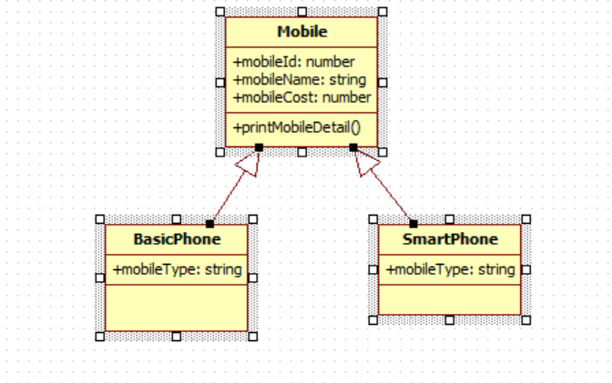

All 3 classes are in separate file. We have to add mobile details such as id, name, cost & type from different typescript file & print data in console

1. Get Data from array