Q1 Configure smtp in localhost

Q2 Create a user in your localhost, which should not be able to execute the sudo command.

* Created user batman using useradd command
* 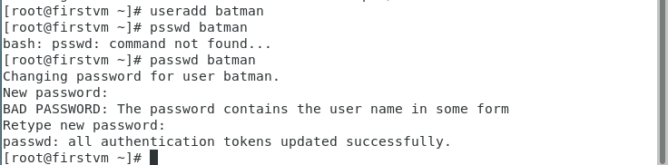
* To check sudo command demicode for which user batman not authenticated.
* 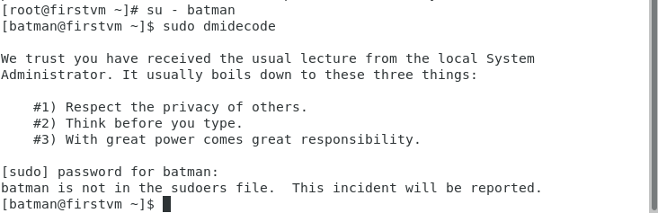
* Furthermore, using visudo command you can check if the user is not present in wheel group as users in wheel group have authentication for sudo command.

Q3. Configure your system in such a way that when a user type and executes a **describe** commandfrom anywhere of the system it must list all the files and folders of the user's current directory.

* Using Alias command create command describe executing “ls -l”

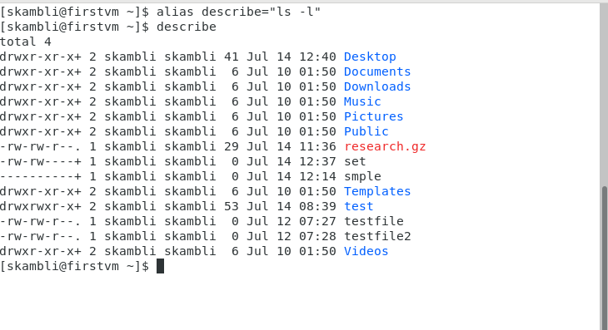

Q4 Users can put a compressed file at any path of the linux file system. The name of the file will be **research** and the extension will be of compression type, example for gzip type extension will be .gz.  
You have to find the file and check the compression type and uncompress it.

* Firstly create a file named research in local directory using touch command.
* Compress it using “gzip research” command and get .gz extension.
* Uncompress it using “gzip -d research.gz” or “gunzip” commands.
* The file is uncompressed.
* 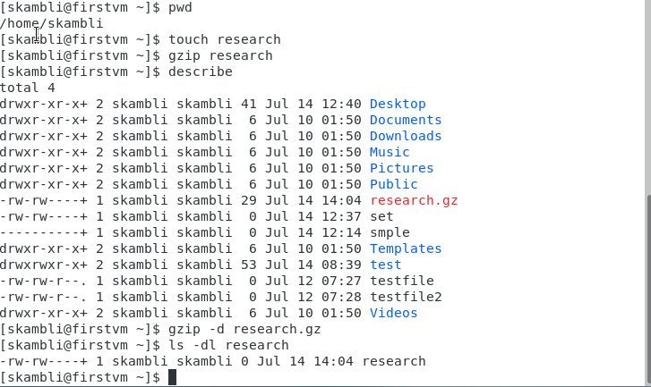

Q5 Configure your system in such a way that any user of your system creates a file then there should not be permission to do any activity in that file.

Note:- Don’t use the chmod command.

* Use umask command to change permission of file.
* First check default umask setting
* Change it to 777
* Create a file using touch
* 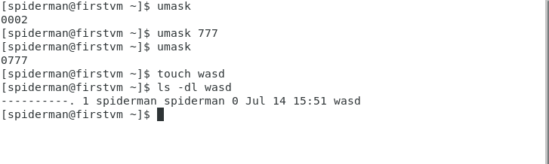

Q6 Create a service with the name **showtime** , after starting the service, every minute it should print the current time in a file in the user home directory.

Ex:-

sudo service showtime start   -> It should start writing in file.

sudo service showtime stop   -> It should stop writing in file.

sudo service showtime status -> It should show status

<https://www.suse.com/support/kb/doc/?id=000019672>