PROJECT NAME | Online Store of HelpLine (Optical/Contact lens) | JOB LOCATION | Lovely Professional University
EST. START DATE | 24th Sept 2024 | EST. FINISH DATE | 10th Jan 2025
PROJECT LEADER | Vishal Kumar Yadav | COMPANY
CONTACT NAME | Sarbind Kumar | ADDRESS | HA - 11, City Centre, Sector - 4, Bokaro Steel City, Jharkhand 827004
PHONE | 9430789062 | EMAIL
SUMMARY
A Website Created using React. It will a Multipage website. With Pages like (Homepage, Store, Eye-Check Appointment, Contact us, About us etc.

DESIRED OUTCOME

Website (HelpLine Optical/Contact Lens).

ACTION TO COMPLETION
- Design the user interface for each page (Homepage, Store, Eye-Check Appointment, Contact Us, About Us).
- Develop the front-end using React.
- Implement functionality for appointment booking.
- Launch and monitor website performance.

BENEFITS OF PROJECT
• Increased online presence for HelpLine Optical/Contact Lens.
• Easier appointment scheduling for customers.
• Enhanced customer experience through an organized online store.

PROJECTED SCHEDULE
Project Kick-off: 24th Sept 2024
Launch: 10th Jan 2025

PROJECTED BUDGET
Total Budget: Rs 5000/

PROJECTED TEAM AND RESOURCE REQUIREMENTS | Web Developer (Vishal Kumar Yadav) |  | - Resource Requirements  - Development environment (React, Node.js, etc.)  - Hosting service for the website

PROJECT APPROVAL FORM

ACCEPTANCE OF PROPOSAL
Client Signature: | 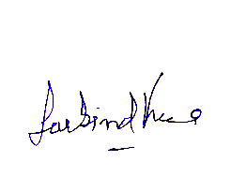 | Date of Acceptance: | 22nd Sept 24

