**Experiment No. – 1.2**

**Aim**: Write a program to implement Bubble sort along with its complexity analysis.

1. **Problem Description:**

We have given an unsorted array of numbers, generate a sorted array of numbers by applying Bubble Sort.

Demonstrate knowledge of time complexity of Bubble Sort by counting the number of operations involved in each iteration and find space complexity.

1. **Algorithm:**

begin BubbleSort(list)

for all elements of list

if list[i] > list[i+1]

swap(list[i], list[i+1])

end if

end for

return list

end BubbleSort

1. **Complexity Analysis**

**Time complexity of Bubble Sort**

Worst Case: O(n2)

Best Case: O(n)

Average: O(n2)

**Space Complexity**: O(1).

1. **Pseudo Code**

procedure bubbleSort( list : array of items )

loop = list.count;

for i = 0 to loop-1 do:

swapped = false

for j = 0 to loop-1 do:

/* compare the adjacent elements */

if list[j] > list[j+1] then

/* swap them */

swap( list[j], list[j+1] )

swapped = true

end if

end for

/*if no number was swapped that means

array is sorted now, break the loop.*/

if(not swapped) then

break

end if

end for

end procedure return list

1. **Source Code (C/C++):**

#include <bits/stdc++.h>

using namespace std;

void bubbleSort(int arr[], int size)

{

    int temp;

    for (int i = 0; i < size; i++)

    {

        for (int j = 0; j < size - i - 1; j++)

        {

            if (arr[j] > arr[j + 1])

            {

                temp = arr[j];

                arr[j] = arr[j + 1];

                arr[j + 1] = temp;

            }

        }

    }

}

int main()

{

    cout << "Name: Saurabh Kumar \nUID: 23MAI10004\n";

    int n;

    cout << "Enter the Size: ";

    cin >> n;

    int arr[n];

    cout << "Enter elements:" << endl;

    for (int i = 0; i < n; i++)

    {

        cin >> arr[i];

    }

    bubbleSort(arr, n);

    cout << "Array after Sorting: ";

    for (int i = 0; i < n; i++)

    {

        cout << arr[i] << " ";

    }

    return 0;

}

1. **Screenshot of Outputs:**

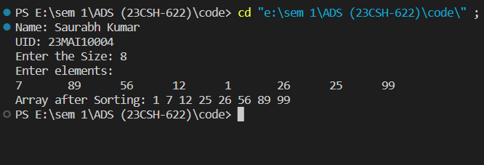

1. **Learning Outcomes**
2. Learnt about how to sort an array.
3. Learnt about how to implement bubble sort.
4. Learnt about how to find time and space complexity
5. Learnt about how to code in c++ and take array as an input.
6. Learnt about how to traverse an array.