##### Logo_21

##### SMART PARKING SYSTEM

Submitted to the

Department of Master of Computer Applications

in partial fulfilment of the requirements

for the Mini Project (MCAP01)

**by**

**SAURABH KUMAR**

**1MS17MCA45**

**Dr. Sailaja Kumar**

**Ramaiah Institute of Technology**

**(Autonomous Institute, Affiliated to VTU)**

**Bangalore – 54**

**2019**

## Logo_21

**DEPARTMENT OF COMPUTER APPLICATIONS**

# CERTIFICATE

This is to certify that the project entitled SMART CAR PARKING carried out by

Student Name USN

SAURABH KUMAR 1MS17MCA45

students of 4th semester, in partial fulfillment for the Mini Project (MCAP01), during the academic year 2018-2019.

­­­­­ Guide Head of the Department

(Dr. Sailaja Kumar) ( [Dr. Yogish H K](http://www.msrit.edu/department/faculty-detail.html?dept=mca&ID=1) )

Name of Examiners Signature with Date

**DECLARATION**

I hereby declare that the project report entitled **“**\_**SMART CAR PARKING\_”** based on study undertaken by me, towards the partial fulfillment for the Mini Project (MCAP01) carried out during the 4th semester, has been compiled purely from the academic point of view and is, therefore, presented in a true and sincere academic spirit. Contents of this report are based on my original study and findings in relation there to are neither copied nor manipulated from other reports or similar documents, either in part or in full, and it has not been submitted earlier to any University/College/Academic institution for the award of any Degree/Diploma/Fellowship or similar titles or prizes and that the work has not been published in any specific or popular magazines.

**Place: Bangalore** SAURABH KUMAR

**Date: 20/12/2019** 1MS17MCA45

## **Acknowledgement**

A project work is a product of experience and it goes a long way in shaping a person in one aspect. With great gratitude I would like to acknowledge the immense help of all those who contributed with their valuable suggestions and timely assistance to complete this work. All that I have done is only due to such supervision and assistance and I would not forget to thank them.

I thank Dr. Sailaja Kumar for providing me an opportunity to do the project giving all support and guidance which made me complete the project duly. I am extremely thankful to her for providing such a nice support and guidance, taking keen interest in my project work and guiding me all along, till the completion of my project work by providing all the necessary information for developing a good system.

**ABSTRACT**

In the early times the concept of smart cities have gained great popularity. The proposed Smart Parking system consists of anon-site deployment of an IOT module that is used to monitor and signalize the state of availability of single parking space. This paper introduce an IOT based coordinated framework for efficient and easy way of parking the vehicles by checking the availability of slots. The proposed Smart Parking framework comprises of an IOT module that is utilized to screen and signalize the condition of accessibility of single parking spot. The paper additionally depicts an abnormal state perspective of the framework engineering. Towards the end, the paper examines the working of the framework in type of an utilization case that demonstrates the rightness of the proposed show. The Ultrasonic Range Detection Sensor is utilized with Arduino to indicate the empty slot .By measuring the distance using ultrasonic sensor drivers are able to find the empty slot in parking to park the car and help the driver to find the slot easily and reduce the searching time. As the parking place is found to be empty it is detected using ultrasonic sensors which report it further. We achieved this by programming the sensors and Arduino.

**TABLE OF CONTENTS**

|  |  |  |
| --- | --- | --- |
| **SLNO** | **CONTENTS** | **PG.NO** |
| **1** | **Introduction**   * 1. **Overview**   2. **Problem Statement** | **07-08** |
| **2** | **Hardware and software requirements** | **09** |
| **3** | **Software Requirements Specification** | **10-13** |
| **4** | **Implementation** | **14-17** |
| **5** | **Reports** | **18-19** |
| **6** | **Conclusion** | **20** |
| **7** | **Future scope** | **21** |
| **8** | **Bibliography** | **22** |

**1. Introduction**

Internet of Things (IOT) plays a vital role in connecting the surrounding environmental things to the network and made easy to access those un-internet things from any remote location. It’s inevitable for the people to update with the growing technology. And generally people are facing problems on parking vehicles in parking slots in a city. In this study we design a Smart Parking System (SPS) which enables the user to find the nearest parking area and gives availability of parking slots in that respective parking area. And it mainly focuses on reducing the time in finding the parking lots and also it avoids the unnecessary travelling through filled parking lots in a parking area. Thus it reduces the fuel consumption which in turn reduces carbon footprints in an atmosphere.

**1.1. Overview**

The demand for accessible and quick parking has always been one of the top wishes for any average person. While there are several solutions which show at a high level whether the parking lot is full or not, there is a scarcity of a smart solution which can tell exactly which parking spot is open, if any, and directions to it. For the current scope of this project we will not be providing directions. Smart Parking is a system that serves drivers and business owners that are looking for an intelligent parking solution. An average user will be able to find parking spots through a mobile or web application, this application will show by location which parking spaces are open or closed in a parking garage, parking lot, or in the city, to help the user avoid circling around while looking for parking. The Smart Parking system will help the user plan his commute and parking ahead of time, saving all of the frustration that is involved when looking for parking. This functionality is helpful when special events, games or fairs occur. Also, it helps in downtown locations or places with which the user is not familiar. This will help our users save time by planning ahead and money by reducing the amount of gas wasted circling around parking lots.

**1.2. Problem Definition**

**Existing System**

**Disadvantages about each existing system**

* In places where there is no provision of GSM networks, it is difficult for communication.
* RFID systems are often more expensive than bar code systems.
* RFID technology is harder to understand.
* Can be (debatable) less reliable.
* RFID tags are usually larger than bar code labels.

**Proposed System**

The smart parking system that we propose is implemented using a mobile application that is connected to the cloud. The system helps a user know the availability of parking spaces on a real time basis. It talks about the factors responsible of Cloud-IOTintegration.

**Feature and its advantage**

* Save the time for searching the parking spaces.
* Reduces the fuel consumption and traffic congestion.
* Avoids air pollution and global warming.
* Scalable, robust and reliable.
* Reduces the driver stress and improves the urban area.

**2. Hardware and Software Requirements**

**Hardware requirement:**

List of Component used:

1. Arduino Mega 2560
2. Lcd display
3. Ultrasonic sensor
4. RGB led
5. Servo motor
6. IR Sensor

Cost analysis of each component:

1. Arduino mega-₹750.
2. LCD-₹120
3. Ultrasonic sensor-₹6\*120
4. RGB led-₹4\*40
5. Servo motor-₹2\*150
6. Connecting wires,Bread board-₹150
7. IR Sensor- ₹200

Total cost estimated-₹6200

**Software Requirements:**

* OS
* Windows-7,8,10
* Ubuntu

**IDE**

* Arduino

**3. Software requirement specification**

* 1. **Purpose**

Our system is a Raspberry pi based parking sensor which detect the empty parking spaces and sends this data to server, this stored data is accessed by users. This enhances the user to check the status/availability of parking spaces before setting their journey. Here the challenge is to use the existing resources in optimum level to reduce the searching time, traffic congestion in the city. Some embedded systems such as arduino, raspberry pi, etc. are used to develop internet of things applications.

* 1. **Product Scope**

Smart Parking can be used to find the free parking lots and also it avoids the unnecessary travelling through filled parking lots in a parking area filter the recipes from the database from the existing ingredients. Smart Parking is a system that serves drivers and business owners that are looking for an intelligent parking solution. An average user will be able to find parking spots through a mobile or web application, this application will show by location which parking spaces are open or closed in a parking garage, parking lot, or in the city, to help the user avoid circling around while looking for parking. The Smart Parking system will help the user plan his commute and parking ahead of time, saving all of the frustration that is involved when looking for parking.

**2. Overall Description**

This project's main purpose is to produce a real life solution to the car parking problem which the whole world is facing frequently. People usually roam around in the parking lots trying to find a suitable place to park in. To solve that problem we have created the automatic car parking system, using an open source hardware, programmable sensors and the use of computers to provide an interface to understand the digital output produced.

**2.1 Product Perspective**

Seeking a vacant parking space during peak hours in areas like Hospitals, Hotels & Shopping Centers, Airports, Universities, and Exhibitions & Convention Center has always been frustrating for many drivers. Surveys says that traffic generated by cars searching for vacancies in Parking Spaces is up to 40% of the total traffic. Smart Parking System is one of the best available solutions to at least reduce the traffic congestion caused due to the above problem. This application gives information about the occupancy status of the spaces in the parking lot equipped with sensors that detect the presence of vehicles. Smart Parking is an Internet of Things (IOT) based application, used to detect the available parking slots. This app uses ultrasonic sensor to detect the presence of a vehicle (whether the parking lot is occupied or not).

**2.2 Product Functions**

The Smart Parking system will consist of parking sensors, micro controllers, and it will work in tandem with an Android application. The parking sensor node will be placed in the parking space. It will provide users the spaces in a parking lot which are opened and closed so users can reduce the frustration of looking for parking. The parking sensors will generate data relevant to the specific parking space that it is located in. The Android application will show the users on Smart Park enabled lots which spaces are open.

**2.3 USER CLASSES AND CHARACTERSICS**

* Typical users, such as drivers and car owners can search for free parking slot to park which is more efficient.
* It can be used in shopping malls, restaurants, hospitals ,parking slots etc to help users know about the availability of free parking spaces.

**2.4 OPERATING ENVIRONMENT**

**Hardware requirement:**

List of Component used:

1. Arduino Mega
2. Lcd display
3. IR Sensor
4. RGB led
5. Servo motor

Cost analysis of each components:

1. Arduino mega-₹750.
2. Lcd-₹120
3. Ultrasonic sensor-₹6\*120
4. RGB led-₹4\*40
5. Servo motor-₹2\*150
6. Connecting wires,Bread board-₹150

Total cost estimated-₹6200

**Software Requirements:**

* OS
* Windows-7,8,10
* Ubuntu

**IDE**

* Arduino
* Artik cloud

**Hardware Description:**

* **Arduino UNO**

The Arduino Mega 2560 is a microcontroller board based on the ATmega2560. It has 54 digital input/output pins (of which 14 can be used as PWM outputs),16 analog inputs, 4 UARTs (hardware serial ports), a 16 MHz crystal oscillator, a USBconnection, a power jack, an ICSP header, and a reset button. It contains everythingneeded to support the microcontroller; simply connect it to a computer with a USB cable orpower it with a AC-to-DC adapter or battery to get started. The Mega is compatible withmost shields designed for the Arduino Duemilanove or diecimila.

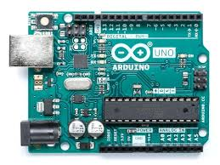

* **Jumper Wires**

A jump wire (also known as jumper, jumper wire, jumper cable, DuPont wire, or DuPont cable – named for one manufacturer of them) is an electrical wire, or group of them in a cable, with a connector or pin at each end (or sometimes without them – simply "tinned"), which is normally used to interconnect the components of a breadboard or other prototype or test circuit, internally or with other equipment or components, without soldering.

**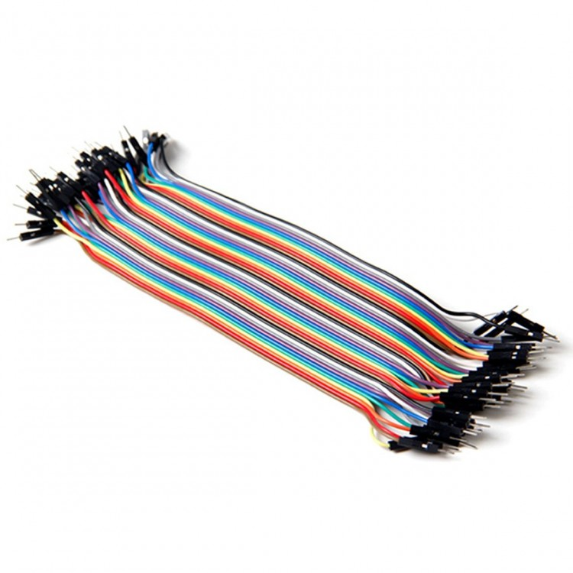**

* **Breadboard**

A breadboard is a solder less device for temporary prototype with electronics and test circuit designs. Most electronic components in electronic circuits can be interconnected by inserting their leads or terminals into the holes and then making connections through wires where appropriate. The breadboard has strips of metal underneath the board and connects the holes on the top of the board.

**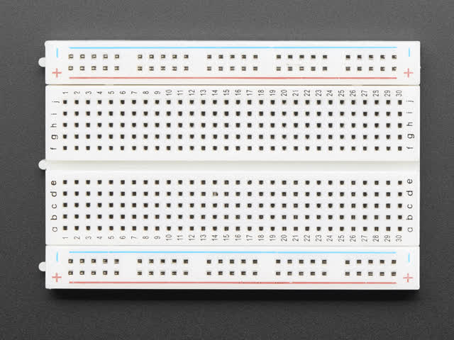**

* **IR sensor**

An **infrared sensor** is an electronic device, that emits in order to sense some aspects of the surroundings. An **IR sensor** can measure the heat of an object as well as detects the motion. These types of **sensors** measures only **infrared** radiation, rather than emitting it that is called as a passive **IR sensor**.

**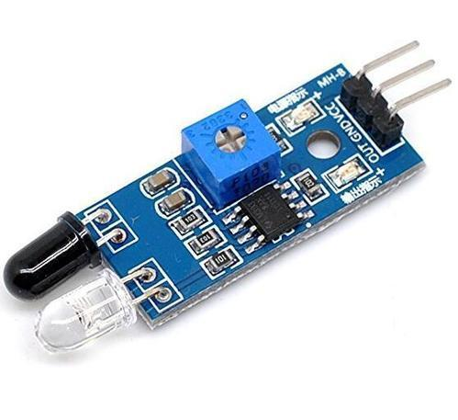**

**4. Implementation**

#include <Servo.h>

#include <Arduino.h>

#include <TM1637Display.h>

#define CLK 6

#define DIO 7

#define TEST\_DELAY 2000

TM1637Display display(CLK, DIO);

const int analogInPin5 = A5;

int sensorrValue = 0;

int servooPin = 8;

int out1 = 2;

int out2 = 3;

int out3 = 4;

int out4 = 5;

int count=0;

Servo servoo;

void setup()

{

Serial.begin(9600);

servoo.attach(servooPin = 8);

pinMode(analogInPin5, INPUT);

pinMode(A0, INPUT);

pinMode(A1, INPUT);

pinMode(A2, INPUT);

pinMode(A3, INPUT);

pinMode(out1, OUTPUT);

pinMode(out2, OUTPUT);

pinMode(out3, OUTPUT);

pinMode(out4, OUTPUT);

}

void loop()

{

int detect0 = digitalRead(A0);

int detect1 = digitalRead(A1);

int detect2 = digitalRead(A2);

int detect3 = digitalRead(A3);

int detect5 = digitalRead(A5);

display.setBrightness(0x0f);

uint8\_t data[] = { 0x0, 0x0, 0x0, 0x0 };

{

sensorrValue = analogRead(analogInPin5);

if (sensorrValue <600) // entrance Gate

{

for (int j=0;j<=90;j++)

{

servoo.write(j);

delay(30);

}

delay(3000);

}

}

if(sensorrValue >600)

{

for (int j=90;j>0;j--)

servoo.write(j);

delay(60);

}

display.showNumberDec(count);

if(detect5 == LOW) // IR 5

{

Serial.println("Obastacle on the way 0 ");

display.setSegments(data);

count++;

delay(TEST\_DELAY);

}

else

{

// Serial.println("All clear 0");

// display.setSegments(data);

// display.showNumberDec(2);

// delay(TEST\_DELAY);

}

if(detect0 == LOW) // IR 0

{

Serial.println("Obastacle on the way 0 ");

digitalWrite(out1,0);

}

else

{

Serial.println("All clear 0");

digitalWrite(out1,1);

}

delay(300);

if(detect1 == LOW) // IR 1

{

Serial.println("Obastacle on the way 1 ");

digitalWrite(out2,0);

}

else

{

Serial.println("All clear 1");

digitalWrite(out2,1);

}

delay(300);

if(detect2 == LOW) // IR 2

{

Serial.println("Obastacle on the way 2 ");

digitalWrite(out3,0);

}

else

{

Serial.println("All clear 2");

digitalWrite(out3,1);

}

delay(300);

if(detect3 == LOW) // IR 3

{

Serial.println("Obastacle on the way 3 ");

digitalWrite(out4,0);

}

else

{

Serial.println("All clear 3");

digitalWrite(out4,1);

}

delay(300);

}

**5. Reports**

**Circuit Diagram**

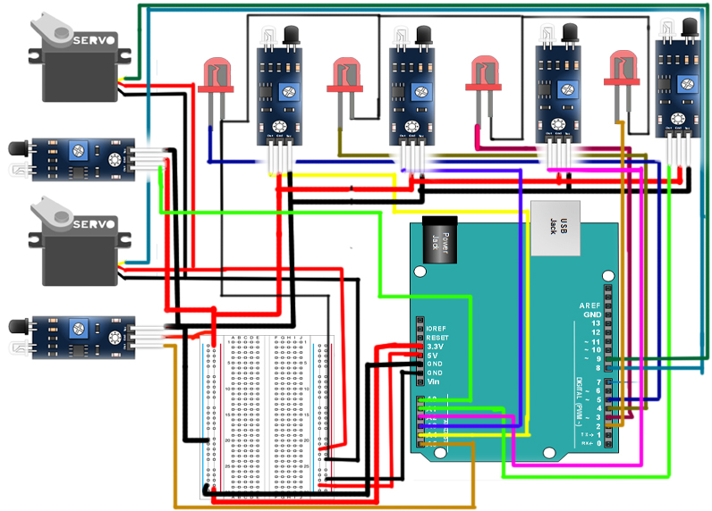

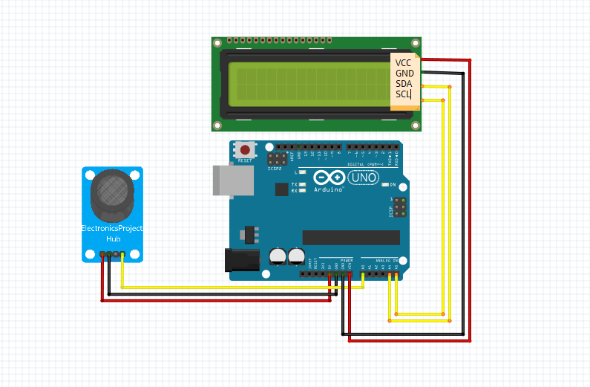

**Model**

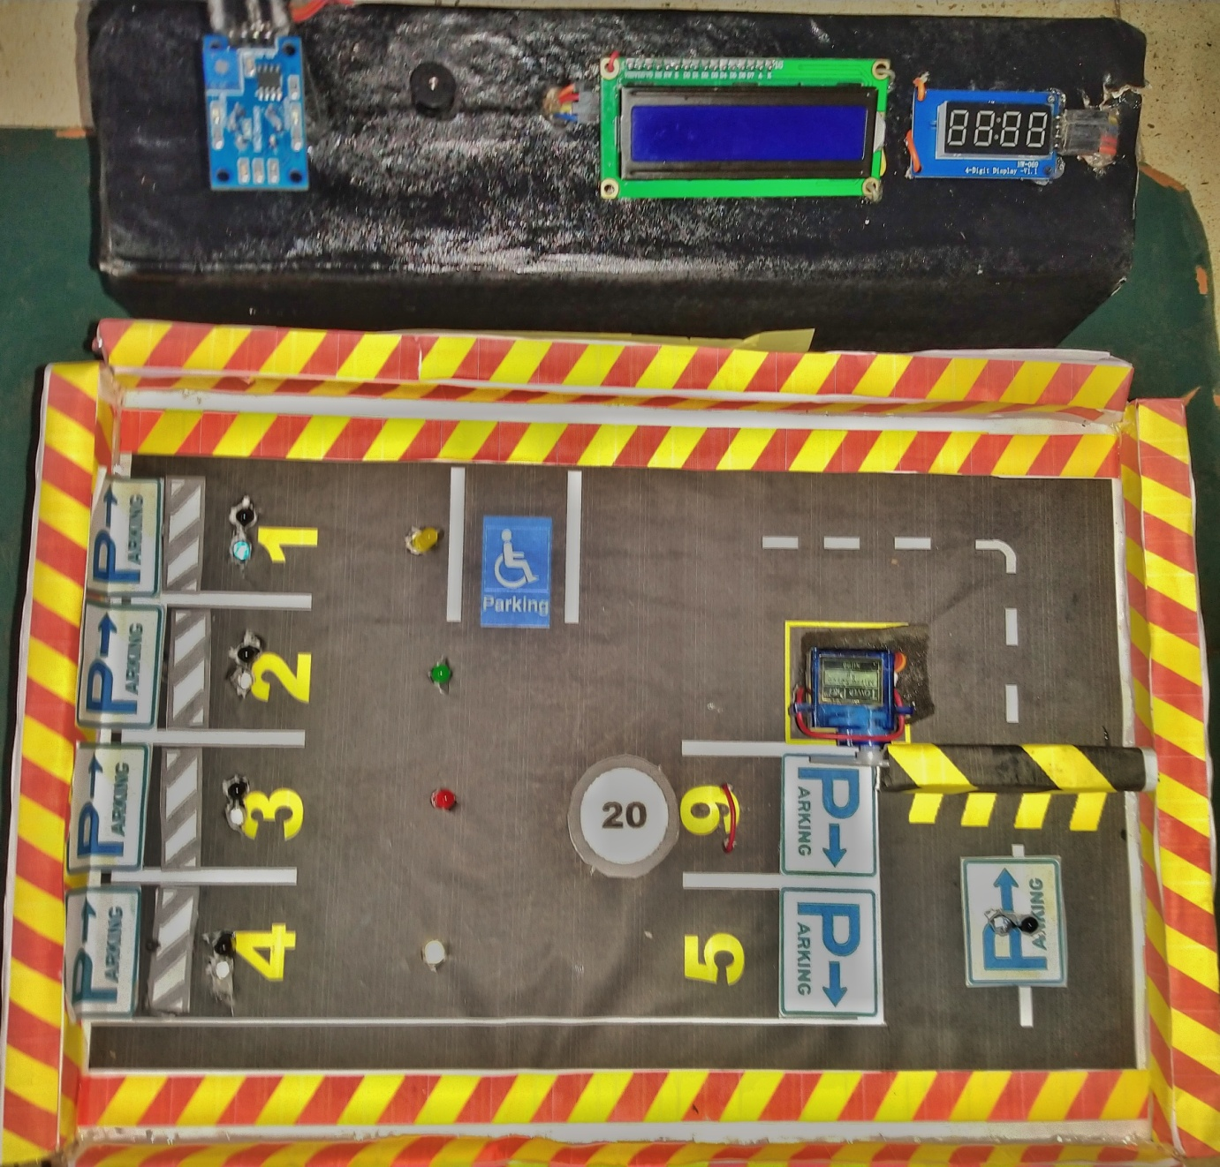

**6. Conclusion**

Our project ensures to find free parking places for public. As soon as parking place is found to be empty it is detected using ultrasonic sensors which report it further. We achieved this by programming the sensors and arduino. Pushing the data to webpage gives us tabular output which shows availability of parking places. The project aims at fast results so that anyone can easily find place for parking and save time in doing so. As raspberry pi is the latest technology, using it gives uniqueness to our project.

**7. Future Enhancement**

The future scope to adopt this automatic smart parking system so that availability of spaces could be displayed on a smart phone Application or even a satellite navigation device so that drivers will always be aware of whetherthere are free spaces are not. And also enhance to send some notifications to users smart phone when vehicle enters to particular shopping places and some streets in a city etc.

1. **Bibliography**

1)<https://www.instructables.com/id/HC-SR04-Ultrasonic-Sensor-With-Raspberry-Pi-2>

2)<https://www.researchgate.net/publication/303842610_IoT_based_Smart_Parking_System>

3)<https://www.sciencedirect.com/science/article/pii/S1877050916321603h>

4)<https://www.hackster.io/hoozi/smart-parking-system-144012>